A Review of the National Orthopaedic Enhanced Recovery after Surgery (ERAS) Quality Improvement Collaborative

November 2013–March 2015

|  |
| --- |
| ‘As demands on our health system grow we need to build efficient systems that maximise efficiency and use resources wisely while providing the highest standard of care and safety for our patients.  ‘Enhanced Recovery after Surgery (ERAS) is a multi-modal, evidence-based approach to patient care evidenced to improve clinical outcomes, productivity and patient experience.’  Jacob Munro  Orthopaedic Surgeon, Auckland DHB  Clinical Leader, National Orthopaedic ERAS Collaborative |

# Acknowledgements

The authors would like to sincerely thank and acknowledge all of those staff in district health boards (DHBs) who participated in the Enhanced Recovery after Surgery (ERAS) Quality Improvement Collaborative. Health professionals from across the sector collaborated to improve care for patients while attending to their usual busy workloads. We appreciate that for a large number of people this collaborative work involved a substantial commitment, effort and willingness to try new ways of working.

We would like to acknowledge members of the Expert Advisory Group who made time to provide valued advice to the Ministry of Health on the ERAS collaborative.

We would also like to acknowledge the valued contributions to this report from Suzanne Proudfoot, Improvement Advisor for the ERAS Collaborative at Ko Awatea and Louis Villa, Evaluation Manager at Ko Awatea and Julie Palmer, Portfolio Manager at the Ministry of Health.

For information on members of the Expert Advisory Group, clinical leaders, project managers and executive sponsors who led improvement teams in DHBs, see Appendices 5 and 6.

Citation: Ministry of Health. 2017. *A Review of the National Orthopaedic Enhanced Recovery after Surgery (ERAS) Quality Improvement Collaborative:  
November 2013–March 2015*. Wellington: Ministry of Health.

Published in August 2017  
by the Ministry of Health  
PO Box 5013, Wellington 6140, New Zealand

ISBN 978-1-98-850283-0 (online)  
HP 6674

This document is available at health.govt.nz



 This work is licensed under the Creative Commons Attribution 4.0 International licence. In essence, you are free to: share ie, copy and redistribute the material in any medium or format; adapt ie, remix, transform and build upon the material. You must give appropriate credit, provide a link to the licence and indicate if changes were made.

Contents

Acknowledgements ii

Executive summary vii

Achievements viii

Considerations for future service improvement initiatives ix

Integrate ERAS principles into business as usual ix

Introduction 1

Background 2

Aim and objectives of the National Orthopaedic ERAS Quality Improvement Collaborative 4

Key objectives 4

Enhanced Recovery after Surgery: An overview 5

ERAS principles 5

Key elements of ERAS for patients having elective arthroplasty or with fractured neck of femur 6

Implementation framework: Institute for Healthcare Improvement’s Breakthrough Series collaborative methodology 7

Improvements in patient care processes 12

Evaluation methodology 14

Data on adopting ERAS principles 14

Clinical outcomes 14

Significance tests 14

Data on clinical outcomes 14

Results: Adoption of ERAS principles 16

Total hip replacement and total knee replacement 16

Fractured neck of femur 17

Conclusion 18

Results: Improving clinical outcomes 19

Total hip replacement 19

Total knee replacement 20

Fractured neck of femur 21

Trend charts 22

Total hip replacement 22

Total knee replacement 23

Fractured neck of femur surgery 24

Clinical outcomes conclusion 25

Results: Success of the collaborative breakthrough series methodology 26

The collaborative methodology 26

DHB survey 26

Results 27

Conclusion 27

Results: Improving the patient experience 28

Ways adoption of ERAS principles supports an improved patient experience 28

Activities to support an improved patient experience 29

Examples of direct patient feedback 30

Patient experience surveys 31

Conclusion 31

Results: Achieving value for money 32

Blood transfusions 32

Average length of stay 32

Conclusion 33

Discussion 34

Achievements of the ERAS collaborative 34

Barriers to implementing ERAS principles 35

Learnings about consumer engagement 36

Conclusion 37

References 38

Glossary 39

Appendices

Appendix 1: Percentage of patients that teams managed using ERAS principles for each care pathway 40

Appendix 2: Significance test results for all patient outcomes 48

Appendix 3: Long-term trends in patient outcomes for individual measures 50

Appendix 4: Results of survey on DHB experiences and perceptions of the ERAS Quality Improvement Collaborative 57

Appendix 5: ERAS Expert Advisory Group for total knee and hip arthroplasty and fractured neck of femur 63

Appendix 6: District health board project managers, executive sponsors and clinical leaders 64

List of Tables

Table 1: Summary of achievements from applying ERAS principles 12

Table 2: Savings made from lower rate of blood transfusions, 2014 32

Table 3: Savings made from a shorter average length of stay, 2014 32

Table 4: Summary of the achievements of DHB teams in using ERAS principles to manage patients 34

List of Figures

Figure 1: Driver diagram describing a functional theory of how to improve care for orthopaedic patients 9

Figure 2: Driver diagram: elective primary total hip and knee arthroplasty 10

Figure 3: Driver diagram for acute fractured neck of femur 11

Figure 4: Percentage of patients having hip arthroplasty that teams managed using ERAS principles, November 2013 to December 2014 16

Figure 5: Percentage of patients having knee arthroplasty that teams managed using ERAS principles, November 2013 to December 2014 17

Figure 6: Percentage of patients with fractured neck of femur that teams managed using ERAS principles, November 2013 to December 2014 18

As demands on our health system grow we need to build efficient systems that maximise efficiency and use resources wisely while providing the highest standard of care and safety for our patients.

Enhanced Recovery after Surgery (ERAS) is a multi-modal, evidence-based approach to patient care evidenced to improve clinical outcomes, productivity and patient experience.

Jacob Munro

Orthopaedic Surgeon

Auckland District Health Board

Clinical Leader

National Orthopaedic ERAS Collaborative

June 2017

# Executive summary

The National Orthopaedic Enhanced Recovery after Surgery (ERAS) Quality Improvement Collaborative took place between November 2013 and March 2015. The 18 participating district health boards (DHBs) implemented ERAS principles for people having elective hip and knee replacement and acute patients with fractured neck of femur.

ERAS is an evidence-informed multi-modal approach that aims to ensure patients are in the best possible condition for surgery and receive the best possible care during and after their surgery. The principles of ERAS are centred on delivery of best practice for patients at each step of the patient journey, from initial consultation through to pre and post-surgery, rehabilitation and longer-term follow-up.

Most teams chose to focus on applying ERAS principles to the elective pathway before starting on the acute pathway. For this reason, teams tended to use principles related to the elective pathway more comprehensively.

The findings of this collaborative support the theory that patients who receive care according to ERAS principles have better clinical outcomes and better experiences of care. More people having total joint arthroplasty are now receiving evidence-based, patient-centred care, resulting in an improved patient experience and a shorter hospital stay but without increasing post-operative complications or acute readmissions.

Similarly, acute patients with fractured neck of femur and their families are better informed about the care patients will receive. Patients are being prepared and taken to surgery sooner and mobilised earlier post-operatively. When these practices are combined with other ERAS principles such as adopting agreed analgesic and anaesthetic regimes, patients recover sooner and have lower post-operative morbidity.

Hip replacement, knee replacement and fractured neck of femur patients all have significantly shorter lengths of stay and fewer complications and blood transfusions on average.

It is difficult to conclude that the ERAS collaborative was the sole cause of these improvements given that five-year hospital trends suggest service in all of these areas was improving before the collaborative began. Nevertheless, the results show that following ERAS principles at least maintained or may well have strengthened the pre-existing trends towards better care.

The 18 participating DHB teams also improved their knowledge of leading a change programme and their capability to do so by using the Institute for Healthcare Improvement’s Breakthrough Series (BTS) collaborative methodology.

The BTS methodology provided a robust and comprehensive framework to support a successful national improvement programme. Given the relatively short timeframe for the ERAS collaborative, (approximately 16 months), improvements to patient care have been substantial in all participating DHBs. These improvements have provided a platform for teams to continue to build from in acute and elective services. Successes in orthopaedics have already led some DHBs to adopt ERAS principles in other specialties.

Patient experience is increasingly recognised as one of the fundamental pillars of quality in health care alongside clinical effectiveness and patient safety. Participating teams adopted a range of strategies to engage with consumers throughout the ERAS collaborative. Strategies varied, and included having consumers on their project team, participating in the National Learning Sessions, presenting to groups about their experience and developing surveys to get direct patient feedback on their experience.

Some teams experienced challenges in managing business as usual and the competing demands of introducing multiple improvements across different teams and departments. For this reason, not all of the ERAS principles related to acute and elective pathways were able to be adopted.

Considering the programme’s impact on patient care and clinical outcomes, along with the budget allocated to the programme, the Ministry of Health is satisfied that the programme was successful and provided value for money.

## Achievements

This was the first nationally led quality improvement collaborative in New Zealand focused on patients who are having elective and acute orthopaedic surgery. Eighteen DHBs participated in the collaborative, implementing ERAS principles and making significant improvements in clinical practice and the organisation of patient care. These improvements were a direct result of strong clinical leadership, multidisciplinary collaboration and engagement with patients and their families, management and front-line staff across multiple departments and teams.

The following is a summary of achievements made throughout the collaborative to improve patients’ quality of care, safety and experience in addition to reducing costs.

* The average length of hospital stay fell from 4.63 to 4.05 days for hip replacement surgery and from 5.00 days to 4.29 days for knee replacement surgery, providing a nominal saving of $1,804,725 in costs.
* The number of blood transfusions fell from 13.9 to 9.2 percent for patients having hip replacements, from 17.8 to 5.5 percent for patients having knee replacements and from 31.9 to 27.5 percent for patients with fractured neck of femur, providing a nominal saving of $515,607 in costs.
* The proportion of patients who were mobilised within 24 hours of surgery increased from about 20 percent to an average of 70 percent for patients having hip and knee replacements and from about 22 to 33 percent for patients with fractured neck of femur.
* The number of patients with fractured neck of femur who were operated on within 48 hours of admission to hospital increased from 82 to 85 percent.
* More patients having hip and knee replacement surgery received comprehensive pre-operative education. As a result, they knew what to expect when they went in for surgery and what would be expected of them.
* Clinicians from a range of specialties – including anaesthetics, emergency department, health of older people and orthopaedics – worked together on this collaborative to incorporate ERAS principles into their practice and improve the delivery of patient care.
* Over 300 health care professionals – including nurses, doctors, pharmacists, physiotherapists and occupational therapists – attended workshops to learn about ERAS and share their achievements as part of the ERAS Quality Improvement Collaborative.
* Teams became more capable, confident and willing to take on other quality improvement initiatives. Teams were supported to engage with consumers to improve safety, patient care and clinical outcomes.

# Considerations for future service improvement initiatives

## Integrate ERAS principles into business as usual

1. The evidence from this ERAS Quality Improvement Collaborative shows that improvements have been achieved in clinical outcomes, patient experience, reduced costs and length of hospital stay. To extend these benefits to a broader range of patients and services, surgical specialties should give consideration to adopting ERAS principles and protocols for commonly performed surgical procedures.

2. Having well-respected, knowledgeable and influential clinical leaders that support their teams improvement efforts has been shown to be invaluable. In the future, all service and quality improvement initiatives that impact patient care should have appropriate clinical leadership.

3. In the planning stages of all improvement initiatives, strategies need to be incorporated that improve communication and develop partnerships with patients and their families, with the goal of improving patient safety and quality of care.

4. The level of achievements in each team participating in this collaborative depended on their specific characteristics, culture, resources, capabilities, willingness and ‘readiness’ to adopt ERAS principles. Before embarking on new initiatives, careful analysis is needed on the readiness, capabilities, capacity and commitment of those who will be required to be involved.

5. Education about ERAS should be more widely available for health staff. The aim is to enable surgical specialties to extend their knowledge about ERAS, enabling it to become a core part of their practice. The health sector already has knowledge, expertise and capability to build on to make integration of ERAS principles business as usual.

6. The BTS methodology has been shown to be an appropriate and robust tool to support teams to improve patient care. When planning future improvement initiatives, consideration should be given to utilising this approach as a framework to support improvement.

# Introduction

This is an evaluation report on the National Orthopaedic Enhanced Recovery after Surgery (ERAS) Quality Improvement Collaborative that took place between November 2013 and March 2015.

This report describes the collaborative approach, achievements and outcomes of applying ERAS principles with people having elective hip and knee replacements and people with acute hip fractures. It also makes recommendations based on learning from the collaborative that health organisations, departments and professionals might consider when making future service improvement initiatives and when adopting ERAS principles in general.

The purpose of the evaluation was to decide whether:

* the National Orthopaedic ERAS Quality Improvement Collaborative achieved its aims and objectives
* the Institute for Healthcare Improvement’s Breakthrough Series (BTS) collaborative methodology is an effective approach for a national quality improvement initiative
* the Ministry of Health’s investment in the ERAS collaborative provided value for money
* patients, staff and services benefited in other ways from the ERAS collaborative.

This evaluation summarises key findings on five domains of the ERAS Quality Improvement Collaborative:

* how widely staff implemented ERAS principles with patients having knee and hip replacements and patients with fractured neck of femur
* whether clinical outcomes improved – comparing outcomes before, during and after the ERAS collaborative
* whether the quality improvement collaborative method was successful
* whether the patient experience improved
* whether the programme provided value for money.

# Background

In Budget 2012 the Government allocated funding to improve elective service delivery by increasing the volume of elective procedures and reducing waiting times for access to elective services. By December 2014 waiting times had fallen from a maximum of six months to four months for first specialist assessment and likewise from a maximum of six months to four months for access to treatment.

A range of strategies contributed to achieving this goal. These included funding innovative models of care that resulted in more streamlined patient pathways, improvements in booking and scheduling systems, and sustained increases in volumes of procedures performed. Orthopaedics and general surgery received additional support to increase volumes and reduce waiting times.

Historically, in some places orthopaedic services struggled to achieve the Ministry of Health’s waiting time requirements. One reason for this difficulty is that orthopaedics is one of the largest surgical services, alongside general surgery, and acute demand affects both orthopaedics and general surgery more than any other service.

Demand for orthopaedic care has increased and is expected to continue to increase due to longer life expectancies, a growing rate of musculoskeletal health conditions and a significant rise in the prevalence of obesity. Public expectations for longer, physically active lifestyles have also increased demand for joint replacement surgery.

A multidisciplinary Expert Advisory Group was formed to explore how improvements in orthopaedic services could be achieved. Its membership included orthopaedic surgeons representing the New Zealand Orthopaedic Association, orthopaedic nurses and managers, musculoskeletal physiotherapists and occupational therapists. Their role was to advise the Ministry of Health on the most effective ways reductions in waiting times in orthopaedic services could be achieved.

The Expert Advisory Group recommended adopting an ERAS pathway for people needing hip and knee arthroplasty and people with fractured neck of femur. The group considered this approach would improve the quality of patient care, clinical outcomes and contribute to a reduction in waiting times.

Hip and knee arthroplasties are the most commonly performed elective procedures in orthopaedics. Approximately 11,000 arthroplasties are performed every year – which translated to 4,952 knee and 6,060 hip arthroplasties in the year ending June 2016 (National Minimum Dataset, June 2016).

With an ageing population alongside increasing prevalence of osteoarthritis, the need for hip and knee arthroplasty is increasing. Reducing the length of hospital stays is a mainstay of effective and cost-efficient orthopaedic practice.

The Expert Advisory Group also recommended including an ERAS pathway for people with acute fractured neck of femur. This patient group was included because acute fractured neck of femur is the most common acute orthopaedic procedure and is a major public health issue for an increasingly ageing population. Approximately 3,000 fractured neck of femur procedures are performed every year in New Zealand.

Acute hip fracture in the elderly is linked with high post-operative mortality, poor functional outcomes and significant financial and social costs. About 10 percent of people with a hip fracture die within one month and about one-third within 12 months. Most of the deaths are due to associated conditions rather than the fracture itself, reflecting how other diseases or disorders often occur along with hip fractures (comorbidity) (Goldacre et al 2002).

The Expert Advisory Group believed outcomes could be improved for this generally frail and vulnerable group of patients. It also expected that improving their management and care would increase the health sector’s capability to deliver elective surgery.

At the beginning of the collaborative, guidance on best practice for hip fracture management was being updated (ANZHFR Steering Group 2014). This quality improvement initiative provided a useful vehicle for raising awareness of and promoting the updated guidelines, supporting health professionals to adopt them.

The acute pathway is generally more complex than the elective pathway, in part because the patients involved are highly variable in their presentation and condition. In addition, for acute surgery a much larger group of health professionals in multiple departments – namely emergency department, pre-operative care, operating theatres and post-operative settings – must collaborate, negotiate and agree on patient flow. The range of health professionals involved in a patient’s care can include, among others, anaesthetists, orthopaedic surgeons, emergency department teams, physiotherapists, ward and outpatient staff, operating theatre teams and social workers.

In contrast, the elective pathway is more streamlined. Patients have more in common in clinical terms, outcomes are more predictable and less risk is involved. All the same, the elective pathway still involves multiple teams, departments and processes, so improving an elective pathway also involves a significant amount of work.

# Aim and objectives of the National Orthopaedic ERAS Quality Improvement Collaborative

The aim of the National Orthopaedic ERAS Quality Improvement Collaborative for the 18 participating DHBs was to apply ERAS principles for all patients having elective hip and knee replacement and all patients with acute neck of femur fracture by December 2014.

## Key objectives

1. Increase the number of patients managed according to ERAS principles.

2. Increase the proportion of elective patients admitted on the day of surgery.

3. Increase the proportion of acute fractured neck of femur patients operated on within 48  hours of their presentation to hospital.

4. Increase the proportion of patients mobilised within 24 hours of surgery.

5. Reduce day of surgery cancellation rates for elective patients.

6. Reduce patients’ average length of hospital stay.

7. Reduce complications.

8. Maintain or reduce readmission rates.

# Enhanced Recovery after Surgery: An overview

The main objective of ERAS is to have a pain and risk-free operation.

Henrik Kehlet (2015)

The concept of ‘fast-track’ surgery, when Kehlet introduced it in the 1990s, focused on the delivery of multimodal surgical care (Wilmore and Kehlet 2001). This idea in part has evolved into what is known today as ‘enhanced recovery pathways’, in which a comprehensive, multimodal, peri-operative care pathway focuses on enhancing recovery and reducing morbidity. These aims are achieved by putting evidence into practice in the fields of anaesthesia, analgesia, reduction of surgical stress, fluid management, minimally invasive surgery, nutrition and ambulation to help patients to recover earlier from major surgery.

By applying evidence-based ERAS principles, DHBs are aiming to reduce variation in patient care and improve peri-operative outcomes. Variations in surgical care are often interpreted as evidence of uncertainty about optimal care. ERAS has been shown to significantly reduce length of stay and complications in both colorectal and musculoskeletal surgery without increasing the rate of readmission (Spanjersberg et al 2011).

When surgical specialties adopt ERAS principles, they make sure patients are in optimal condition for surgery, have the best possible care during surgery and have the best possible rehabilitation afterwards. As a result, patients recover more quickly with a lower risk of post-operative complications.

The ERAS pathway can also make patients more confident in their health care organisations. Additionally, because it improves quality of care and reduces harm, this pathway is assumed to make a patient’s hospital stay more efficient, and hospital services will benefit as well.

## ERAS principles

Ensure the patient:

1. is involved in all decisions about their care

2. is in the best possible condition for their surgery

3. has the best possible management during and after their surgery

4. experiences the best possible rehabilitation, which will accelerate their recovery and discharge from hospital, allowing them to return to normal activities sooner.

## Key elements of ERAS for patients having elective arthroplasty or with fractured neck of femur

ERAS principles that DHB teams adopted in the Quality Improvement Collaborative included:

* pre-operative education and discharge planning
* locally agreed, standardised anaesthetic, analgesic and anti-emetic regimes
* day of surgery admission (hip and knee replacements) or surgery within 48 hours (acute neck of femur fracture)
* mobilisation within 24 hours
* criteria-based discharge.

# Implementation framework: Institute for Healthcare Improvement’s Breakthrough Series collaborative methodology

The approach taken to support teams adopt the ERAS principles recommended by the Expert Advisory Group was based on the Institute for Healthcare Improvement’s Breakthrough Series (BTS) collaborative methodology. The BTS methodology has been proven to be effective with improvement initiatives across a wide range of organisations. More recently in New Zealand, 20 DHBs used it successfully to reduce the rate of central line-associated bacteraemia in intensive care units (Gray et al 2015).

The BTS approach draws on the principles of the Model for Improvement, a tool for accelerating improvement. Using this approach, teams work together to set clear aims, identify evidence-informed changes and agree on measures they will use to decide whether the changes are leading to improvement. The BTS structure includes Learning Sessions interspersed with Action Periods.

The Learning Sessions provided opportunities to develop knowledge about ERAS, the BTS and Model for Improvement (Langley et al 2009) and share learning across teams. During Action Periods, the Model for Improvement was used by teams to set specific aims and measures. Teams then developed and tested ideas using plan, do, study, act (PDSA) cycles (Figure 1) to test and adapt interventions to their local settings.

Expert clinical faculty, who were specialists in orthopaedic ERAS and experts in improvement methodology, led development and delivery of improvement content, measurement strategies and resources that supported the change effort.

Mr Jacob Munro, Orthopaedic Consultant at Auckland District Health Board was the clinical leader for the collaborative national team. This team included a programme manager, a senior advisor, communications and information management advice and a consumer representative. The team managed and advised on the day-to-day operation of the collaborative.

Experts in improvement at Ko Awatea supported teams in their adoption of ERAS principles using the Model for Improvement. Ko Awatea is a health system improvement and innovation centre with experience in leading national improvement campaigns.

The Ministry of Health made funding available to support DHB teams to participate in the collaborative. With a modest budget, teams could secure project management resource, develop materials to support implementation of ERAS principles and participate in collaborative activities such as national learning sessions and the National Outcomes Conference.

Eighteen DHBs participated in the collaborative. Each DHB established an improvement team that comprised a project manager, clinical leader and representatives from front-line staff from disciplines involved in the ERAS care pathway (for example nurses, anaesthetists and physiotherapists).

The following support and resources were developed and made available for participating DHB teams.

* **Two patient information videos** for patients to view in their home before surgery so they were better prepared for their surgery. The videos are available online across New Zealand.
* **Patient information booklets** covered all stages in the hip and knee surgical pathways. DHBs could adapt these resources to suit their own specific community’s needs and practices.
* **An online ERAS microsite** offered a suite of resources, including protocols and various topic-related literature, to support teams in applying ERAS principles.
* **DHB site visits and teleconferences** promoted awareness and understanding of the Model for Improvement to apply ERAS principles.
* **Patient engagement resources** to support teams incorporate the patients voice in planning and delivery of the ERAS collaborative.
* **Monthly, regional WebEx sessions**, led by the national project team, focused on specific topics related to leading change, the Model for Improvement and ERAS best-practice principles for effective peri-operative care and engaging with consumers.
* **Three national learning sessions** allowed teams to share their learning and experiences around adopting ERAS using the Model for Improvement.
* **An online reporting platform** enabled teams to submit standardised electronic reports, so that they could monitor and share their own progress and learn about how other DHBs were progressing with implementing ERAS.
* **A National Outcomes Conference** at the end of the collaborative was an opportunity for participants to share their achievements, learning, and outcomes from implementing ERAS.
* **Change Packages** were developed for the elective total joint arthroplasty (hip and knee) and acute fractured neck of femur pathways. These packages presented the interventions that the ERAS collaborative would use, and the evidence base for these. Key sources of evidence were the *Australian and New Zealand Guideline for Hip Fracture Care* (ANZHFR Steering Group 2014) and a how-to guide from the Welsh 1000 Lives Plus campaign (1000 Lives Plus 2011). The change packages also cited a wide range of other sources.

The elective hip and knee arthroplasty change package grouped drivers and interventions into care bundles for: primary care; pre-admission; pre-operative; peri-operative; post-operative; discharge and follow-up (Figure 2).

The acute fractured neck of femur change package used the groupings of: pre-hospital and emergency department; pre-operative; peri-operative; post-operative; discharge and follow-up (Figure 3). Together, Figures 2 and 3 give an overview of interventions for the elective and acute pathways respectively.

Figure 1: Driver diagram describing a functional theory of how to improve care for orthopaedic patients

Figure 1: Driver diagram describing a functional theory of how to improve care for orthopaedic patients

Key: SMART = Specific, measurable, achievable, realistic, time-based.

Figure 2: Driver diagram: elective primary total hip and knee arthroplasty

Use ERAS principles to manage patients having knee/hip replacement surgery

**Primary care bundle**  
Maximise physical and functional status

**Discharge bundle and follow-up care**  
Plan for timely discharge, supporting the patient in a safe discharge and monitoring care post-operatively to detect potential complications

**Peri-operative bundle (includes 1 week before admission along with time in theatre)**  
Reduce the stress response to surgery and promote homeostasis

**Pre-operative assessment bundle**  
Maximise physical and functional status while preparing patients for surgery

* Optimise fitness through:
  + ‘Fit for List’ health screen
  + smoking cessation
  + nutritional assessment
  + healthy living advice as required
* Manage comorbidities
* Provide education and decision support
* Assess a patient’s anaesthetic fitness for surgery
* Comply with protocols for management of anticoagulation and platelets
* Discuss discharge plans / needs, including predicted date of discharge
* Multidisciplinary team completes assessments and referrals as required
* Hold multidisciplinary patient educational sessions (4 to 6 weeks before surgery)
* Admit patient on day of surgery
* Confirm all discharge arrangements, including transport home, with patient
* Establish and follow standardised protocols for:
  + analgesia, anaesthesia, nausea and vomiting
  + avoiding deep vein thrombosis
  + adequate hydration
  + limited use of drains and catheters
  + maintenance of normothermia
* Conduct criteria-based discharge
* Use agreed communication processes for:
  + nominated health professional to follow up contact within 48 hours after discharge
  + patient to initiate follow-up after discharge
  + multidisciplinary team to follow up as appropriate after discharge
* Plan early mobilisation within 24 hours
* Place patients in cohorts where possible
* Confirm discharge needs with family and/or social services within 24 hours after surgery
* Provide oral nutrition as soon as patient is able to tolerate it, or within 12 hours of surgery
* Establish and follow protocols for assessment and management of pain and post-operative nausea and vomiting
* Provide 7-day-per-week health cover for physiotherapy

**Post-operative bundle**  
Provides patient-centred and goal-oriented specialist care following surgery

Focus

Drivers

Interventions

Figure 3: Driver diagram for acute fractured neck of femur

Use ERAS principles to manage patients having neck of femur surgery

**Pre-hospital – ambulance**  
Manage physical and functional status

**Discharge bundle and follow-up care**  
Plan timely discharge, supporting the patient in a safe discharge and monitoring care post-operatively to detect potential complications

**Peri-operative**  
Reduce the stress response to surgery and promote homeostasis

**Pre-operative assessment bundle**  
Manage physical and functional status while preparing patients for surgery

* Follow standardised analgesia regime for early effective pain management
* Assess and manage hydration and analgesia
* Identify causes of fall and pre-fall function
* Identify inter-current illnesses early
* Plan to provide surgery as soon as possible, within 24–48 hours
* Establish process for rapid assessment by emergency department, orthopaedics, specialist medical/geriatrics and anaesthesia
* Multidisciplinary team assesses, manages and optimises pre-existing comorbidities, including anti-coagulation detection and risk management. This work includes:
  + mental health, dementia and delirium screening
  + falls risk assessment
  + medication reconciliation
  + nutritional screening
  + pressure area assessment
* Discuss discharge plans and needs with the patient and their family
* Conduct surgery as soon as possible (within 24–48 hours) with the aim where possible of achieving full weight bearing as soon as possible
* Senior anaesthetists and surgeons provide care for the patient
* Agree on and follow standardised protocols for peri-operative management of:
  + anaesthesia, analgesia, nausea and vomiting
  + avoiding deep vein thrombosis
  + adequate hydration
  + limited use of drains and catheters
  + maintenance of normothermia
* Conduct criteria-based discharge
* Use agreed communication processes for:
  + nominated health professional to follow up contact within  
    48 hours after discharge
  + patient to initiate follow -up after discharge
  + multidisciplinary team to follow up as appropriate after discharge
* Plan early mobilisation within 24 hours
* Provide oral nutrition as soon as patient is able to tolerate it, or within 12 hours of surgery
* Provide effective opioid -sparing analgesia to help patient become mobile early, in line with the agreed protocol
* Regularly assess pain control and post-operative nausea and vomiting
* Collaborate with orthogeriatrician as early as possible
* Confirm all discharge arrangements, including transport home, with patient, family and/or social services
* Appropriate MDT follow up post discharge

**Post-operative bundle**  
Provides patient-centred and goal-oriented specialist care after surgery

Focus

Drivers

Interventions

# Improvements in patient care processes

Table 1 summarises what the Quality Improvement Collaborative achieved through applying ERAS principles.

Table 1: Summary of achievements from applying ERAS principles

| **Component** | **Requirement** | **Rationale** | **Achieved** | |
| --- | --- | --- | --- | --- |
| **Hip or knee** | **Fractured neck of femur** |
| Criteria-based discharge | Team has agreed on standardised discharge criteria for the procedure and has followed the protocol and charted it for this patient. Criteria may vary slightly between hospitals but, in general, it is expected that patients will: tolerate diet and oral fluids, be able to mobilise safely, and have their pain under control, be confident and agree to go home. | Well-organised discharge planning can help reduce length of hospital stay, improve early return to function and reduce both readmission rates and the level of nursing care required. It can reduce delays when discharging patients. | Yes | Yes |
| Pre-operative education | The team gives the patient verbal and written education about their procedure and the ERAS programme. As a result, the patient understands what they can expect and what will be expected of them before they are admitted. | Effective education improves the patient’s experience before and after surgery. Optimal education manages the expectations of the patients and their family, and has been demonstrated to reduce pain by reducing stress and anxiety, which helps to optimise recovery. | Yes | NA |
| Pre-operative discharge planning | Before admission, the team gives the patient a predicted date of discharge and explicitly assesses their discharge needs (such as home support, equipment or home adaptations) and documents these in the patient record. | Well-organised discharge planning and follow-up care can help shorten hospital stay, return patients to function earlier and affect both readmission rates and the level of nursing care required. | Yes | NA |
| Day of surgery admission and day of surgery cancellation (elective surgery) | The elective patient is admitted on the day of surgery (that is, the procedure date is the same as the day of admission). | Same-day admission reduces surgical site infections and post-operative complications. These benefits will help to improve the patient experience, with patients spending less time in hospital, and ultimately will improve capacity within secondary care settings. | Yes | NA |
| Operated on within 48 hours (acute surgery) | The operation begins within 48 hours of the acute patient’s presentation to hospital. | One of the crucial factors affecting the patient’s outcomes, experience and mortality following a hip fracture is the length of delay till surgery: longer waiting times are linked with higher mortality, longer stays and additional complications. Performing surgery within 48 hours is a key marker of quality. | NA | Yes |
| Standard nausea and vomiting protocol | Local teams have agreed a standardised protocol for the management of nausea and vomiting and the protocol has been followed. | Patients often report post-operative nausea and vomiting can be more distressing than pain and makes it harder for them to mobilise. Staff should prescribe appropriate anti-emetics, either to prevent nausea and vomiting or to be given at the first sign of symptoms. | Yes | Yes |
| Standardised anaesthetic and analgesic regime | Local teams agreed on a standardised anaesthetic and analgesic protocol for the procedure that the patient has undergone and the protocols were followed. | With a standardised protocol, it is possible to monitor the effects of the local regimen on outcomes. It also supports wards in taking a clinically consistent approach to treating all patients using the agreed protocol. | Yes | Yes |
| Mobilisation within 24 hours | Patient is walking (active weight bearing), with appropriate walking aid, within 24 hours from the end of the operation. | Early mobilisation maintains muscle mass and promotes muscle strength while maximising respiratory function, which leads to earlier recovery. | Yes | Yes |

# Evaluation methodology

## Data on adopting ERAS principles

Reported data on teams’ use of ERAS principles comes from data that all the 18 participating DHBs entered into the national ERAS database from the beginning of the collaborative up to and including 19 March 2015. Capital & Coast and Southern DHBs were excluded, as they were not participating in this specific ERAS programme.

Shewhart process control *p* charts show the percentage of teams that complied with the ERAS principles related to each of the three pathways: elective knee replacement, elective hip replacement and acute fractured neck of femur.

Note that teams generally made greater progress with the elective pathway than the acute pathway as the majority of them focused on the elective pathway first. It is also important to note that each DHB applied different principles at different times.

## Clinical outcomes

To assess the impact of changes, the analysis compared results for the above measures from April to September 2013 (pre-ERAS) with results from April to September 2015 (post-ERAS).

## Significance tests

Statistical significance tests (chi-squared) compared 2013 (pre-ERAS) with 2015 (post-ERAS).

Chi-squared tests were not used for average length of stay because this measure is an average rather than a proportion. For this measure, a *t*-test for statistical significance was used instead.

Due to the type of data used in this analysis, it was not possible to control for other factors that may affect patient outcomes (for example, changes to a DHB’s internal processes that are not related to ERAS principles). Therefore it is not possible to state conclusively whether the ERAS programme affected patient outcomes, or if rates would have dropped at a similar speed without the ERAS programme.

## Data on clinical outcomes

Data on clinical outcomes is from the National Minimum Dataset using version 6 ICD-10 codes, extracted on 7 January 2016. Data is by DHB of service (that is, the DHB that performed the operation).

The data excludes:

* Capital & Coast and Southern DHBs, as they were not participating in this specific ERAS programme
* non-elective admissions for hip and knee replacements
* elective admissions for fractured femur
* Accident Compensation Corporation events (purchaser code = A0)
* non case-mix admissions
* short stays in the emergency department
* admissions for palliative care (ICD code Z515)
* admissions where DHB of domicile is unknown/unassigned.

# Results: Adoption of ERAS principles

## Total hip replacement and total knee replacement

Figure 4 summarises the overall national results on the percentage of patients that teams managed using ERAS principles for hip arthroplasty from November 2013 to December 2014.

The hip arthroplasty ERAS pathway included these eight core principles:

1. pre-operative education

2. pre-operative discharge planning

3. criteria-based discharge

4. day of surgery admission

5. day of surgery cancellation

6. standard anaesthetic and analgesia regime

7. standard nausea protocol

8. mobilisation within 24 hours.

Figure 5 presents the results for total knee replacement, which involved the same eight core principles as for hip arthroplasty.

Figure 4: Percentage of patients having hip arthroplasty that teams managed using ERAS principles, November 2013 to December 2014

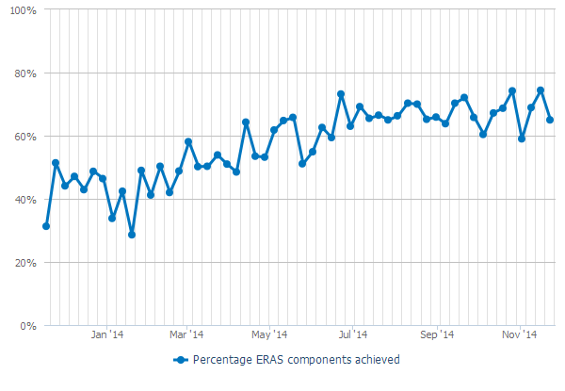

Figure 5: Percentage of patients having knee arthroplasty that teams managed using ERAS principles, November 2013 to December 2014

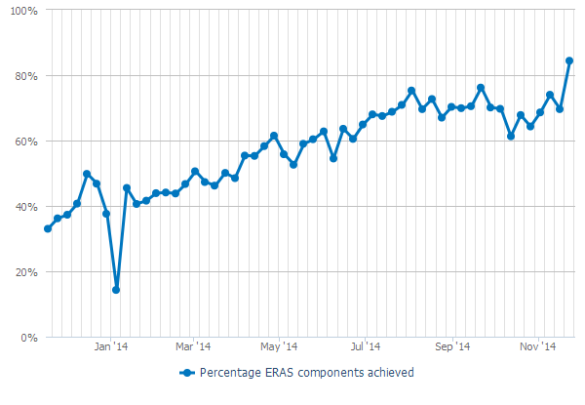

The results show that for total hip arthroplasty, the percentage of patients that teams managed using ERAS principles significantly increased for almost all of the ERAS principles over the collaborative period. The exceptions were day of surgery admission, which was already well established before the collaborative began, and day of surgery cancellation, which is more strongly influenced by patient factors than the other components.

Likewise, for total knee arthroplasty, the percentage of patients managed using ERAS principles increased significantly over the ERAS period, except for day of surgery admission and day of surgery cancellation. See Appendix 1 for individual graphs for each principle that teams used in managing patients having a hip or knee replacement.

## Fractured neck of femur

For fractured neck of femur guidance, the ERAS collaborative used *The Australian and New Zealand Guideline for Hip Fracture Care* (ANZHFR Steering Group 2014).

Principles of the ERAS pathway for fractured neck of femur were:

* **pre-operative principles** – patients are operated on within 48 hours of presentation to the emergency department
* **peri-operative principles** – having locally agreed and standardised:
* anaesthetic and analgesic regimens
* nausea and vomiting protocols
* **post-operative principles**:
* mobilisation within 24 hours
* criteria-based discharge.

Applying ERAS principles provides an opportunity to significantly improve outcomes and reduce mortality for this group of patients. Earlier surgery is linked with better functional outcomes and lower rates of peri-operative complications and mortality. Those who support early treatment argue this approach minimises the length of time a patient is confined to bed rest, which in turn reduces the risk for associated complications, such as pressure sores, deep vein thrombosis and urinary tract infections.

Overall the percentage of patients that teams managed using the five principles for the fractured neck of femur pathway increased over the collaborative period (see Figure 6), although not as much as they did in the elective pathway. One reason for this difference is that a number of DHBs reported they focused on the elective pathway at the start of the Quality Improvement Collaborative and only began work on the acute pathway later – about midway through the collaborative period.

The exception was the use of the principle of operating on patients within 48 hours, which did not rise significantly. However, a large proportion of patients were already being operated on within this timeframe before the collaborative began.

See Appendix 1 for graphs showing the percentage of patients that teams managed using each of the five ERAS principles related to fractured neck of femur.

Figure 6: Percentage of patients with fractured neck of femur that teams managed using ERAS principles, November 2013 to December 2014

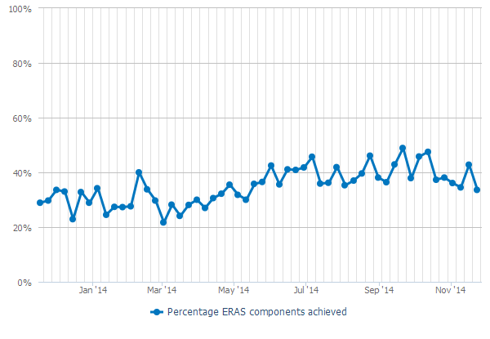

## Conclusion

The data demonstrates a substantial increase across all three pathways in the percentage of patients that teams managed according to ERAS principles. The proportion of patients operated on within 48 hours reached a peak of 91 percent in the week beginning 24 August 2014. The data also shows the percentage of patients mobilised within 24 hours and admitted on the day of surgery increased.

The quantitative evidence is sufficient to demonstrate that practice changed nationally over the period of this collaborative.

# Results: Improving clinical outcomes

This section compares data before and after the ERAS collaborative period to identify any changes in patient outcomes. Patient outcomes analysed were:

* average length of stay
* day of surgery admission (elective hip and knee replacements only)
* surgery within 48 hours (acute fractured neck of femur only)
* readmission rates within 28 days
* mortality within 30 days
* complication rates (including blood transfusions’, stroke, myocardial infarction, gastrointestinal bleeding, deep vein thrombosis and pulmonary embolism).

Note that teams generally made more progress on the elective pathway than on the acute pathway as the majority of them focused on the elective pathway first.

See Appendix 2 for significance tests for all patient outcomes.

## Total hip replacement

### Average length of stay

Nationally, the average length of stay for a hip replacement decreased from 4.63 days in the pre‑ERAS period to 4.05 days post-ERAS.

The difference between these two measures has a *p*-value of less than 0.05 (*p*-value = 0.00), indicating that the reduction in length of stay for patients having hip replacements over the period of the collaborative is statistically significant.

Also, in the post-ERAS period, the mode of the distribution of length of stay for all events was the lowest ever at three days.

### Patients receiving surgery on their day of admission

Day of surgery admission rates were already high (98.1 percent) at the start of the collaborative and remained so after it ended (98.4 percent).

### Mortality

Similarly, mortality rates within 30 days of discharge were low at the start of the collaborative and remained so. No deaths were reported in the pre-ERAS period and one death post-ERAS (giving a mortality rate of 50.4 per 100,000 population).

### Readmissions

Readmission rates increased marginally from 5.6 percent to 6.5 percent of discharges. However, this increase was not statistically significant (*p*-value = 0.27).

### Blood transfusion rates

Blood transfusion rates fell from 13.9 percent to 9.2 percent of discharges, which is a statistically significant result (*p*-value = 0.00). The main reason for this result is that services increasingly used tranexamic acid in a standardised way as part of the ERAS protocol.

### Other complications (excluding blood transfusions)

In total, rates for other reported complications fell slightly. However, these reductions were not statistically significant for the individual complications or for the complications in total.

## Total knee replacement

### Average length of stay

Nationally, the average length of stay for a knee replacement decreased from 5.00 days in the pre-ERAS period to 4.29 days post-ERAS.

The difference between these two measures has a *p*-value of less than 0.05(*p*-value = 0.00), indicating that the reduction in length of stay for patients having knee replacements over the period of the collaborative is statistically significant.

### Patients receiving surgery on their day of admission

Day of surgery admission rates were already high (98.3 percent) at the start of the collaborative and remained so after it ended (98.3 percent).

### Mortality

Similar to hip replacements, mortality rates within 30 days of discharge were low at the start of the collaborative and remained so. One death was reported within 30 days of discharge in the pre-ERAS period (57.6 per 100,000) and one death post-ERAS (50.3 per 100,000).

### Readmissions

Acute readmission rates for knee replacements increased from 6.3 percent to 8.5 percent of discharges, which was statistically significant (*p*-value = 0.02).

The analysis looked at data by DHB to identify whether the size of the reduction in length of stay or blood transfusion rates was related to an increase in readmissions. No individual DHB had a statistically significant increase in readmission rates.

At the national level, the correlation between a shorter length of stay and higher readmission rates was 0.20. This therefore showed a very weak relationship between the size of the reduction in length of stay and the increase in readmission rate. There was almost no relationship between reduced blood transfusion rates and readmission rates (correlation of 0.07).

It is very important to monitor acute readmissions when applying ERAS principles. The statistically significant increase in readmissions at the national level highlights the need for teams to be vigilant in monitoring and analysing any increase in readmission rates and adjusting models of care if they identify a cause of that increase.

### Blood transfusion rates

Blood transfusion rates fell from 17.8 percent to 5.5 percent of discharges, which is statistically significant (*p*-value = 0.00).

### Other complications (excluding blood transfusions)

The rate of stroke as an in-hospital complication fell at the national level from 0.5 percent to 0.1 percent of discharges, a statistically significant result (*p*-value = 0.02). No other reported complication had a statistically significant change.

## Fractured neck of femur

### Average length of stay

Nationally, the average length of stay for fractured neck of femur patients decreased from 9.9 days in the pre-ERAS period to 8.56 days post-ERAS.

The difference between these two measures has a *p*-value of less than 0.05 (*p*-value = 0.00), indicating that the reduction in length of stay for people with a fractured neck of femur over the period of the collaborative is statistically significant.

### Patients receiving surgery within 48 hours of their admission

The proportion of patients that received surgery within 48 hours of admission improved from 82 percent (pre-ERAS) to 85 percent (post-ERAS). Although anecdotal evidence from several DHBs indicated that they had made significant changes to the in-hospital pathway, this increase was not statistically significant at the national level.

### Mortality

Mortality rates within 30 days of discharge fell from 2,800 per 100,000 (pre-ERAS) to 2,351 per 100,000 (post-ERAS). This reduction is not statistically significant at the national level (*p‑*value = 0.44).

### Readmissions

Readmission rates fell from 2.7 percent to 2.2 percent of discharges. However, this reduction was not statistically significant (*p*-value = 0.41).

### Blood transfusion rates

Blood transfusions fell from a rate of 31.9 percent to 27.5 percent of discharges, which is statistically significant (*p*-value = 0.03).

### Other complications (excluding blood transfusions)

In total, the rate of other complications fell from 9.1 percent to 7.3 percent of discharges but this reduction is not statistically significant (*p*-value = 0.07). No change in individual complications was statistically significant.

## Trend charts

To understand the improvements noted above in the context of longer-term trends, the analysis included data over the longer period of 2010–2015.

The trend in many patient outcome measures from 2010 indicates that patient care was improving before the ERAS collaborative began. Trend charts were created to be read alongside the significance tests.

For the purposes of the trend charts, ‘pre-ERAS’ was defined as January 2010–December 2013, and ‘during ERAS’ as January 2014–September 2015. This timeframe differs from the formal period of ERAS from November 2013–March 2015. However, because any changes from November–December 2013 that result from the ERAS programme are likely to be minimal, January 2014 was chosen as a more likely date from which changes could be observed. As only two quarters of data were available after the ERAS programme formally ended, this data was combined with the ‘during ERAS’ time period.

Note that each DHB applied individual principles at different times. For this reason, the results towards the end of the ERAS programme’s run should more strongly reflect its effects. See Appendix 3 for individual trend charts.

## Total hip replacement

**Average length of stay.** Over the longer period, the average length of stay for a hip replacement has decreased at a relatively constant rate from 5.6 days in the first three-quarters of 2010 to 4 days in 2015. This represents a drop of over 1.5 days in five years.

Variation in the average length of stay was reduced during the ERAS programme. This result suggests the collaborative has been successful in its aim of getting standardised care processes in place.

While the length of stay did not decrease at a faster rate during the ERAS programme, it is possible that the reductions may have levelled off without introduction of the programme.

**Patients receiving surgery on their day of admission.** DHBs were already achieving excellent results with the number of patients receiving surgery on the day of their admission. The numbers increased from 87 percent in 2010 to 98 percent in 2013, where it has since remained steady. Throughout the ERAS collaborative this outcome continued at this high level.

**Mortality**. Mortality from hip replacements has remained low (ranging from zero to three patients per quarter).

**Readmissions.** Readmission rates did increase slightly on average from 5.3 percent between 2010 and 2013 to 5.9 percent in 2015. However, the increase was not statistically significant (*p‑*value = 0.7).

**Blood transfusion rates.** Blood transfusion rates dropped on average from 25 percent in the first three-quarters of 2010 to 15 percent in the first three-quarters of 2013. Rates dropped to below 10 percent in 2015, a statistically significant fall from the 2013 results (*p*-value = 0.00).

While the rates did not decrease at a faster rate during the ERAS collaborative, it is possible that the reductions may have levelled off without the introduction of ERAS principles.

**Other complications (excluding blood transfusions)**. Complications did not increase during the ERAS collaborative period. In some cases their rate fell, although not at a statistically significant level (for example, deep vein thrombosis). This suggests that adoption of ERAS principles did not lead to a deterioration in complication rates and may have improved them in some cases.

## Total knee replacement

**Average length of stay.** The average length of stay for a knee replacement has decreased at a relatively constant rate from 5.85 days in the first three-quarters of 2010 to 4.3 days in 2015. This represents a drop of almost 1.5 days in five years.

Variation in the average length of stay was already minimal before the ERAS collaborative began. It did not increase during the collaborative.

While the length of stay did not decrease at a faster rate during the ERAS collaborative, it is possible that the reductions may have levelled off without the introduction of ERAS.

**Patients receiving surgery on their day of admission.** DHBs were already achieving excellent results with the number of patients receiving surgery on the day of their admission. The numbers increased from 89 percent in 2010 to 98 percent in 2013 and have since remained steady at this high level, including throughout the ERAS collaborative.

**Mortality.** Mortality from knee replacements has remained low (ranging from zero to two patients per quarter). The ERAS collaborative did not lead to an increase in mortality for knee replacements.

**Readmissions.** Readmission rates increased on average from 7.3 percent between 2010 and 2013 (including a record low of 5.7 percent in quarter one of 2013) to 8.6 percent in 2015. This increase is statistically significant (*p*-value = 0.00).

**Blood transfusion rates.** Blood transfusion rates dropped on average from 21 percent in the first three-quarters of 2010 to 18 percent in the first three-quarters of 2013, to 5.8 percent in 2015. This fall is statistically significant (*p*-value = 0.00). The slope of the trend chart indicates that the ERAS programme may have had an effect on blood transfusion rates for knee replacements because clinicians increased their use of tranexamic acid in a standardised way as part of an ERAS protocol.

**Other complications (excluding blood transfusions).** Complications did not increase during the ERAS collaborative period. In some cases they fell (for example, deep vein thrombosis). Stroke numbers fell significantly, but the result is not reliable because the numbers involved are low. This suggests that the ERAS collaborative did not lead to a deterioration in complication rates and may have improved them in some cases.

## Fractured neck of femur surgery

**Average length of stay**. The average length of stay for a fractured neck of femur decreased from around 10 days between 2010 and 2013 to 8.5 days in 2015. The length of stay remained relatively stable at around 10 days between quarter two of 2012 and quarter three of 2014, and from there dropped by about 1.5 days.

Variation in the average length of stay increased during the ERAS programme. However, fractured neck of femur patients can vary significantly in their presentation and condition, more so than elective hip or knee replacement patients.

Many DHBs began adopting ERAS principles for fractured neck of femur later than they did for hip and knee replacements. Therefore it is possible that the ERAS collaborative may have had an effect on the average length of stay.

**Patients receiving surgery within 48 hours of their admission.** DHBs were achieving an average of 81 percent of patients who received surgery within 48 hours of admission between 2010 and 2013. The numbers increased to over 85 percent for 2014 and 2015, although the increase was not statistically significant (*p*-value = 0.13). The ERAS collaborative may have contributed to this slight increase.

**Mortality.** Mortality from fractured neck of femur did not increase during the ERAS collaborative and a record low (1.6 percent) was recorded in quarter one of 2015. While the results were not statistically significant (*p*-value = 0.20), they suggest that the collaborative did not lead to an increase in mortality for fractured neck of femur patients.

**Readmissions**. Readmission rates did not increase during the ERAS collaborative.

**Blood transfusion rates.** Blood transfusion rates dropped on average from 39 percent in the first three-quarters of 2010 to 32 percent during the first three-quarters of 2013 to 27 percent in 2015. This represents a statistically significant drop (*p*-value = 0.00).

While the rates did not decrease at a faster rate during the ERAS collaborative, it is possible that the reductions may have levelled off without the introduction of the collaborative.

**Other complications (excluding blood transfusions).** Complications did not increase during the ERAS collaborative period. In some cases they fell: the proportions of total complication rates (excluding blood transfusions), myocardial infarctions and pulmonary embolisms fell by a statistically significant level between 2013 and 2015 (*p*-value = 0.00, 0.01,0.04, respectively). This suggests that the ERAS collaborative did not lead to a deterioration in complication rates and may have improved them in some cases.

## Clinical outcomes conclusion

There has been an improvement in clinical outcomes in nearly all measures.

Average length of stay and administration of blood transfusions decreased in the elective pathway and these reductions were statistically significant.

Improvements in the acute fractured neck of femur pathway led to a reduction in average length of stay. Patients were taken to theatre sooner and the number of people who required blood transfusions were reduced with the result being statistically significant.

While there was a statistically significant increase in readmissions for the elective knee replacement pathway, no relationship was found between DHB length of stay or blood transfusion reductions and increases in acute admissions.

In relation to the longer term trend, improvement was occurring in most of these measures prior to the collaborative. However results showed that trends were at least maintained and in some areas improved.

This was an area [fractured neck of femur] where the ERAS project really provided our DHB with the impetus for a system; we had many specialities brought together to work on this pathway with very good effect and ownership. Thanks to the ERAS project, our patients are benefiting.

ERAS collaborative participant

# Results: Success of the collaborative breakthrough series methodology

This section explores whether the collaborative methodology that teams used on the ERAS programme helped to achieve the programme’s goals.

## The collaborative methodology

The collaborative methodology (Institute for Healthcare Improvement Breakthrough Series 2003) has been proven to be effective in achieving large-scale systems change and measurable outcomes. It provides a quality improvement model that can be applied to achieve incremental, rapid and locally relevant improvements across a broad range of clinical and practice business issues.

The collaborative methodology uses a complex learning and change management process, based on a robust data driven structure. To use this methodology effectively and protect the rigor of the process, its users must have a sound understanding of its theory and application, and pay attention to detail.

A collaborative is not a research project, a set of conferences or a passive exercise. It is about actually doing and improving. A key component of the doing and improving within the collaborative methodology is the Model for Improvement. This quality improvement tool provides a framework for developing, testing and implementing changes. It helps break down change efforts into small, manageable chunks, which are then tested to ensure improvements are happening and effort is not wasted.

Key features of the collaborative methodology are that it:

* uses knowledge about what already works, rather than creating new knowledge or evidence through research or a pilot
* provides a framework of change principles and practical ideas, with examples to draw on for rapid and sustainable improvement
* tests changes in small, manageable cycles
* measures changes so that improvement can be monitored and demonstrated
* gives participants dedicated, ‘hands on’ support
* promotes ‘protected time’ (time specifically set aside for quality improvement work) for participants to solve problems as a team.

## DHB survey

The Ministry of Health and Ko Awatea created a survey to explore participants’ perceptions of areas such as communication/information, engagement with key stakeholders, overall collaborative approach, establishment, implementation, learning sessions, action periods, webinar programmes, and resources developed for DHBs.

The survey was distributed to 166 recipients. Ko Awatea Research and Evaluation Office analysed the results, which are presented below.

## Results

The response rate was 50.6 percent (84 respondents). The majority of participating DHBs were represented in this response.

Participants’ perceptions of how well both national and project teams communicate with them was excellent. Over 90 percent of participants agreed that the objectives and purpose of the ERAS collaborative were clearly communicated.

Respondents greatly appreciated the collaborative methodology. Over three-quarters found it was understandable and an effective approach for applying ERAS principles.

More than three out of four respondents found leadership and support to teams were strong, that goal setting for the ERAS collaborative was clear and that they carried out PDSA cycles with positive outcomes. However, they were unsure if they would continue using the methodology in the future.

The feedback on the learning sessions was excellent, with more than 80 percent of respondents finding them useful.

Although many information materials have been developed across the DHBs, a high percentage of respondents did not know if these resources had been developed or not.

The Ministry of Health’s funding seems to be the element of the intervention that teams valued most, followed by clinical leadership, project manager, team culture, DHB culture, learning sessions, patient information booklets and access to data.

Participation in webinars was low: almost half of the respondents did not attend any session. Less than half of respondents found them useful as learning or networking tools. See Appendix 4 for results for individual questions in this survey.

## Conclusion

The Breakthrough methodology was a useful approach for leading a large scale improvement programme. The various components supported adoption of interventions, sharing of learning while also promoting collaboration between teams.

Consideration

The BTS methodology has been shown to be an appropriate and robust tool to support the tasks of making improvements. When planning future improvement initiatives, consideration should be given to adopting this methodology as a framework to support change.

# Results: Improving the patient experience

This section looks at the patient experience of the ERAS collaborative. Patient experience is increasingly recognised as one of the fundamental pillars of quality in healthcare alongside clinical effectiveness and patient safety. Improving the patient experience has been shown to contribute to improvements in clinical outcomes, quality and efficiency, a safer patient environment, more engaged employees and lower costs.

## Ways adoption of ERAS principles supports an improved patient experience

By adopting ERAS principles, patients and their families:

* become more educated about and engaged in their care and recovery, they understand what to expect and what will be expected of them
* experience improved functional outcomes, a shorter stay, and fewer complications and readmissions
* are more satisfied with their care – for example, because post-operative nausea, vomiting and pain is reduced through more effective, proactive management.

The ERAS collaborative aims to standardise the journey of care and reduce variation in patient care. This means it gives patients a better idea of what to expect. A more prepared patient is likely to have a better experience.

A literature review in June 2015 focused on experiences and views of consumers about shorter hospital stays as part of an ERAS collaborative. Of the 18 articles retrieved, 14 provided relevant information on patient experience in this area.

Several other articles in the review explored the relationship between patient experience and a shorter stay as part of an ERAS pathway in emergency departments and in gynaecology, liver, breast and day stay surgeries.

Based on evidence in publications about orthopaedic ERAS programmes, a consistent theme was that patients were satisfied with the care they received in fast-track pathways that included shorter hospital stays. Fast-track programmes were found to be safe, as well as to improve patient care and clinical outcomes. The shorter stay was not achieved at the expense of the patient’s experience.

In the small number of publications in the review that evaluated patient experience with fast-track pathways in other specialties, levels of patient satisfaction and experience also appear to be good.

Two publications identified patient concerns about the consequences of early discharge for them or their family, particularly in relation to managing pain and mobility problems at home and needing more support. Some patients also had concerns about who they would contact if they were worried on discharge.

## Activities to support an improved patient experience

### National project team activities

The national project team supported individual DHBs to involve consumers in the implementation of the ERAS collaborative through:

* collaborating with consumer engagement advisors at the Health Quality & Safety Commission to identify effective strategies to engage with consumers as part of the ERAS collaborative
* running a webinar for DHB teams, which focused on evidence demonstrating the rationale for and benefits of engaging with consumers and gave practical examples for how teams can implement consumer engagement activities
* distributing local articles on teams’ experiences with consumers and the outcomes and benefits of these
* collaborating with a consumer advisory group on the development of patient education booklets and videos for patients having hip and knee replacement surgery and patients with fractured neck of femur and their families
* developing a resource library on consumer engagement as part of the ERAS microsite for ERAS teams to use
* Hosting a workshop on strategies for engaging with consumers.

### Consumer advisor activities

A consumer advisor was appointed by the national project team. Their role was to provide advice to the national project team, expert faculty and DHB teams on how to put consumers at the centre of planning and implementation of ERAS principles and on measures to evaluate consumer engagement.

The consumer advisor:

* supported DHB teams to include consumers and their families as part of project teams and to have them attend learning sessions with teams
* participated in discussions with the national project team on how to promote consumer engagement with DHB teams
* created and worked with a consumer advisory group, and fed information back to the national project team on how the consumers would like to be engaged with
* wrote several articles on patient perspectives and engaging with consumers for the ERAS newsletters, which were sent to all participating DHBs and other key stakeholders
* presented on the ERAS collaborative consumer engagement webinar, providing an overview of approaches and tools to support engaging with consumers through shared decision-making and health literacy
* worked with individual DHB teams to help them plan their consumer engagement activities
* liaised with DHB consumer representatives to help strengthen their contributions to DHB teams.

### Consumer engagement activities of DHBs

DHB teams were required to engage with consumers and to report on their engagement strategies and the outcomes of these efforts. Their activities included:

* developing patient experience questionnaires and auditing the surveys
* creating new patient information resources or updating existing ones, usually in collaboration with consumers
* creating new resources or updating existing ones for families
* providing more frequent pre-operative education classes
* training staff on patient resources
* engaging with patient groups, including focus groups.

## Examples of direct patient feedback

Feedback that patients gave to DHBs directly was generally positive. DHBs received feedback from patients at irregular intervals, so analysis of any themes was not possible. However, the following are selected comments demonstrating the general tone of the feedback.

* Patient feedback from Bay of Plenty DHB (from Bay of Plenty DHB’s outcomes conference presentation):
* **From the pre-op exercise class:**

Very helpful

Very grateful for all the support given

Very well organised

Climb stairs better since attending class

Enjoyed the class talking to others with similar problems

* **From the education class:**

Greatly appreciative of the whole system

Very beneficial. Thanks

Very good layman’s terms used

It was great. Achieved with excellence

This was not available 7 years ago – great

Well set-out. Gave a good up-beat message on post-op expectations

Caring knowledgeable and professional.

* A knee replacement patient found the education session before surgery was motivating them to keep up the exercises and felt it helped them cope better with physiotherapy after surgery. The patient felt prepared and organised and was surprised at the quick recovery once pain was controlled*:* ‘I found I was jumping up and down on my shovel and had forgotten about my knees’ (from Auckland DHB outcomes conference presentation).
* A hip replacement patient found the pre-operation education class interesting and helpful, but would have preferred to have attended it closer to the operation. They found the information booklet helped prepare them for what to expect post-operation (from newsletter no. 8, December 2014, South Canterbury DHB).
* A knee replacement patient found being able to practice with crutches helped in the recovery. They also liked being able to choose the type of anaesthetic. The patient felt well prepared for post-surgery (from newsletter no. 7, October/November 2014, DHB).
* DHB staff commented on how much better-prepared patients were as a result of the ERAS programme.

In addition to the positive feedback from patients, it is clear that the ERAS collaborative led to an enhanced patient experience through:

* standardising the journey of care for patients. This means that patients will have a better idea of what to expect. A more prepared patient is likely to have a better experience
* improving care processes for the patient, as demonstrated in earlier sections, meaning the patient should be more satisfied with the care they receive
* involving consumers in the development of the ERAS collaborative, As resources are developed in conjunction with consumers, patients may find the resources more relevant and engaging.

## Patient experience surveys

Patient experience surveys were used as a way for patients to provide feedback about the care they received. DHBs undertook surveys, which gave a valuable indicator of how well health services are working for patients and their families.

## Conclusion

Informal feedback from patients indicates that their care was of high quality, information resources and education sessions were beneficial. In the absence of a formal patient experience survey on the ERAS collaborative, indications were that it did improve patient experience.

It is recognised challenges exist with actively incorporating consumer views when improving service models. However it is recognised there are also many benefits, not only improved decision making, more accessible and effective health services but also the crucial outcome of services being safer, and better for patients.

# Results: Achieving value for money

The total spend for the ERAS collaborative was $1.3 million. The Ministry of Health provided a fixed sum to each participating DHB to help it run its part of the ERAS collaborative. It was up to the DHB to determine which pathway (that is, elective or acute) and which ERAS principles to implement first.

Formal analysis using an economic perspective was not undertaken to quantify savings from improving capability of teams to implement quality improvement initiatives, improve patient experience, and collaboration between teams and clinicians. However there is a large body of evidence that shows improved quality of care saves lives as well as money.

A formal Return on Investment was not calculated for the ERAS collaborative. However, this evaluation looked at potential cost savings from shorter stays and fewer blood transfusions.

## Blood transfusions

The cost savings were calculated based on the difference in the average percentage of blood transfusions in 2013 and 2014 (Table 2). Results from 2015 were not used as a full year of data was not available.

Table 2: Savings made from lower rate of blood transfusions, 2014

|  |  |  |  |  |
| --- | --- | --- | --- | --- |
| **2014** | **Number of procedures** | **Reduction in blood transfusion rates** | **Estimated cost per blood transfusion** | **Nominal savings from blood transfusions** |
| Hip replacements | 4,055 | 1.50% | $1,008 | $61,312 |
| Knee replacements | 4,200 | 8.50% | $1,008 | $359,856 |
| Fracture neck of femur | 3,123 | 3.00% | $1,008 | $94,440 |
|  |  |  | **Total savings** | **$515,607** |

## Average length of stay

The cost savings were calculated based on the difference in the average length of stay in 2013 and 2014 (Table 3). Results from 2015 were not used as a full year of data was not available.

Table 3: Savings made from a shorter average length of stay, 2014

|  |  |  |  |  |  |
| --- | --- | --- | --- | --- | --- |
| **2014** | **Number of procedures** | **Reduction in ALOS** | **Reduction in total bed days** | **Nominal cost per bed day** | **Nominal reduction in bed costs** |
| Hip replacements | 4,055 | 0.27 | 1,095 | $500 | $547,425 |
| Knee replacements | 4,200 | 0.45 | 1,890 | $500 | $945,000 |
| Fracture neck of femur | 3,123 | 0.20 | 625 | $500 | $312,300 |
|  |  |  |  | **Total savings** | **$1,804,725** |

## Conclusion

Based on quantifiable savings from only two key markers (reductions in average length of stay and blood transfusions administered, it can be seen that significant cost savings are likely to have been made.

# Discussion

This section draws together evaluation findings, considers achievements of the ERAS collaborative, barriers experienced and learnings for DHBs about engaging with consumers.

## Achievements of the ERAS collaborative

### Did the ERAS collaborative achieve its aim and objectives?

For participating DHBs, the aim of the ERAS collaborative was to use ERAS principles to manage all patients needing elective hip and knee replacement and all patients with acute neck of femur fracture by December 2014. Table 4 summarises the extent to which DHB teams managed patients using ERAS principles.

Table 4: Summary of the achievements of DHB teams in using ERAS principles to manage patients

|  |  |
| --- | --- |
| **Objective** | **Achieved?** |
| Increase the number of patients managed according to ERAS principles | Teams increasingly applied individual ERAS principles as the collaborative progressed. By the end of the collaborative teams were managing patients with hip and knee replacements using over 75% of ERAS principles, and fractured neck of femur patients using around 50% of ERAS principles.  The number of patients that teams managed using all ERAS principles increased throughout the collaborative. However, overall percentages are low (around 20% for hip and knee replacements and around 5% for fractured neck of femur**). Partially achieved**. |
| Increase the proportion of fractured neck of femur patients operated on within 48 hours of presentation to hospital | While the proportion of patients operated on within 48 hours increased slightly, the change was not statistically significant. **Partially achieved**. |
| Increase the proportion of patients mobilised within 24 hours of surgery | During the ERAS collaborative the proportion of patients mobilised within 24 hours of surgery increased for hip and knee replacements (from around 20% to an average of 70%) and fractured neck of femur (from around 23% to 33%). **Achieved.** |
| Reduce unplanned acute readmission rates | Readmission rates did not fall during the ERAS collaborative, and increased slightly in the case of hip and knee replacements.  **Not achieved**. |
| Increase the proportion of elective patients admitted on the day of surgery | DHBs were already achieving this objective. However, during the ERAS collaborative, the proportion was sustained at over 98%. **Achieved.** |
| Reduce average length of stay | The average length of stay was already falling. During the ERAS collaborative, this trend was sustained. **Achieved.** |
| Reduce day of surgery cancellation rates for elective patients | Rates for day of surgery cancellation rates for elective patients did not improve significantly. **Not achieved**. |

### Did the collaborative methodology help teams apply ERAS principles with patients having hip or knee replacements and patients with fractured neck of femur?

The collaborative approach encouraged a culture of support and a willingness to learn among participating teams. ERAS project managers and other team members shared protocols, patient information resources, planning and implementation documentation, PDSA tests and results. The collaborative used a range of mechanisms – such as learning sessions, webinars and newsletters – to share good practice and influence key stakeholders. As a result, individual DHBs participating in the collaborative did not need to ‘reinvent the wheel’.

### Did the Ministry of Health’s funding for the ERAS collaborative provide value for money on the investment?

While no formal Return on Investment was calculated, estimates of the money saved through fewer blood transfusions and shorter hospital stays indicate that the ERAS collaborative provided value for money.

### Did patients, services and staff benefit in other ways from the ERAS collaborative?

In the absence of a formal patient experience survey on the ERAS collaborative, anecdotal feedback from patients indicates that the resources developed through the collaborative were beneficial. Involving consumers in the development of the collaborative may have enhanced the patient experience.

## Barriers to implementing ERAS principles

Although feedback from teams was overwhelmingly positive, participants did note some challenges. The greatest challenge, as the majority of the teams identified, was the amount of work that they needed to do across all three pathways (hip replacement, knee replacement and neck of femur) while having the same or similar resource.

I feel we failed in our ERAS implementation as we didn’t have a dedicated project manager, just our charge nurse trying to do it in conjunction with a full case load. We didn’t have regular meetings ourselves so the momentum was lost.

There was an in-house project methodology which clashed with the improvement methodology employed by the national team, this impacted on the workload of the project manager trying to ensure all documentation remained current.

I feel if the leaders in our DHB had been more engaged we would have achieved more. I also believe a project manager from the beginning and starting the same time as everyone else would have been helpful.

ERAS collaborative participants

Barriers to implementing ERAS principles on both the elective and acute pathways included:

* gaining buy-in from stakeholders – for example, from surgeons or anaesthetists
* having adequate leadership – for example, some commented that management support was lacking or that appointees could not be effective leaders because they were not released from clinical responsibilities
* making consistent changes to staff practice – for example, with staff rotation continued re‑education was necessary and staff in general resisted change
* limits to data – it was difficult to get good-quality data and manually collect it
* other barriers – including lack of funding and overloads of acute presentations.

|  |
| --- |
| **Considerations**  The level of achievements in each team participating in this collaborative depended on their specific characteristics, culture, resources, capabilities, willingness and ‘readiness’ to adopt ERAS principles. Before taking up a new initiative, carefully analyse the readiness, capabilities, capacity and commitment of those involved.  Having a well-respected, knowledgeable and influential clinical leader to provide advice, support and clinical leadership to those participating in the collaborative is invaluable. In the future, all service or quality improvement programmes that impact patient care should include appropriate clinical leadership. This may mean having more than one clinical leader so that all key health professional groups are represented. Having an appropriate range of clinical leaders will strengthen the focus on each clinical group and the engagement of those groups in the programme. |

## Learnings about consumer engagement

DHBs learnt the following from their experiences of engaging with consumers, which may help with future projects.

* Consumers working alongside health professionals may need an introduction to the health system in general.
* Many consumers bring a strong personal aspect to the discussion, which can be challenging to manage. Strategies need to be put in place to manage this aspect.
* Where consumers are involved in developing resources, it is important to ‘close the loop’ by informing them about the outcomes of those resources.
* Engage with consumers from the start and include them as part of the project team.

|  |
| --- |
| **Considerations**  In the planning stages of all improvement initiatives, strategies need to be incorporated that improve communication and develop partnerships with patients and their families, with the goal of improving patient safety and quality of care. |

# Conclusion

The Orthopaedic ERAS Quality Improvement Collaborative was a complex improvement programme that covered both acute and elective pathways. For most DHBs it involved making a significant shift from current practice that required coordination and some level of change for the whole multidisciplinary team. To successfully adopt ERAS principles, a wide range of stakeholders were required to engage with the collaborative and be willing to make changes. Stakeholders included staff from primary care, emergency departments, outpatients, anaesthetics, allied health, post-anaesthesia care units, ward nurses, orthogeriatricians and orthopaedic surgeons.

One of the outcomes of teams participating in this collaborative is that patients are now getting better care and having a better experience. All DHBs that participated in the collaborative made gains in both the acute and elective pathways, improving patient care and clinical outcomes. The level of achievement depended on the specific characteristics, resources and capability of individual teams and on their willingness or readiness to implement ERAS principles.

# References

1000 Lives Plus. 2011. *How to Guide for Enhanced Recovery after Surgery (Hip and Knee Joint Arthroplasty*). Cardiff: 1000 Lives Plus.

ANZHFR Steering Group. 2014. *Australian and New Zealand Guideline for Hip Fracture Care: Improving outcomes in hip fracture management of adults*. Sydney: Australian and New Zealand Hip Fracture Registry Steering Group.

Goldacre MJ, Roberts SE, Yeates D. 2002.Mortality after admission to hospital with fractured neck of femur: database study. *British Medical Journal* 325: 868.

Gray J, Proudfoot S, Power M, et al. 2015. Target CLAB Zero: a national improvement collaborative to reduce central line-associated bacteraemia in New Zealand intensive care units. *New Zealand Medical Journal* 128(1421): 13–21.

Institute for Healthcare Improvement. 2003. *The Breakthrough Series: Institute for Healthcare Improvement’s Collaborative Model for Achieving Breakthrough Improvement*. IHI Innovation Series white paper. Boston: Institute for Healthcare Improvement.

Kehlet H. 2015. *Can J Anesth/J Can Anesth* 62: 99. doi:10.1007/s12630-014-0261-3.

Langley GL, Moen R, Nolan KM, et al. 2009. *The Improvement Guide: A practical approach to enhancing organizational performance*. San Francisco: Jossey-Bass.

Spanjersberg WR, Reurings J, Keus F, et al. 2011. Fast track surgery versus conventional recovery strategies for colorectal surgery. *Cochrane Database of Systematic Review* 16(2): CD00763.

Wilmore DW, Kehlet H. 2001. Management of patients in fast track surgery. *British Medical Journal* 322(7284): 473–6.

# Glossary

|  |  |
| --- | --- |
| **Acute pathway** | Within the ERAS collaborative the acute pathway refers to patients who have a fractured neck of femur. |
| **Arthroplasty** | Arthroplasty is a surgical procedure to restore the function of a joint. A joint can be restored by resurfacing the bones. An artificial joint (called a prosthesis) may also be used. |
| **Average length of stay** | The average length of stay in hospitals (ALOS) is often used as an indicator of efficiency. All other things being equal, a shorter stay will reduce the cost per discharge and shift care from inpatient to less expensive post-acute settings. The ALOS refers to the average number of days that patients spend in hospital. Source: https://data.oecd.org/healthcare/length-of-hospital-stay.htm |
| **Criteria-based discharge** | This is where clinicians agree criteria that will ensure patients are prepared and safe to be discharged. In the ERAS collaborative examples of discharge criteria included the patient is able to tolerate diet and fluids, able to mobilise safely and is confident and agrees they are ready to go home. |
| **Day of surgery admission** | The process where patients are admitted to hospital and have surgery, on the same day. |
| **Day of surgery cancellation** | Where a planned surgery is cancelled on the day it was planned to happen. A cancellation may be due to a change in the patient’s condition. Alternatively it could be due to a medical emergency requiring staff and other resources such as operating theatres to be diverted away from the planned surgery. |
| **Elective pathway** | Patients who have planned surgery, as opposed to acute surgery which is unplanned. |
| **Homeostasis** | The ability or tendency to maintain internal stability in an organism to compensate for environmental changes. An example of homeostasis is the human body keeping an average temperature of 98.6 degrees. |
| **Mobilisation** | The action of making something movable or capable of moving. |
| **Statistical significance** | A statement of the probability that an observation represents a true causal relationship and not a chance occurrence. |

# Appendix 1: Percentage of patients that teams managed using ERAS principles for each care pathway

### Total hip replacement

(Date of report run: Monday, 15 December 2014)

#### 1. Pre-operative education

Through a pre-operative assessment, staff can estimate the patient’s risk, stabilise any co existing disease and optimise organ dysfunction before surgery. Evidence shows that educating the patient effectively before surgery is also helpful in that it reduces anxiety, analgesic requirements and length of hospital stay.

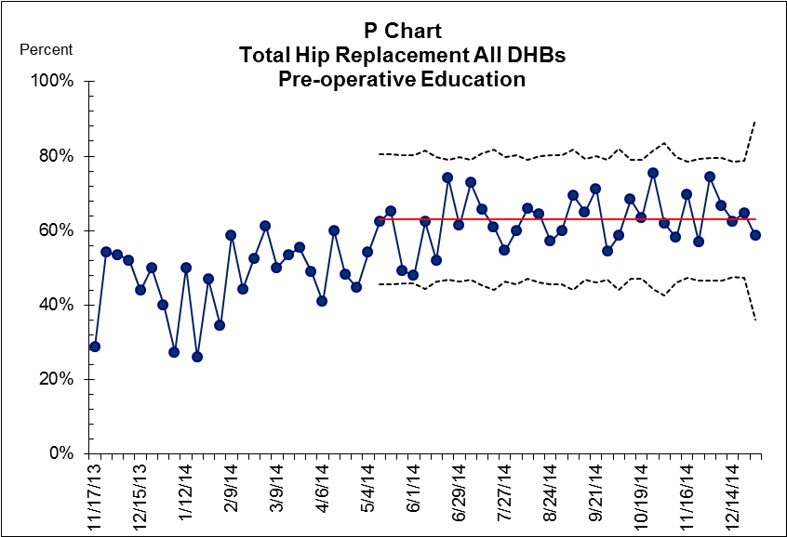

#### 2. Pre-operative discharge planning

The results for pre-operative discharge planning are very similar to those for pre-operative education. At the start of the collaborative period, six DHBs had adequate processes in place for pre-operative discharge planning. Six others had already started testing improvements. By December 2014 all 18 DHBs had successfully implemented pre-operative discharge planning processes.

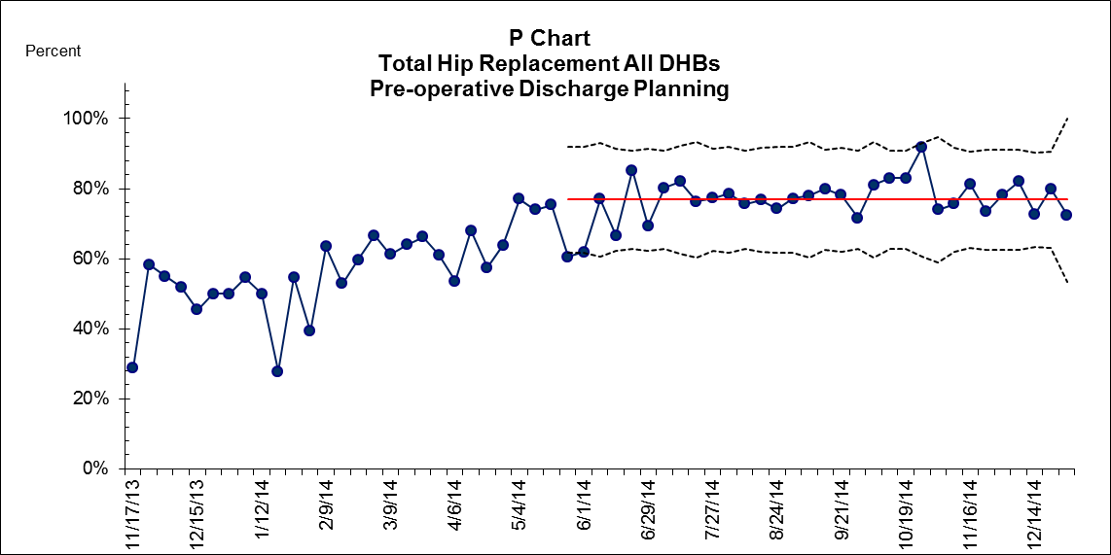

#### 4. Criteria-based discharge

With criteria-based discharge, staff and patients understand clearly what patients have to do before they go home. This approach also prevents delays in discharging patients.

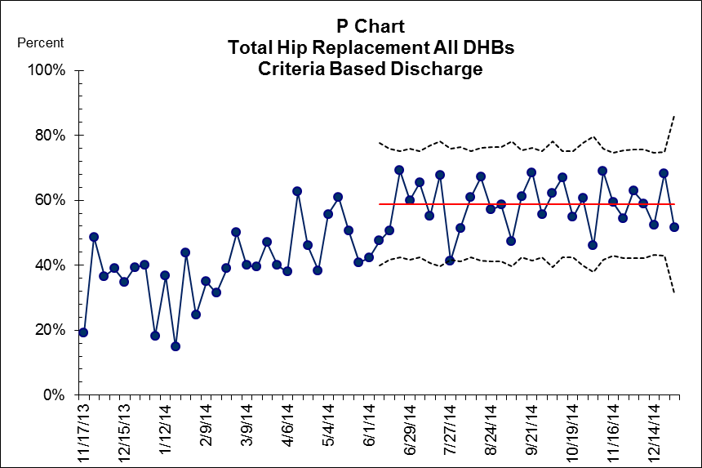

#### 5. Day of surgery admission

The practice of admitting patients on the day of surgery supports more efficient use of surgical resources and reduces the inconvenience of hospitalisation for patients and their families. Crucial to the success of applying this principle is having watertight pre-operative assessment and patient education.

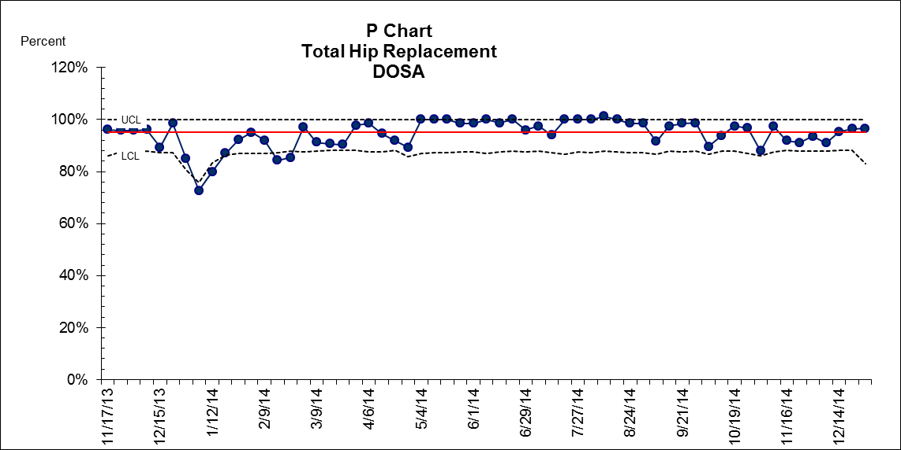

#### 6. Day of surgery cancellation

As the chart below shows, the ERAS collaborative did not have a significant effect on the number of operations cancelled on the day of surgery.

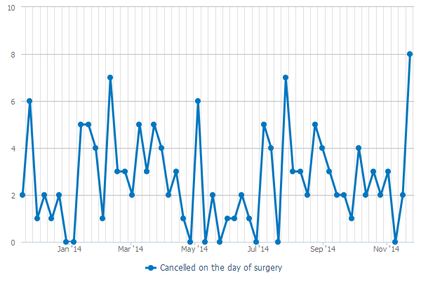

#### 7. Standard anaesthetic and analgesia regime

Effective post-operative analgesia is essential to help patients to mobilise early. The ERAS principle of early mobilisation in turn is critical in ensuring patients recover faster from surgery.

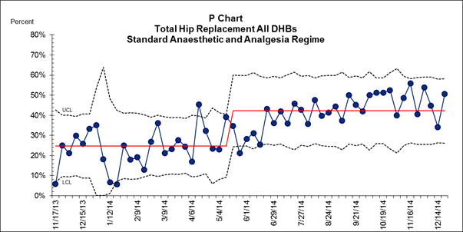

#### 8. Standard nausea protocol

Patients often report that post-operative nausea and vomiting can be more stressful than pain. Proactive management of nausea and vomiting helps prevent delays in mobilisation.

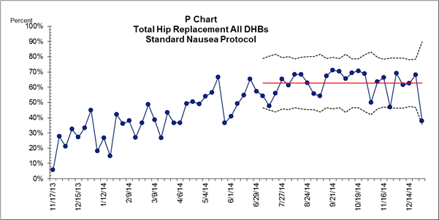

#### 9. Mobilisation within 24 hours

Early mobilisation maintains muscle mass and promotes muscle strength, while maximising respiratory function. Limited mobility is linked with increased risk of thromboembolism.

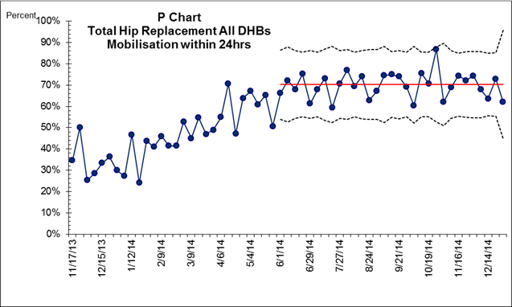

### Total knee replacement

#### 1. Pre-operative discharge planning

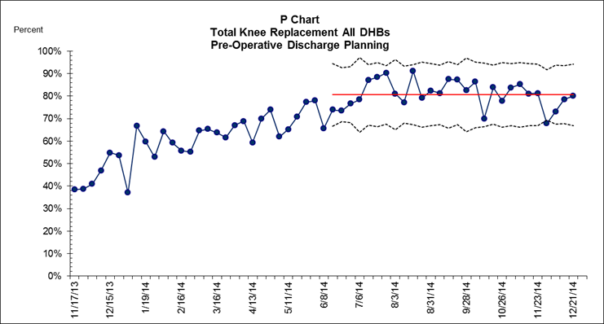

#### 2. Pre-operative education

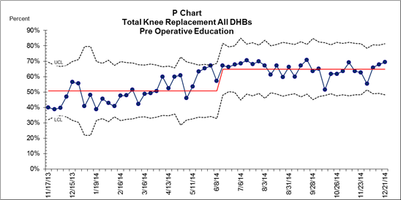

#### 3. Criteria-based discharge

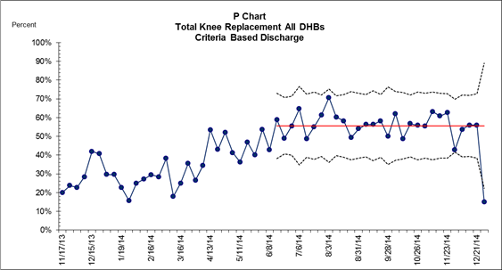

#### 4. Day of surgery admission

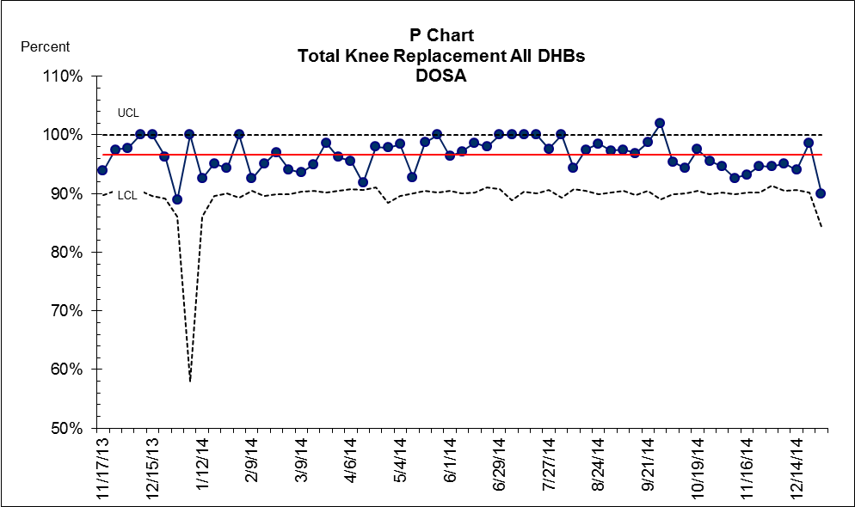

#### 5. Day of surgery cancellation

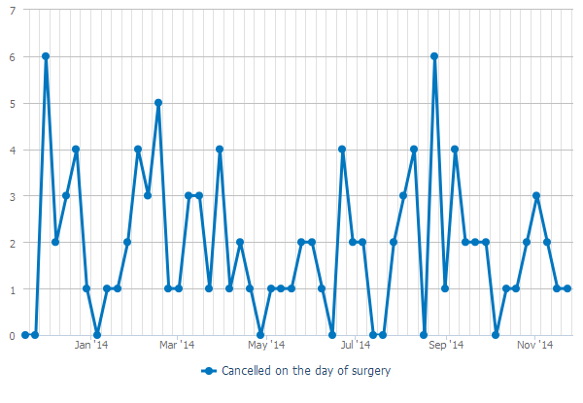

#### 6. Standard anaesthetic and analgesia regime

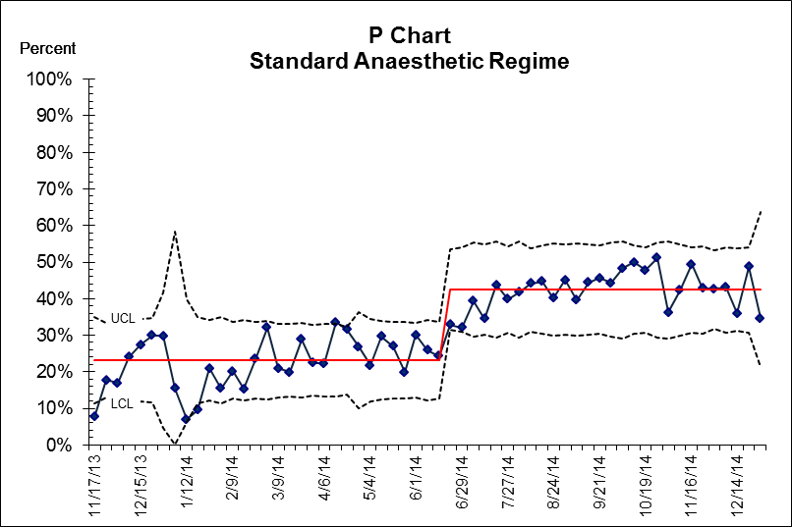

#### 7. Standard nausea protocol

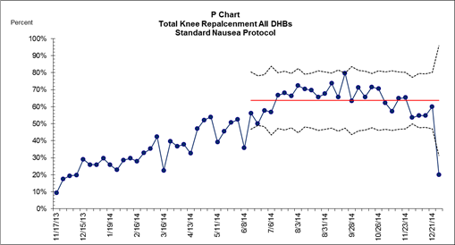

#### 8. Mobilisation within 24 hours

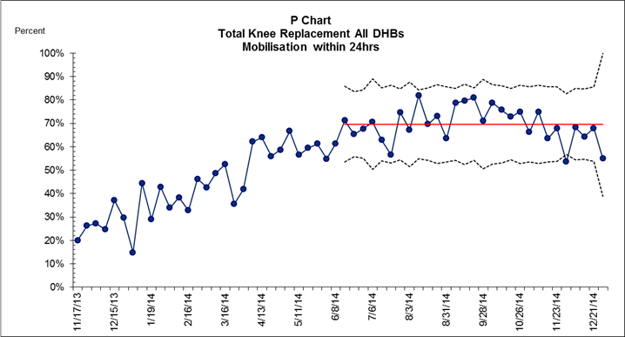

### Fractured neck of femur

#### 1. Operated on within 48 hours

A fractured neck of femur is a condition that primarily affects the elderly. Earlier surgery for hip fracture patients is associated with decreased mortality. Additionally rehabilitation and secondary prevention of fractures are important methods that help patients to regain mobility as well as preventing a later fracture. A crucial influence on outcome and mortality following a hip fracture is how long the patient has to wait for surgery: longer waiting times are linked with increased mortality.

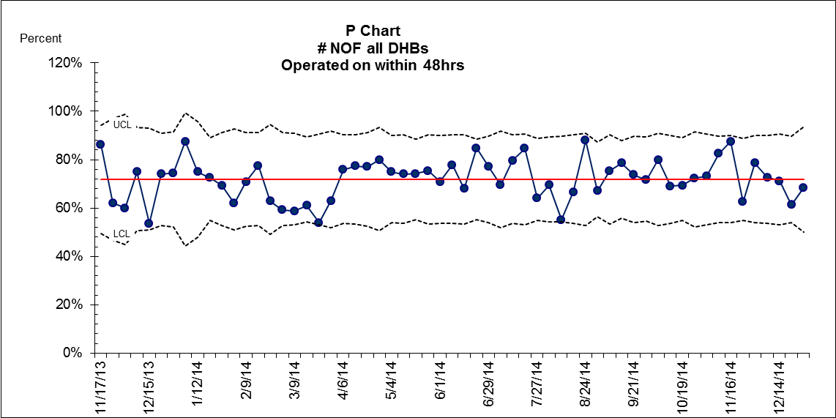

#### 2. Mobilisation within 24 hours

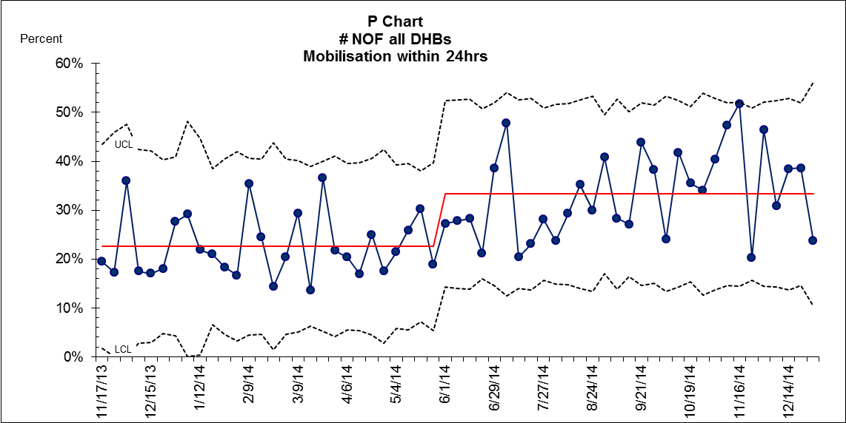

#### 3. Standard anaesthetic regime

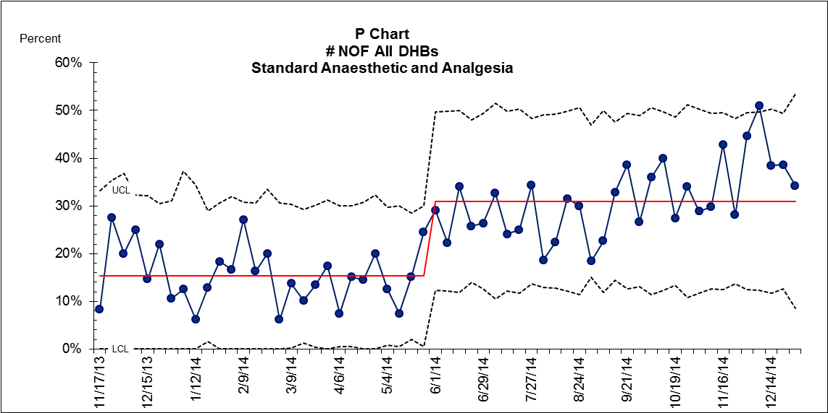

#### 4. Standard nausea protocol

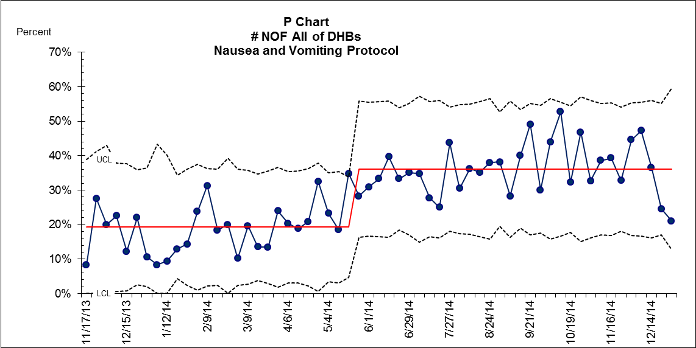

#### 5. Criteria-based discharge

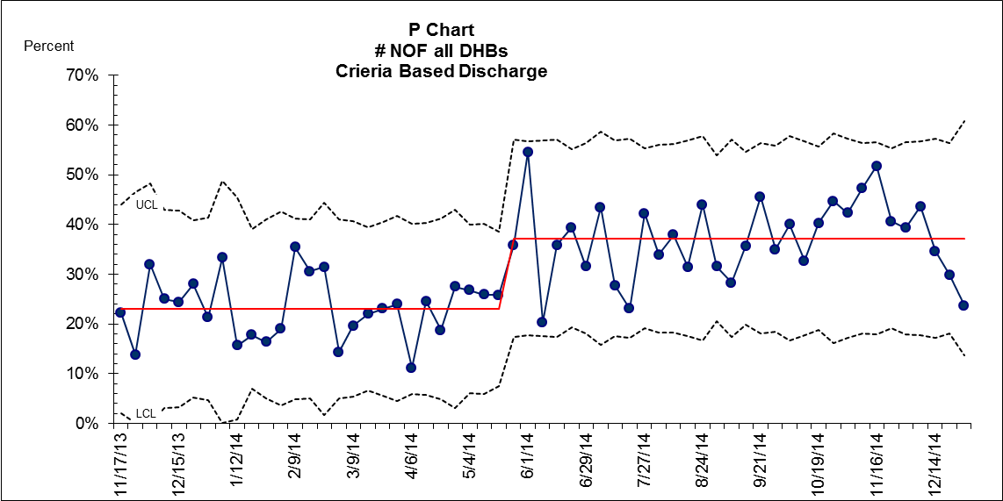

# Appendix 2: Significance test results for all patient outcomes

### Total hip replacements



Key:

ALOS = average length of stay BT = blood transfusion DOSA = day of surgery admission

DVT = deep vein thrombosis GI bleed = gastrointestinal bleed MI = myocardial infarction

PE = pulmonary embolism

### Total knee replacements



Key:

ALOS = average length of stay BT = blood transfusion DOSA = day of surgery admission

DVT = deep vein thrombosis GI bleed = gastrointestinal bleed MI = myocardial infarction

PE = pulmonary embolism

### Fractured neck of femur



Key:

ALOS = average length of stay BT = blood transfusion DOSA = day of surgery admission

DVT = deep vein thrombosis GI bleed = gastrointestinal bleed MI = myocardial infarction

PE = pulmonary embolism

# Appendix 3: Long-term trends in patient outcomes for individual measures

### Hip replacements

|  |  |
| --- | --- |
|  |  |
|  |  |
|  |  |
|  |  |
|  |  |
|  |  |

### Knee replacements

|  |  |
| --- | --- |
|  |  |
|  |  |
|  |  |
|  |  |
|  |  |
|  |  |

### Fractured neck of femur

|  |  |
| --- | --- |
|  |  |
|  |  |
|  |  |
|  |  |
|  |  |
|  |  |

# Appendix 4: Results of survey on DHB experiences and perceptions of the ERAS Quality Improvement Collaborative

The following is a summary of feedback from DHB staff on their experiences and perceptions of the ERAS Quality Improvement Collaborative.

### Communication with teams

Participants’ perceptions of how well the teams (national and project) communicated were excellent. Over 90 percent agreed that the objectives and purpose of ERAS were clearly communicated. The majority of respondents reviewed their DHB monthly reports on ERAS provided by the Ministry of Health project team on a monthly basis.

#### During the initial communication to DHBs about the collaborative, did the national and local project team communicate effectively?

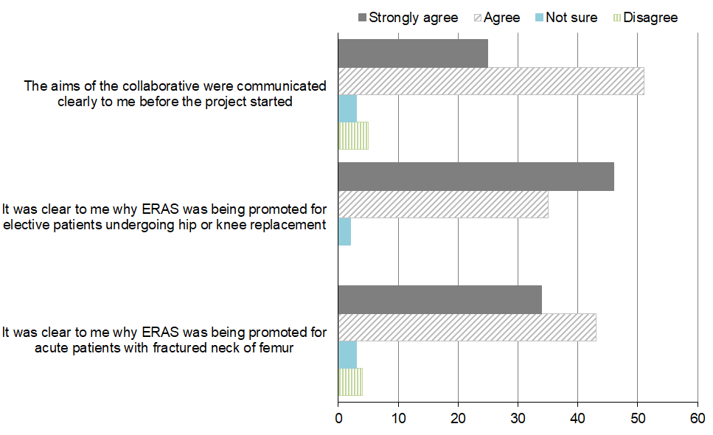

#### Regarding the information to DHBs, did teams get information in a format and at the time they needed?

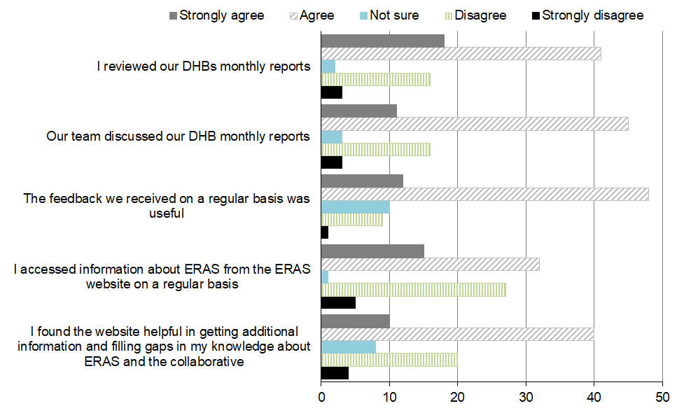

### Collaborative methodology

Respondents greatly appreciated the Institute for Healthcare Improvement’s (IHI’s) collaborative methodology. Over three-quarters found it understandable and effective in helping them to apply ERAS principles.

#### Regarding the overall collaborative approach, how did teams find the collaborative approach?

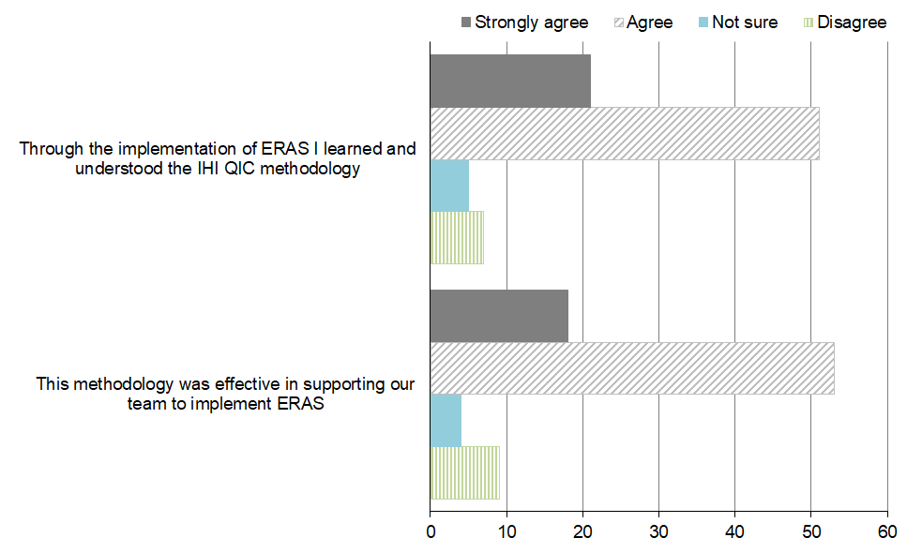

### Learning sessions

A third of respondents attended all three learning sessions, a third attended two sessions, 22 percent attended one session and 2 percent did not know how many they attended. Among those who attended, 86 percent of respondents found the sessions useful.

### Webinars

Participation in webinars was low, with almost half of the respondents not attending any session. Another 20 percent attended one session, 11 percent two sessions and only 23 percent all three sessions.

Of all respondents who attended the webinars, less than half found them useful as a learning or networking tool. In contrast, 41 percent responded that they were ‘not sure’ if the webinars were useful and 19 percent stated that they were not useful. The reasons for these findings may be that participation was low and the webinars faced many technical difficulties (17 respondents commented specifically on the technical difficulties, which included difficulty accessing the webinars, inability to access it through iPhones and poor DHB equipment). If these technical difficulties could be addressed, webinars could more useful in the future.

#### Can you please provide us with your feedback on webinars?

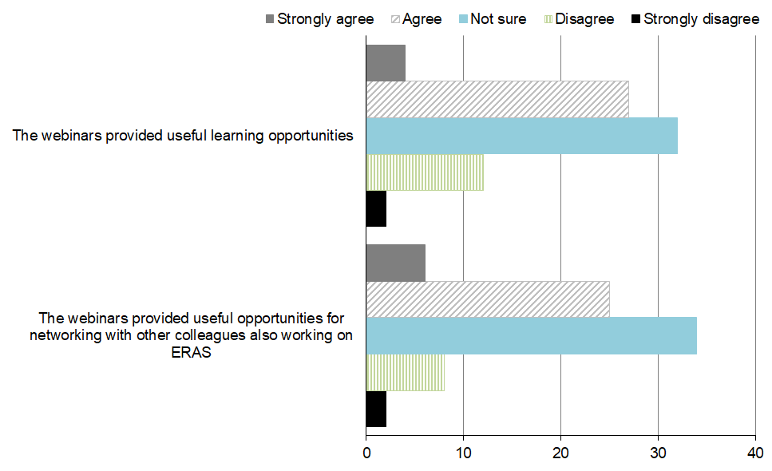

### Plan, do, study, act (PDSA) cycles

More than three-quarters of respondents thought leadership and support to teams were strong and ERAS goal-setting was clear. The same proportion successfully followed PDSA cycles to make the desired changes in care. In all, 67 percent of respondents believed they will continue to use PDSA cycles in the future to test improvement ideas.

#### Regarding action periods / PDSA cycles

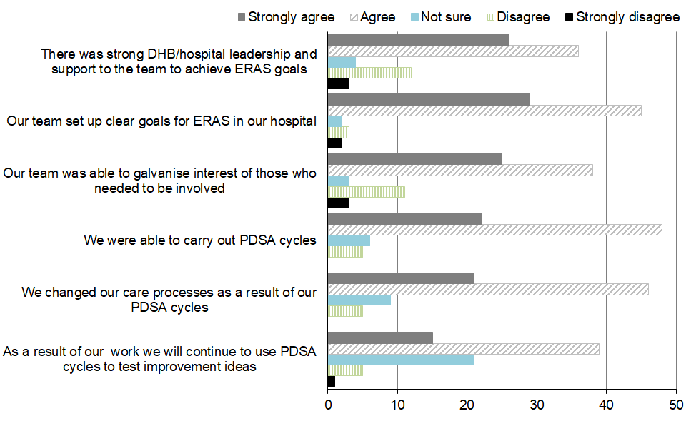

### Resources developed for the ERAS collaborative

The ERAS resources that most respondents were aware of were: ‘Is a knee replacement right for me?’, ‘A guide to hip replacement surgery’ and ‘Knee/hip replacement patient education videos’.

Less well known were ‘A guide to knee replacement surgery for patients’ and ‘Your broken hip: a guide for patients and their families’ – only around 20 percent of respondents were aware of their existence.

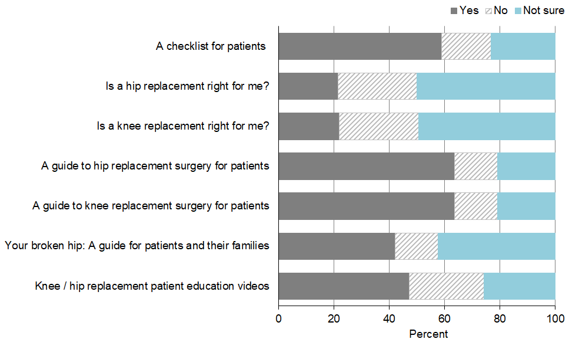

### Valued elements of the ERAS collaborative

Of all the elements of the ERAS collaborative, respondents valued Ministry of Health funding the most. They also valued clinical leadership, project managers, team culture, DHB culture, learning sessions, patient information booklets and access to data.

#### Importance of ERAS collaborative (scale 1 = least valuable to 5 = most valuable)

|  |  |  |
| --- | --- | --- |
|  |  |  |
|  |  |  |
|  |  |  |
|  |  |  |
|  |  |  |
|  |  |  |

# Appendix 5: ERAS Expert Advisory Group for total knee and hip arthroplasty and fractured neck of femur

|  |  |
| --- | --- |
| **Margaret Aimer** Head of Health System Improvement Ko Awatea I Health System Innovation and Improvement  **Dr Peter Bramley** Service Director Medical Surgical Services Directorate Nelson Marlborough DHB  **Dr Ulrike Buehner** Clinical Director for Quality and Innovation Lakes DHB  **Dr Owen Doran** Emergency Medicine Specialist Emergency Department Auckland City Hospital Auckland DHB  **Diana Dowdle** 20,000 Days Campaign Manager Ko Awatea I Health System Innovation and Improvement  **Mr Steve Earnshaw** MidCentral DHB  **Suzanne Proudfoot** Projects and Campaigns Manager Ko Awatea I Health System Innovation and Improvement Counties Manukau DHB  **Mr Richard Street** Clinical Head of Department Consultant Orthopaedic Surgeon Counties Manukau DHB  **Dr Michael Thwaite** General Practitioner Liaison for older persons’ health Canterbury DHB  **Dr Martin Thomas** Anaesthetist and Clinical Director Surgical Services Lakes DHB  **Teresa Wingate** ERAS Nurse Waitemata DHB | **Steve Earnshaw** Clinical Director Orthopaedics Orthopaedic surgeon South Canterbury DHB  **Dr Roger Harris** Geriatrician Older Peoples Health Auckland City Hospital Auckland DHB  **Dr Michal Kluger** Anaesthesiologist and Pain Physician Waitemata DHB  **Mr Jacob Munro** Consultant Orthopaedic Surgeon Auckland DHB  **Leighton Murray** Physiotherapist Southern DHB  **Carrie Naylor Williams** Nurse Director for Emergency Services  **Jodie Wood** Clinical Nurse Manager, Orthopaedics Northland DHB  **Jackie Herkt** Consumer advisor National Health Board staff **Simon Duff** Team Leader – Service Improvement Team Electives  **Dr Ros Gellatly** Clinical Advisor, Service Improvement Electives  **Julie Palmer** Senior Advisor Service Improvement, Electives  **Loren Shand** Senior Advisor Funding and Monitoring Electives |

# Appendix 6: District health board project managers, executive sponsors and clinical leaders

|  | | **ERAS project team leader** | | **ERAS project clinical leader** | | **ERAS project executive sponsor** |
| --- | --- | --- | --- | --- | --- | --- |
| **Northern region** | | | | | | |
| Northland | Jodie Wood Clinical Nurse Manager [Jodie.Wood@northlanddhb.org.nz](mailto:Jodie.Wood@northlanddhb.org.nz) | | Margy Pohl Clinical Head of Department Orthopaedics [margy@clear.net.nz](mailto:margy@clear.net.nz) | | Andrew Potts General Manager Clinical Services [andrew.potts@northlanddhb.org.nz](mailto:andrew.potts@northlanddhb.org.nz) | |
| Waitemata | Teresa Wingate ERAS/Colorectal Clinical Nurse Specialist, General Surgery [Teresa.Wingate@waitematadhb.govt.nz](mailto:Teresa.Wingate@waitematadhb.govt.nz) | | Mr John Cullen Director, Elective Surgery Centre [john.cullen@waitematadhb.govt.nz](mailto:john.cullen@waitematadhb.govt.nz) | | Dr Andrew Brant Chief Medical Officer [Andrew.Brant@waitematadhb.govt.nz](mailto:Andrew.Brant@waitematadhb.govt.nz)  Cath Cronin General Manager Surgical & Ambulatory Services [Cath.cronin@waitematadhb.govt.nz](mailto:Cath.cronin@waitematadhb.govt.nz) | |
| Auckland | Katie Moloney [KMoloney@adhb.govt.nz](mailto:KMoloney@adhb.govt.nz) | | Mr Jacob Munro Orthopaedic Surgeon and National clinical leader for the ERAS collaborative [jacobtmunro@gmail.com](mailto:jacobtmunro@gmail.com) | | Rosalie Percival Chief Financial Officer [CFO@adhb.govt.nz](mailto:CFO@adhb.govt.nz) | |
| Counties Manukau | Michelle McCallum-Jones Orthopaedic Service Manager [Michelle.McCallum-Jones@cmdhb.org.nz](mailto:Michelle.McCallum-Jones@cmdhb.org.nz) | | Mr Richard Street Clinical Head of Department, Orthopaedics [Richard.Street@middlemore.co.nz](mailto:Richard.Street@middlemore.co.nz) | | Gillian Cossey General Manager Surgical Services Gillian.Cossey@middlemore.co.nz | |
| **Midland region** | | | | | | |
| Bay of Plenty | Wendy Carey Project Manager [wendy.carey@bopdhb.govt.nz](mailto:wendy.carey@bopdhb.govt.nz) | | Mr Andy Vane Orthopaedic Surgeon [av.ortho@gmail.com](mailto:av.ortho@gmail.com) | | Pete Chandler Chief Operating Officer [Pete.Chandler@bopdhb.govt.nz](mailto:Pete.Chandler@bopdhb.govt.nz) | |
| Lakes | Greg Vandergoot Surgery & Elective Services Manager [greg.vandergoot@lakesdhb.govt.nz](mailto:greg.vandergoot@lakesdhb.govt.nz)  Kellie Lash Project Manager Lakes District Health Board – Rotorua site [Kellie.Lash@lakesdhb.govt.nz](mailto:Kellie.Lash@lakesdhb.govt.nz) | | Dr David Blundell Anaesthetist  Mr Dawie Nieuwenhuizen Orthopaedic Surgeon [Dawid.Vannieuwenhuizen@lakesdhb.govt.nz](mailto:Dawid.Vannieuwenhuizen@lakesdhb.govt.nz) | | Dale Oliff General Manager Clinical Services [dale.oliff@lakesdhb.govt.nz](mailto:dale.oliff@lakesdhb.govt.nz) | |
| Tairawhiti | Hannalie Fourie Orthopaedic Project Manager [Hannelie.Fourie@tdh.org.nz](mailto:Hannelie.Fourie@tdh.org.nz) | | Mrs Karel Chivers Head of Department, Orthopaedics [Karel.Chivers@tdh.org.nz](mailto:Karel.Chivers@tdh.org.nz) | | Lynsey Bartlett Adult Services Manager LynseyB@tdh.org.nz | |
| Taranaki | Greg Sheffield Clinical Leader Outpatient Physiotherapy gregory.sheffield[@tdhb.org.nz](mailto:Gregory.Sheffield@tdhb.org.nz) | | Mr Charlie Lewis Orthopaedic Surgeon [Charlie.Lewis@tdhb.org.nz](mailto:Charlie.Lewis@tdhb.org.nz) | | Rosemary Clements Chief Operating Officer Rosemary.Clements@tdhb.org.nz | |
| Waikato | Melody Mitchell Nurse Manager General Surgery and Orthopaedics [Melody.mitchell@waikatodhb.health.nz](mailto:Melody.mitchell@waikatodhb.health.nz)  Fiona Stephens Project Manager – Enhanced recovery after surgery – orthopaedics [Fiona.Stephens@waikatodhb.health.nz](mailto:Fiona.Stephens@waikatodhb.health.nz) | | Mr Paul Wotherspoon Orthopaedic Surgeon [Paul.Wotherspoon@waikatodhb.health.nz](mailto:Paul.Wotherspoon@waikatodhb.health.nz) | | Jan Adams Chief Operating Officer jan.adams@waikatodhb.health.nz  Mark Spittal Group Manager Waikato and Thames Hospital [Mark.Spittal@waikatodhb.health.nz](mailto:Mark.Spittal@waikatodhb.health.nz) | |
| **Central region** | | | | | | |
| Hawkes Bay | Bernie Fail Clinical Nurse Manager Orthopaedics [Bernard.Fail@hawkesbaydhb.govt.nz](mailto:Bernard.Fail@hawkesbaydhb.govt.nz) | | Mr Sud Rao Consultant Orthopaedic Surgeon [Sud.Rao@hawkesbaydhb.govt.nz](mailto:Sud.Rao@hawkesbaydhb.govt.nz)  Dr Lucy Fergus Consultant Geriatrician [Lucy.Fergus@hawkesbaydhb.govt.nz](mailto:Lucy.Fergus@hawkesbaydhb.govt.nz) | | Warrick Frater Chief Operating Officer warrick.frater@hawkesbaydhb.govt.nz | |
| Wairarapa | Lisa Tonkin Occupational Therapist [Lisa.Tonkin@wairarapa.dhb.org.nz](mailto:Lisa.Tonkin@wairarapa.dhb.org.nz) | |  | | Caroline Cooper Acting Chief Operating Officer [carolyn.cooper@huttvalleydhb.org.nz](mailto:carolyn.cooper@huttvalleydhb.org.nz) | |
| Hutt Valley | Nick Clode Physiotherapy Outpatient Team leader ERAS Co-ordinator, HVDHB Nick.Clode@huttvalleydhb.org.nz  Anne Taylor Clinical Nurse Manager Orthopaedic Ward [Anne.Taylor@huttvalleydhb.org.nz](mailto:Anne.Taylor@huttvalleydhb.org.nz) | | Helen Tobin Clinical Director, Orthopaedics [tobinfamily@xtra.co.nz](mailto:tobinfamily@xtra.co.nz) | | Caroline Cooper Acting Chief Operating Officer [carolyn.cooper@huttvalleydhb.org.nz](mailto:carolyn.cooper@huttvalleydhb.org.nz) | |
| MidCentral | Erica Calvert Charge Nurse, Orthopaedics [Erica.calvert@midcentraldhb.govt.nz](mailto:Erica.calvert@midcentraldhb.govt.nz)  Maria Shaw Clinical Nurse Specialist Lead Orthopaedics [Maria.Shaw@midcentraldhb.govt.nz](mailto:Maria.Shaw@midcentraldhb.govt.nz) | | Mr Supratim Mukherjee MOSS Orthopaedics [Supratim.mukherjee@midcentraldhb.govt.nz](mailto:Supratim.mukherjee@midcentraldhb.govt.nz) | | Lynn Horgan Operations Director lyn.horgan@midcentraldhb.govt.nz | |
| Whanganui | Declan Rogers Nurse Manager, Surgical Services [Declan.Rogers@wdhb.org.nz](mailto:Declan.Rogers@wdhb.org.nz)  Clinical Nurse Coordinator Surgical Ward / Trend Care Resource Nurse Shona Kirkby [Shona.Kirkby@wdhb.org.nz](mailto:Shona.Kirkby@wdhb.org.nz) | | Mr Andreas Stadtmueller Orthopaedic Surgeon [Andreas.Stadtmueller@wdhb.org.nz](mailto:Andreas.Stadtmueller@wdhb.org.nz) | | Julie Patterson Chief Executive Officer [julie.patterson@wdhb.org.nz](mailto:julie.patterson@wdhb.org.nz) | |
| **Southern region** | | | | | | |
| Nelson Marlborough | Hilary Exton  Director Allied Health Service Manager Allied Health Services [Hilary.Exton@nmdhb.govt.nz](mailto:Hilary.Exton@nmdhb.govt.nz) | | Clinical Leader Orthopaedics Surgeon [richard.peterson@nmdhb.govt.nz](mailto:richard.peterson@nmdhb.govt.nz) | | Peter Bramley Service Director Medical Surgical Services Directorate Peter.Bramley@nmdhb.govt.nz | |
| South Canterbury | Belinda Dore Service Manager Surgical Services [bdore@scdhb.health.nz](mailto:bdore@scdhb.health.nz) | | Mr Steve Earnshaw Clinical Director, Orthopaedics [SEarnshaw@scdhb.health.nz](mailto:SEarnshaw@scdhb.health.nz)  Dr Russell Rarity Clinical Director, Anaesthetics [rrarity@scdhb.health.nz](mailto:rrarity@scdhb.health.nz) | | Christine Nolan General Manager Secondary Services cnolan@scdhb.health.nz | |
| Canterbury | Dan Coward General Manager / Older Persons, Orthopaedics & Rehabilitations Services Dan.Coward@cdhb.health.nz  Kit Hoeben Canterbury & West Coast DHB -- Programme Manager | Planning & Funding [Kit.Hoeben@cdhb.health.nz](mailto:Kit.Hoeben@cdhb.health.nz)  David Brydon Service Manager Orthopaedics [David.Brydon@cdhb.health.nz](mailto:David.Brydon@cdhb.health.nz) | | Mr Kris Dalzell Orthopaedic Consultant [Kris.dalzell@gmail.com](mailto:Kris.dalzell@gmail.com)  Dr Graham Roper Clinical Director, Anaesthetics [Graham.roper@cdhb.health.nz](mailto:Graham.roper@cdhb.health.nz) | | Carolyn Gullery General Manager Planning & Funding Carolyn.Gullery@cdhb.health.nz | |
| West Coast | Rosalie Waghorn Acting Nurse Manager (Strategic) [rosalie.waghorn@westcoastdhb.health.nz](mailto:rosalie.waghorn@westcoastdhb.health.nz)  Kay Bone Orthopaedic Coordinator [kay.bone@westcoastdhb.health.nz](mailto:kay.bone@westcoastdhb.health.nz) | | Mr Kris Dalzell Orthopaedic Consultant [Kris.dalzell@gmail.com](mailto:Kris.dalzell@gmail.com)  Dr Graham Roper Clinical Director, Anaesthetics [Graham.roper@cdhb.health.nz](mailto:Graham.roper@cdhb.health.nz) | | Carolyn Gullery General Manager Planning & Funding Carolyn.Gullery@cdhb.health.nz | |