

Table of Contents
Key Findings 5
Introduction 8
1. New Zealand mathematics achievement in 2010/11 in an international context 12
Mathematics achievement in TIMSS 2010/11 12
International trends in mathematics achievement at the lower secondary level 16
Relative rankings among countries 18
International mathematics benchmarks 19
Mathematics content and cognitive domains 25
2. Trends in New Zealand mathematics achievement 1994 to 2010 27
Trends in means and ranges since 1994 27
Trends in benchmarks for mathematics 28
Trends on the mathematics test questions from 2002 to 2010 29
Trends in mathematics content and cognitive domains from 2002 to 2010 29
3. TIMSS and the New Zealand mathematics curriculum 30
Mathematics curriculum levels and the TIMSS content domains 30
Curriculum match 32
Coverage of mathematics topics 34
4. Progress over time – Year 5 students in 2006 now Year 9 students in 2010 36
Progress from 2006 to 2010 36
5. Mathematics achievement of Year 9 boys and girls 38
Mathematics achievement of boys and girls 38
Benchmarks for boys and girls 40
Achievement on the content and cognitive domains for boys and girls 40
6. Mathematics achievement, ethnicity of students, and language of the home 41
Mathematics achievement among ethnic groupings 41
Benchmarks of mathematics achievement among ethnic groupings 42
Mathematics achievement of boys and girls within ethnic groups 43
Mathematics achievement by language 44
7. Mathematics achievement and socio-economic status 45
Home possessions and books as proxies for SES 45
Socio-economic indicators of schools attended 48
8. More about the home climate for learning mathematics 52
Interactions with parents 52
Education expectations 53
Reading for enjoyment 54
Computer use 54
9. Student attitudes to and engagement with mathematics 55
Student attitudes toward mathematics 55
Students like learning mathematics 56
Students value mathematics 57
Students confident in mathematics 58
Attitudes to mathematics by gender 60
Attitudes to mathematics by ethnicity 61
10. Teaching mathematics 62
Characteristics of secondary mathematics teachers 62
Preparation and confidence of secondary teachers 63
Professional development 65
Mathematics teaching and learning activities 66
Use of resources 70
Monitoring student progress 71
Monitoring teacher practice 72
11. School climate 73
Student perceptions of climate for learning 73
Teacher perceptions of climate for learning 75
Principal perceptions of climate for learning 79
Student perceptions of school safety and student behaviours 81
Teacher perceptions of school safety and student behaviours 84
Principal perceptions of school safety and student behaviours 86
Relationship between home and school 87
Interactions between teachers 90
Vacancies 91
School and classroom size 92
Limitations to teaching 93
Quality and availability of school buildings and resources 93
Impact of shortages of resources 95
12. School Leadership 98
Time spent by principals on leadership activities 98
Time spent on leadership activities and school characteristics 99
Time spent on leadership activities and student achievement 100
Conclusion 101
Appendices 104
References 110
Definitions and technical notes 112

Acknowledgements
TIMSS is a collaborative effort internationally and nationally. There are many people that have been involved and it is not possible to thank all of them individually here. However, there are a few key people that I would like to acknowledge.
This study was made possible by the cooperation of the schools, teachers, students, and parents that participated. Thanks to these participants, large amounts of data have been collected about the teaching and learning of New Zealand Year 9 students.
Thanks also to the many members of the Research Division, and also those from the wider ministry, that have contributed to the successful collection of data for TIMSS. I would like to particularly thank Sarah Kirkham (TIMSS data manager plus many other tasks from inception to publication), Kate Lang, Jessica Balfour (née Herewini), and Megan Chamberlain.
Thanks to those that contributed to this publication by reviewing, editing and publishing this report.
Finally, thanks to my co-authors, Sarah Kirkham and Nicola Marshall.

Robyn Caygill
TIMSS National Research Coordinator

Key Findings
Achievement in an international context
- New Zealand Year 9 students had mathematics achievement around the middle when compared with other participating countries, lower than 14 countries, similar to 4, and higher than 23 countries.
- There has been no significant change in the mean mathematics achievement of Year 9 students since the first cycle of TIMSS in 1994/95, although due to a non-significant decrease it is now significantly below the TIMSS scale centre value.
- In the international context, the range of achievement within New Zealand was moderate. This is in contrast to the 15-year-old students assessed in PISA where New Zealand has one of the widest ranges of achievement.
- There was a relatively high proportion of very low achievers (students who did not reach the low benchmark) in this cycle of TIMSS compared with countries with similar or higher mean mathematics achievement.
- Instructional hours in mathematics in New Zealand lower secondary classrooms was about average when compared to other countries.
- New Zealand lower secondary students performed relatively better on statistics questions (called data display in TIMSS) and relatively worse on algebra questions. The cognitive aspects of reasoning and applying were relative strengths for Year 9 students while knowing was a relative weakness.
Equity in the New Zealand system
- Year 9 boys had higher mathematics achievement, on average, than girls. Since the previous cycle of TIMSS (2002/03) there has been a significant decrease in achievement for Year 9 girls, and a small non-significant increase for Year 9 boys. This cycle (2010/11) is now the first to show a significant difference between the boys and the girls.
- There were advanced achievers and very low achievers in all ethnic groupings. However, there were proportionately more Pākehā/European and Asian advanced achievers compared with the Pasifika and Māori ethnic groupings. There were also more very low achievers among Pasifika and Māori groupings than among Pākehā/European and Asian groupings. There has been a significant decrease in mean achievement among Pākehā/European students since the first cycle of TIMSS in 1994/95.
- Regardless of the measure used to assess socio-economic status (SES), students with lower SES had lower achievement than students with higher SES. In particular, on an international measure of the SES of the school attended, students in schools with a greater concentration of affluent students had higher achievement than students in schools with a greater concentration of disadvantaged students. On this measure New Zealand had one of the highest differences in achievement between these two groups.
Student attitudes
- Nearly all Year 9 students planned to get some form of qualification, some with expectations at the secondary level and some at tertiary.
- Year 9 students in New Zealand were generally positive about learning mathematics. Compared to other countries, on average, similar proportions of New Zealand Year 9 students were confident and valued mathematics, but fewer liked it.
- Students who were more positive about learning mathematics had, on average, higher achievement than those who were more negative. The self-confidence of students had a stronger relationship with mathematics achievement than how much they liked or valued learning mathematics.
- Year 9 boys’ enjoyment, confidence and valuing of learning mathematics were all higher than that of girls in New Zealand. Nearly half of girls reported not liking and not being confident in mathematics.
- A greater proportion of Pasifika and Asian students reported liking and valuing learning mathematics, compared with Māori or Pākehā/European students. Asian students were more likely to report high levels of confidence in learning mathematics than students from any of the other ethnic groupings.
Teaching
- More New Zealand lower secondary mathematics teachers felt well prepared to teach topics in mathematics compared with their peers in other countries but slightly fewer expressed high levels of confidence in their ability to teach mathematics.
- New Zealand mathematics teachers tended to require memorisation of facts less frequently than their peers in other countries. Similarly, they used assessment less frequently than their peers in other countries, on average.
- New Zealand mathematics teachers tended to use textbooks more as a supplement rather than as a basis for instruction. In contrast, teachers in other countries were more likely to use textbooks as a basis for instruction.
- New Zealand mathematics classrooms were less likely to have computers available for instructional use compared with other countries.
School climate for learning
- Year 9 students generally perceived their school to be a good place to be. More than eight out of ten students agreed that they felt like they belonged at school and were safe there. A higher proportion of girls than boys were positive about school and Pasifika and Asian students were the most positive of the ethnic groupings.
- Fewer New Zealand Year 9 students liked being at school compared to the average student internationally.
- Teachers and principals were generally very positive about their school climate for learning, including having a safe environment, knowledgeable staff, supportive parents, and well-behaved students. However, principals tended to be slightly less positive about the teaching staff and more positive about parental support than the teachers.
- The proportion of New Zealand Year 9 students experiencing negative behaviours at school was similar to the average internationally. A higher proportion of boys than girls experienced these behaviours but no particular ethnic grouping experienced these negative behaviours more than would be expected based on their proportion of the population.
- Teachers of Year 9 students indicated that there were several factors that presented at least some limitations to their teaching of mathematics, particularly having students with a lack of prerequisite knowledge or skills.
- More than half of the TIMSS Year 9 students had teachers who perceived various issues were at least a minor problem in their current school, particularly teachers having too many teaching hours or inadequate workspace. New Zealand teachers were relatively positive about their working conditions compared to most other TIMSS countries.
- A lack of computers and computer software for mathematics instruction were the resources most commonly seen by principals as having an impact on instruction.
School leadership
- Principals of New Zealand schools with Year 9 students were, on average, less likely than their international counterparts to report spending a lot of time on any leadership activity.

Introduction
This report examines the mathematics results for New Zealand Year 9 students from the Trends in International Mathematics and Science Study (TIMSS) in 2010/11.¹ Along with the reports on New Zealand’s results for mathematics at Year 5 (Caygill, Kirkham, and Marshall, 2013a) and on science at Years 5 (Caygill, Kirkham, and Marshall, 2013b) and 9 (Caygill, Kirkham, and Marshall, 2013c), this report forms the beginning of a series of publications about New Zealand’s participation in TIMSS 2010/11. International findings for mathematics for TIMSS 2010/11 have been published by the IEA² (Mullis, Martin, Foy, & Arora, 2012). A separate international report on science was also published at this time (Martin, Mullis, Foy, & Stanco, 2012).
This report begins by examining New Zealand’s mathematics achievement in relation to other countries that participated in the study. It then looks at trends in New Zealand mathematics achievement at the Year 9 level from 1994 to 2011. An examination of the TIMSS assessment questions in relation to New Zealand’s mathematics curriculum is presented followed by analyses of achievement by sub-groupings (such as gender and ethnicity) and student background factors. Comprehensive coverage of background questions about teaching and learning as well as the school context for learning is also provided.
What is TIMSS?
The Trends in International Mathematics and Science Study (TIMSS) is a large-scale comparative study of mathematics and science achievement at the fourth and eighth grades (Years 5 and 9) around the world. As well as examining student achievement, it also monitors curricular implementation and aims to identify the most promising instructional practices from around the world.
Conducted on a regular 4-year cycle, TIMSS has assessed mathematics and science in 1994/95³, 1998/99, 2002/03, 2006/07, and 2010/11 with planning underway internationally for 2014/15.
What does TIMSS consist of?
TIMSS consists of assessments of students’ achievements in mathematics and science along with questionnaires for students, teachers, and principals to gather background information. The background information provides a context within which the achievement can be examined.
The TIMSS assessments are organised around two dimensions: a content dimension specifying the domains or subject matter to be assessed within mathematics and science; and a cognitive dimension specifying the domains or thinking processes to be assessed. These domains are published in the TIMSS 2011 assessment frameworks (Mullis, Martin, Ruddock, O’Sullivan, Arora, and Preuschoff, 2009). To guide questionnaire development, the contextual factors associated with students’ learning in mathematics and science are also included in the frameworks.

1 Internationally this cycle of the study is called TIMSS 2011. As New Zealand conducted TIMSS at the Year 9 level towards the end of 2010 and at the Year 5 level towards the end of 2011, it is referred to as TIMSS 2010/11 throughout this report.
2 The International Association for the Evaluation of Educational Achievement (IEA) is an independent, international cooperative of national research institutions and governmental research agencies. It conducts large-scale comparative studies of educational achievement and other aspects of education.
3 Note that this cycle of the study is called TIMSS 1995 internationally as most countries participated in 1995. However, southern hemisphere countries conducted the assessment towards the end of 1994 so in New Zealand reports the study is referred to as TIMSS 1994/95. Similarly for the subsequent cycles, the two years in which administrations occurred in participating countries are indicated.
Assessment framework for mathematics in TIMSS
The four content dimensions for mathematics at the lower secondary level (Year 9 level in New Zealand) are: number, algebra, geometry, and data and chance. Briefly, each of the content areas is described in the frameworks (Mullis, Martin, et al., 2009) as follows.
“The number content domain includes understanding of numbers, ways of representing numbers, relationships among numbers, and number systems.” (p. 30).
“The algebra content domain includes recognizing and extending patterns, using algebraic symbols to represent mathematical situations, and developing fluency in producing equivalent expressions and solving linear equations.” (p. 32).
“The three topic areas in geometry are: geometric shapes, geometric measurement, and location and movement.” (p. 34).
“The data and chance content domain consists of the following three major topic areas: data organization and representation, data interpretation, and chance.” (p. 36).
In order to answer questions in the TIMSS test correctly, as well as being familiar with the mathematics content, students need to draw on a range of cognitive skills. Also, in their lives outside and beyond school, students will need to do more than accurately recall a range of mathematics facts. This is acknowledged in the framework with three aspects to the cognitive dimension entitled knowing, applying, and reasoning. Briefly, each cognitive dimension is described in the framework as follows.
“The first domain, knowing, covers the facts, concepts, and procedures students need to know, while the second, applying, focuses on the ability of students to apply knowledge and conceptual understanding to solve problems or answer questions. The third domain, reasoning, goes beyond the solution of routine problems to encompass unfamiliar situations, complex contexts, and multi-step problems.” (p. 40).
How was TIMSS developed?
The TIMSS tests were developed cooperatively with representatives from participating countries. Questions were field-tested with a representative sample of students in these countries and the results generated were used to select and refine the questions for the final test. Questions for the background questionnaires underwent a similar process.
Who participated?
In TIMSS 2010/11, approximately 608,000 students in 63 countries and 14 economies (known as benchmarking participants) from all around the world took part. Participants included 301,603 students from 52 countries (three of which tested students at a higher grade) and 7 benchmarking participants at the middle primary level, and 307,038 students from 44 countries (two of which tested students at a higher grade) and 14 benchmarking participants at the lower secondary level.⁴ This cycle of TIMSS coincided with the third cycle of Progress in International Reading Literacy Study (PIRLS).

4 Some countries only tested students who were much older than the target population. For example, lower secondary students should be around 14 years old according to the design of TIMSS (in the eighth grade or the year level where the average age is closest to 14). However, in some countries these children have not covered enough of the material to achieve adequately on the TIMSS tests so the country has decided to test much older children. Throughout this report the countries that tested at a higher grade and the benchmarking participants are not discussed and do not appear in any totals or comparisons.
In this cycle of TIMSS, both Year 5 and Year 9 students participated in New Zealand. Schools in New Zealand were sampled so that there was no overlap between the samples: TIMSS Year 5, TIMSS Year 9, and PIRLS Year 5. In TIMSS in New Zealand, there were 5,336 students from 158 schools assessed at the Year 9 level in November 2010 and 5,572 students from 180 schools assessed at the Year 5 level in October 2011.
Participating countries and benchmarking participants
 | Armenia |  | Ireland |  | Poland
 | Australia |  | Israel |  | Portugal
 | Austria |  | Italy |  | Qatar
 | Azerbaijan |  | Japan |  | Romania
 | Bahrain |  | Jordan |  | Russian Federation
 | Belgium (Flemish) |  | Kazakhstan |  | Saudi Arabia
 | Chile |  | Korea, Rep. of |  | Serbia
 | Chinese Taipei |  | Kuwait |  | Singapore
 | Croatia |  | Lebanon |  | Slovak Republic
 | Czech Republic |  | Lithuania |  | Slovenia
 | Denmark |  | Macedonia, Rep. of |  | Spain
 | England |  | Malaysia |  | Sweden
 | Finland |  | Malta |  | Syrian Arab Republic
 | Georgia |  | Morocco |  | Thailand
 | Germany |  | Netherlands |  | Tunisia
 | Ghana |  | New Zealand |  | Turkey
 | Hong Kong SAR |  | Northern Ireland |  | Ukraine
 | Hungary |  | Norway |  | United Arab Emirates
 | Indonesia |  | Oman |  | United States
 | Iran, Islamic Rep. of |  | Palestinian Nat’l Auth. |  | Yemen
 | Benchmarking participants
 | Alberta, Canada |  | Alabama, US |  | Indiana, US
 | Ontario, Canada |  | California, US |  | Massachusetts, US
 | Quebec, Canada |  | Colorado, US |  | Minnesota, US
 | Abu Dhabi, UAE |  | Connecticut, US |  | North Carolina, US
 | Dubai, UAE |  | Florida, US
 | Out of grade participants
 | Botswana (6,9) |  | Honduras (6,9) |  | South Africa (9)
 | Yemen (6)
Note:  means the country participated at both middle primary and lower secondary level (usually Grade 4 and 8 equivalents).
 means the country participated at only the middle primary level (usually Grade 4 equivalent).
 means the country participated at only the lower secondary level (usually Grade 8 equivalent).

Who administered TIMSS?
A consortium was responsible for managing the international activities required for the project. This consortium was comprised of: the International Study Centre, Lynch School of Education at Boston College, (Massachusetts) United States; the IEA Secretariat in Amsterdam, the Netherlands; the IEA’s Data Processing Centre in Hamburg, Germany; Statistics Canada in Ottawa, Canada; and the Educational Testing Service (ETS) in Princeton, New Jersey in the United States. In New Zealand the Comparative Education Research Unit in the Ministry of Education was responsible for carrying out TIMSS.
How was TIMSS administered?
Each lower secondary student was assessed in two timed sessions of 45 minutes, and answered a combination of mathematics and science questions. The assessment was a pencil-and-paper test containing both multiple-choice and constructed-response questions. Following this, students were given a questionnaire containing questions about themselves, their opinions about mathematics and science, interactions at home, their computer use, and their attitudes to school. Principals and teachers were also given questionnaires in order to gain further information about the context in which the mathematics teaching and learning take place. In New Zealand, the assessments and questionnaires were conducted in English.
What procedures were used to ensure the quality of the data?
Members of the consortium ensured procedures were adhered to by all participating countries. TIMSS procedures are designed to ensure the reliability, validity, and comparability of the data through careful planning and documentation, cooperation among participating countries, standardised procedures, and attention to quality control throughout. Procedures included verification of translations and layout of booklets and questionnaires, monitoring of sampling activities, international and national quality control observers during test administration, checking of data, detailed manuals covering procedures, and rigorous training for all involved.
Technical information
A lot of information is gathered during the TIMSS administration and a number of techniques are applied when collecting and analysing the data. The Methods and Procedures in TIMSS and PIRLS 2011 report (Martin, & Mullis (Eds.), 2012) contains a detailed account of the assessment framework and instrument development, sampling, translation of materials, survey operations, quality assurance, creating the international databases, and scaling the achievement data. In addition, the TIMSS 2011 user guide for the international database (Foy, Arora, & Stanco (Eds.), 2013) contains information on how to analyse the data. Brief details of the technical information are given in the Definitions and technical notes at the end of this report.
Why participate in TIMSS?
Although it is often assumed that the international studies are only useful for international benchmarking purposes, the real value of TIMSS lies in its ability to provide a rich picture of mathematics and science achievement within New Zealand over time.
TIMSS (along with other international assessment studies) can provide information about the performance of the New Zealand education system at the national level within a global context. The information from studies such as TIMSS is used in the development and review of policy frameworks and also to inform and improve teaching practice. Developments arising out of previous cycles of TIMSS include resource materials for schools and teachers along with teacher in-service training programmes.
The TIMSS encyclopaedia
In order to provide a context in which the TIMSS results can be examined, TIMSS also publishes the TIMSS 2011 encyclopedia: a guide to mathematics and science education around the world (Mullis, Martin, Minnich, Stanco, Arora, Centurino, & Castle (Eds.), 2012). This encyclopaedia contains short reports from each country describing mathematics and science education policies and practices in that country.

1. New Zealand mathematics achievement in 2010/11 in an international context
In 2010 and 2011 63 countries participated in the fifth cycle of TIMSS, a large-scale assessment of the mathematics and science skills and knowledge of middle primary and early secondary students. In addition 14 economies took part as what are known as benchmarking participants. Of these countries and economies, 45 countries and 14 benchmarking participants assessed their lower secondary students. This chapter will examine the mathematics achievement of New Zealand’s Year 9 students in relation to that of other participating countries.
Mathematics achievement in TIMSS 2010/11
The mean mathematics score for New Zealand Year 9 students in 2011 was 488 scale score points. New Zealand’s score was significantly lower than the TIMSS scale centre point, but similar to Italy (498), Kazakhstan (487), Sweden (484), and Ukraine (479) and higher than 23 countries (see Definitions and technical notes for details re the scales and the centre point). However, 488 is lower than the mean score of 14 countries including all the other English-speaking countries who participated. Scotland, who had a similar score to New Zealand in the 2002/03 cycle, did not participate in this cycle.
The highest achieving countries, the Republic of Korea, Singapore, and Chinese Taipei all had average achievement among their grade 8 students of over 600 scale score points. Of the countries that tested in English, Singapore had the highest mean score (611). The next highest mean scores among the countries testing in English were 100 scale score points lower: the United States (509), England (507) and Australia (505).
It is also useful to look at the range of achievement. The lowest outer limit of the bars presented in Figure 1.1 is called the 5th percentile, the score at which only five percent of students achieved a lower score. The upper-most limit presented is the 95th percentile, the score at which only five percent of students achieved a higher score. The range of achievement from the 5th percentile (346) to the 95th percentile (624) for New Zealand Year 9 students was 278 scale score points. New Zealand’s range of achievement is narrower than the three highest-performing countries and similar to England and Hong Kong SAR. In particular, Chinese Taipei’s range of achievement (352) was much wider than that of New Zealand. Norway (211) and Finland (212) had the narrowest ranges of achievement. Similar observations can be made based on the inter-quartile range.
Table 1.1 provides information to help put mathematics achievement in context. Countries are presented in the same order as Figure 1.1. Information about economic conditions in each country is shown along with information about education for the students tested in TIMSS. Two versions of the Gross National Income (GNI) in U.S. dollars are given in the table. The first version of GNI is a measure of income that includes GDP plus other primary income (see World Bank, 2011 for details); the second version is an adjusted value that allows comparison of real levels of expenditure between countries and is calculated by simultaneously comparing prices of similar goods and services among a large number of countries.
Many of the high-achieving countries had much higher income per capita than New Zealand, especially when purchasing power was taken into account. The exception was the Republic of Korea whose GNI was a bit smaller than that of New Zealand and a lot smaller than the other countries with high achievement. In terms of the countries that tested in English, all had higher income per capita than New Zealand.
Table 1.1 also shows the average age of students at the time of testing. Students from Scandinavian and Eastern European countries tended to be more than half a year older than New Zealand students were but were only in their eighth year of formal schooling. However, it is evident that some of these countries with older starting ages were teaching topics in their early childhood sectors that would be taught in our early years of schooling. Many countries had larger proportions of students beginning school knowing how to read some words or sentences compared with New Zealand (see Chamberlain, 2012 for details).
Compared to other countries, New Zealand students had about the average number of hours of mathematics teaching per year (141 - not significantly different from the international average 138). Among the English-speaking and high performing countries there was quite a variation in instructional hours for mathematics (as shown in Table 1.1). For example, students in the United States had 157 hours of mathematics instruction compared with 116 in England.
Figure 1.1: Distribution of lower secondary mathematics achievement in TIMSS 2010/11
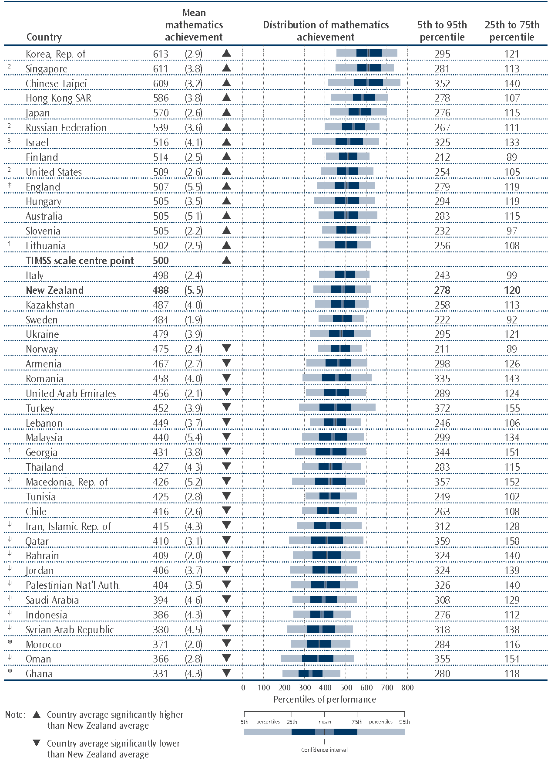
See Appendices for notes explaining the other symbols.
Benchmarking participants and countries testing at a higher grade are not included in this table.
Source: Adapted from Exhibit 1.2, Mullis, Martin, Foy, and Arora, 2012.
Table 1.1: Selected contextual factors for TIMSS 2010/11 countries
Country | Gross National Income per Capita (in $US)¹ | GNI per Capita (Purchasing Power Parity)² | Public Expenditure  on Education  (% of GDP)³ | Average age  at time  of testing | Average hours of  instructional time  in mathematics  (teacher reports)⁴
Korea, Rep. of | 19,830 | 27,240 | 4 | 14.3 | 137 | (1.8)
Singapore | 37,220 | 49,780 | 3 | 14.4 | 138 | (1.7)
Chinese Taipei | 16,471 | 34,520 | 4 | 14.2 | 166 | (2.4)
Hong Kong SAR | 31,570 | 44,540 | 5 | 14.2 | 138 | (2.9)
Japan | 38,080 | 33,440 | 4 | 14.5 | 108 | (1.4)
Russian Federation | 9,340 | 18,330 | 4 | 14.7 | 142 | (2.0)
Israel | 25,790 | 27,010 | 6 | 14.0 | 165 | (3.0)
Finland | 45,940 | 35,280 | 6 | 14.8 | 105 | (1.8)
United States | 46,360 | 45,640 | 6 | 14.2 | 157 | (3.2)
England | 41,370 | 35,860 | 5 | 14.2 | 116 | (2.1)
Hungary | 12,980 | 19,090 | 5 | 14.7 | 119 | (1.9)
Australia | 43,770 | 38,510 | 5 | 14.0 | 143 | (3.5)
Slovenia | 23,520 | 26,470 | 6 | 13.9 | 121 | (1.5)
Lithuania | 11,410 | 17,310 | 5 | 14.7 | 132 | (2.7)
Italy | 35,110 | 31,870 | 4 | 13.8 | 155 | (2.5)
New Zealand | 28,810 | 27,790 | 6 | 14.1 | 141 | (1.8)
Kazakhstan | 6,920 | 10,320 | 3 | 14.6 | 117 | (3.2)
Sweden | 48,840 | 38,050 | 7 | 14.8 | 97 | (2.2)
Ukraine | 2,800 | 6,180 | 5 | 14.2 | 132 | (3.5)
Norway | 84,640 | 55,420 | 7 | 13.7 | 125 | (3.4)
Armenia | 3,100 | 5,410 | 3 | 14.6 | 143 | (3.0)
Romania | 8,330 | 14,540 | 4 | 14.9 | 145 | (3.7)
United Arab Emirates | 54,738 | 59,993 | 1 | 13.9 | 157 | (2.9)
Turkey | 8,720 | 13,500 | 4 | 14.0 | 117 | (1.8)
Lebanon | 8,060 | 13,400 | 2 | 14.3 | 178 | (3.9)
Malaysia | 7,350 | 13,710 | 4 | 14.4 | 123 | (3.4)
Georgia | 2,530 | 4,700 | 3 | 14.2 | 123 | (3.3)
Thailand | 3,760 | 7,640 | 4 | 14.3 | 129 | (4.3)
Macedonia, Rep. of | 4,400 | 10,880 | – | 14.7 | 122 | (4.6)
Tunisia | 3,720 | 7,810 | 7 | 14.3 | 131 | (3.0)
Chile | 9,470 | 13,420 | 4 | 14.2 | 193 | (4.5)
Iran, Islamic Rep. of | 4,530 | 11,470 | 5 | 14.3 | 124 | (3.3)
Qatar | 71,008 | – | – | 14.0 | 162 | (3.6)
Bahrain | 25,420 | 33,690 | – | 14.4 | 142 | (2.5)
Jordan | 3,980 | 5,730 | 4 | 13.9 | 130 | (3.8)
Palestinian Nat’l Auth. | 1,749 | – | – | 13.9 | 134 | (4.0)
Saudi Arabia | 17,210 | 24,020 | 6 | 14.1 | 134 | (5.4)
Indonesia | 2,050 | 3,720 | 3 | 14.3 | 173 | (7.9)
Syrian Arab Republic | 2,410 | 4,620 | 5 | 13.9 | 118 | (4.7)
Morocco | 2,770 | 4,400 | 6 | 14.7 | 148 | (2.1)
Oman | 17,890 | 24,530 | 4 | 14.1 | 161 | (5.1)
Ghana | 1,190 | 1,530 | 6 | 15.8 | 165 | (6.8)
Note: 1. GNI per capita in U.S. dollars is converted using the World Bank Atlas method (World Bank, 2011, pp. 10-13).
2. An international dollar has the same purchasing power over GNI as a U.S. dollar in the United States (World Bank, 2011,
pp. 10-13).
3. Current and capital expenditures on education by local, regional, and national governments, including municipalities
(World Bank, 2011, pp. 76-79).
4. Standard errors are presented in parentheses.
Source: Adapted from Exhibits C.1 and 8.7, Mullis, Martin, Foy, and Arora, 2012 and from the encyclopaedia, Mullis, Martin, Minnich
et al., 2012.
International trends in mathematics achievement at the lower secondary level
There have now been five cycles of TIMSS internationally at the lower secondary level, 1994/95, 1998/99, 2002/03, 2006/07, and 2010/11. The design of TIMSS allows us to measure trends over time. Table 1.2 presents changes in mean mathematics achievement for those countries that have participated in at least four cycles of TIMSS. The Republic of Korea and Lithuania are the countries with the largest increase in mathematics achievement since the 1994/95 cycle. Chinese Taipei has also had a large increase in mathematics achievement since 1998/99. Although New Zealand’s 2010/11 mathematics score is 13 scale score points lower on average than the 1994/95 score, this difference is not significant. Therefore, New Zealand has had no significant change over time. In contrast, Malaysia and Sweden have had large significant decreases in mean mathematics achievement across the cycles.
Table 1.2: Differences in mean mathematics achievement across time for selected countries
Country | 1994/95 to 2010/11 difference |  | 1998/99 to 2010/11 difference |  | 2002/03 to 2010/11 difference |  | 2006/07 to 2010/11 difference
Korea, Rep. of | 32 | ❐ | 26 | ❐ | 24 | ❐ | 16 | ❐
Lithuania | 31 | ❐ | 21 | ❐ | 1 |   | -3 |  
Chinese Taipei | - |   | 24 | ❐ | 24 | ❐ | 11 | ❐
Italy | - |   | 19 | ❐ | 15 | ❐ | 19 | ❐
United States | 17 | ❐ | 8 |   | 5 |   | 1 |  
Hong Kong SAR | 17 | ❐ | 4 |   | 0 |   | 13 |  
Russian Federation | 15 | ❐ | 13 |   | 31 | ❐ | 27 | ❐
Slovenia | 10 | ❐ | - |   | 12 | ❐ | 3 |  
England | 9 |   | 10 |   | 8 |   | -7 |  
Singapore | 2 |   | 7 |   | 6 |   | 18 | ❐
Iran, Islamic Rep. of | -3 |   | -7 |   | 4 |   | 12 |  
Australia | -4 |   | - |   | 0 |   | 9 |  
Japan | -11 | ❑ | -9 | ❑ | 0 |   | 0 |  
New Zealand | -13 |  | -3 |  | -6 |  | -
Romania | -16 | ❑ | -14 | ❑ | -17 | ❑ | -3 |  
Hungary | -22 | ❑ | -27 | ❑ | -24 | ❑ | -12 | ❑
Jordan | - |   | -22 | ❑ | -18 | ❑ | -21 | ❑
Tunisia | - |   | -23 | ❑ | 14 | ❐ | 4 |  
Norway | -24 | ❑ | - |   | 13 | ❐ | 5 |  
Sweden | -55 | ❑ | - |   | -15 | ❑ | -7 | ❑
Malaysia | - |  | -79 | ❑ | -69 | ❑ | -34 | ❑
Note: - indicates that the country did not participate in that cycle
❐ 2010/11 means that the mean score was significantly higher than other cycle
❑ 2010/11 means that the mean score was significantly lower than other cycle
Source: Adapted from Exhibit 1.6, Mullis, Martin, Foy, and Arora, 2012.

In addition to those countries presented in the table, the Palestinian National Authority (37 scale score points) and Chile (29 scale score points) have also had a large increase in mathematics achievement since previous cycles (2006/07 and 2002/03 respectively). In contrast, Finland (38 scale score points) has had a large decrease in mathematics achievement since 1998/99.
In order to help understand some of the larger country increases, information is presented below about changes in the education systems in the Republic of Korea, Lithuania, and Chinese Taipei.
Korea
The objectives of the Korean education system are to assist all people in perfecting their individual characters, developing the ability to achieve independent lives, and acquiring the qualifications of democratic citizens, which will allow them to participate in building a democratic state and promote the prosperity of all humankind (Cho, Kim, Kim, and Rim, 2012). Korea has an emphasis on life-long learning enshrined in an Act of Government. Since 1991, there has also been a strong emphasis on local educational autonomy with regional guidelines supplementing a national curriculum.
The national curriculum was revised in 2007 to meet evolving national and social needs and then again in 2011. The revision in 2011 places emphasis on nurturing creative student talent and is intended to develop an environment of consideration and sharing. Another recent development is the establishment of 23 special science high schools in 2011. These science schools aim to develop human resources in advanced science and technology fields by selecting students who are gifted in science, encouraging them to develop their talents, and preparing them to become leaders in science and technology. Mathematics is an important part of the education of these students.
In 2011, a new initiative in science, technology, engineering, art, and mathematics education (STEAM) brought STEAM subject teachers together to develop curricula and teaching materials. Resources developed were distributed to schools in 2012.
Ten levels of mathematics courses are offered from Grades 1 to 10 and each level is divided into two sublevels that are taught on a semester schedule. Students must complete one level to move on to the next. Those who fail must take special supplementary classes. At Grade 8, instructional time in mathematics is 12 percent of total instructional time.
Lithuania
Lithuania has been participating in TIMSS since the first cycle in 1994/95, when the educational system was just starting to see the effects of post-soviet reforms (Elijio, 2012). Mathematics education is heavily emphasised because many universities require good results on mathematics examinations for admission. Therefore, the majority of students in secondary school choose to study higher-level mathematics.
According to Elijio (2012), reforms in mathematics teaching and learning have been influenced by participation in TIMSS. Educational specialists have turned to the conceptual frameworks of other jurisdictions to help in their development of subject content.
The mathematics curriculum for Grades 5 to 10, sets out the expectations that students should be able to communicate and collaborate using mathematical concepts as a means of conveying information, learn to use mathematical vocabulary and symbols, adopt elements of mathematical reasoning and activity, and conduct mathematical investigations of simple problems from every-day life. Instructional time in mathematics is 14 percent of total instructional time.
Chinese Taipei
Since the 1990’s, the Taiwanese public has called for educational reforms in response to societal changes. These reforms have led to greater local autonomy over educational policy (Jen, Lee, Chen, Lin, & Lo, 2012). However, for the first time they have instituted a centralised curriculum. To meet student interest, encourage motivation to learn, and reduce pressure on both students and their parents, a new Multi-route Promotion Program for Entering Senior High Schools was implemented in 2001 (Grade 10 is the beginning of Senior High). As part of this a new flexible entrance system, a new exam called the Basic Competency Test was introduced (at the end of Grade 9).
TIMSS results have become one of the primary sources of information used to evaluate the efficacy of mathematics and science education in Taiwan, and the basis on which to develop the future curriculum. Since 2001 the National Science Council has focused on assisting disadvantaged students to learn mathematics and on enhancing the interest and self-confidence in learning mathematics and science of all students.
Students in Taiwan have specialist teachers for mathematics from Grade 7. At Grade 8, instructional time in mathematics is 10 to 15 percent of total instructional time.
Relative rankings among countries
Many commentators on the international studies focus on New Zealand’s ranking relative to other countries. In order to inform this commentary, Table 1.3 presents New Zealand’s relative ranking in mathematics achievement compared with the other countries who have participated in TIMSS in 1994/95, 2002/03, and 2010/11. Of all the 42 countries that participated in TIMSS 2010/11 at the upper secondary level, only 16 have participated in all these three cycles. In addition, standard errors are presented so that the reader can calculate whether apparent differences are real. For example, the score of 613 in the Republic of Korea (2010/11) is not significantly different from the score of 611 in Singapore (see the section entitled Definitions and technical notes for details of how significance can be calculated).
Table 1.3 shows that the mean mathematics achievement in New Zealand has shifted downwards relative to the mean for the 16 countries in the later cycles compared with 1994/95. In 1994/95 New Zealand’s mean was 9th of the 16 countries (though not significantly different from Norway and England), but in subsequent cycles it was 12th out of the 16 countries (although not significantly different from those countries close in ranking). In addition, the mean for all 16 countries has stayed approximately the same over time.
Table 1.3: Relative rankings of selected countries participating in 3 cycles of TIMSS
1994/95 mean  mathematics score |  |  |  |  | 2002/03 mean  mathematics score |  |  |  |  | 2010/11 mean  mathematics score
Singapore | 609 | (4.0) | ❐ |  | Singapore | 605 | (3.6) | ❐ |  | Korea | 613 | (2.9) | ❐
Japan | 581 | (1.6) | ❐ |  | Korea | 589 | (2.2) | ❐ |  | Singapore | 611 | (3.8) | ❐
Korea | 581 | (2.0) | ❐ |  | Hong Kong SAR | 586 | (3.3) | ❐ |  | Hong Kong SAR | 586 | (3.8) | ❐
Hong Kong SAR | 569 | (6.1) | ❐ |  | Japan | 570 | (2.1) | ❐ |  | Japan | 570 | (2.6) | ❐
Sweden | 540 | (4.3) | ❐ |  | Hungary | 529 | (3.2) | ❐ |  | Russian Fed | 539 | (3.6) | ❐
Hungary | 527 | (3.2) | ❐ |  | Russian Fed | 508 | (3.7) |  |  | USA | 509 | (2.6) | ❑
Russian Fed | 524 | (5.3) |  |  | Australia | 505 | (4.6) | ❑ |  | England | 507 | (5.5)
Australia | 509 | (3.7) | ❑ |  | USA | 504 | (3.3) | ❑ |  | Hungary | 505 | (3.5) | ❑
New Zealand | 501 | (4.7) | ❑ |  | Lithuania | 502 | (2.5) | ❑ |  | Australia | 505 | (5.1) | ❑
Norway | 498 | (2.2) | ❑ |  | Sweden | 499 | (2.6) | ❑ |  | Slovenia | 505 | (2.2) | ❑
England | 498 | (3.0) | ❑ |  | England | 498 | (4.7) | ❑ |  | Lithuania | 502 | (2.5) | ❑
Slovenia | 494 | (2.9) | ❑ |  | New Zealand | 494 | (5.3) | ❑ |  | New Zealand | 488 | (5.5) | ❑
USA | 492 | (4.7) | ❑ |  | Slovenia | 493 | (2.2) | ❑ |  | Sweden | 484 | (1.9) | ❑
Romania | 474 | (4.6) | ❑ |  | Romania | 475 | (4.8) | ❑ |  | Norway | 475 | (2.4) | ❑
Lithuania | 472 | (4.1) | ❑ |  | Norway | 461 | (2.5) | ❑ |  | Romania | 458 | (4.0) | ❑
Iran | 418 | (3.9) | ❑ |  | Iran | 411 | (2.4) | ❑ |  | Iran | 415 | (4.3) | ❑
Mean for all 16 | 518 | (1.0) |  |  | Mean for all 16 | 514 | (1.0) |  |  | Mean for all 16 | 517 | (1.0)
Note:  means that the country mean score was significantly higher than the mean for all 16 countries
❑ means that the country mean score was significantly lower than the mean for all 16 countries
The mean for all 16 countries has been calculated by pooling all student results for 16 countries and weighting so that each country contributes equally to the mean.
Standard errors are presented in parentheses.

International mathematics benchmarks
In order to describe more fully what achievement on the mathematics scale means, the TIMSS international researchers have developed benchmarks. These benchmarks link student performance on the TIMSS mathematics scale to performance on mathematics questions and describe what students can typically do at set points on the mathematics achievement scale. The international benchmarks are four points on the mathematics scale: the advanced benchmark (625), the high benchmark (550), the intermediate benchmark (475), and the low benchmark (400). The performance of students reaching each benchmark is described in relation to the types of questions they answered correctly. Table 1.4 presents the descriptions of the international benchmarks of mathematics achievement for lower secondary students.
Table 1.4: Descriptions of TIMSS 2010/11 international benchmarks of mathematics achievement
Advanced international benchmark — 625
Students can reason with information, draw conclusions, make generalisations, and solve linear equations. Students can solve a variety of fraction, proportion, and percent problems and justify their conclusions. Students can express generalisations algebraically and model situations. They can solve a variety of problems involving equations, formulas, and functions. Students can reason with geometric figures to solve problems. Students can reason with data from several sources or unfamiliar representations to solve multi-step problems.
High international benchmark — 550
Students can apply their understanding and knowledge in a variety of relatively complex situations. Students can use information from several sources to solve problems involving different types of numbers and operations. Students can relate fractions, decimals, and percents to each other. Students at this level show basic procedural knowledge related to algebraic expressions. They can use properties of lines, angles, triangles, rectangles, and rectangular prisms to solve problems. They can analyse data in a variety of graphs.
Intermediate international benchmark — 475
Students can apply basic mathematical knowledge in a variety of situations. Students can solve problems involving decimals, fractions, proportions, and percentages. They understand simple algebraic relationships. Students can relate a two-dimensional drawing to a three-dimensional object. They can read, interpret, and construct graphs and tables. They recognise basic notions of likelihood.
Low international benchmark — 400
Students have some knowledge of whole numbers and decimals, operations, and basic graphs.
Source: Exhibit 2.18, Mullis, Martin, Foy, and Arora, 2012.

Figure 1.2 presents two ways of looking at this data – those students achieving at each of the benchmarks (as shown in the graphical part) and those students achieving at or above each of the benchmarks (as shown in the table part). Five percent of New Zealand lower secondary students reached the advanced benchmark, the point where students were deemed capable of reasoning with information, drawing conclusions, making generalisations, and solving linear equations. In comparison, nearly one-half of students in Chinese Taipei, Singapore, and the Republic of Korea, reached this advanced level of mathematics ability. There were also fewer advanced lower secondary mathematicians in New Zealand compared with Australia (9%), England (8%), and the United States (7%).
There were 16 percent of lower secondary students in New Zealand who did not demonstrate the ability to consistently perform the simplest tasks TIMSS seeks to measure (they correctly completed less than half of the low benchmark tasks). In comparison there were five percent or fewer students in the highest-performing countries below this low benchmark. There were also fewer really low performing lower secondary students (those who did not reach the low benchmark) in the United States (8%), Australia (11%), and England (12%).
Included in the figure is the international median percentage of students at each benchmark. The proportion of New Zealand students reaching each of the benchmarks was higher than the international median percentage.
Figure 1.2: Proportion of lower secondary students at each international benchmark
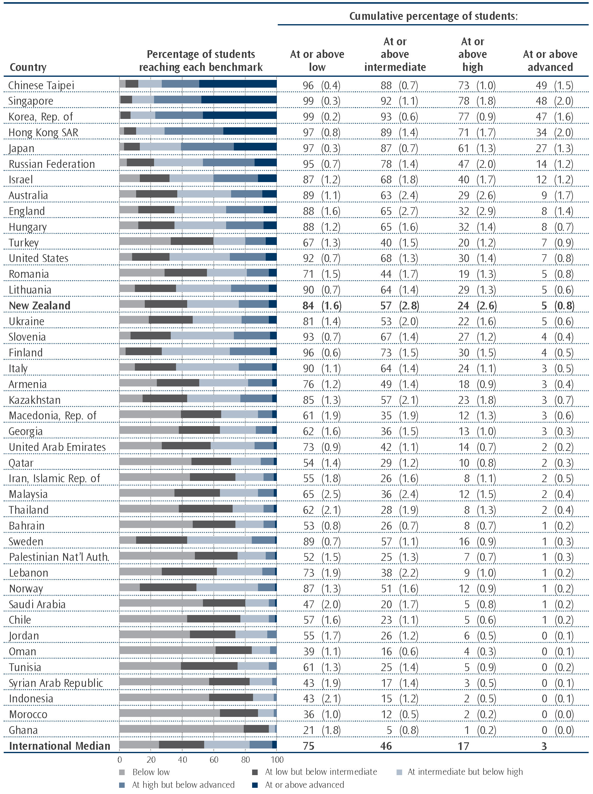
Note: Standard errors are presented in parentheses.
The proportion of students at the low benchmark includes those that achieved at higher benchmarks also.
Source: Exhibit 2.19, Mullis, Martin, Foy, and Arora, 2012.

Figures 1.3 to 1.6 present examples of questions that Year 9 students achieving at or above the advanced (Figure 1.3), high (Figure 1.4), intermediate (Figure 1.5), and low (Figure 1.6) benchmarks were likely to have answered correctly. An example of a correct answer and a description of the intention of the question are presented. In addition, proportions of students successfully completing the question for a selection of countries, including the best performing country on that question, are shown. The international average is also presented as an indication of how students in all 42 countries performed on this question.
Figure 1.3: Example of a question students reaching the advanced benchmark are likely to have
answered correctly
Content domain: geometry  Cognitive domain: reasoning  Description: solves a word problem involving filling a  three-dimensional shape with rectangular solids |  | Country | Percent  full credit
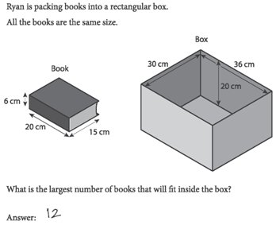 |  | Chinese Taipei | 66 | (1.8)
 |  | Hong Kong SAR | 65 | (2.1)
 |  | Korea, Rep. of | 62 | (2.0)
 |  | Singapore | 60 | (1.9)
 |  | Japan | 58 | (1.8)
 |  | Australia | 29 | (2.3)
 |  | Finland | 29 | (2.3)
 |  | Slovenia | 28 | (2.6)
 |  | New Zealand | 27 | (2.3)
 |  | England | 26 | (2.3)
 |  | United States | 26 | (1.5)
 |  | International Avg. | 25 | (0.3)
 |  | Norway | 22 | (2.0)
Note: Standard errors are presented in parentheses.
Source: Adapted from Exhibit 2.33, Mullis, Martin, Foy, and Arora, 2012.
Figure 1.4: Example of a question students reaching the high benchmark are likely to have
answered correctly
Content domain: algebra  Cognitive domain: reasoning  Description: identifies the quantity that satisfies two inequalities  represented by balances in a problem situation |  | Country | Percent  full credit
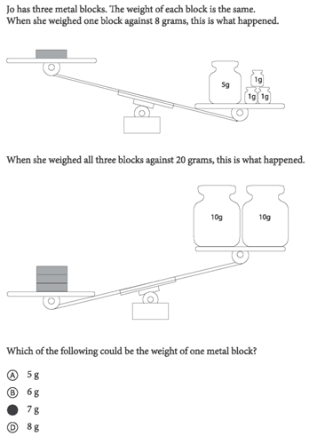 |  | Korea, Rep. of | 79 | (1.6)
 |  | Japan | 76 | (2.0)
 |  | Singapore | 75 | (1.7)
 |  | Finland | 74 | (1.9)
 |  | Chinese Taipei | 74 | (1.6)
 |  | Hong Kong SAR | 68 | (2.1)
 |  | Russian Federation | 67 | (2.2)
 |  | England | 62 | (2.8)
 |  | Australia | 62 | (2.4)
 |  | Sweden | 62 | (2.1)
 |  | Slovenia | 58 | (2.3)
 |  | United States | 57 | (1.5)
 |  | New Zealand | 57 | (2.4)
 |  | Norway | 55 | (2.5)
 |  | Italy | 51 | (2.2)
 |  | Turkey | 47 | (1.7)
 |  | International Avg. | 47 | (0.3)
 |  | Chile | 45 | (1.7)
 |  | Kazakhstan | 43 | (2.7)
 |  | Iran, Islamic Rep. of | 37 | (2.1)
 |  | Malaysia | 36 | (2.4)
Note: Standard errors are presented in parentheses.
Source: Adapted from Exhibit 2.29, Mullis, Martin, Foy, and Arora, 2012.
Figure 1.5: Example of a question students reaching the intermediate benchmark are likely to have answered correctly
Content domain: geometry  Cognitive domain: knowing  Description: given a net of a three-dimensional object, completes a two-dimensional drawing of it from a specific viewpoint |  | Country | Percent  full credit
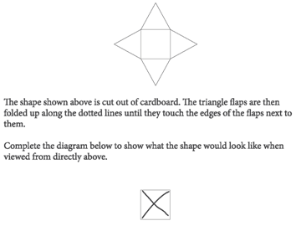 |  | Japan | 89 | (1.2)
 |  | Finland | 89 | (1.1)
 |  | Australia | 87 | (1.2)
 |  | Korea, Rep. of | 85 | (1.3)
 |  | New Zealand | 84 | (1.7)
 |  | Singapore | 83 | (1.4)
 |  | England | 82 | (2.1)
 |  | United States | 81 | (1.0)
 |  | Slovenia | 81 | (1.7)
 |  | Hong Kong SAR | 77 | (2.0)
 |  | Norway | 74 | (2.4)
 |  | Chinese Taipei | 74 | (1.7)
 |  | International Avg. | 58 | (0.3)
Note: Standard errors are presented in parentheses.
Source: Adapted from Exhibit 2.26, Mullis, Martin, Foy, and Arora, 2012.

Figure 1.6: Example of a question students reaching the low benchmark are likely to have
answered correctly
Content domain: number  Cognitive domain: knowing  Description: adds a two-place and a three-place decimal |  | Country | Percent  full credit
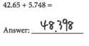 |  | Singapore | 94 | (0.8)
 |  | Hong Kong SAR | 91 | (1.5)
 |  | Chinese Taipei | 89 | (1.1)
 |  | United States | 89 | (1.0)
 |  | Korea, Rep. of | 87 | (1.5)
 |  | Slovenia | 85 | (1.7)
 |  | Australia | 82 | (2.0)
 |  | Norway | 81 | (1.9)
 |  | Japan | 81 | (1.6)
 |  | England | 79 | (2.4)
 |  | Finland | 79 | (1.8)
 |  | International Avg. | 72 | (0.3)
 |  | New Zealand | 70 | (2.9)
Note: Standard errors are presented in parentheses.
Source: Adapted from Exhibit 2.22, Mullis, Martin, Foy, and Arora, 2012.

Mathematics content and cognitive domains
Questions for the TIMSS tests were written to assess the content and cognitive aspects as described in the TIMSS 2011 assessment frameworks (Mullis, Martin, et al., 2009). Scores were created for each of these domains so that they are comparable with each other. Note that in previous cycles of TIMSS a score of 500 on one domain was not directly comparable to 500 on another domain, but this new methodology ensures they are. The content domains describe the subject matter to be assessed. In mathematics at the lower secondary level the content domains are number, algebra, geometry, and data and chance. The cognitive domains describe the thinking processes to be assessed. They describe the sets of behaviours expected of students as they engage with the content. The cognitive domains are entitled knowing, applying, and reasoning.
When content domains were compared, in the highest performing countries, the Republic of Korea and Singapore, achievement was similar across the four domains. For the relatively lower-performing countries in this selection, data and chance was the category with the highest performance compared to the other three categories. New Zealand lower secondary students performed relatively better on data and chance and relatively worse on algebra questions.
Table 1.4: Achievement in mathematics content domains for selected countries
Country | Number |  | Algebra |  | Geometry |  | Data & Chance
Korea, Rep. of | 618 | (2.6) | 617 | (3.2) | 612 | (2.7) | 616 | (2.5)
Singapore | 611 | (3.6) | 614 | (4.1) | 609 | (3.9) | 607 | (4.4)
Chinese Taipei | 598 | (3.1) | 628 | (3.8) | 625 | (3.7) | 584 | (3.0)
Hong Kong SAR | 588 | (3.7) | 583 | (3.9) | 597 | (4.3) | 581 | (4.1)
Japan | 557 | (3.0) | 570 | (3.0) | 586 | (3.5) | 579 | (3.0)
Finland | 527 | (2.4) | 492 | (2.9) | 502 | (2.9) | 542 | (3.1)
United States | 514 | (3.0) | 512 | (2.6) | 485 | (2.7) | 527 | (3.3)
England | 512 | (5.8) | 489 | (5.7) | 498 | (5.7) | 543 | (6.8)
Australia | 513 | (5.4) | 489 | (5.3) | 499 | (5.4) | 534 | (5.9)
Slovenia | 511 | (2.5) | 493 | (2.6) | 504 | (3.1) | 518 | (3.3)
New Zealand | 492 | (5.9) | 472 | (5.5) | 483 | (5.5) | 513 | (6.7)
Norway | 492 | (2.8) | 432 | (2.7) | 461 | (3.5) | 513 | (3.6)
Note: Standard errors are presented in parentheses.
Source: Adapted from Exhibit 3.2, Mullis, Martin, Foy, and Arora, 2012.

There was no consistent pattern across countries when cognitive domains were compared (see Table 1.5). As was the case in the previous cycle in New Zealand, knowing was a relative weakness, with reasoning and applying relative strengths.
Table 1.5: Achievement in mathematics cognitive domains for selected countries
Country | Knowing |  | Applying |  | Reasoning
Korea, Rep. of | 616 | (2.9) | 617 | (2.9) | 612 | (2.5)
Singapore | 617 | (3.8) | 613 | (3.9) | 604 | (4.3)
Chinese Taipei | 611 | (3.7) | 614 | (3.5) | 609 | (3.4)
Hong Kong SAR | 591 | (3.9) | 587 | (3.7) | 580 | (3.9)
Japan | 558 | (2.7) | 574 | (2.5) | 579 | (3.0)
Finland | 508 | (2.5) | 520 | (2.5) | 512 | (2.7)
United States | 519 | (2.7) | 503 | (2.8) | 503 | (2.7)
England | 501 | (5.4) | 508 | (5.5) | 510 | (5.5)
Australia | 504 | (5.1) | 506 | (4.8) | 506 | (4.9)
Slovenia | 508 | (2.4) | 502 | (2.1) | 500 | (2.7)
New Zealand | 481 | (5.6) | 491 | (5.0) | 494 | (5.3)
Norway | 465 | (2.5) | 480 | (2.6) | 478 | (2.9)
Note: Standard errors are presented in parentheses.
Source: Adapted from Exhibit 3.4, Mullis, Martin, Foy, and Arora, 2012.

2. Trends in New Zealand mathematics achievement 1994 to 2010
New Zealand has participated in TIMSS since its inception in 1994. However, in 2006 we opted not to participate at the Year 9 level. Therefore, we now have information from four assessments of mathematics achievement. This chapter will present trends for New Zealand in means, distributions, benchmarks, item statistics, and the content and cognitive domains.
Trends in means and ranges since 1994
Mean mathematics achievement has not changed significantly since 1994. However, achievement appears to be trending downwards (see Figure 2.1). As mentioned in the previous chapter, New Zealand’s mean score in 2010/11 (488) was significantly lower than the international scale centre value of 500, whereas it was the same in 1994/95.
Figure 2.1: Mean mathematics achievement of New Zealand Year 9 students from 1994 to 2010
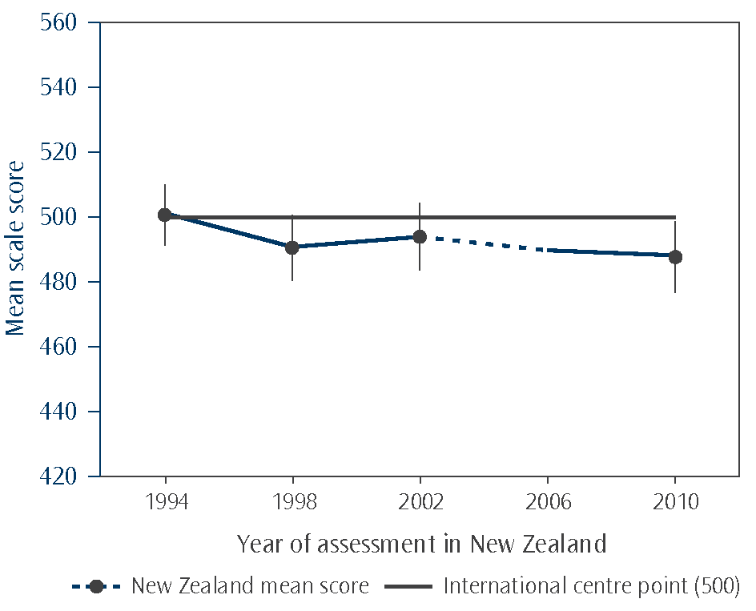
Note: New Zealand did not conduct the TIMSS assessment in 2006 so the dotted line indicates the possible location of mean achievement in that cycle.

In addition to looking at the mean achievement of students, it is useful to look at the range of achievement among the students. Considerable commentary on the ‘tail of underachievement’ has occurred in the last few years. Therefore, it is important to explore whether any changes have happened across the spectrum of achievement. Figure 2.2 presents achievement at the 5th, 25th, 75th, and 95th percentiles. The lower limit of achievement, the 5th percentile, is the score at which five percent of students achieved a lower score. The upper limit of achievement, the 95th percentile, is the score at which five percent of students achieved a higher score.
As shown in Figure 2.2, the range of achievement in 2010 was wider than most cycles with the exception of 1998. The range of mathematics achievement of Year 9 students was the most narrow in 2002. While there are fewer low achievers in 2010 compared with 1998, there are also fewer high achievers as shown by the 5th and 95th percentiles. However, when compared with 2002, there are more low achievers in 2010.
Figure 2.2: Distribution of mathematics achievement of New Zealand Year 9 students from 1994 to 2010
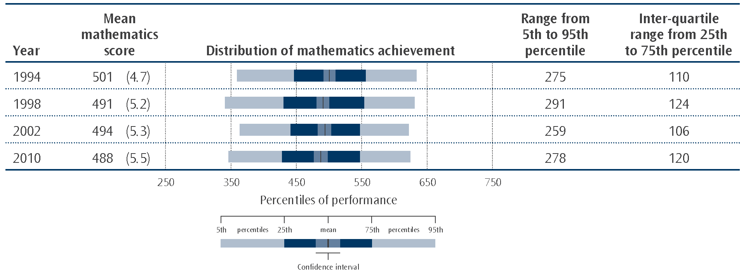
Note: Standard errors are presented in parentheses.

Trends in benchmarks for mathematics
As mentioned earlier, in order to describe more fully what achievement on the mathematics scale means, the TIMSS international researchers have developed benchmarks. These benchmarks link student performance on the TIMSS mathematics scale to performance on mathematics questions and describe what students can typically do at set points on the mathematics achievement scale. Figure 2.3 presents those Year 9 students achieving at each of the benchmarks (as shown in the graphical part) and those students achieving at or above each of the benchmarks (as shown in the table part) in each cycle from 1994 to 2010.
As noted earlier when comparing the distributions of achievement in terms of percentiles, there were fewer high achievers and more low achievers than previous cycles. An examination of the benchmark information confirms this (see Figure 2.3). Although the proportions of students at the high and advanced benchmarks were the same in 2010 as in 2002, they were lower than 1998 and 1994. At the other end of the spectrum, there were the same proportions of low achievers as 1998, as measured by the intermediate and low benchmarks, and these were lower than 1994 and 2002.
Figure 2.3: Trends in proportions of New Zealand Year 9 students at each benchmark from 1994 to 2011
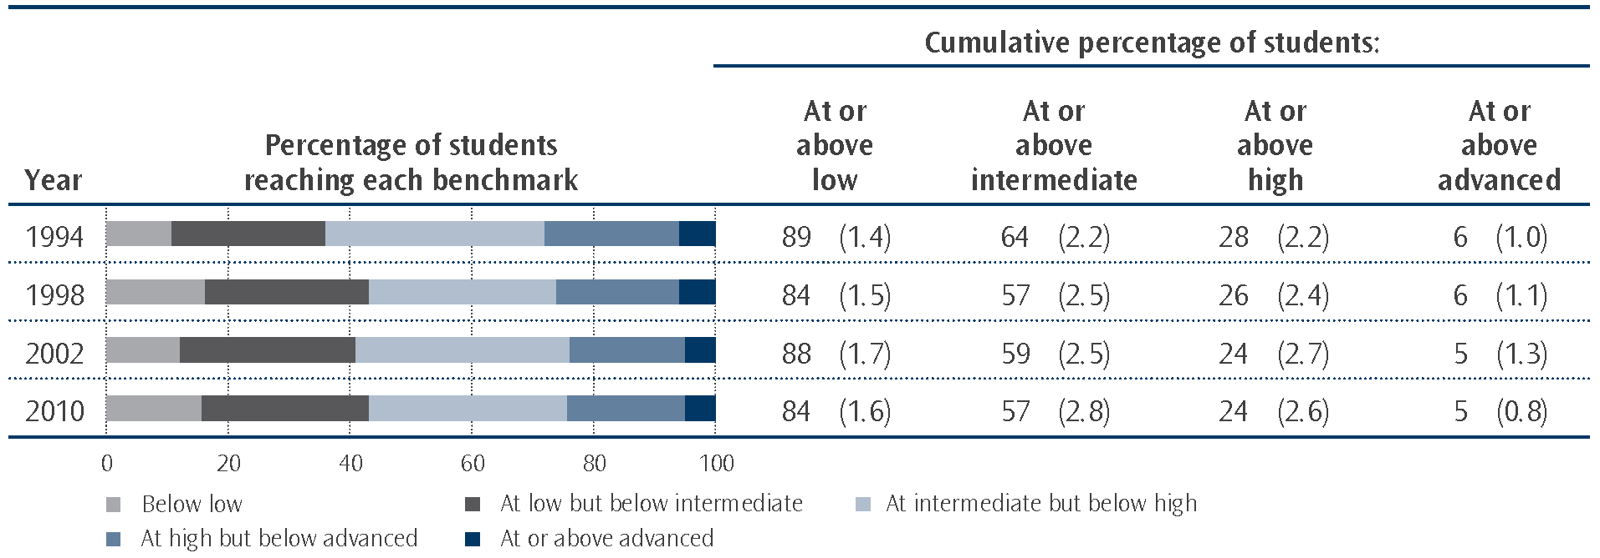
Note: Standard errors are presented in parentheses.
“At or above” means that the proportion of students at the benchmark includes those that achieved at higher benchmarks also. For example, the 84% of students in 2010 that achieved at or above the low benchmark includes 28% who achieved at the low benchmark, 32% at the intermediate, 19% at the high, and 5% at the advanced benchmark.

Trends on the mathematics test questions from 2002 to 2010
At the end of each cycle of TIMSS, test questions are released into the public domain. At the beginning of the next cycle, new questions are developed to replace released questions. In addition, each cycle of TIMSS includes some questions from previous cycles to provide a trend measure over time. This section presents an analysis of the trend questions included in both TIMSS 2002/03 and 2010/11.
There were 40 questions common to both 2002 and 2010. Of these 40 questions, 4 questions had similar proportions of New Zealand Year 9 students correctly answering them across the two cycles (as shown in Table 2.1). Less than one-quarter of the questions (7) showed a decline; that is they were correctly answered by fewer students in 2010 compared with 2002. In contrast, more than half of the questions showed an increase; that is they were correctly answered by more students in 2010 compared with 2002.
These item statistics show that despite the apparent downward trend, there were some improvements between 2002 and 2010. Note that the increases were spread across all content areas: number, algebra, geometry, and data and chance but proportionately fewer questions increased in the number content area.
Table 2.1: Trends in proportions of New Zealand Year 9 students correctly answering mathematics questions common to 2002 and 2010
 | Change between 2002 and 2010
 | decrease by  5% or more | decrease by  between  1% and 5% | increase or decrease by  1% or less | increase by  between  1% and 5% | increase by  5% or more
Number of questions | 0 | 7 | 4 | 17 | 12

Trends in mathematics content and cognitive domains from 2002 to 2010
As mentioned earlier, questions for the TIMSS tests were written to assess the content and cognitive aspects as described in the TIMSS 2011 assessment frameworks (Mullis, Martin, et al., 2009). Scores were created for each of these domains using a different methodology from previous cycles (see previous chapter and the Definitions and technical notes for details). This new methodology was applied to the questions in the 2006/07 assessment to create revised domain scores for this cycle. Therefore, comparisons can be made between 2006 and 2010 but not with earlier cycles. Comparisons here only focus on relative strengths and weaknesses.
In terms of content, data and chance remains a relative strength in 2010. Similarly, reasoning remains a relative strength in terms of cognitive demands of questions. Questions that required students to know facts or procedures remain a relative weakness for Year 9 students. One change that has occurred is that algebra has become a relative weakness for New Zealand Year 9 students in 2010.

3. TIMSS and the New Zealand mathematics curriculum
The New Zealand curriculum guides teaching and learning. The alignment of curriculum levels with year levels is flexible. Teachers are expected to tailor lessons to meet students’ individual needs. Students in the same year level may be working at different curriculum levels as appropriate to their abilities and pace of progression. As with previous cycles of TIMSS, teachers have given indications of what topics they have taught in the current school year to their Year 9 students and the curriculum level the majority of their Year 9 students are working at. This section will examine what is implemented in terms of the curriculum as well as the match between the TIMSS test and the intended curriculum.
Mathematics curriculum levels and the TIMSS content domains
New Zealand teachers were asked at which level(s) of Mathematics and Statistics in the New Zealand Curriculum were most of the Year 9 students in their class working for each of the strands: Number and Algebra, Geometry and Measurement, and Statistics. Figure 3.1 shows that the proportions of students working at level 5 of the curriculum were relatively low. The proportions varied across strands from just over one-fifth on the number and algebra strand (21%) down to below one-fifth (17%) on the statistics strand. Results from the Numeracy Development Projects (Young-Loveridge, 2009) also show many students working at lower levels of the curriculum than might be desired.
We can use the TIMSS content domains to examine attainment on the curriculum strands due to their similar mathematical content. For example, the geometry content domain for lower secondary in TIMSS consists of: geometric shapes, geometric measurement, and location and movement which includes transformations (see Mullis, Martin, Ruddock, O’Sullivan, Preuschoff, 2009). Similarly, the geometry and measurement strand at level 5 of the New Zealand curriculum consists of: measurement, shape, position and orientation, and transformation (Ministry of Education, 2007). Figure 3.1 shows that students whose classes are working at higher levels of the curriculum have higher achievement on the associated TIMSS content domain.
Examining these results in the international context shows that if we only included those Year 9 students working at level 5 of the curriculum in the TIMSS testing, New Zealand would still have a lower mean score than the high-performing countries (the Republic of Korea, Singapore, Chinese Taipei and Hong Kong). For example the average score for New Zealand students working at level 5 of the statistics strand of the curriculum is still significantly lower on the data and chance content domain (579) than their Korean counterparts (616 scale score points).
Figure 3.1: Curriculum levels and New Zealand Year 9 student achievement on mathematics content domains
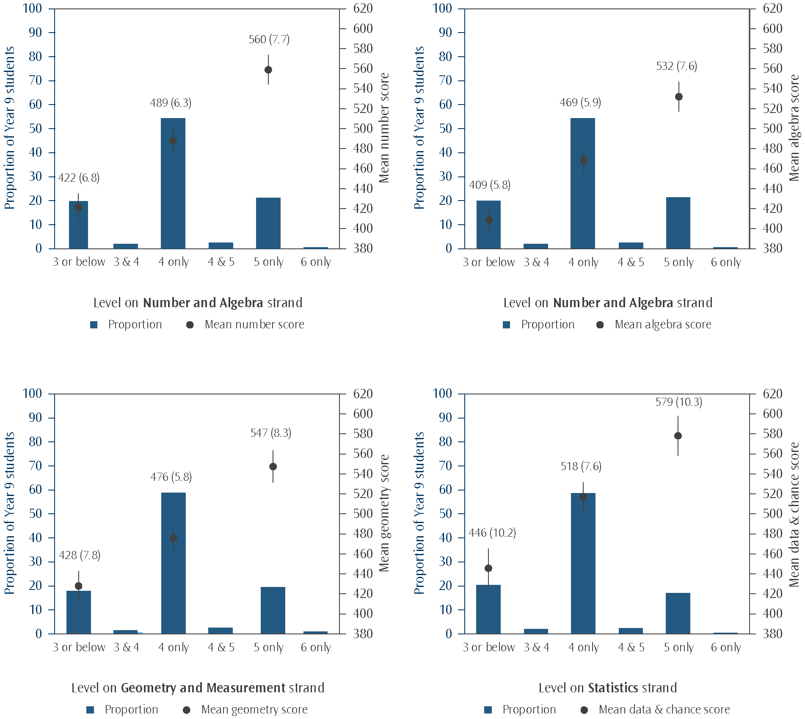
Note: The bars on the graph represent proportions of Year 9 students whose class were working at that level of the curriculum. The points represent mean scores on the appropriate content domain while the lines extending from those points represent the 95% confidence interval associated with estimating the mean of the population from the sample. No mean achievement is presented for groups smaller than 2%.

Curriculum match
Questions about international studies often focus on the appropriateness of the assessment questions for New Zealand students. New Zealand is not unique in asking this question; other countries are also concerned with appropriateness of the tests. The TIMSS assessment questions are developed through a collaborative process that begins with the development of an assessment framework. The TIMSS 2011 assessment frameworks (Mullis, Martin, et al., 2009) were designed to specify the important aspects of mathematics that participating countries agreed should be the focus of an international assessment of mathematics achievement. However it is inevitable that the tests included questions that were unfamiliar to some students in some countries. In order to investigate the extent to which the TIMSS 2010/11 assessment was relevant to each country’s curriculum, TIMSS conducted a Test-Curriculum Matching Analysis (TCMA). The TCMA was also used to investigate the impact of selecting only appropriate questions on a country’s performance.
For the TCMA, each assessment question was examined using the following two criteria:
- whether or not the topic of the question is in the intended curriculum for the majority (50 percent or more) of lower secondary students in the grade or school level tested (in our case Year 9); and
- whether or not the item topic was intended to be encountered by the students prior to the TIMSS testing (in our case November 2010).
While all questions, regardless of this analysis, were included in any overall results reported for TIMSS, this analysis was used to ascertain the level to which the results might change for New Zealand if only questions judged appropriate were included in the tests. The analysis also included an examination of how students in other countries would fare if given only the “New Zealand-appropriate” test.
Table 3.1 shows the proportion of questions considered appropriate to the New Zealand curriculum in each of the TIMSS content areas. However, it should be noted that New Zealand’s mathematics curriculum provides some challenges for deciding whether at least half of Year 9 students are likely to have met the question topics in the TIMSS test. The curriculum is not prescriptive, instead providing some broad guidelines of mathematics concepts and skills that schools can choose to cover. Schools are encouraged to design mathematics programmes that are relevant to their students and communities. Consequently, when schools plan their mathematics programmes there is considerable variation between them. Another challenge is that the broad achievement objectives are grouped in levels that cover approximately two years of schooling. This cycle we also had the National Standards in mathematics, implemented in 2010, which give expectations for Year 8 students in mathematics. These standards helped to give a clearer understanding of what teachers might be teaching their Year 9 students.
As shown in the previous section, New Zealand Year 9 students were generally working at levels 4 and 5 of the curriculum, so information from levels 4 and 5, but with a concentration on 5, was used to guide judgements on the TCMA. In addition, curriculum-matched resources available on nzmaths.co.nz were used for further clarification.⁵

5. Thanks to Bernie Wills, Penelope de Boer, and Andrew Ball for their contributions to this work.
Table 3.1: Appropriateness of the TIMSS tests to the New Zealand Curriculum
TIMSS content domain | Number of score points judged appropriate for  New Zealand curriculum | Number of score points in TIMSS assessment | Proportion of score points judged appropriate for  New Zealand curriculum
Number | 64 | 67 | 96%
Algebra | 67 | 76 | 88%
Geometry | 42 | 44 | 95%
Data and Chance | 45 | 45 | 100%
Total | 218 | 232 | 94%
Note: The TIMSS content areas of Number and Algebra correspond to the Number and Algebra strand in the curriculum, Geometry
corresponds to the Geometry and Measurement strand in the curriculum, and Data and Chance corresponds to the Statistics strand in the curriculum.

As Table 3.1 shows, 94 percent of the TIMSS questions were judged appropriate for New Zealand students in terms of the curriculum expectations. However, given that only about 20% of students were working at level 5 of the curriculum, this may be an over-estimation of the appropriateness of the test. The TCMA analysis shows that even if the TIMSS test was reduced to include only those questions considered appropriate to the New Zealand curriculum, the average New Zealand Year 9 student would have got less than half the items correct (see Table 3.2). In contrast, the average student in some of the high performing countries would have got nearly three-quarters of the items correct.
Table 3.2: Performance of lower secondary students from selected countries on the New Zealand appropriate test in 2010/11
Country | Average percent correct  on New Zealand test
Korea, Rep. of | 74
Singapore | 74
Chinese Taipei | 72
Hong Kong SAR | 69
Japan | 65
Russian Federation | 57
Finland | 51
United States | 50
England | 50
Australia | 49
Slovenia | 48
New Zealand | 45
Kazakhstan | 43
Norway | 41
Source: Adapted from Exhibit F.2 in Mullis, Martin, Foy, and Arora, 2012.

Coverage of mathematics topics
Teachers provided information on mathematics topics taught to Year 9 students prior to or during the year of the TIMSS assessment. For each of 19 topics, teachers were asked if the topic was mostly taught before this year, mostly taught this year, or not yet taught or just introduced. Just over three-quarters of students had been taught all these topics in 2010 or the preceding years (78% of students). In comparison, four-fifths of students (80%) on average across countries had been taught all these 19 topics (range from 52% in Norway to 95% in Romania and Macedonia).
More New Zealand students had been taught number topics in 2010 or the preceding years (96%) than data and chance topics (76%), geometry topics (72%), or algebra topics (68%). Note that this question was not about the proportion of time spent on these but rather the coverage of items in the TIMSS assessment framework (Mullis, Martin, et al., 2009). The TIMSS framework guided the writing of questions for the TIMSS assessment and the final formulation of the test. As mentioned earlier, data and chance is the area of TIMSS where New Zealand students show the best performance while the other areas were lower.
The mathematics topics covered by fewer than half of all New Zealand students were:
- Simultaneous (two variables) equations (10%); and
- Congruent figures and similar triangles (42%).
Table 3.3 shows a complete list of topics and coverage among New Zealand Year 9 students.
The relationship between coverage and achievement is complicated although high-achieving countries generally had greater than 80 percent coverage of topics. It is interesting to note that nearly all of the high-performing countries had higher coverage of algebra topics (Hong Kong SAR 87%, Republic of Korea 91%, Singapore 94%, and Chinese Taipei 97%) than New Zealand (68%).
Table 3.3: Mathematics topics taught to Year 9 students in New Zealand before or during 2010
Topic | Proportion of students in classes where the topic was taught before or during 2010
Number
Computing, estimating, or approximating with whole numbers | 98
Concepts of fractions and computing with fractions | 98
Concepts of decimals and computing with decimals | 98
Representing, comparing, ordering, and computing with integers | 98
Problem solving involving percents and proportions | 86
Algebra
Numeric, algebraic, and geometric patterns or sequences (extension, missing terms, generalisation of patterns) | 88
Simplifying and evaluating algebraic expressions | 92
Simple linear equations and inequalities | 84
Simultaneous (two variables) equations | 10
Representation of functions as ordered pairs, tables, graphs, words, or equations | 69
Geometry
Geometric properties of angles and geometric shapes (triangles, quadrilaterals, and other common polygons) | 92
Congruent figures and similar triangles | 42
Relationship between three-dimensional shapes and their two-dimensional representations | 54
Using appropriate measurement formulas for perimeters, circumferences, areas, surface areas, and volumes | 94
Points on the Cartesian plane | 72
Translation, reflection, and rotation | 81
Data and Chance
Reading and displaying data using tables, pictographs, bar graphs, pie charts, and line graphs | 89
Interpreting data sets (e.g., draw conclusions, make predictions, and estimate values between and beyond given data points) | 71
Judging, predicting, and determining the chances of possible outcomes | 68

4. Progress over time – Year 5 students in 2006 now Year 9 students in 2010
The cohort of New Zealand students who participated in TIMSS in 2006 as Year 5 students were in Year 9 in the 2010 cycle of TIMSS. Similarly, across other countries in TIMSS, the Grade 4 students in the fourth cycle of TIMSS were Grade 8 students in the fifth cycle. TIMSS was designed with a four-year cycle to allow a quasi-longitudinal study of mathematics and science achievement. Although the mathematics achievement scales for the middle primary and lower secondary levels are not comparable, it is possible to look at the relative performance of countries in each assessment to examine the progress the younger cohort has made in four years.
Progress from 2006 to 2010
Nineteen countries that assessed their middle primary students in TIMSS 2006/07 also participated in TIMSS 2010/11 at the lower secondary level. The expectation, as demonstrated in the frameworks for TIMSS, was that students should be able to solve much more difficult mathematics problems in lower secondary school than in middle primary. For example at the middle primary level, items in the number domain cover:
- whole numbers;
- fractions and decimals;
- number sentences with whole numbers; and
- patterns and relationships.
However, at the lower secondary level, there is both a number domain and an algebra domain. The number domain is expanded to include:
- whole numbers;
- fractions and decimals;
- integers; and
- ratio, proportions, and percent.
In addition, the algebra domain includes:
- patterns;
- algebraic expressions; and
- equations/formulas and functions.
The mean mathematics achievement of New Zealand Year 5 students (492) was significantly lower than the mean of all 19 countries (504 scale score points) in the 2006/07 study. In 2010/11 the mean mathematics achievement of this group as Year 9 students (488) was still significantly lower than the mean of all 19 countries (504 scale score points). However, New Zealand’s relative ranking among these countries improved as these students matured so that there were more countries below New Zealand as shown in Figure 4.1.
Also shown in Figure 4.1 is the relative ranking among this group of countries for the previous Year 9 cohort of students, assessed in 2002/03. This group had a higher relative ranking, achieving approximately the same as the mean for all 19 countries.
Figure 4.1: Relative mathematics performance of middle primary students in 2006/07 and again when they were lower secondary students in 2010/11 (and 2002/03 for comparison)
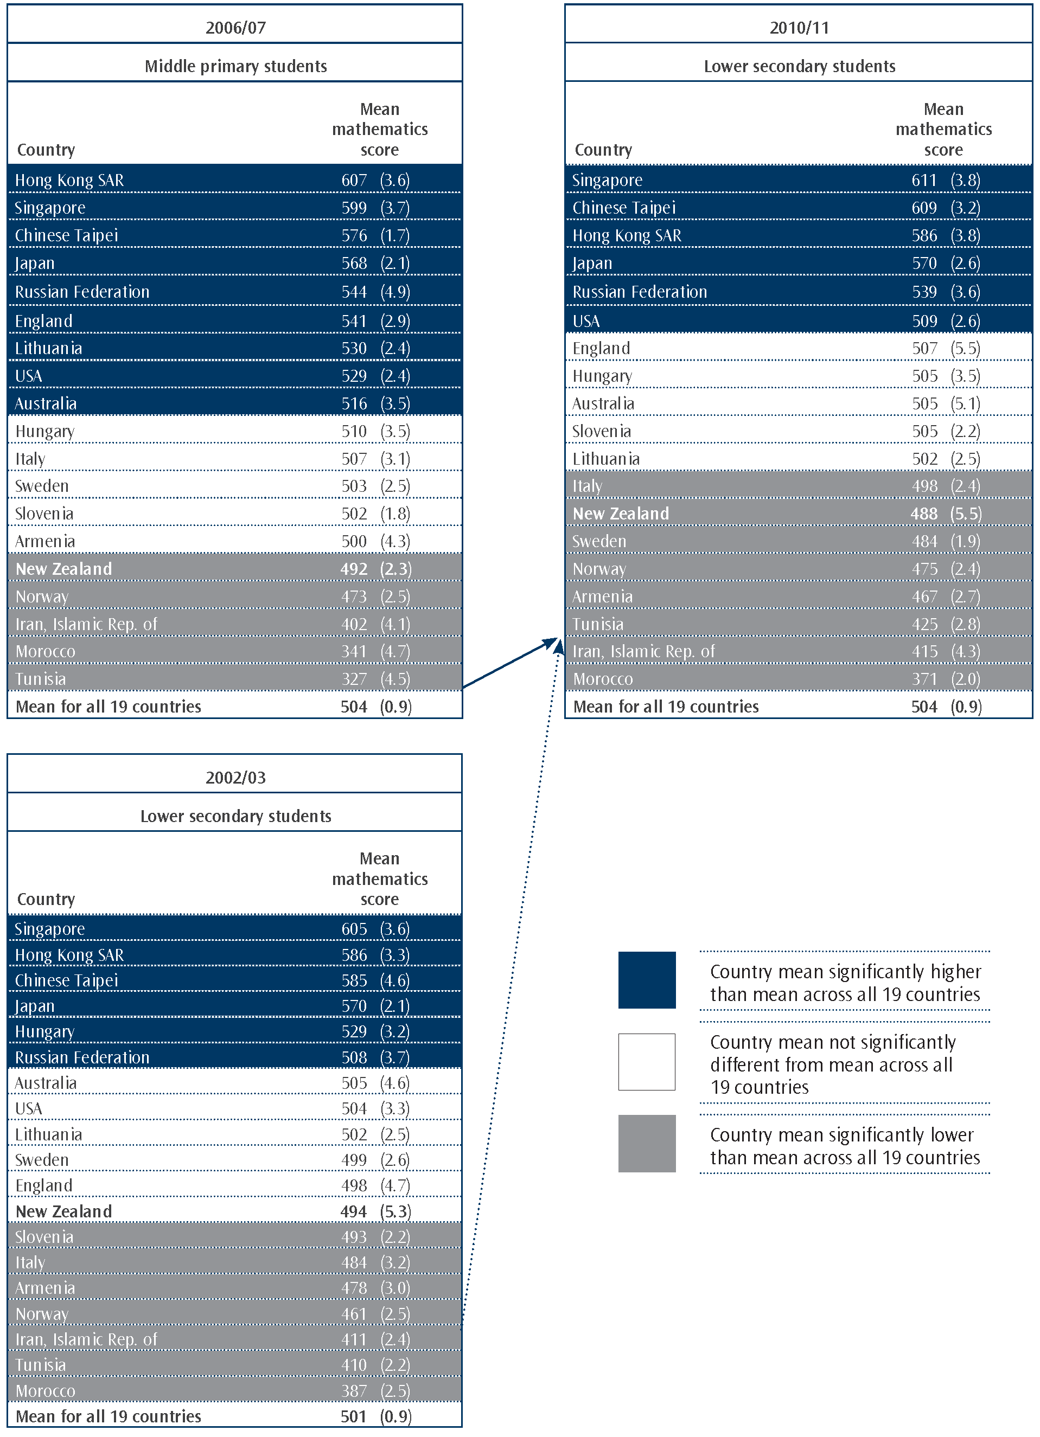

5. Mathematics achievement of
Year 9 boys and girls
The Government sets the National Education Goals (NEGs) to recognise the fundamental importance of education to New Zealand. The first of these goals seeks to have “the highest standards of achievement, through programmes which enable all students to realise their full potential as individuals, and to develop the values needed to become full members of New Zealand’s society” (Ministry of Education, 2009). Currently the focus is on the outcomes of boys in the New Zealand system rather than girls. Some New Zealand boys appear not to be reaching their full potential in our current education system (Ministry of Education, 2007). Qualification data shows different proportions of boys and girls having success (see for example www.educationcounts.govt.nz/statistics/schooling/ncea-attainment/ncea-achievement-data-roll-based/ncea-attainment). This chapter will examine the mathematics achievement of Year 9 boys and girls in TIMSS in 2010 with some comparisons with previous cycles.
Mathematics achievement of boys and girls
New Zealand boys had higher average mathematics achievement (496) than girls (478 – 18 scale score points difference) in 2010. However, the range of achievement for boys was wider than for girls (as shown in Figure 5.1). This is the first cycle to show a significant difference in mathematics achievement between the boys and the girls. This large increase in the difference is due to the large decrease in achievement for the girls from 2002 to 2010 (17 scale score points). There is no significant difference in mean achievement for boys between 2002 and 2010.
In comparison with other countries, New Zealand really stands out for having nearly the largest gender difference in favour of boys. The other countries with large gender differences favouring boys were Ghana (23), Tunisia (17), Chile (14), and Lebanon (12). With the exceptions of Singapore and the Republic of Korea, countries who were high-performing had no gender difference. Singapore had a small gender difference in favour of girls (9 scale score points difference) and Korea had a small gender difference in favour of boys (6 scale score points difference).
Figure 5.1: Trends in distributions of achievement for New Zealand girls and boys from 1994 to 2010
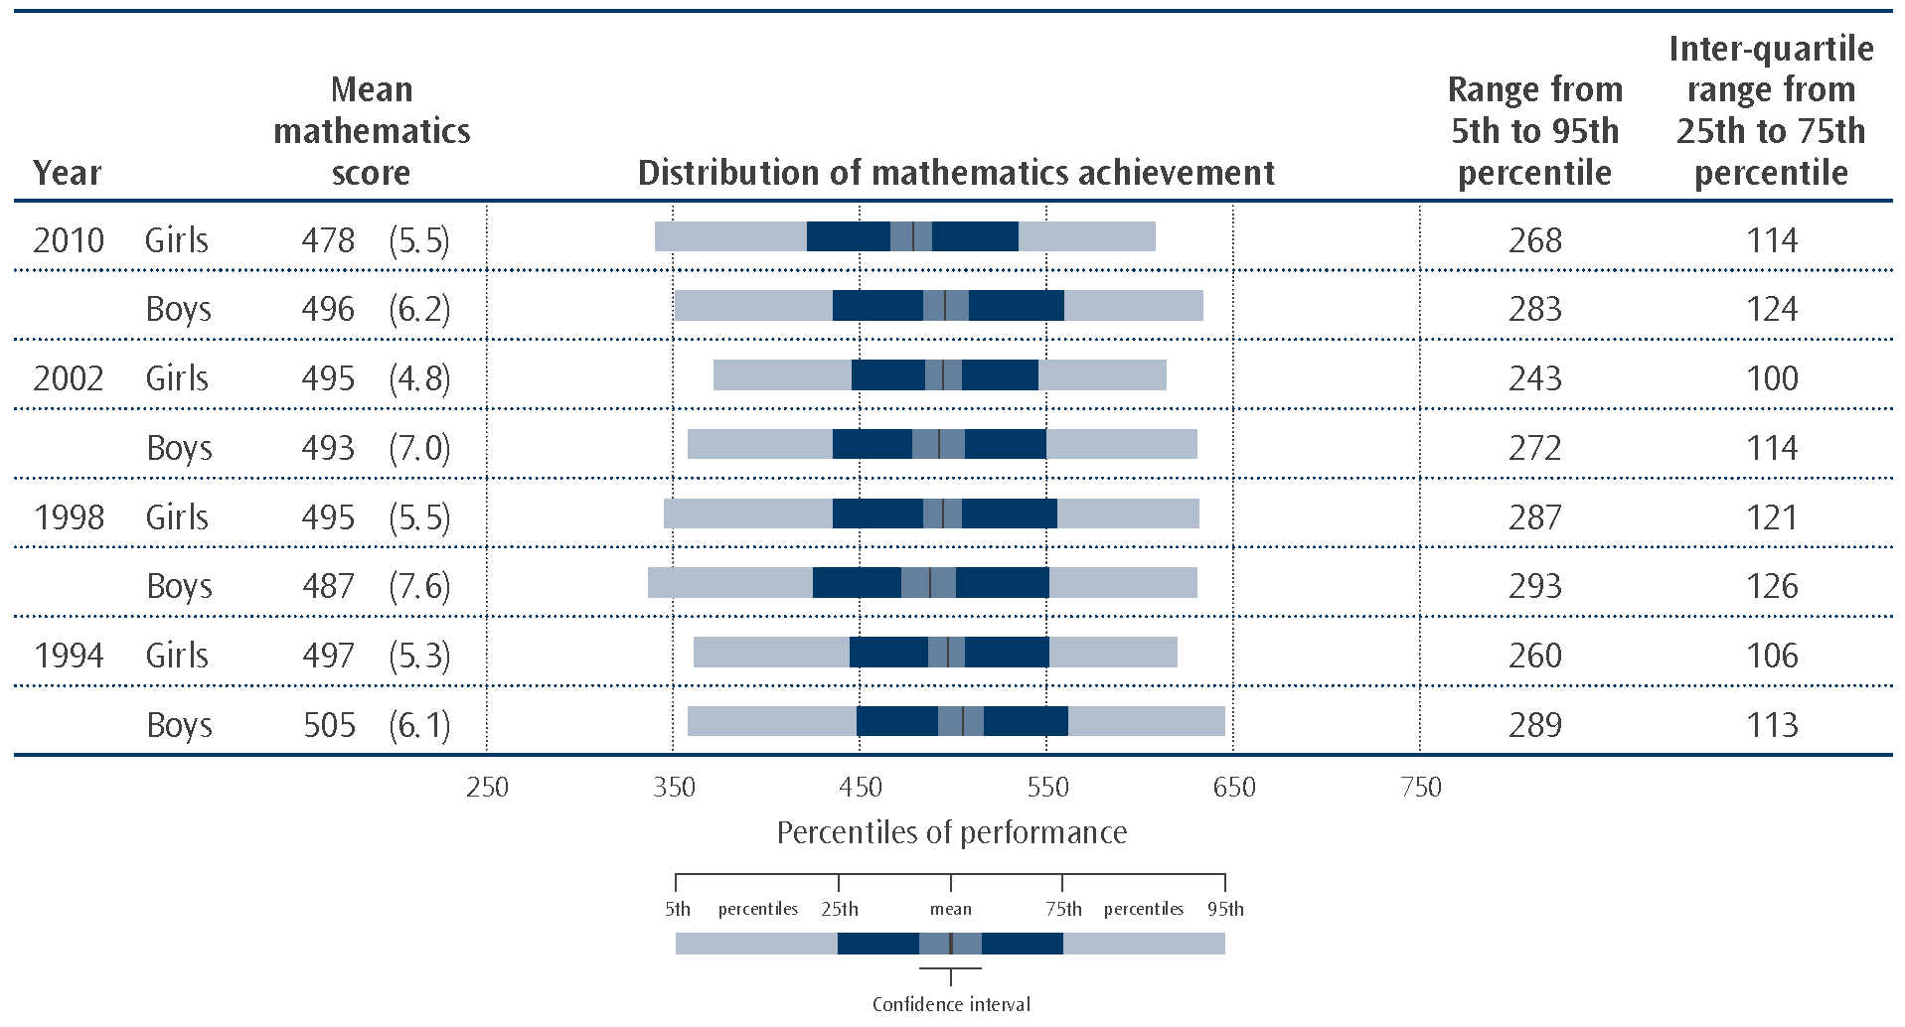
Note: Standard errors are presented in parentheses.

Figure 5.2 presents trends in mean mathematics achievement for girls and boys. As Figure 5.2 shows, girls mathematics achievement did not differ from 1994 through to 2002, with the only change being the significant decrease between 2002 and 2010. In contrast, boys achievement has not differed significantly across the 4 cycles of TIMSS. Note that although there appears to be a drop in mean achievement for boys between 1994 and 1998, due to relatively large standard errors, this is not significant.
Figure 5.2: Trends in mean achievement for New Zealand girls and boys from 1994 to 2010
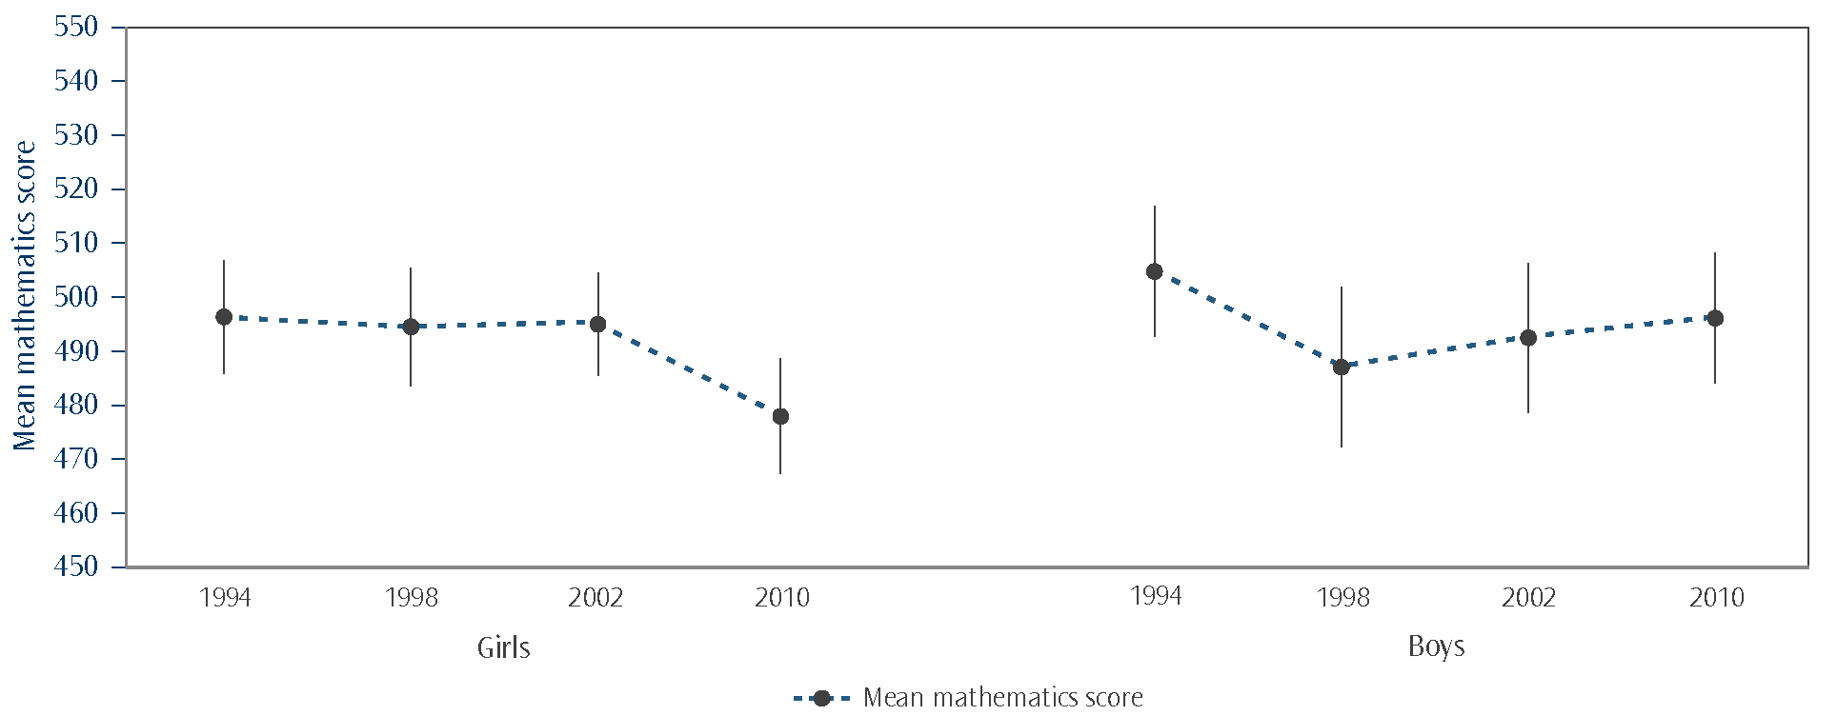
Note: The lines extending from the points represent the 95% confidence interval, i.e., the range in which we are 95 percent confident that the true population value lies.
Benchmarks for boys and girls
More boys reached the high and advanced benchmarks compared to girls as shown in Figure 5.3. There were significant proportions of both girls (18%) and boys (14%) who did not reach the low benchmark – these students did not demonstrate the ability to complete the basic mathematical tasks that TIMSS seeks to measure.
Figure 5.3: Proportion of New Zealand boys and girls reaching each mathematics international benchmark in 2010
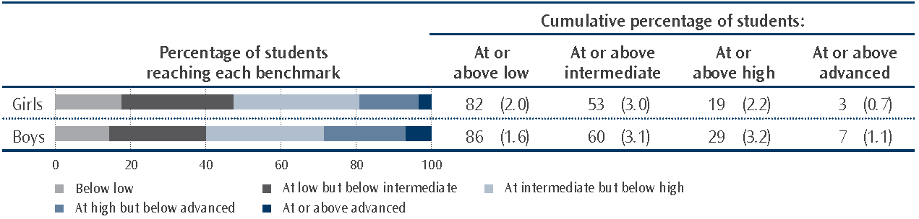
Note: Standard errors are presented in parentheses.
“At or above” means that the proportion of students at the benchmark includes those that achieved at higher benchmarks also. For example, the just over 82% of girls that achieved at or above the low benchmark includes 30% who achieved at the low benchmark, just under 34% at the intermediate, 16% at the high, and 3% at the advanced benchmark.

Although it appears there have been some small changes in the proportions of boys and girls reaching each of the benchmarks since 2002, only the changes in the proportions of girls reaching the intermediate and low benchmarks are statistically significant (see Table 5.1). There were more girls with low achievement in 2010 compared with 2002. In particular, in 2002 there were only 10 percent of girls who did not reach the low benchmark, but this proportion had grown to 18 percent by 2010.
Table 5.1: Proportion of New Zealand boys and girls reaching each mathematics international benchmark in 2002
 | Cumulative percentage of Year 9 students at or above each benchmark
 | Low |  | Intermediate |  | High |  | Advanced
Girls | 90 | (1.6) | 61 | (2.7) | 23 | (2.6) | 4 | (1.1)
Boys | 87 | (2.2) | 58 | (3.2) | 25 | (3.6) | 6 | (1.7)
Note: Standard errors are presented in parentheses.
Achievement on the content and cognitive domains for boys and girls
As mentioned earlier, boys had higher average mathematics achievement than girls. As shown below, this higher achievement was across all content and cognitive domains.
Table 5.2: New Zealand Year 9 mean mathematics scores on the content and cognitive domains by gender
Content  domain | Mean domain score |  |  |  |  | Cognitive domain | Mean domain score
Content  domain | Girls |  | Boys |  |  | Cognitive domain | Girls |  | Boys
Number | 478 | (6.1) | 505 | (6.5)  |  | Knowing | 471 | (5.5) | 490 | (6.2) 
Algebra | 467 | (5.5) | 477 | (6.2)  |  | Applying | 481 | (5.0) | 500 | (5.6) 
Geometry | 471 | (5.5) | 494 | (6.2)  |  | Reasoning | 486 | (5.3) | 500 | (6.1) 
Data & Chance | 505 | (7.4) | 521 | (7.1) 
Note:  mean domain score significantly higher than other gender.
Standard errors are presented in parentheses.
Source: Exhibits 3.10 & 3.12, Mullis, Martin, Foy, and Arora, 2012.

6. Mathematics achievement, ethnicity of students, and language of the home
The Ministry of Education is currently placing priority on improving outcomes for Māori learners and for Pasifika learners (as well as students with special needs and those with low socio-economic status). While this is not a new focus, with previous documents and programmes aimed in this direction, it is important to review our progress towards this goal. It is not the ethnicity of these groups per se that influences outcomes but rather ethnicity can be indicative of underlying social, cultural, educational, and economic influences. Thus the existence of a relationship between ethnicity and achievement demonstrated in this section does not imply that being classified in a particular ethnic group is a cause of poor or good achievement. In contrast, language knowledge may strongly influence mathematical learning with languages like Māori and some of the Asian languages being inherently structured for an understanding of base ten and place value. This section will examine mathematics achievement among ethnic groupings and language users.
Mathematics achievement among ethnic groupings
Five broad categories are used to describe ethnicity in this report: Pākehā/European, Māori, Pasifika, Asian, and ‘Other’.⁶ The majority of students were classified as Pākehā/European (58%) or Māori (20%). Of the remainder, eight percent were classified as Pasifika, ten percent as Asian and only four percent as ‘Other’.
As shown in Figure 6.1, there was a range of achievement within each ethnic grouping, with the widest range among students in the ‘Other’ ethnic grouping. On average, Asian students had higher achievement than Pākehā/European, Māori, Pasifika and ‘Other’ students.
Figure 6.1: Distribution of New Zealand Year 9 mathematics achievement for each ethnic grouping
in TIMSS 2010
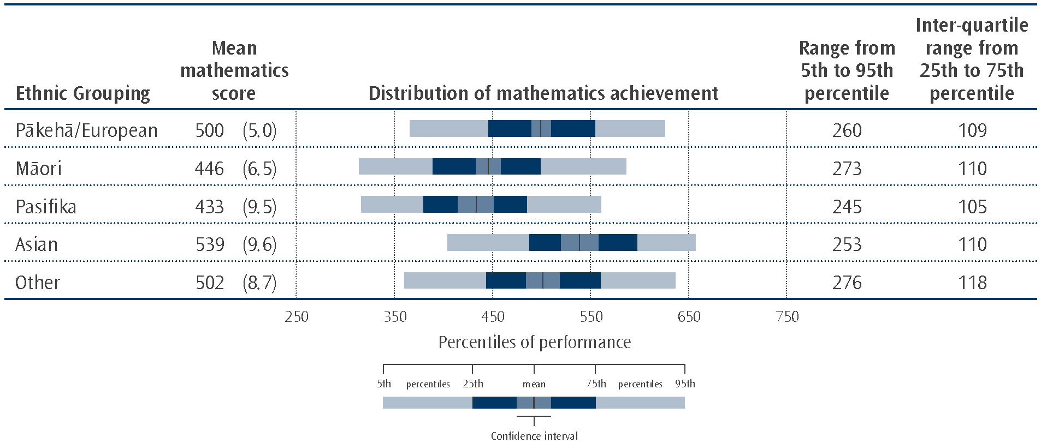
Note: Standard errors are presented in parentheses.

6 Note that information was collected from both schools and students and the data presented summarises this information. Also note, that although students were able to identify with more than one ethnic grouping, each student was assigned to only one group using prioritisation as per previous cycles. This allows groups to be compared with each other. See the appendix for the results of multiple categorisation of ethnicity.
In terms of trends over time, the average mathematics achievement of Pākehā/European students has shown a significant decrease since 1994. While the decrease for Māori students is of a similar magnitude to those of Pākehā/European, due to the variation among their results and having fewer students, this decrease is not statistically significant. Although indicative of the continuing downward trend, between 2002 and 2011 none of the differences were significant.
Table 6.1: Trends in mathematics achievement for Year 9 students in New Zealand over five cycles of TIMSS by ethnic grouping
 | Mean mathematics achievement |  |  |  |  |  |  |  | Change  1994 to 2010
 | 1994 |  | 1998 |  | 2002 |  | 2010
Pākehā/European | 517 | (4.5) | 508 | (5.1) | 510 | (5.9) | 500 | (5.0) | -17 | (6.7)
Māori | 463 | (6.4) | 454 | (5.0) | 458 | (4.8) | 446 | (6.5) | -17 | (9.1)
Pasifika | 430 | (6.8) | 429 | (10.4) | 440 | (13.7) | 433 | (9.5) | 3 | (11.7)
Asian | 532 | (10.9) | 534 | (10.0) | 555 | (9.8) | 539 | (9.6) | 7 | (14.5)
Other | 522 | (16.8) | 508 | (15.3) | 500 | (13.3) | 502 | (8.7) | -20 | (18.9)
Note: Due to rounding some results may appear inconsistent.
Standard errors are presented in parentheses.

Benchmarks of mathematics achievement among ethnic groupings
The TIMSS benchmarks provide an understanding of achievement beyond mere averages and ranges (see Chapter 1 for details of these benchmarks). There were high achieving students in all ethnic groupings as measured by the high and advanced benchmarks. However, there were larger proportions of Asian and Pākehā/European students in these high achieving groups compared with Māori and Pasifika students. As shown in Figure 6.2 there were students in all ethnic groupings who did not demonstrate the ability to complete a reasonable number of the simplest mathematics tasks that TIMSS seeks to measure (that is, they did not reach the low benchmark). However, there were larger proportions of Māori and Pasifika students in this low achieving group compared with Asian and Pākehā/European students.
Figure 6.2: Proportion of New Zealand Year 9 students reaching each international mathematics benchmark by ethnic grouping in TIMSS 2010/11
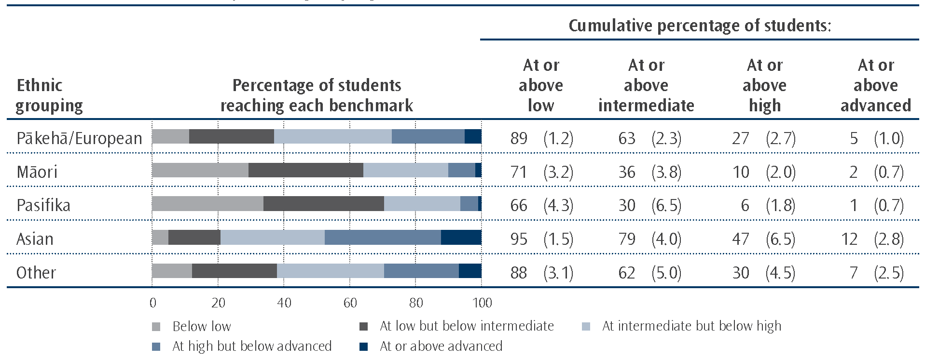
Note: Standard errors are presented in parentheses.
“At or above” means that the proportion of students at the benchmark includes those that achieved at higher benchmarks also. For example, the 89% of Pākehā/European students that achieved at or above the low benchmark includes 26% who achieved at the low benchmark, 36% at the intermediate, 22% at the high, and 5% at the advanced benchmark.

There were proportionately more low achieving Pākehā/European students (not reaching the low benchmark) this cycle (2011) compared with the previous cycle (2002 – see Table 6.2). Although the proportions of Māori, Pasifika, and Asian students reaching the low benchmark also appear smaller this cycle (2011) compared with the previous cycle, none of these differences is statistically significant.
Table 6.2: Proportion of New Zealand Year 9 students reaching each international mathematics benchmark in 2002, by ethnic grouping
 | Cumulative percentage of Year 9 students at or above each benchmark
 | Low |  | Intermediate |  | High |  | Advanced
Pākehā/European | 94 | (1.5) | 69 | (2.8) | 29 | (3.4) | 5 | (1.5)
Māori | 79 | (3.1) | 40 | (3.1) | 9 | (1.6) | 2 | (0.6)
Pasifika | 71 | (8.5) | 33 | (7.1) | 6 | (2.0) | 1 | (1.0)
Asian | 97 | (1.7) | 85 | (4.0) | 55 | (7.1) | 19 | (5.4)
Note: Standard errors are presented in parentheses.
There were too few students in the ‘Other’ ethnic grouping in 2002 to report achievement.
Source: Table 2.8, Chamberlain, 2007.

We can also examine the composition of the group who did not reach the low benchmark (just under 16% of students over all New Zealand). The majority of these students were Pākehā/European or Māori as shown in Figure 6.3. However, both Māori and Pasifika students are over-represented in this lower achieving group compared to their proportion in the population.
Figure 6.3: Ethnic composition of New Zealand Year 9 students who did not reach the low benchmark
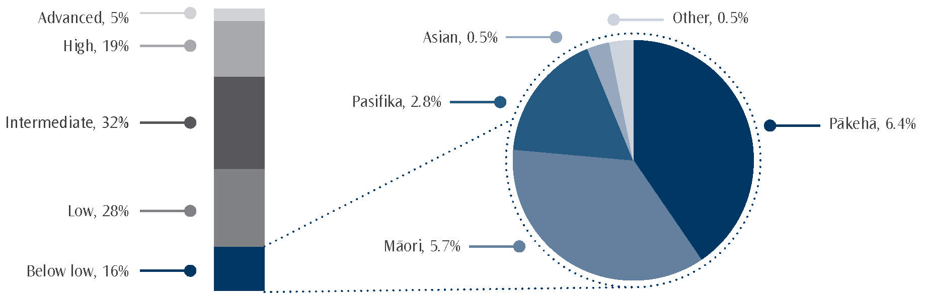
Note: The values presented in the pie chart are proportions of the whole population and add to just under 16% - the proportion of students in the ‘below low’ group.

Mathematics achievement of boys and girls within ethnic groups
As mentioned earlier, the mathematics achievement of boys overall was higher than girls overall. This difference only occurred among the larger ethnic groupings: Pākehā/European boys and Māori boys had higher mathematics achievement than their female counterparts.
Mathematics achievement by language
Students were asked how often they spoke English at home. Most students (92%) indicated that they always or almost always spoke English at home. Nearly all of the rest of the students indicated that they sometimes spoke English and sometimes another language. Only one percent of students reported never speaking English at home. Of those who spoke another language, it was most common to speak an Asian language or Māori, with a Pacific Islands language a close third.
Many studies point to the advantages of bilingualism (or indeed multilingualism) including greater flexibility of thinking (see for example Adesope, O. O., Lavin, T., Thompson, T., and Ungerleider, C., 2010). The base 10 structure of languages such as Māori and Chinese languages may also be an advantage for students learning to add and subtract. However, you might expect that by the time students began secondary school (providing all their education occurred in New Zealand) that they had learnt enough English that the language background of the home would not be a strong influence on achievement. Interestingly there was no significant difference in mathematics achievement between those who always or almost always spoke English at home and those who sometimes did.⁷ This was not, however, the pattern observed across many of the other countries who participated in TIMSS; students who nearly always used the language of the test at home often had higher achievement on average than those who only sometimes spoke it at home.
To provide further evidence about the relationship between language and achievement, principals were asked about the language composition of the school to ascertain whether this affected mathematics achievement. However, there was no difference in mathematics achievement on average between those schools with many students (more than 90%) with English as their first language and those with few students (25% or less) nor with any of the categories in between.

7 Note that there were too few students regularly speaking other languages at home to examine their achievement by ethnic or
language groupings.

7. Mathematics achievement and socio-economic status
The New Zealand education system recognises that students from homes poor in wealth and educational resources may need extra help to achieve at the same level as students from well-resourced homes. Schools with larger numbers of these students with low socio-economic status are provided with extra funding per student. TIMSS only provides a snap-shot measure of achievement so cannot provide a measure of value-adding that schools do for these students. Numerous studies, including previous TIMSS studies, have shown that students with fewer resources at home have lower achievement, on average, than those with more resources. Therefore, it is important to continue to measure the level of socio-economic status of students as well as the achievement of these students. This chapter will present details of some of the measures used to examine socio-economic status along with their association with achievement.
Home possessions and books as proxies for SES
Home possessions and books in the home can be used to give a measure of both the wealth of the home and the level of importance given to education and culture. The TIMSS questionnaires asked students about the presence in their home of five resources which could be used for educational purposes: a computer, a study desk or table for their use (presumably for learning activities at home), their own books, their own room (a quiet place for undertaking learning activities on their own), and an internet connection. Additionally, countries could specify their own list of resources that might be indicators of relative wealth – in New Zealand this list was: musical instruments, clothes dryer, dishwasher, two or more bathrooms, their own computer or laptop, and swimming or spa pool. Students were also asked about the number of books in their home. This next section will discuss the results of these questions.
Books in the home
TIMSS has asked about the number of books in the home since 1994/95. Figure 7.1 shows proportions of students in three summarised categories of numbers of books in the home and their mean achievement.
Figure 7.1: Mean mathematics achievement of New Zealand students by number of books in the home
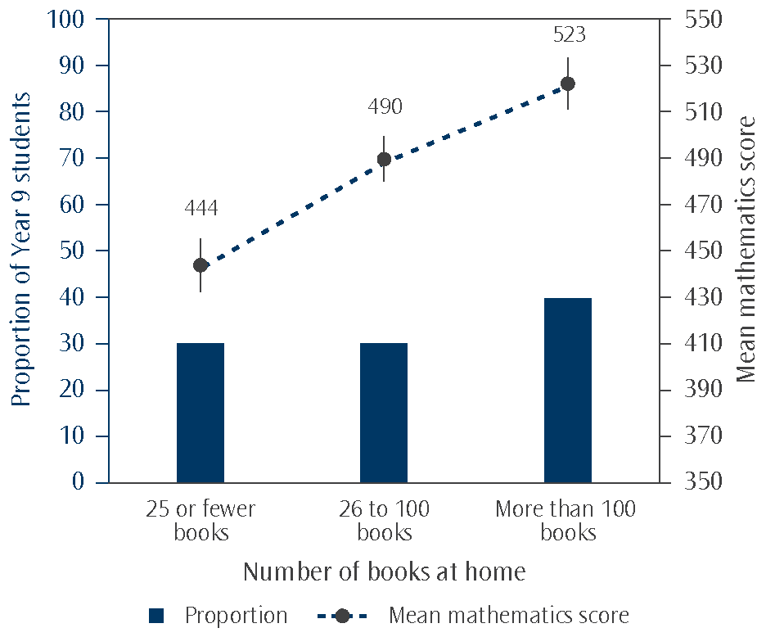
Note: The bars on the graph represent proportions of Year 9 students. The points represent mean scores while the lines extending from those points represent the 95% confidence interval associated with estimating the mean of the population from the sample.
Just under one-third of students (30%) reported that they had 25 or fewer books in their home. Just over one-third of students (40%) reported that they had more than 100 books in their home. This proportion of students with more than 100 books is a little lower than 2002/03 (47%) but much lower than in 1994 (66%).
As shown in Figure 7.1, students that reported more books in the home had higher mathematics achievement than those with fewer books.
Educational resources in the home
Table 7.1 shows the proportions of students that had each of the educational resources in their homes. Nearly all students reported having a computer in their home (97%) and the majority of students had an internet connection (91%). The least common resource students possessed was a study desk (86%).
Table 7.1: Proportions of New Zealand students with educational resources in their homes
Educational resource | Proportion of Year 9 students having resource
Computer | 97
Study desk/table | 86
Own books (do not count school books) | 88
Own room | 89
Internet connection | 91

Nearly two-thirds of all students (66%) had all five educational resources; less than one percent had only one or none of the resources. Students with a greater number of these resources had higher achievement than those with fewer of the resources. Figure 7.2 shows the relationship between the number of these educational resources and mathematics achievement.
Figure 7.2: Mean mathematics achievement of New Zealand students by number of educational resources at home
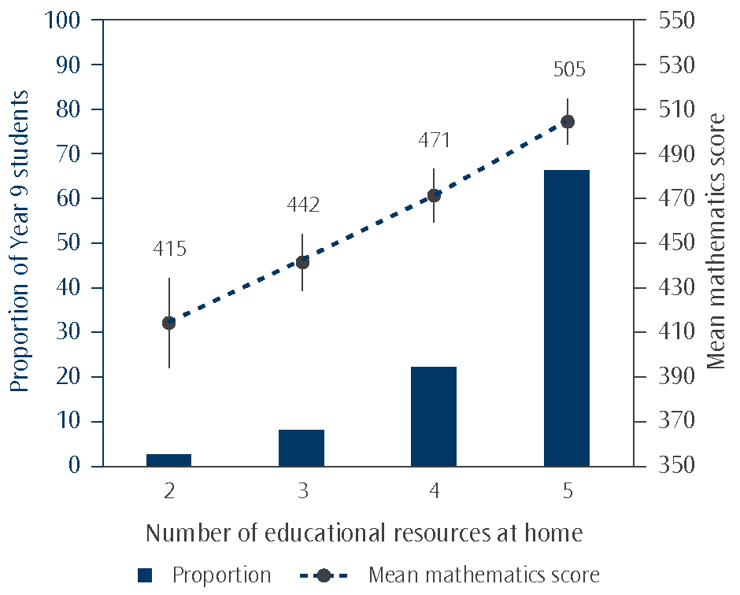
Note: The bars on the graph represent proportions of Year 9 students. The points represent mean scores while the lines extending from those points represent the 95% confidence interval associated with estimating the mean of the population from the sample.
Less than one percent of students had only one or none of the resources.

The relationship between educational resources in the home and achievement was evident among all ethnic groupings. However, far fewer Māori (47%) and Pasifika (41%) students had all five educational resources compared with Asian (74%) and Pākehā/European students (74%).
Number of items in the home
Table 7.2 shows the proportions of students that had each of the items in their homes used as an indicator of wealth. The majority of students reported having a clothes dryer in their home (82%) and many had a dishwasher (72%). The least common resources students possessed were their own computer or laptop (42%) and having a swimming or spa pool at home (22%). Among these items, in many cases, those students who reported having them at home had higher achievement than those who did not. The exceptions were swimming or spa pools, clothes dryer, and own computer, and students who said they had these items had the same achievement as those who did not.
Table 7.2: Proportions of New Zealand students with items in their homes
Items used as a surrogate for SES | Proportion of Year 9 students having resource
Musical instruments (e.g., piano, violin, guitar) | 67
Clothes dryer | 82
Dishwasher | 72
Two or more bathrooms | 57
Your own computer or laptop | 42
Swimming pool or spa pool | 22

Generally, students who had more items in the home had higher achievement than those who had fewer. However, the differences between adjacent groupings are not necessarily statistically significant but the overall pattern is significant (see Figure 7.3).
Figure 7.3: Mean mathematics achievement of New Zealand students by number of home possessions
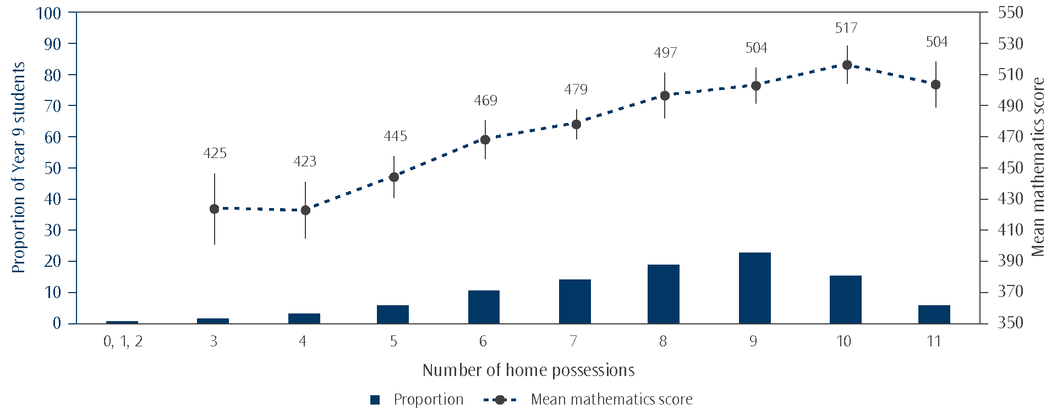
Note: The bars on the graph represent proportions of Year 9 students. The points represent mean scores while the lines extending from those points represent the 95% confidence interval associated with estimating the mean of the population from the sample.

A higher proportion of Pākehā/European (53%) and Asian students (43%) had 9 or more of the home possessions compared with Māori (29%) or Pasifika (18%) students. With home possessions used as a proxy for socio-economic status, we could conclude that more Pākehā/European and Asian students have higher socio-economic status compared with Māori or Pasifika students.
Socio-economic indicators of schools attended
Schools with larger numbers of students from low socio-economic communities are provided with extra funding per student. The school decile indicator within New Zealand is used to allocate differentiated funding. Decile 1 schools are the schools with the highest proportion of students from socio-economically disadvantaged communities, while decile 10 schools have the lowest proportion of students from these communities.
Internationally, there was also information collected from principals that allows examination of the socio-economic status of the school intake. The School Questionnaire included two questions, one that asked about the approximate proportions of students in the school from economically disadvantaged homes and one that asked about approximate proportions from economically affluent homes. The responses to these two questions were combined to give a measure of school composition by student economic background. This measure allows us to compare the equity of our system with other countries. It is important to note that principals were providing estimates so this measure can provide only an approximate view of economic disadvantage.
Decile
Studies have shown that students attending schools with fewer students from lower socio-economic backgrounds (having higher decile) had higher achievement than those attending schools with more students from lower socio-economic backgrounds (from lower decile schools – see for example Caygill & Sok, 2008; Caygill & Kirkham, 2008). As shown in Figure 7.4, this is also true of the latest cycle of TIMSS, with students from higher decile schools (9 and 10; independent) having higher achievement (521 scale score points on average for both groupings) than those from the low decile schools (1 and 2 – 427 scale score points).
Figure 7.4: Mean mathematics achievement by decile of school attended
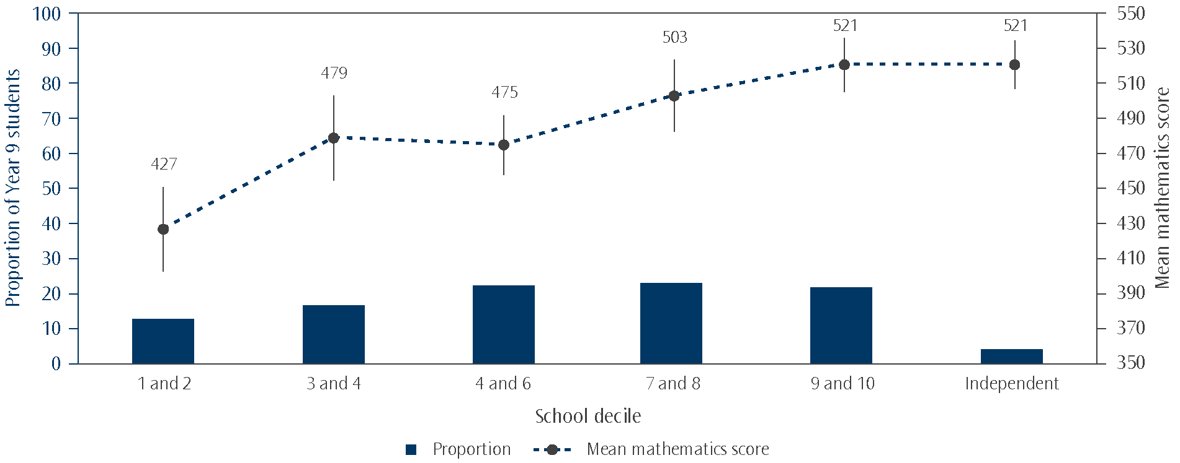
Note: The bars on the graph represent proportions of Year 9 students. The points represent mean scores while the lines extending from those points represent the 95% confidence interval associated with estimating the mean of the population from the sample.

The TIMSS benchmarks provide an understanding of achievement beyond mere averages and ranges (see Chapter 1 for details of these benchmarks). Figure 7.5 presents two different ways of looking at this data – those students achieving at each of the benchmarks (as shown in the graphical part) and those students achieving at or above each of the benchmarks (as shown in the table part). Presenting those students achieving at or above the benchmarks allows the reader to make comparisons with other countries’ data as presented in the international reports.
There were high achieving students in all decile groupings as measured by the high and advanced benchmarks (see Figure 7.5). However, there were larger proportions of students in the higher decile schools achieving at or above the high benchmarks (37% in decile 9 and 10 schools) compared with the lower decile schools (8% in decile 1 and 2 schools). As shown in the figure there were students in all decile groupings who did not demonstrate the ability to complete a reasonable number of the simplest mathematics tasks which TIMSS seeks to measure (that is they did not reach the low benchmark). However, there were larger proportions of students in the lower decile groupings in this low achieving group (39% of decile 1 and 2 students below low) compared with high decile groupings (6% of decile 9 and 10 students).
Figure 7.5: Proportion of Year 9 students in each decile grouping at each international benchmark
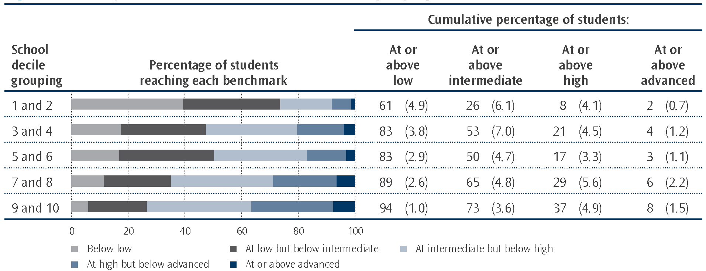
Note: Standard errors are presented in parentheses.
“At or above” means that the proportion of students at the benchmark includes those that achieved at higher benchmarks also. For example, the 61% of students in deciles 1 and 2 schools that achieved at or above the low benchmark includes 34% who achieved at the low benchmark, 18% at the intermediate, just below 7% at the high, and just below 2% at the advanced benchmark.

School composition by student economic background
As mentioned earlier, there was also information collected from principals across the TIMSS countries that allows examination of the socio-economic status of the combined student population in the schools. Principals were asked to choose from four categories to estimate the percentage of students in their school that came from economically disadvantaged homes as well as the percentage from economically affluent homes. The international researchers combined the responses from these two questions into three categories: schools with more affluent than disadvantaged students, schools with more disadvantaged than affluent students, and schools with neither more affluent nor more disadvantaged students.⁸
As shown in Figure 7.6, just under one-third of New Zealand students were in schools with more affluent students (30%), while just under one-quarter were in schools with more disadvantaged students (24%). Mathematics achievement was higher for students in schools with more affluent students (522 scale score points) than those in schools with more economically disadvantaged students (450 scale score points). The difference in mathematics achievement between these two groupings within New Zealand (72 scale score points) was higher than many other countries in the TIMSS study. Only Turkey (105), the Islamic Republic of Iran (82), Israel (75), Chile (75), and Singapore (74) had higher differences than New Zealand between the students in more affluent schools and those in more economically disadvantaged schools. On average internationally, this difference was 46 scale score points. In comparison, Australia (67), England (66), and the United States (53) all had relatively large differences between the students in more affluent schools and those in more economically disadvantaged schools.

8 Schools with more affluent than disadvantaged students are defined as those where the principal estimated that 25% or fewer came from economically disadvantaged homes and more than 25% came from affluent homes. Schools with more disadvantaged than affluent students are defined as those where the principal estimated that more than 25% came from economically disadvantaged homes and 25% or fewer came from affluent homes. All other students were assigned to the third category: schools with neither more affluent nor more disadvantaged students.
Figure 7.6: Mean mathematics achievement of students by economic composition of school attended
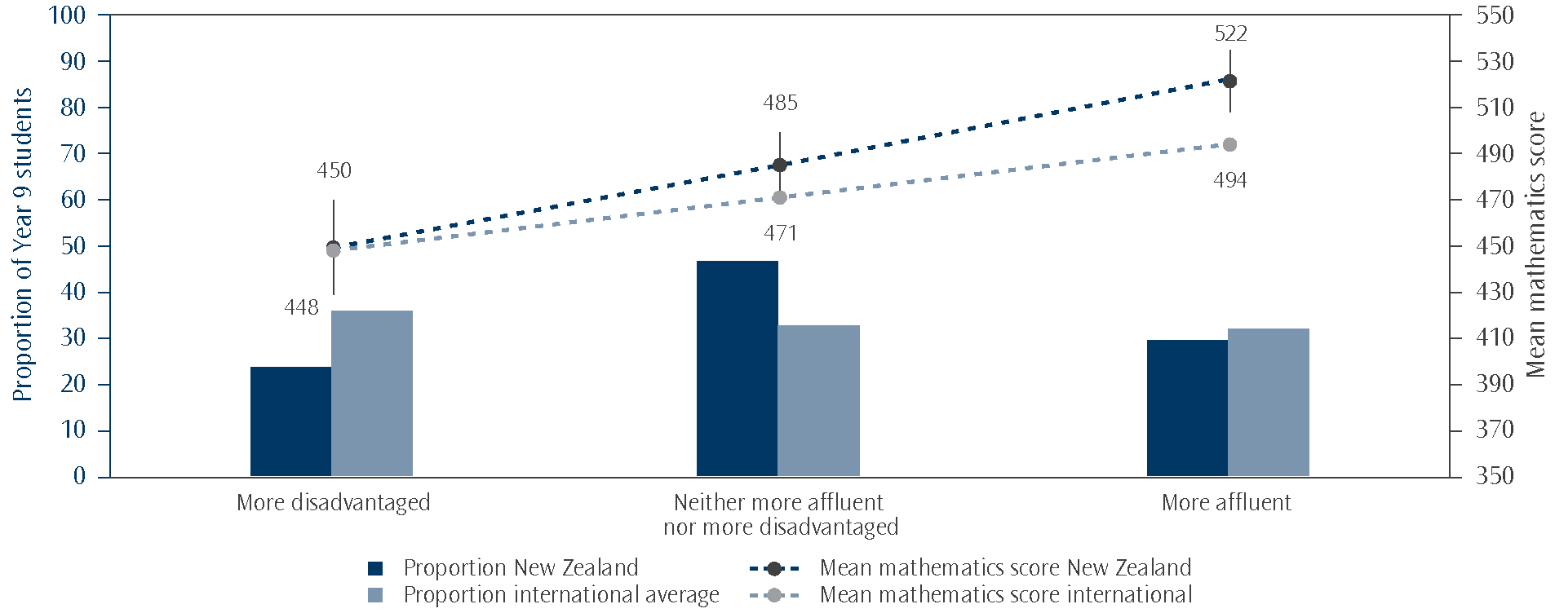
Source: Adapted from Exhibit 5.4, Mullis, Martin, Foy, and Arora, 2012.

As with the measure of decile, the TIMSS benchmarks show that within each of these three categories of economic composition of the school population, there are high and low achievers. Figure 7.7 presents two different ways of looking at this data – those students achieving at each of the benchmarks (as shown in the graphical part) and those students achieving at or above each of the benchmarks (as shown in the table part).
There were larger proportions of students in the more affluent schools achieving at or above the high benchmarks (38% in schools with more affluent than economically disadvantaged students) compared with the economically disadvantaged schools (13% in schools with more economically disadvantaged than affluent students). As shown in the figure there were students in each of the three categories of school composition who did not demonstrate the ability to complete a reasonable number of the simplest mathematics tasks which TIMSS seeks to measure (that is they did not reach the low benchmark). However, there were larger proportions of students in the economically disadvantaged schools in this low achieving group (29% in schools with more economically disadvantaged than affluent students) compared with affluent schools (7% in schools with more affluent than economically disadvantaged students).
Figure 7.7: Proportion of New Zealand Year 9 students at each international benchmark by economic composition of school attended
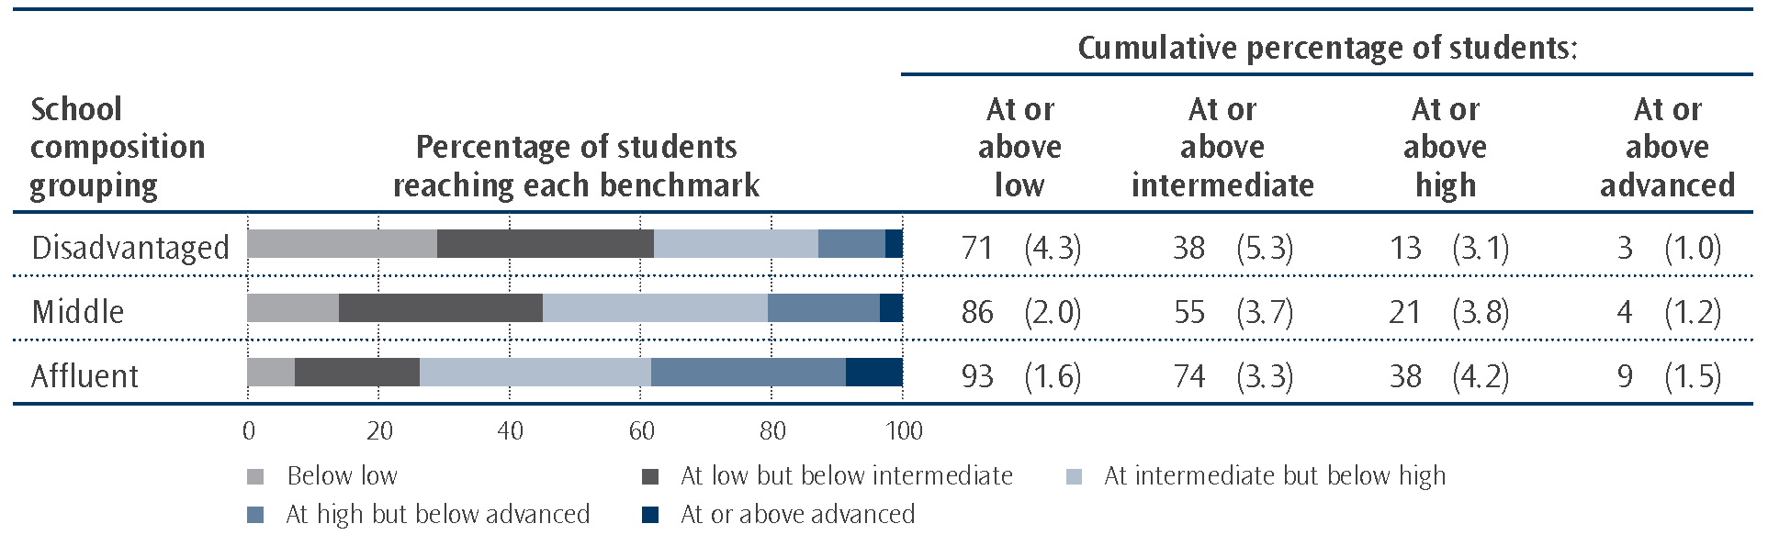
Note: Standard errors are presented in parentheses.
‘Disadvantaged’ refers to those schools with more economically disadvantaged than affluent students, ‘Affluent’ refers to those schools with more affluent than economically disadvantaged students, and ‘Middle’ refers to all other schools.
“At or above” means that the proportion of students at the benchmark includes those that achieved at higher benchmarks also. For example, the 71% of students in ‘disadvantaged’ schools that achieved at or above the low benchmark includes 33% who achieved at the low benchmark, 25% at the intermediate, 10% at the high, and just under 3% at the advanced benchmark.

8. More about the home climate
for learning mathematics
As shown in the previous chapter, the home matters. Much of the information about the home of the students in the previous chapter focussed on socio-economic status. However, educational resources in the home were also discussed. This chapter will focus on interactions with parents about education, students’ educational expectations, reading for enjoyment, and computer use.
Interactions with parents
Interactions with parents about school may be indicative of the importance placed on education in the home. However, there may be a lower frequency of interactions between parents and children if a child is highly self-motivated, or the parents have many interactions with the school directly. Students were asked four questions about the frequency of discussions about schoolwork and homework (shown in Figure 8.1). More than two-fifths of Year 9 students reported that their parents made sure that they set aside time for their homework each day and just over two-fifths had parents asking what they were learning at school each day. More than one-third of students were rarely asked by their parents if they had done their homework (23% never or almost never and 15% once or twice a month).
Figure 8.1: Frequency New Zealand Year 9 students reported interacting with parents about schoolwork and homework
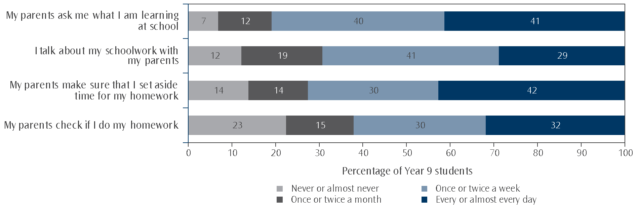
Note: Results may appear inconsistent due to rounding.

On average, those students with relatively regular interactions with their parents, about schoolwork or setting aside time for homework, had higher mathematics achievement than those with few interactions. Those with more frequent checking of homework had similar achievement to those whose parents never checked if they had done their homework.
Education expectations
At the age of 14, many students will not yet have made the decision about their futures. However, students were asked about their intentions for further education. This can give an indication of the importance they place on education. Very few students expected that they would finish school without some form of qualification with only four percent saying they would only complete up to the end of Year 10. A further 17 percent expected to complete only Level 1 of NCEA. Most students expected to do some form of tertiary study and complete either a certificate, a diploma, or a degree (71%). Just over one-quarter of students (26%) expected to complete some form of post-graduate diploma or degree.
Generally, students with lower educational expectations had lower mathematics achievement on average as shown in Figure 8.2. The exception to that general pattern of lower achievement for lower expectations is the group of students who expected to gain some form of post-graduate diploma or degree who had lower mathematics achievement than other students with tertiary expectations.
Figure 8.2: Mean mathematics achievement by educational expectations of New Zealand students
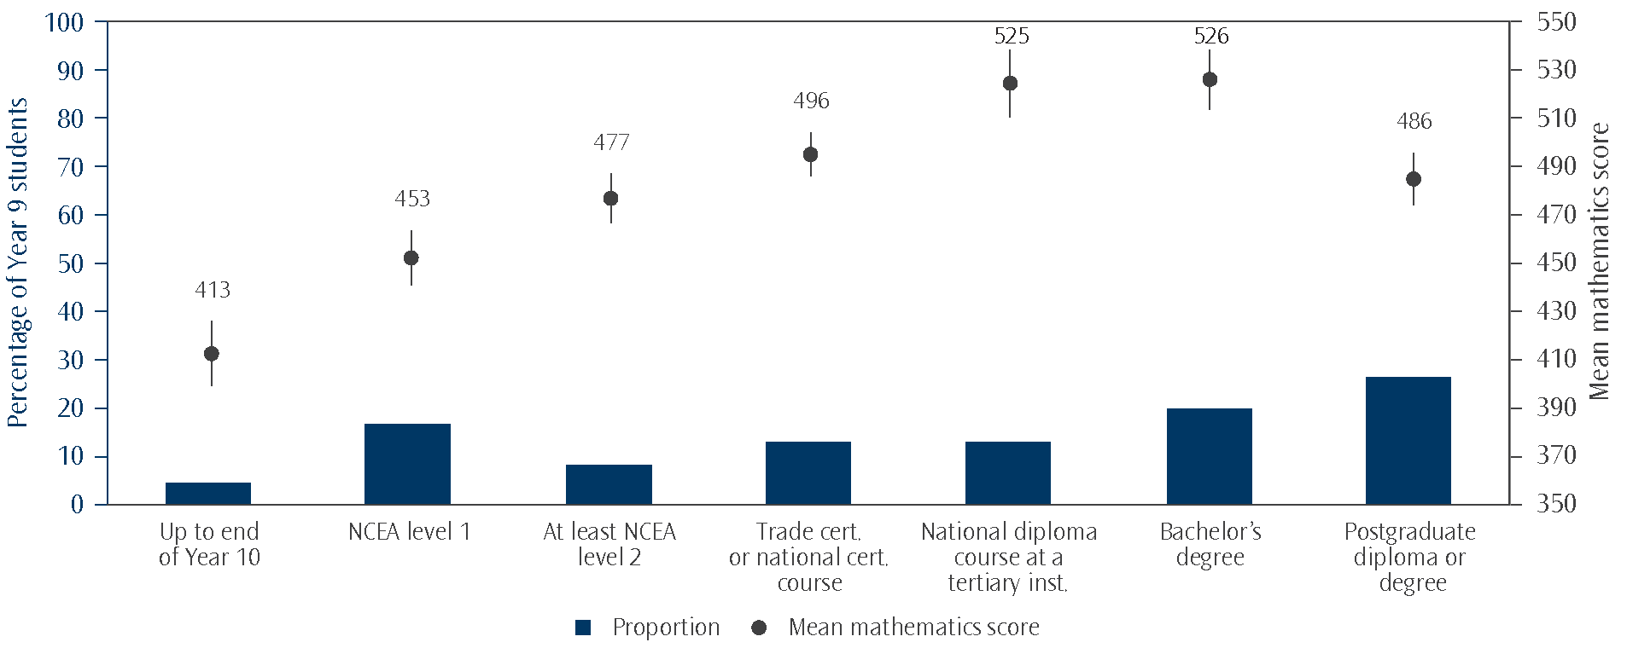
Note: Results may appear inconsistent due to rounding.

Figure 8.3 shows that more Asian students had expectations of tertiary education than any of the other ethnic groupings. Only 12 percent of Asian students expected to conclude their education at the secondary level without further study. A relatively high proportion of Pasifika students expected to complete a degree (51%).
Of all the ethnic groupings, Māori students had the largest proportion expecting to complete their education at secondary school. However, nearly two-thirds of Māori 14-year olds expected to complete some form of tertiary qualification (64%).
Figure 8.3: Educational expectations summarised by ethnic groupings in New Zealand
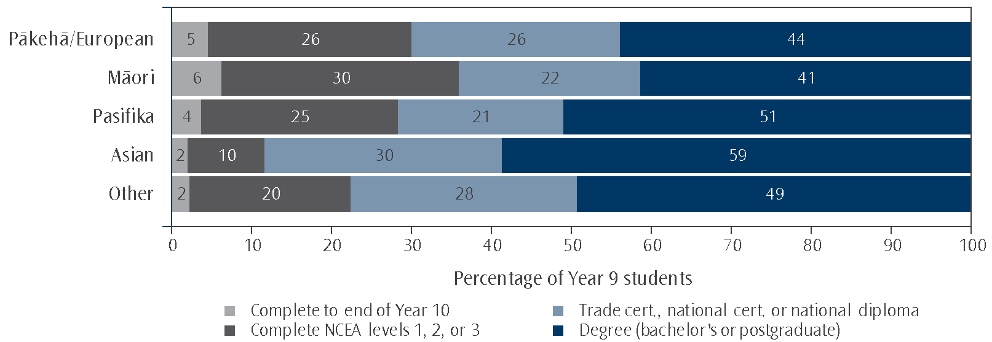
Note: Results may appear inconsistent due to rounding.
Reading for enjoyment
Just under one-third of students (30%) reported that they had 25 or fewer books in their home as mentioned in the previous chapter. However, most young people in New Zealand have access to libraries at school and many have libraries in their local community. Therefore, the lack of books in their home need not be an impediment to reading activities. In New Zealand we asked students how often they read a book for enjoyment. As shown in Figure 8.4, one-quarter of all students read a book daily for enjoyment. However, more girls (29%) read books for enjoyment daily compared with boys (22%). Fewer Māori and Pasifika students read for enjoyment daily compared with Pākehā/European students, Asian students, or students in the ‘Other’ ethnic grouping.
Figure 8.4: How regularly New Zealand Year 9 students read a book for enjoyment
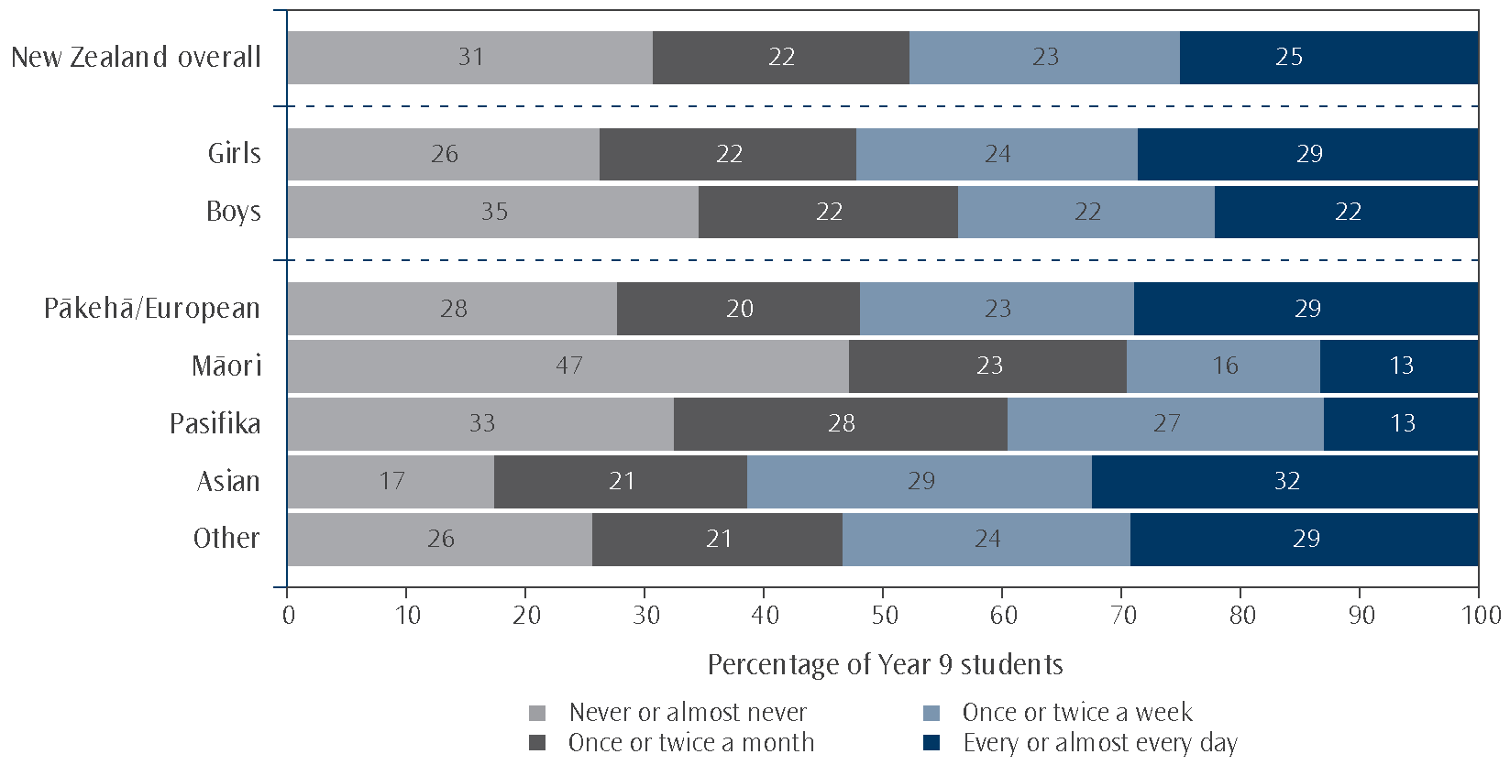
Students who reported that they read a book for enjoyment daily had higher mathematics achievement than those who did not. Students who never or almost never read a book for enjoyment had lower mathematics achievement than their peers who read once a month or once or twice a week.
Computer use
The digital age has given students access to more information and entertainment than they had in the first cycle of TIMSS. Although some of the information available online is of dubious quality, an inquisitive mind is an asset to a learner. Students were asked how often they used a computer at home, at school, or at some other place (not defined). Nearly all students had computers at home (97%). Of these students, many used the computer regularly (93% at least weekly). Of those that did not have one, most used a computer at school or some other place.

9. Student attitudes to and engagement with mathematics
The vision of what we want for our young people, as presented in The New Zealand Curriculum, includes that they will be “confident, connected, actively involved, and lifelong learners” (Ministry of Education, 2007, p.8). In addition the curriculum document notes that “Mathematics and statistics have a broad range of practical applications in everyday life, in other learning areas, and in workplaces” (Ministry of Education, 2007, p.26).
As a nation we want to maximise the contribution of education to the New Zealand economy (Ministry of Education, 2012). In particular, science, technology, engineering, and mathematics (STEM subjects), are seen by many as a means to increase innovation in society and have been identified as a priority area. The Tertiary Education Commission’s guidance to tertiary education organisations includes eight priorities for new plans, one of which is that there will be “more learners engaged in study toward STEM qualifications...to better meet workforce demand” (Tertiary Education Commission, 2012, p.13).⁹ Similarly, an education and skills survey in the United Kingdom found employers calling for action to improve the quantity and quality of STEM graduates, with almost half of firms still experiencing difficulties recruiting STEM skilled staff. The authors of the report on this survey asserted that “these skills will be vital if the UK is to harness opportunities in growth areas such as green technologies and creative industries” (CBI, 2010).
To meet these objectives we need more learners confident, engaged, and continuing in mathematics beyond the compulsory years. This chapter will examine students’ attitudes towards learning mathematics – their enjoyment, confidence levels and the importance they attach to it.
Student attitudes toward mathematics
To gauge their attitudes towards learning mathematics, students were asked how much they agreed with a series of 21 statements. They were given four response options: agree a lot, agree a little, disagree a little, and disagree a lot. Positive and negative statements were interwoven in the questionnaire but are reordered in Figure 9.1 for ease of reading.
Of all the statements, New Zealand Year 9 students were most likely to agree that: it is important to do well in mathematics, with 94 percent agreeing either a little or a lot. However only 44 percent agreed that they would like a job that involves using mathematics – this proportion has decreased since both 1994 and 1998 (50% and 49%). Conversely, the proportion of students agreeing that they need to do well in mathematics to get into the university, polytechnic, or other tertiary education institute of my choice has increased with each cycle of TIMSS (1994: 80%, 1998: 84%, 2002: 88%, 2010: 91%). While 77 percent of the students agreed that they usually do well in mathematics, a much smaller proportion (53%) agreed that they are good at working out difficult mathematics problems. The proportion agreeing that they usually do well in mathematics has gradually decreased over the previous cycles of TIMSS (1994: 85%, 1998: 82%, 2002: 80%). Over half of New Zealand Year 9 students agreed that mathematics is boring, but 63 percent of students agreed that they enjoy learning mathematics, a similar proportion to 2002 (61%), but somewhat fewer than in 1998 (73%) or 1994 (74%).

9 Earle (2009) identified ongoing skill-shortages in New Zealand in engineering and related technologies, architecture and building, information technology and accounting; and ongoing demand in medical studies, nursing and health.
Figure 9.1: New Zealand Year 9 student attitudes to mathematics
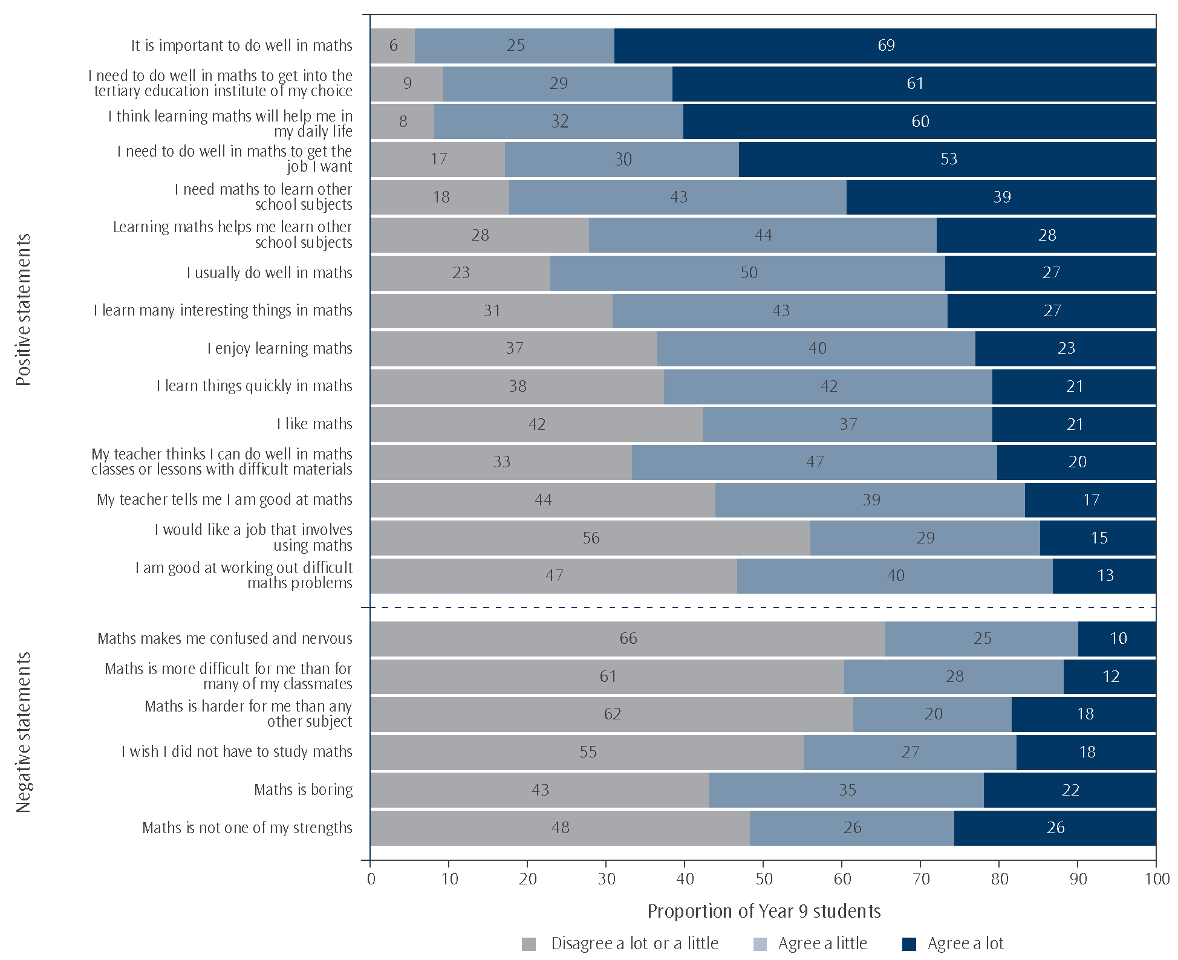
Note: Due to rounding some results may appear inconsistent.
Positive and negative statements were interwoven in the questionnaire but are reordered here for ease of reading.

Generally, students with positive attitudes towards mathematics had higher achievement than students with negative attitudes. To further examine the relationship with achievement the international researchers combined the data into three scales: the Students Like Learning Mathematics (SLM) scale, the Students Value Mathematics (SVM) scale and the Students Confident in Mathematics (SCM) scale. Each student’s responses to a particular set of statements were used to generate a single score on a continuous scale¹⁰. For ease of interpretation, each scale was then divided into three categories.
Students like learning mathematics
Students were categorised into one of three groups, like learning mathematics, somewhat like learning mathematics, or do not like learning mathematics, according to their responses to five statements: I enjoy learning mathematics; I wish I did not have to learn mathematics; Mathematics is boring; I learn many interesting things in mathematics; and I like mathematics. Seventeen percent of New Zealand Year 9 students like learning mathematics, 41 percent somewhat like learning mathematics, while the remaining 42 percent do not like learning mathematics. As shown in Figure 9.2, students who were most positive about learning mathematics had higher achievement than those in the middle group, who in turn performed better than those in the least positive group.

10 See Created scales for contextual variables in the Definitions and technical notes for a brief description of the methodology.
Figure 9.2: Proportion and mean mathematics achievement of students in each category of the Students Like Learning Mathematics (SLM) scale
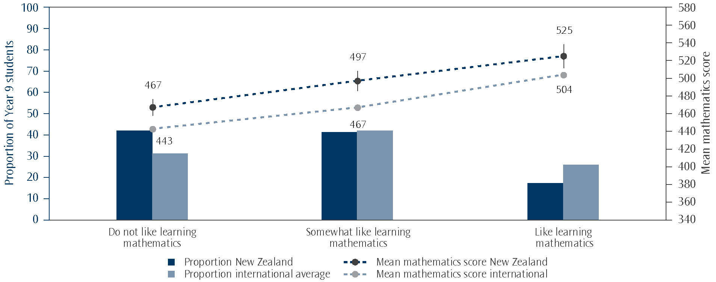
Note: The bars on the graph represent the proportions of Year 9 students while the points represent the mean scores. Lines extending from the points represent the 95% confidence interval, i.e. the range within which we are 95 percent confident that the true population value lies.
Students who like learning mathematics had a score on the Students Like Learning Mathematics (SLM) scale of at least 11.3, which corresponds to their “agreeing a lot” with three of the five statements and “agreeing a little” with the other two, on average. Students who do not like learning mathematics had a score no higher than 9.0, which corresponds to their “disagreeing a little” with three of the five statements and “agreeing a little” with the other two, on average. All other students somewhat like learning mathematics. Negative statements were reverse coded.
Source: Adapted from Exhibit 8.2, Mullis, Martin, Foy, and Arora, 2012.

New Zealand had fewer Year 9 students who like learning mathematics than on average internationally (17% compared with 26%), and more who do not like learning mathematics (42% compared with 31%). The mean difference internationally between students in these two categories was 61 scale score points, compared with a difference of 55 score points on average in New Zealand.
Students value mathematics
Students were categorised as value, somewhat value, or do not value mathematics according to their responses to six statements: It is important to do well in mathematics; I need to do well in mathematics to get into the university, polytechnic, or other tertiary education institute of my choice; I think learning mathematics will help me in my daily life; I need to do well in mathematics to get the job I want; I need mathematics to learn other school subjects; and I would like a job that involves using mathematics. Forty-six percent of New Zealand Year 9 students value mathematics, 41 percent somewhat value and 13 percent do not value mathematics. As shown in Figure 9.3, in New Zealand there was no significant difference in mathematics achievement between those who value and those who somewhat value mathematics. Students in both these categories had higher achievement on average than those who do not value mathematics.
Figure 9.3: Proportion and mean mathematics achievement of students in each category of the
Students Value Mathematics (SVM) scale
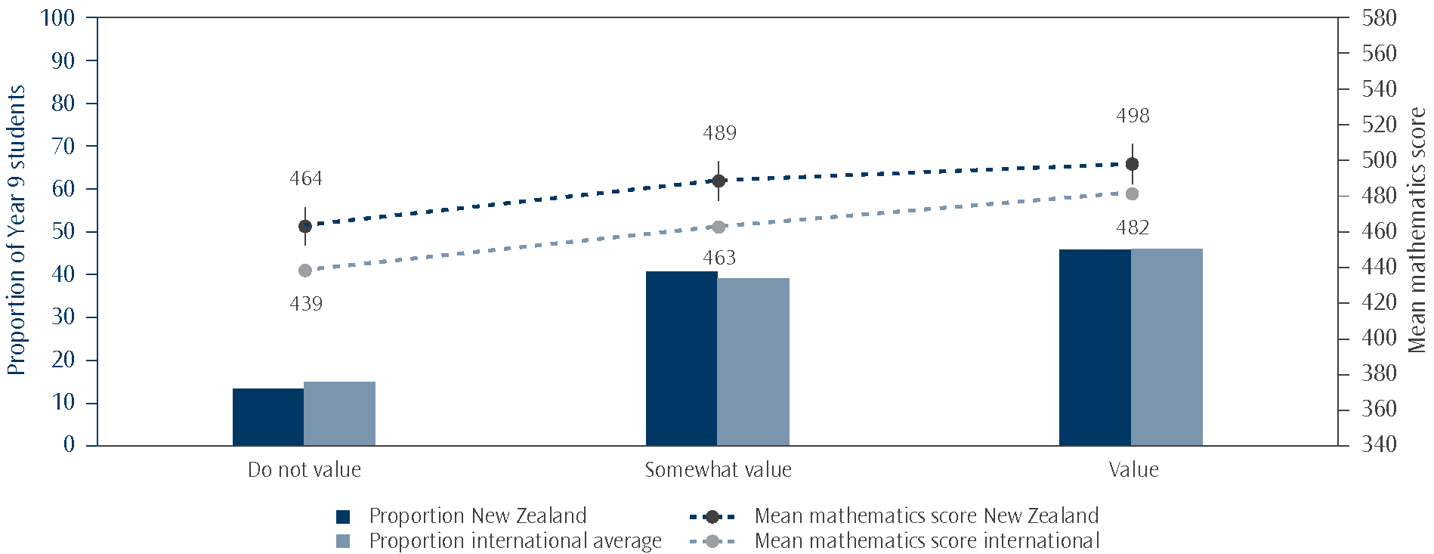
Note: The bars on the graph represent the proportions of Year 9 students while the points represent the mean scores. Lines extending from the points represent the 95% confidence interval, i.e. the range within which we are 95 percent confident that the true population value lies.
Students who value mathematics had a score on the Students Value Mathematics (SVM) scale of at least 10.3, which corresponds to their “agreeing a lot” with three of the six statements and “agreeing a little” with the other three, on average. Students who do not value mathematics had a score no higher than 7.9, which corresponds to their “disagreeing a little” with three of the six statements and “agreeing a little” with the other three, on average. All other students somewhat value mathematics.
Source: Adapted from Exhibit 8.3, Mullis, Martin, Foy, and Arora, 2012.

The proportions of students in New Zealand who value, somewhat value or do not value mathematics were quite similar to the international average (46%, 41% and 13% compared with 46%, 39% and 15%). Although in almost all countries students who value mathematics had somewhat higher achievement scores than those who do not value mathematics, the attitudes measured by this scale had a weaker relationship with mathematics achievement on average, than either students’ enjoyment or their confidence in mathematics.
Students confident in mathematics
Students were categorised as confident, somewhat confident, or not confident in mathematics according to their responses to nine statements: I usually do well in mathematics; Mathematics is more difficult for me than for many of my classmates; Mathematics is not one of my strengths; I learn things quickly in mathematics; Mathematics makes me confused and nervous; I am good at working out difficult mathematics problems; My teacher thinks I can do well in mathematics classes or lessons with difficult materials; My teacher tells me I am good at mathematics; and Mathematics is harder for me than any other subject. Sixteen percent of New Zealand Year 9 students were confident in mathematics, 45 percent were somewhat confident and the remaining 39 percent were not confident with mathematics.
As shown in Figure 9.4, students who were more positive about their abilities to learn mathematics (in the confident category) had higher mean achievement than those who were more negative. Those students with the lowest self-confidence had the lowest mathematics achievement on average. Note that the difference in mean mathematics score between students who were confident and those who were not confident (113 score points) is greater than between those in the corresponding groups on the Students Like Learning Mathematics scale (58 score points) and the Students Value Mathematics scale (34 score points). Thus the self-confidence of students had a stronger relationship with mathematics achievement than how much they like or value learning mathematics.
Figure 9.4: Proportion and mean mathematics achievement of students in each category of the
Students Confident in Mathematics (SCM) scale
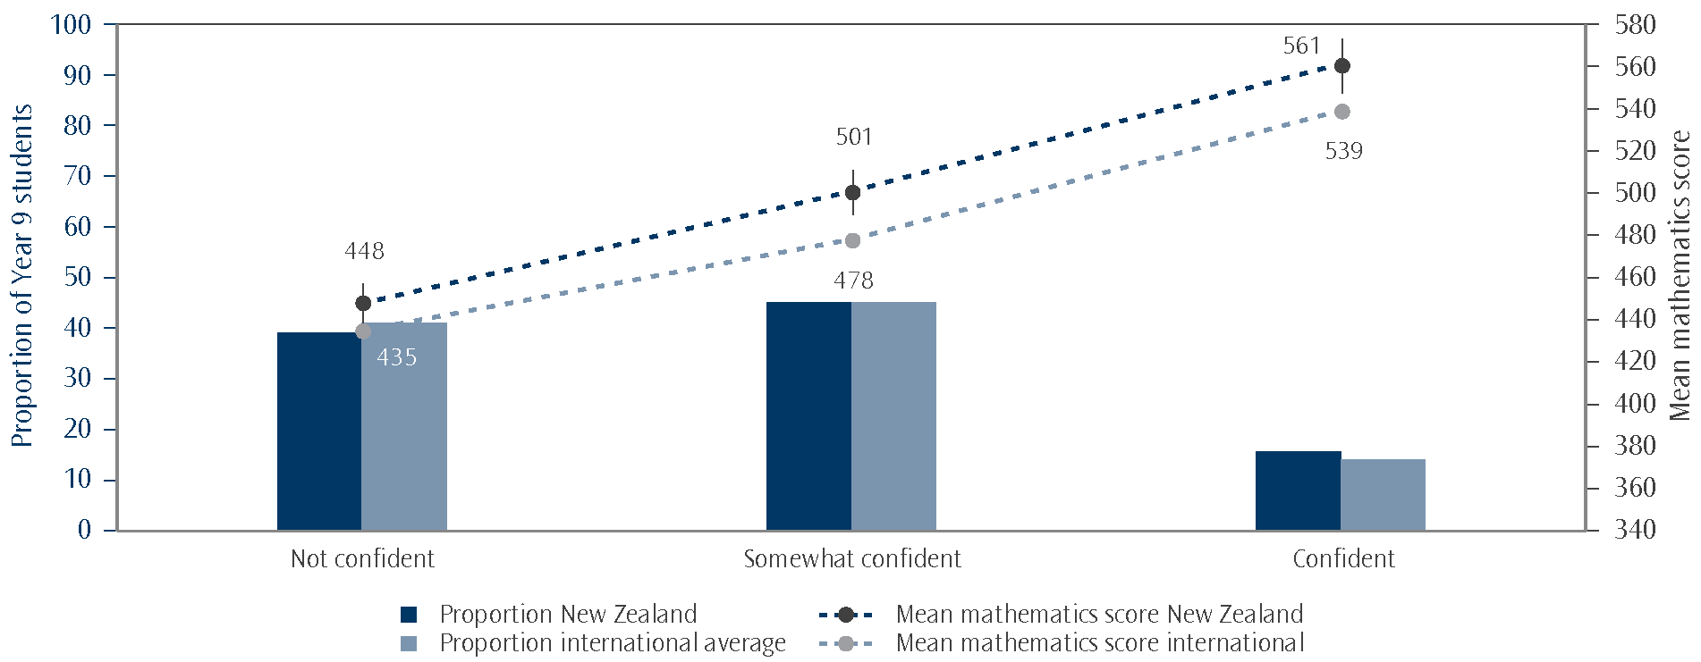
Note: The bars on the graph represent the proportions of Year 9 students while the points represent the mean scores. Lines extending from the points represent the 95% confidence interval, i.e. the range within which we are 95 percent confident that the true population value lies.
Students confident with mathematics had a score on the Students Confident in Mathematics (SCM) scale of at least 12.0, which corresponds to their “agreeing a lot” with five of the nine statements and “agreeing a little” with the other four, on average. Students who were not confident had a score no higher than 9.4, which corresponds to their “disagreeing a little” with five of the nine statements and “agreeing a little” with the other four, on average. All other students were somewhat confident with mathematics. Negative statements were reverse coded.
Source: Adapted from Exhibit 8.5, Mullis, Martin, Foy, and Arora, 2012.

New Zealand had similar proportions of students in each of the confidence categories compared with the international average (16%, 45% and 39% compared with 14%, 45% and 41% internationally). Many of the high-performing countries had quite low proportions of confident students (Hong Kong SAR 7%, Chinese Taipei 7%, Rep. of Korea 3% and Japan 2%). However, within each country, those students who had the highest levels of confidence in their mathematics abilities had higher average achievement than those who were less confident. The international mean difference in mathematics achievement between those in the most confident category and those in the least, was 104 score points.
Attitudes to mathematics by gender
Year 9 boys’ enjoyment, confidence and valuing of learning mathematics were all higher than those of girls in New Zealand. As shown in Figure 9.5, nearly half of girls do not like learning mathematics and were not confident in mathematics, compared with 36 percent and 30 percent of boys. In the most positive categories, over half of boys value mathematics compared with 40 percent of girls. Boys were also more likely to like learning mathematics (21% compared with 13%) and to be confident in mathematics (20% compared with 11%).
Students’ degree of confidence had a stronger relationship with mathematics achievement than either enjoyment or valuing of mathematics, for both boys and girls.
Figure 9.5: Proportion of New Zealand students in each category of the Students Like Learning Mathematics (SLM), Students Confident in Mathematics (SCM) and Students Value Mathematics (SVM) scales, by gender
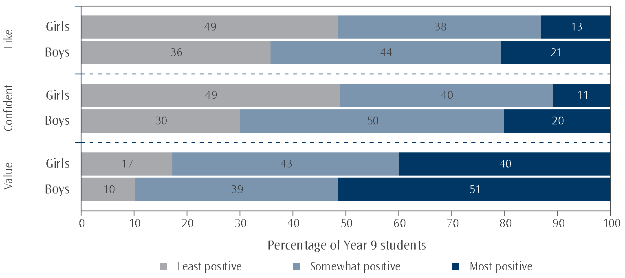
Note: Due to rounding some results may appear inconsistent.

Attitudes to mathematics by ethnicity
Some differences were evident among the ethnic groupings when attitudes to mathematics were considered. As shown in Figure 9.6, a greater proportion of Pasifika (31%) and Asian students (30%) reported positive attitudes to mathematics and like learning mathematics, compared with Māori or Pākehā/European students (both 14%). Similarly, a greater proportion of Pasifika and Asian students value mathematics (59% and 56%) compared with Māori and Pākehā/European students (44% and 43%). However, on the Students Confident in Mathematics scale, a greater proportion of Asian students (24%) reported high levels of confidence in learning mathematics than students from the other ethnic groupings (Pākehā/European 16%, Pasifika 13%, and Māori 12%). Similarly, a smaller proportion of Asian students (26%) were not confident compared to Māori (42%), Pākehā/European (40%) and Pasifika students (40%).
Figure 9.6: Proportion of New Zealand students in each category of the Students Like Learning Mathematics (SLM), Students Confident in Mathematics (SCM) and Students Value Mathematics (SVM) scales,
by ethnicity
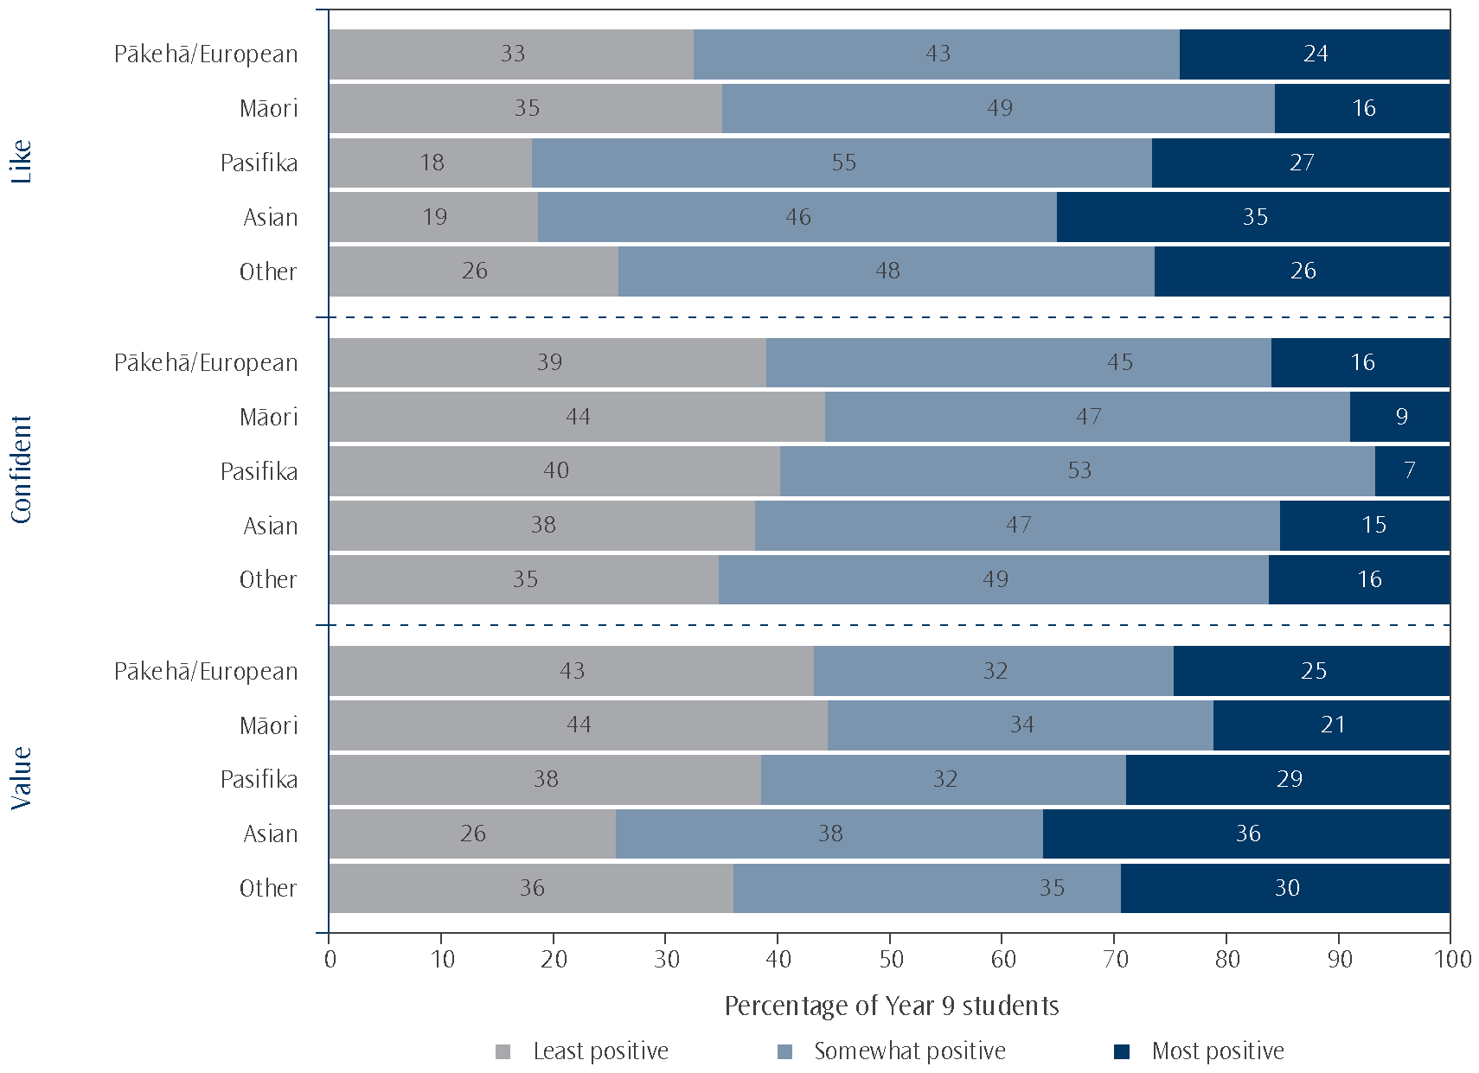
Note: Due to rounding some results may appear inconsistent.

Within each ethnic grouping, students’ degree of confidence in mathematics had a much stronger relationship with their average achievement than how much they reported liking or valuing mathematics. The differences in confident students’ mean mathematics scores compared with not confident ranged between 70 scale score points on average for Pasifika students up to 111 score points difference for Pākehā/European students (Asian 100 and Māori 106 score points difference). Students who like learning mathematics scored between 44 (Asian students) and 69 (Pākehā/European students) scale score points higher than those who do not like learning mathematics (Pasifika 46 points difference, Māori 56).

10. Teaching mathematics
Recent media coverage of education has focussed on the quality of teaching. ‘Supporting improvement in teaching practice’ is part of the current operating framework of the Ministry of Education (p. 14, Ministry of Education, 2012). One of the useful aspects of TIMSS is that it examines the context of student achievement, collecting information from students, teachers, and school leadership (usually principals). This section will report information collected about what happens in classrooms with a focus on mathematics teaching.
Characteristics of secondary mathematics teachers
It seems intuitive to believe that more experienced and better educated teachers will lead to higher achievement among students. However, it is difficult to examine this belief in a snapshot study like TIMSS, particularly because there are schools that assign the more experienced teachers to groups of students with the highest need. However, it is useful to know if well-educated people are being attracted into teaching and whether they are being retained. TIMSS allows us to compare these rates of recruitment and retention with other countries. This section will look at these characteristics of experience and education.
Experience
More than one-third of Year 9 students (36%) had mathematics teachers who had 20 years or more teaching experience. Less than one-fifth of students (17%) had teachers with less than 5 years teaching experience. On average, the New Zealand Year 9 mathematics teachers had had 15 years teaching experience. As Table 10.1 shows, New Zealand teachers, on average, had similar amounts of teaching experience as on average across countries (16 years). On average internationally, 36 percent of lower secondary students had mathematics teachers with 20 years or more teaching experience. Countries with similarly experienced teachers to New Zealand included Australia and the United States. England had more students whose teachers had less than 5 years teaching experience (32% of students).
Table 10.1: Proportion of students by the years of experience of their mathematics teacher
Years of experience of mathematics teachers
(percentage of students)
 | Less than  5 years |  | At least 5  but less than  10 years |  | At least 10  but less than  20 years |  | 20 years  or more |  | Average years of experience
New Zealand | 17 | (2.8) | 25 | (3.0) | 22 | (2.7) | 36 | (3.0) | 15 | (0.8)
International Avg. | 18 | (0.4) | 19 | (0.4) | 28 | (0.5) | 36 | (0.5) | 16 | (0.1)
Note: Standard errors are presented in parentheses.
Source: Exhibit 7.6, Mullis, Martin, Foy, and Arora, 2012.
Education
Just over one-third of New Zealand Year 9 students (35%) had teachers with some form of postgraduate university education and just over one-half (55%) had teachers with a bachelor’s degree or equivalent. As shown in Table 10.2, although the proportion with teachers qualified with degrees was similar in New Zealand to the international average, there were more New Zealand teachers with postgraduate qualifications and fewer with only bachelors’ degrees. However, there were large variations in proportions across countries. For example, there were a few countries where a large proportion of teachers had postgraduate university degrees. These countries included the Russian Federation (99%), Armenia (97%), Georgia (85%), and Finland (78%). In contrast, there were also quite a few countries where the large majority of students had teachers with a bachelor’s degree but no postgraduate qualification. These countries included Norway (98%), Kazakhstan (98%), Ukraine (98%), Oman (95%), Saudi Arabia (95%) and Japan (91%).
Table 10.2: Proportion of students by education level of their mathematics teacher
Education levels of mathematics teachers
(percentage of students)
 | No further than upper-secondary education |  | Completed  post-secondary education but not  a bachelor’s degree |  | Completed bachelor’s degree or equivalent but not a postgraduate degree |  | Completed postgraduate university degree
New Zealand | 0 | (0.0) | 10 | (2.0) | 55 | (3.5) | 35 | (3.2)
International Avg. | 3 | (0.1) | 11 | (0.3) | 63 | (0.5) | 24 | (0.4)
Note: Standard errors are presented in parentheses.
Source: Exhibit 7.2, Mullis, Martin, Foy, and Arora, 2012.

Nearly one-third of New Zealand students (30%) had mathematics teachers who had majored in something other than mathematics or mathematics education. A further nearly one-third of students had teachers who had majored in mathematics and mathematics education. In contrast, on average across all countries, 12 percent of students had mathematics teachers who had majored in something other than mathematics or mathematics education as shown in Table 10.3.
Table 10.3: Proportion of students by specialisation in education of their mathematics teacher
Specialisation in education of mathematics teachers
(percentage of students)
 | Major in mathematics and mathematics education |  | Major in mathematics education but no major in mathematics |  | Major in mathematics but no major in mathematics education |  | All other  majors |  | No formal education beyond upper-secondary
New Zealand | 29 | (2.8) | 5 | (1.6) | 37 | (3.4) | 30 | (3.1) | 0 | (0.0)
International Avg. | 32 | (0.5) | 12 | (0.3) | 41 | (0.5) | 12 | (0.4) | 3 | (0.1)
Note: Standard errors are presented in parentheses.
Source: Exhibit 7.4, Mullis, Martin, Foy, and Arora, 2012.
Preparation and confidence of secondary teachers
How well prepared do mathematics teachers feel?
Teachers were asked how well prepared they felt to teach 19 topics in mathematics based on the TIMSS 2011 Assessment Frameworks (Mullis, Martin, et al., 2009).¹¹ Of these 19 topics, 5 were number topics, 5 were algebra topics, 6 were geometry topics, and 3 data and chance topics. On average across all 19 topics, 89 percent of New Zealand students were taught mathematics by teachers who felt very well prepared to teach the topics.¹² More New Zealand teachers felt very well prepared compared with the average internationally as shown in Table 10.4.
In general, New Zealand teachers were more likely to say they felt very well prepared to teach the number or algebra topics (92% and 90% of students respectively) than geometry or data and chance topics (88% and 84% respectively). While England and the United States had larger proportions of teachers who felt very well prepared to teach the mathematics topics (94% of students), New Zealand secondary mathematics teachers generally felt well prepared compared to many of their peers in other countries. In comparison, fewer primary teachers, questioned as part of TIMSS at the Year 5 level, felt very well prepared to teach topics in mathematics (79% - see Caygill, Kirkham & Marshall, 2013a).

11 There were four options given: not applicable, very well prepared, somewhat prepared, and not well prepared.
12 All analysis in this section calculates the percentage of students whose teachers felt very well prepared. However, for ease of reading, the text will often refer to ‘teachers’
Table 10.4: Proportion of students whose mathematics teacher felt very well prepared to teach topics
Feel very well prepared to teach topics
(percentage of students)
 | Overall mathematics  (19 topics) |  | Number  (5 topics) |  | Algebra  (5 topics) |  | Geometry  (6 topics) |  | Data and chance  (3 topics)
New Zealand | 89 | (1.4) | 92 | (1.7) | 90 | (1.8) | 88 | (1.6) | 84 | (1.7)
International Avg. | 84 | (0.3) | 92 | (0.3) | 87 | (0.3) | 85 | (0.3) | 62 | (0.4)
Note: Standard errors are presented in parentheses.
Teachers were told to select ‘not applicable’ if they were not responsible for teaching this topic or it was not in the curriculum for Year 9 students. ‘Not applicable’ responses were not included in the totals from which these percentages are calculated.
Source: Exhibit 7.10, Mullis, Martin, Foy, and Arora, 2012.

Among the individual topics, there were three topics with far fewer New Zealand teachers feeling very well prepared to teach them.¹³ Simultaneous (two variables) equations was the topic with the fewest teachers agreeing they were very well prepared (62% of students). Congruent figures and similar triangles (71%), and relationship between three–dimensional shapes and their two–dimensional representations (75%) were the other two topics which fewer teachers felt very well prepared to teach. The simultaneous equations topic was part of the algebra content domain, which is the topic area where New Zealand students also perform the least well (see section in Chapter 2 of this report entitled Mathematics content and cognitive domains for details).
Confidence to teach mathematics
Along with asking about preparedness to teach mathematics content, TIMSS also asked teachers how confident they felt doing a range of teaching activities. The activities listed are shown in Table 10.5 and teachers were given the response categories: very confident, somewhat confident, and not confident. Most New Zealand students had mathematics teachers who felt very confident to answer students’ questions about mathematics (91%). Fewer New Zealand teachers felt very confident to adapt their teaching to engage students’ interest (58% of students) or help students appreciate the value of learning mathematics (56% of students).
Table 10.5: Proportion of students whose mathematics teacher felt very confident to do teaching activities
Proportion of students whose mathematics teachers  felt very confident to: | Percentage of students
 | New Zealand |  | International Avg.
Answer students’ questions about mathematics | 91 | (2.0) | 87 | (0.4)
Show students a variety of problem solving strategies | 77 | (2.4) | 77 | (0.5)
Provide challenging tasks for capable students | 70 | (2.5) | 65 | (0.5)
Adapt my teaching to engage students’ interest | 58 | (3.0) | 62 | (0.5)
Help students appreciate the value of learning mathematics | 56 | (3.3) | 65 | (0.5)
Note: Standard errors are presented in parentheses.
Source: Exhibit 7.14, Mullis, Martin, Foy, and Arora, 2012.

13 These three topics had the highest proportions of ‘Not applicable’ responses, 24%, 16%, and 10% respectively. The question told teachers to select ‘Not applicable’ if the topic was not in the curriculum or they were not responsible for teaching it.
As shown in Table 10.5, New Zealand teachers were less likely to express high confidence in some of the areas than many of their peers in other countries and similar for others. In order to summarise comparisons between countries, the international researchers created a scale that combined teachers’ responses to these five items and called it the Confidence in Teaching Mathematics scale.
Proportions of students with very confident teachers ranged from 99 percent in Kazakhstan and Ukraine down to 36 percent in Japan (as shown in Table 10.6). On average across countries, just over three-quarters of students had very confident mathematics teachers (76%). Fewer New Zealand teachers were very confident (73%) using these techniques than their counterparts in the United States (86%) and England (84%).
Table 10.6: Proportion of students whose mathematics teachers felt very confident according to the Confidence in Teaching Mathematics Scale for selected countries
Country | Percentage of students
Country | Teacher  somewhat confident |  | Teacher  very confident
Kazakhstan | 1 | (0.8) | 99 | (0.8)
Ukraine | 1 | (0.7) | 99 | (0.7)
Slovenia | 8 | (1.5) | 92 | (1.5)
United States | 14 | (2.0) | 86 | (2.0)
England | 16 | (3.2) | 84 | (3.2)
Australia | 22 | (3.4) | 78 | (3.4)
Norway | 24 | (3.9) | 76 | (3.9)
New Zealand | 27 | (2.5) | 73 | (2.5)
Chinese Taipei | 31 | (3.5) | 69 | (3.5)
Finland | 31 | (3.4) | 69 | (3.4)
Singapore | 41 | (2.8) | 59 | (2.8)
Hong Kong SAR | 44 | (4.7) | 56 | (4.7)
Korea, Rep. of | 50 | (3.3) | 50 | (3.3)
Japan | 64 | (3.9) | 36 | (3.9)
International Avg. | 24 | (0.5) | 76 | (0.5)
Note: Standard errors are presented in parentheses.
A score for the five items combined was created using item response theory. For any score 9.2 or greater, the teacher was assigned to the ‘very confident’ grouping which corresponds to their teachers being ‘very confident’ in using three of the five instructional strategies and ‘somewhat confident’ in using the other two, on average. Otherwise, they were assigned to the ‘somewhat confident’ grouping.
Source: Exhibit 7.13, Mullis, Martin, Foy, and Arora, 2012.

Professional development
Professional development has many purposes. It may be used to bring teachers up-to-date with the latest methodologies and understandings about the way students learn, or to demonstrate how new technology can be integrated into the classroom. Whatever the purpose, it may also help teachers gain confidence and gain the skills to help them feel better able to fulfil the needs of their students. Teachers were asked about the types of professional development they had participated in in the past two years. As shown in Table 10.7, more New Zealand teachers had participated in professional development in mathematics than on average across countries. The most common area of professional development was around the curriculum or content (73% and 64% of students respectively).
Table 10.7: Proportion of students whose mathematics teacher had participated in professional development in the past two years
Type of professional development: | Percentage of students
Type of professional development: | New Zealand |  | International Avg.
Mathematics content | 64 | (3.8) | 55 | (0.5)
Mathematics pedagogy / instruction | 60 | (4.8) | 58 | (0.6)
Mathematics curriculum | 73 | (3.4) | 52 | (0.5)
Integrating information technology into mathematics | 53 | (4.0) | 48 | (0.5)
Improving students’ critical thinking | 47 | (4.0) | 43 | (0.6)
Mathematics assessment | 50 | (3.6) | 47 | (0.5)
Note: Standard errors are presented in parentheses.
Source: Exhibit 7.8, Mullis, Martin, Foy, and Arora, 2012.

Mathematics teaching and learning activities
A series of questions were asked of both teachers and students about the extent to which the teachers tried to engage students in the learning activities. Along with this, the teachers were also asked about the way they worked with the class (whole class teaching or getting students to explain their answers). This section will explore these questions.
Extent to which teachers engage students
Teachers were asked about the frequency with which they used certain instructional techniques for engaging the students (listed in Table 10.8). Most New Zealand students had mathematics teachers who reported that they praised students for good effort every or almost every lesson (85% of students). Similarly, most New Zealand students were in classes where teachers reported encouraging all students to improve their performance every or almost every lesson (81% of students). More than half of students had teachers who regularly summarised what students should have learned in lessons (45% every or almost every lesson, 30% about half of lessons).
Table 10.8: Frequency with which New Zealand teachers used methods for engaging the students
when teaching the class
Methods for engaging the students when teaching the class: | Percentage of students
Methods for engaging the students when teaching the class: | Never | Some lessons | About half  the lessons | Every or almost every lesson
Summarise what students should have learned from the lesson | 2 | 23 | 30 | 45
Relate the lesson to students’ daily lives | <1 | 47 | 32 | 21
Use questioning to elicit reasons and explanations | <1 | 7 | 19 | 73
Encourage all students to improve their performance | 0 | 2 | 17 | 81
Praise students for good effort | 0 | <1 | 15 | 85
Bring interesting materials to class | 5 | 57 | 32 | 7
Note: Results may appear inconsistent due to rounding.

In order to summarise responses to this question, the international researchers created a scale that combined teachers’ responses to four of these six items and called it the Engaging Students in Learning scale. The omitted items were relate the lesson to students’ daily lives, and bring interesting materials to class.
As is shown in Table 10.9, on average, New Zealand teachers engaged students in learning with about the same frequency as on average internationally. However, the United States (93%) and England (92%) had higher proportions of students whose teachers attempted to engage them in learning most lessons while many of the high-achieving Asian countries had smaller proportions. Proportions of students ranged from 93 percent in the United States down to 46 percent in Chinese Taipei whose teachers tried to engage them in learning most lessons. This implies that there could be different cultural expectations for these types of instructional techniques.
Table 10.9: Frequency with which teachers ‘engaged students in learning’
 | Percentage of students
 | Some lessons |  | About half  the lessons |  | Most lessons
New Zealand | 2 | (1.1) | 20 | (2.8) | 79 | (3.0)
International Avg. | 3 | (0.2) | 17 | (0.4) | 80 | (0.4)
Note: Standard errors are presented in parentheses.
Results may appear inconsistent due to rounding.
A score for the four items combined was created using item response theory. For any score 8.7 or greater, the teacher was assigned to the most lessons grouping which corresponds to them using two of the four practices every or almost every lesson and using the other two in about half the lessons, on average. For any score 5.7 or smaller, the teacher was assigned to the some lessons grouping which corresponds to them using two of the four practices in some lessons and using the other two in about half the lessons, on average. Otherwise, they were assigned to the about half the lessons grouping.
Source: Exhibit 8.15, Mullis, Martin, Foy, and Arora, 2012.

Students were asked their agreement with a series of five questions (shown in Table 10.10) to gauge their level of engagement with their mathematics lessons. Most New Zealand Year 9 students (91%) agreed a little or a lot that they know what their teacher expects them to do in their mathematics lessons. Nearly three-quarters of students (70%) admitted thinking of things not related to the lesson. Similar proportions found their teacher easy to understand (73%). Nearly two-thirds of students were interested in what their teacher said in lessons (65%) and just over a half (55%) thought that their teacher gave them interesting things to do.
Table 10.10: Percentage of New Zealand students who agreed at least a little with statements about their engagement with their mathematics lessons
Statements | Percentage of students  who agreed at least a little  with each statement |  | Is agreeing with the  statement associated with  higher mathematics achievement?
I know what my teacher expects me to do | 91 | (0.6) | students agreeing higher
I think of things not related to the lesson | 70 | (0.8) | agreeing and disagreeing the same
My teacher is easy to understand | 73 | (1.5) | students agreeing higher
I am interested in what my teacher says | 65 | (1.3) | students agreeing higher
My teacher gives me interesting things to do | 55 | (1.4) | agreeing and disagreeing the same
Note: Standard errors are presented in parentheses.

Students who agreed they were interested in what their teacher had to say had higher mathematics achievement than those who disagreed. Similarly, students who knew what their teacher expected them to do, and those who found their teacher easy to understand, had higher mathematics achievement than those who did not. There was no difference in mathematics achievement between those who agreed that their teacher gave them interesting things to do, or those who agreed they thought of things not related to the lesson, and those who disagreed.
The international researchers created a scale that combined students’ responses to these five items and called it the Students Engaged in Mathematics Lessons scale. Fewer New Zealand students were engaged in mathematics lessons according to this measure than on average internationally. New Zealand students who were engaged had higher mathematics achievement than those who were not engaged (40 scale score points lower than engaged). The same pattern was observed across nearly all other countries.
Table 10.11: Proportion of Students Engaged in Mathematics Lessons
 | Percentage of students
 | Not engaged |  | Somewhat engaged |  | Engaged
New Zealand | 32 | (1.4) | 56 | (1.2) | 12 | (0.7)
International Avg. | 21 | (0.2) | 54 | (0.2) | 25 | (0.2)
Note: Standard errors are presented in parentheses.
A score for the five items combined was created using item response theory. For any score 11.4 or greater, the student was assigned to the ‘engaged’ grouping which corresponds to them “agreeing a lot” with three of the five statements and “agreeing a little” with the other two, on average. For any score 8.3 or smaller, the student was assigned to the ‘not engaged’ grouping which corresponds to them “disagreeing a little” with three of the five statements and “agreeing a little” with the other two, on average. Otherwise, they were assigned to the ‘somewhat engaged’ grouping. The negative statement was reverse coded.
Source: Exhibit 8.18, Mullis, Martin, Foy, and Arora, 2012.

Learning activities
New Zealand teaching activities differ quite markedly from many other countries (see Table 10.12 and Figure 10.1 for details). Work problems (individually or with peers) with teacher guidance was used frequently by more New Zealand teachers than any of the other activities. More than two-thirds of New Zealand students (68%) had mathematics teachers who always asked students to work problems with teacher guidance (every or almost every lesson according to the teachers). This technique was used frequently by more New Zealand teachers than on average internationally (55% every or almost every lesson), but less often than in Finland (83%) or the United States (75%).
Whole class teaching and asking students to memorise rules, facts and procedures were less likely to be used frequently in New Zealand classrooms compared with other countries. Although memorising was used by fewer teachers every lesson in general, New Zealand stands out as having few teachers that use this technique frequently (only 19% of students had teachers who did this every or almost every lesson). Similarly, New Zealand teachers were also less likely to use whole class teaching frequently (39% every or almost every lesson c.f. 48% on average internationally).
Table 10.12: Proportion of students whose mathematics teachers asked them to do activities
every or almost every lesson
Proportion of students whose mathematics teachers asked them to do the following every or almost every lesson: | Percentage of students
 | New Zealand |  | International Avg.
Work problems (individually or with peers) with teacher guidance | 68 | (3.9) | 55 | (0.6)
Work problems together in the whole class with direct teacher guidance | 39 | (2.9) | 48 | (0.6)
Work problems (individually or with peers) while teacher occupied by other tasks | 19 | (2.5) | 14 | (0.4)
Memorise rules, procedures, and facts | 19 | (2.9) | 45 | (0.5)
Explain their answers | 52 | (3.4) | 60 | (0.5)
Apply facts, concepts, and procedures to solve routine problems | 50 | (3.2) | 49 | (0.6)
Note: Standard errors are presented in parentheses.
Source: Exhibit 8.28, Mullis, Martin, Foy, and Arora, 2012.

To further show the difference between New Zealand and a selection of other countries Figure 10.1 gives the proportions of students whose teachers said they did the activities every or almost every lesson. The figure emphasises the relatively low use of memorisation in New Zealand classrooms. Interestingly, some of the high performing countries had relatively high use of whole class teaching and memorisation.
Figure 10.1: Proportion of students in selected countries whose mathematics teachers asked them to do activities every or almost every lesson
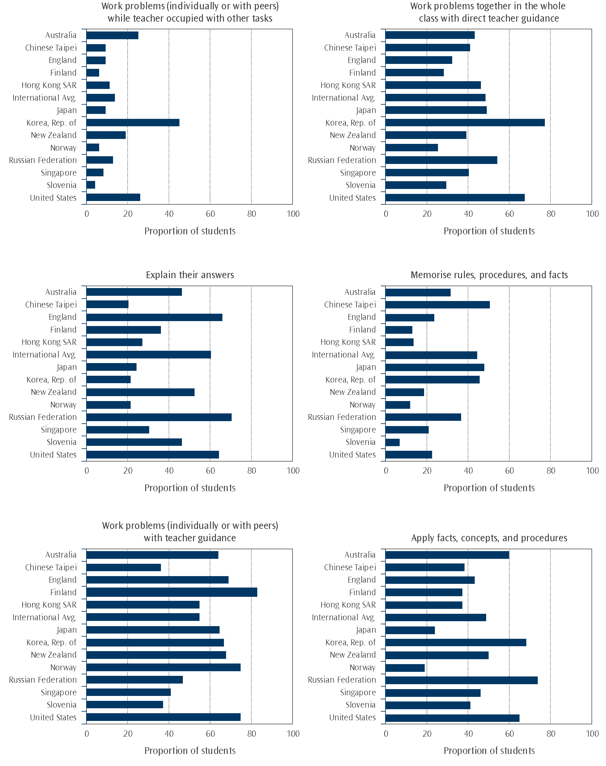
Use of resources
There is interesting variation around the world in the way resources are used for teaching mathematics. Teachers were asked if their use of textbooks, workbooks or worksheets, concrete materials, and computer software was as a basis for instruction, as a supplement, or not used at all in mathematics lessons. As Table 10.13 shows, the resources most commonly used as a basis for instruction in New Zealand were textbooks (39% of students). Workbooks or worksheets (77% of students) and concrete materials (74%) were most commonly used as a supplementary resource.
Table 10.13: Use of resources in New Zealand classrooms
 | Percentage of students whose teacher used the resources as a:
 | Basis for instruction | Supplement | Not used
Textbooks | 39 | 53 | 7
Workbooks or worksheets | 22 | 77 | 1
Concrete objects or materials that help students understand quantities or procedures | 16 | 74 | 11
Computer software for mathematics instruction | 12 | 57 | 31
Note: Results may appear inconsistent due to rounding.

In comparison to New Zealand, textbooks were more commonly used as a basis for instruction in many of the countries. Table 10.14 shows the international average but there was quite a variation among countries. Countries like Lithuania, the Korean Republic, Sweden and Norway had nearly all teachers using textbooks as a basis for instruction (94% of students or more). New Zealand had nearly the lowest proportion of students (39%) with mathematics teachers using textbooks as a basis for instruction with only England and Chile having lower proportions (29% and 23% respectively).
Table 10.14: Use of resources in classrooms on average internationally
 | Percentage of students on average internationally whose teacher used the resources as a:
 | Basis for instruction | Supplement | Not used
Textbooks | 77 | 21 | 2
Workbooks or worksheets | 34 | 62 | 4
Concrete objects or materials that help students understand quantities or procedures | 23 | 71 | 6
Computer software for mathematics instruction | 7 | 55 | 38
Note: Results may appear inconsistent due to rounding.

Use of computers
As shown in Tables 10.13 and 10.14, more New Zealand teachers used computer software as a supplementary resource in their instruction than on average internationally. Nearly all New Zealand teachers used computers for preparation (92% of students), for administration purposes (98%) and most in their classroom instruction (85% - note this question was not about mathematics instruction specifically so differs from the proportion in Table 10.13). Most of those who used computers in their classroom instruction agreed they felt comfortable using computers in their teaching (73% of students had teachers who agreed a lot and 25% agreed a little).
Specifically during mathematics lessons, New Zealand had a relatively low proportion of students (29%) whose teachers responded that computers were available for use during lessons. In comparison, 36 percent of students on average internationally were in classes where computers were available for use during mathematics lessons. New Zealand also had relatively low use of computers for exploring, looking up information, analysis, and practicing (see Table 10.15 for details).
Table 10.15: Computer availability and use during mathematics lessons
 | Percentage of students
 | New Zealand |  | International Avg.
Have computers available for mathematics lessons | 29 | (3.4) | 36 | (0.5)
Computers used for:
exploring mathematics principles and concepts | 17 | (2.9) | 22 | (0.5)
looking up ideas and information | 16 | (3.0) | 23 | (0.5)
processing and analysing data | 16 | (2.7) | 21 | (0.5)
practicing skills and procedures | 18 | (3.1) | 24 | (0.5)
Note: Standard errors are presented in parentheses.
Source: Exhibit 8.30, Mullis, Martin, Foy, and Arora, 2012.

Monitoring student progress
According to the National Administration Guidelines schools in New Zealand are required to: “through a range of assessment practices, gather information that is sufficiently comprehensive to enable the progress and achievement of students to be evaluated” (Ministry of Education, 2012). Teachers were asked how much emphasis they placed on different sources to monitor students’ progress in mathematics (sources shown in Table 10.16). As shown in the table, more New Zealand teachers placed major emphasis on classroom tests (72% of students in such classes) than on evaluation of ongoing work.
On average internationally, proportions of students were much higher for the level of emphasis placed on evaluation of students’ ongoing work (major emphasis 73% of students), and national or regional achievement tests (major emphasis 32%). The emphasis on classroom tests on average internationally (major emphasis 75% of students) was about the same as in New Zealand.
Table 10.16: Emphasis New Zealand teachers placed on sources for monitoring students’ progress
 | Emphasis placed by teachers (percentage of students)
 | Little or no emphasis | Some emphasis | Major emphasis
Evaluation of students’ ongoing work | 3 | 41 | 57
Classroom tests (for example, teacher-made or textbook tests) | 0 | 28 | 72
National or regional achievement tests | 39 | 43 | 18
Note: Results may appear inconsistent due to rounding.

On average internationally, giving tests frequently was a more common practice than in New Zealand as shown in Table 10.17. However, there was quite a large variation across countries with high use of tests among Chinese Taipei (98% of students tested fortnightly or more often) and the Russian Federation (97%), and low use in Sweden (0%) and Finland (1%).
Table 10.17: Frequency of giving tests
 | Frequency of giving tests (percentage of students)
 | A Few Times a Year  or Less | About Once  a Month | Every 2 Weeks  or More
New Zealand | 18 | 65 | 17
International average | 15 | 40 | 45
Note: Results may appear inconsistent due to rounding.
Source: Exhibit 8.32, Mullis, Martin, Foy, and Arora, 2012.

The most frequently used type of question in mathematics tests, both in New Zealand and across many other countries, was questions involving application of mathematical procedures (see Table 10.18). Fewer teachers frequently asked students to answer questions involving searching for patterns and relationships (more commonly used in algebra questions) or explain or justify their answers – both internationally and in New Zealand.
Table 10.18: Types of questions used in tests
 | New Zealand  (percent of students) |  |  | International Average  (percent of students)
 | Never or almost never | Sometimes | Always or almost always | Never or almost never | Sometimes | Always or almost always
Involving application of mathematical procedures | 1 | 28 | 71 | 0 | 23 | 77
Involving searching for patterns and relationships | 3 | 68 | 30 | 5 | 64 | 31
Requiring explanations or justifications | 8 | 59 | 33 | 8 | 56 | 37
Source: Exhibit 8.32, Mullis, Martin, Foy, and Arora, 2012.

Monitoring teacher practice
The National Administration Guidelines for New Zealand schools require schools to maintain an on-going programme of self-review. Principals were asked what sources of information they used to evaluate the practice of Year 9 teachers. Student achievement was used by nearly all principals to evaluate the practice of teachers (97% of students in such schools). Similarly, nearly all principals reported that they or their senior staff observed the teachers to evaluate their practice (4% did not). Observations by people not part of the school staff were also used but not in as many schools (51% of students in such schools).
Table 10.19: Sources of information used to evaluate the practice of Year 9 teachers in New Zealand
Percentage of students
whose principal responded ‘yes’
Student achievement | 97 | (1.4)
Observations by the principal or senior staff | 96 | (1.7)
Teacher peer review | 87 | (3.4)
Observations by inspectors or other persons external to the school | 51 | (3.8)
Note: Standard errors are presented in parentheses.

11. School climate
“Providing a caring, safe and respectful school environment in which learning can flourish is a key priority for educators…” (Boyd & Barwick, 2011). Student learning takes place for the individual within a classroom, situated in a school. It seems intuitive that a positive school environment would result in positive academic results for students.
In addition to data on achievement in mathematics and science, TIMSS collects a vast amount of contextual information, including responses to questions about the school gathered from teachers, school principals and students. This section examines student, teacher, and principals’ perceptions of the climate for learning, teachers’ beliefs on the limitations to mathematics learning, and perceptions of school safety and student behaviour. This chapter also looks at the responses of teachers to the conditions in which they find themselves teaching and how they feel about their role as teacher. The relationships between some school context variables and mathematics achievement are also examined and comparisons with previous cycles are presented where possible.
“…to bring about change we need to understand the contribution of, and relationship between, the different parts of the system.” (Boyd & Barwick, 2011).
Student perceptions of climate for learning
Students in all countries were asked whether they agreed with three statements about their schools: I like being in school, I feel safe when I am at school, and I feel like I belong at this school. They were able to respond with one of four options: agree a lot, agree a little, disagree a little, and disagree a lot. In addition, New Zealand students were asked if they agreed with a further statement: I think that students at this school care about each other.
Most New Zealand Year 9 students were positive about their schools and their teachers, with almost eight out of every ten students agreeing with most of the statements as shown in Table 11.1. The statement with the lowest level of agreement was I think that students at this school care about each other with 24 percent disagreeing a little and nine percent disagreeing a lot – in total, 67 percent of students agreed with this statement. The statement with the highest level of agreement was I feel safe when I am at school, with 42 percent agreeing a lot and 44 percent agreeing a little.
Either higher or similar percentages of girls agreed with all four statements listed in Table 11.1 when compared to boys.
Table 11.1: New Zealand Year 9 student agreement with statements about their school
Statements about the school | Proportion of students agreeing (agreeing a little and a lot combined)
Statements about the school | Total |  | Girls |  | Boys
I like being in school | 79 | (0.8) | 81 | (0.9) | 77 | (1.2)
I feel safe when I am at school | 86 | (0.6) | 87 | (0.6) | 85 | (0.9)
I feel like I belong at this school | 83 | (0.7) | 82 | (1.0) | 84 | (0.9)
I think that students at this school care about each other | 67 | (1.0) | 70 | (1.5) | 64 | (1.2)
Note: Standard errors are presented in parentheses.

All four ethnic groupings were generally positive about their schools, particularly Pasifika students, and a high proportion agreed with three of the four statements. Reflecting the pattern in the overall percentages, all ethnic groupings had fewer students agreeing that they think students at their school care about each other than they had agreeing with the other statements. Pākehā/European and Māori students reflected the general pattern of students, with those who agreed with the statements having higher mathematics achievement than those within the group who disagreed. For Pasifika and Asian students, the size of the groups who disagreed was too small to draw valid conclusions about differences in achievement.
Table 11.2: New Zealand Year 9 student agreement with statements about their school by ethnic grouping
Statements about the school | Proportion of students agreeing (agreeing a little and a lot combined)
Statements about the school | Pākehā/European |  | Māori |  | Pasifika |  | Asian
I like being in school | 77 | (1.1) | 74 | (1.5) | 93 | (1.1) | 90 | (1.9)
I feel safe when I am at school | 85 | (0.7) | 85 | (1.2) | 90 | (1.7) | 84 | (2.5)
I feel like I belong at this school | 84 | (1.0) | 78 | (1.4) | 87 | (2.2) | 83 | (2.3)
I think that students at this school care about each other | 67 | (1.2) | 60 | (2.1) | 75 | (3.6) | 71 | (2.2)
Note: Standard errors are presented in parentheses.
There were too few students in the ‘Other’ ethnic grouping to include that grouping in the table.

All of the four statements showed a significant relationship with achievement for New Zealand overall. The students that disagreed with the statements had lower achievement than their counterparts who agreed with the statements.
There is not a consistent pattern across TIMSS countries in terms of the relationship between student achievement and to what degree students agreed with the statement I like being in school (see Table 11.3). However, it seems that for many countries, those who answered with agree a little or disagree a little scored higher than those who responded at the extremes with agree a lot or disagree a lot. Those countries that had the highest number of students agreeing with the statement (Indonesia, Morocco, and Ghana; with 99%, 97% and 97% agreement rates respectively) all had lower mathematics achievement than New Zealand. The countries with higher proportions of students who disagreed with this statement tended to have significantly higher mathematics achievement than New Zealand. So while within a country there may be some pattern with achievement being better amongst students who agreed that they liked school, higher proportions of students agreeing with this statement did not necessarily mean the country as a whole achieved better.
Table 11.3: Student agreement with the statement “I like being in school” for selected countries
in TIMSS 2010/11
Country | Proportion of students agreeing  (agreeing a little and a lot combined)
Indonesia | 99
Morocco | 97
Ghana | 97
Kazakhstan | 95
Syrian Arab Republic | 95
Thailand | 95
Singapore | 90
Hong Kong SAR | 81
New Zealand | 79
Korea, Rep. of | 78
Australia | 77
England | 76
United States | 73
Chinese Taipei | 72
International Avg. | 84
Note: The order of this table is based on percentage of students agreeing.

Trends in student perceptions
The first statement listed in Table 11.1 was also posed to TIMSS students in 2002/03. The proportions of New Zealand students agreeing with the statement I like being in school was similar in 2002/03 (78%) to the proportions agreeing in 2010/11 (79%). This statement did not have a significant relationship with achievement in 2002/03.
Teacher perceptions of climate for learning
Teachers of Year 9 students were asked how they would characterise eight aspects of life at their school from teachers’ job satisfaction to students’ desire to do well in school as listed in Table 11.4. They were given five response options: very high, high, medium, low, and very low.
Of all the statements listed, teachers were most positive about other teachers in their schools. In particular, around 80 percent of students had mathematics teachers that felt their expectations for student achievement were very high or high, with small percentages having teachers who characterised this aspect as being low or very low. Around 80 percent of students also had mathematics teachers that characterised the teachers’ understanding of the school’s curricular goals as being very high or high, with around one percent of students having teachers who rated this as low or very low.
Conversely, teachers were less enthusiastic about the parental support and involvement and student attitudes asked about. Parental involvement in school activities had the lowest percentages of students with teachers who rated this statement as high/very high (26% for mathematics) and highest percentages of students whose teachers rated the statement as low/very low (29% for mathematics). Teachers were also less enthusiastic about students’ regard for school property, with around 30 percent of students having teachers who indicated this aspect was very high or high and just under a quarter (22%) of students having teachers who characterised this as low or very low in their school.
Table 11.4: Extent to which mathematics teachers characterised aspects of school climate in New Zealand
in TIMSS 2010/11
Statements on aspects of school climate | Proportion of Year 9 students
Statements on aspects of school climate | Very low  or Low |  | Medium |  | Very high  or High
Teachers’ job satisfaction | 4 | (1.5) | 28 | (3.3) | 68 | (3.7)
Teachers’ understanding of the school’s curricular goals | 1 | (0.6) | 17 | (2.8) | 81 | (2.8)
Teachers’ degree of success in implementing the school’s curriculum | 3 | (1.3) | 20 | (3.1) | 76 | (2.6)
Teachers’ expectations for student achievement | 1 | (0.6) | 20 | (2.8) | 79 | (2.8)
Parental support for student achievement | 9 | (1.5) | 49 | (3.9) | 42 | (3.8)
Parental involvement in school activities | 29 | (3.4) | 46 | (4.4) | 26 | (3.5)
Students’ regard for school property | 22 | (2.6) | 48 | (3.4) | 30 | (3.2)
Students’ desire to do well at school | 14 | (2.2) | 53 | (3.7) | 32 | (3.6)
Note: Standard errors are presented in parentheses.
Proportions in each row should add to 100%; inconsistencies are due to rounding.

Out of the statements in Table 11.4, students’ desire to do well in school was the only statement for which there was a significant difference between all three categories (very high/high, medium, low/very low) for mathematics achievement. The higher this statement was regarded by the teachers, the higher the students’ achievement was, on average, showing student attitude, perhaps unsurprisingly, has a particular impact on achievement.
The effect of parental support and involvement on mathematics achievement was more varied. Students whose teachers characterised parental support for achievement as low or very low had lower mathematics achievement than those whose teachers characterised this as medium, high, or very high. This was also the case for parental involvement in school activities. There was little difference in mathematics achievement across the categories for the statements pertaining to teachers.
Teachers’ expectations for student achievement was the only teacher related statement that seemed to have a discernible pattern with mathematics achievement – those whose teachers characterised it as low or very low had lower mathematics achievement than those whose teachers characterised this as medium, high, or very high.
Principals were also asked how they would characterise the same eight aspects of life at their school (refer to section Principal perceptions of climate for learning later in this chapter). Responses to five out of these eight statements, intended to represent academic optimism in schools, were summarised into two continuous scales, one for teachers’ responses and one for principals, referred to as the School Emphasis on Academic Success scale. The statements that did not go into the creation of this scale were: Teachers’ job satisfaction, Parental involvement in school activities, and Students’ regard for school property. To report the scale in a meaningful way, values were grouped into three categories, very high, high, and medium emphasis. As teachers had responded very positively to these statements, there was no low or very low category.
The general pattern, as shown by the international average, indicated that the higher the emphasis, the higher the associated achievement scores in TIMSS for mathematics (see Table B.1 in the Appendices), however the general pattern was not consistent across all countries. New Zealand schools followed a similar pattern for mathematics achievement (see Figure 11.1).
For a number of other countries, such as England and Korea, there was no significant difference in mathematics achievement across the very high and the high categories. In some countries, such as Indonesia, there was no significant difference in mathematics achievement across the three categories.
Figure 11.1: Levels on the School Emphasis on Academic Success scales (based on teachers’ reports)
by mean mathematics achievement in TIMSS 2010/11
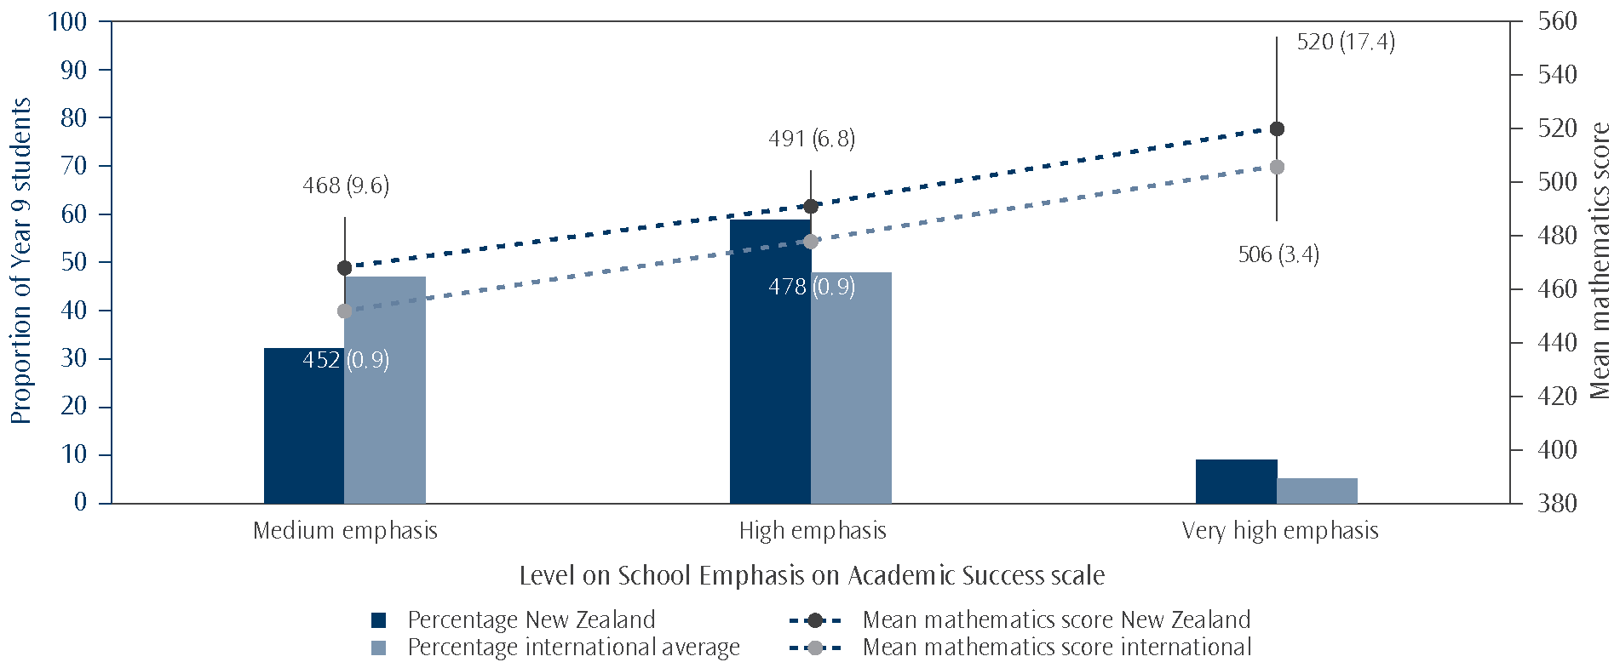
Note: A classification as very high meant that students in a school had teachers who responded with very high for an average of three of the five statements and high for the other two. Medium meant students in the school had teachers who responded to an average of no more than three of the five statements as medium and the others as high. Those left over were classified as high.
Source: Adapted from Exhibit 6.4, Mullis, Martin, Foy, and Arora, 2012.

For the first time in TIMSS, teachers were also asked about their feelings about being a teacher. See Table 11.5 for the six statements with which teachers could agree a lot, agree a little, disagree a little, or disagree a lot. There was almost complete agreement amongst the mathematics teachers who responded to the questionnaire that the work they do is important and around 90 percent said they were content with their profession (90%), were satisfied with being a teacher at their school (88%), and planned to continue as a teacher for as long as they can (89%). Despite a number of mathematics teachers being positive about their role and school, almost 50 percent of teachers agreed that they had more enthusiasm when they started teaching than they had when they completed the questionnaire and 44 percent were frustrated as a teacher.
Table 11.5: New Zealand teachers’ agreement with statements about teaching in TIMSS 2010/11
Statements about teaching | Proportion of students with teachers agreeing  (agreeing a little and a lot combined)
I am content with my profession as a teacher | 90 | (2.2)
I am satisfied with being a teacher at this school | 88 | (2.3)
I had more enthusiasm when I began teaching than I have now | 49 | (3.8)
I do important work as a teacher | 99 | (0.4)
I plan to continue as a teacher for as long as I can | 89 | (2.2)
I am frustrated as a teacher | 44 | (3.9)
Note: Standard errors are presented in parentheses.

Students in the selection of English speaking and high achieving countries shown in Table 11.6 were very likely to have mathematics teachers who agreed that they do important work as teachers. There were also high levels of agreement that teachers were content with their profession. There was a larger range however for the two statements about enthusiasm and frustration. Out of the countries listed in Table 11.6, the Asian countries tended to have higher proportions of students with teachers who agreed that they had more enthusiasm when they began teaching. The exception to this is Japan who actually had the lowest level of agreement out of those listed, and also had the lowest proportion of students with teachers who were frustrated as teachers.
Table 11.6: Lower secondary mathematics teacher agreement with statements about their role as teachers for selected countries in TIMSS 2010/11
Country | Proportion of student with teachers agreeing (agreeing a little and a lot combined)
Country | Contentment with profession as teacher | More enthusiasm when began teaching | Do important work  as a teacher | Frustrated  as a teacher
Korea, Rep. of | 88 | 78 | 95 | 43
Singapore | 95 | 69 | 95 | 41
Chinese Taipei | 99 | 68 | 99 | 33
Hong Kong SAR | 96 | 62 | 97 | 29
Japan | 90 | 41 | 93 | 29
United States | 92 | 51 | 100 | 54
England | 88 | 50 | 100 | 40
Australia | 85 | 54 | 100 | 45
New Zealand | 90 | 49 | 99 | 44
International Avg. | 94 | 58 | 99 | 24
Note: The order of this table is based on achievement order in mathematics.

The international TIMSS team also constructed a Teachers’ Career Satisfaction scale, based on how much mathematics teachers agreed with the six statements about their role as a teacher. Teachers’ responses were combined into a continuous scale to describe the extent to which they agreed with the statements and the scale values were then grouped into three categories, Satisfied, Somewhat satisfied, and Less than satisfied, to report the scale in a meaningful way.
The proportion of New Zealand Year 9 students taught by teachers who were satisfied with their career (i.e., in the Satisfied category) was similar to the international average for mathematics (49% versus 47% – see Figure 11.2). New Zealand also had similar rates of students with satisfied mathematics teachers compared to the other English speaking countries who took part in TIMSS at Year 9 (see Table B.2 in the Appendices).
On average internationally, those students with teachers in the Satisfied category had higher achievement than those with teachers who were Less than satisfied. For New Zealand however, achievement does not appear to be related to how teachers rated on career satisfaction, as mathematics achievement was not significantly different across the three categories. New Zealand was not the only country that deviated from the overall pattern; Chinese Taipei had a similar lack of relationship between teacher career satisfaction and mathematics achievement, as did Korea.
Figure 11.2: Levels on the Teacher Career Satisfaction scale by mean mathematics achievement
in TIMSS 2010/11
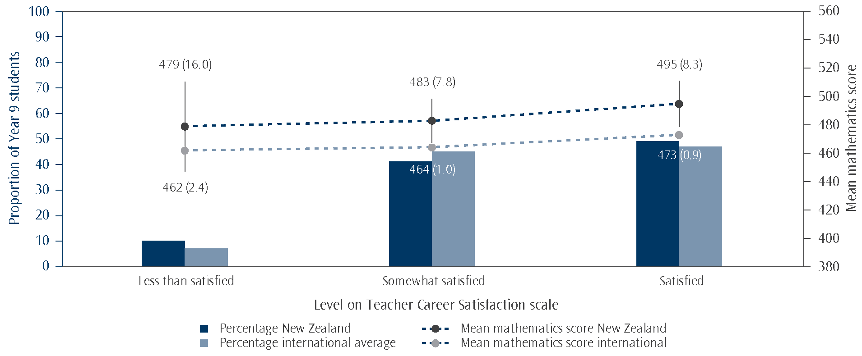
Note: The category Satisfied covers the proportion of students who had teachers that marked at least agree a lot for three out of the six statements and agree a little with the other three, on average. Less than satisfied teachers at most disagreed a little with three of the six statements and agreed a little with the other three, on average. The rest of students were classified as having Somewhat satisfied teachers.
Source: Adapted from Exhibit 7.16, Mullis, Martin, Foy, and Arora, 2012.

Trends in teacher perceptions
Teachers’ feelings about their own role as a teacher were asked about for the first time in the 2010/11 cycle but the questions given to teachers about school climate were introduced in 2002/03. The proportions of students whose teachers gave positive responses have not changed significantly for most questions between 2002/03 and the 2010/11 cycle. The only two questions that have significantly increased for mathematics are How would you characterise teachers’ job satisfaction within your school? and How would you characterise students’ regard for school property within your school?.
Principal perceptions of climate for learning
Principals of Year 9 students were asked how they would characterise the same eight aspects of life at their school as the teachers, and these are listed in Table 11.7. They were given the same five options as the teachers: very high, high, medium, low, and very low.
While percentages were different, the pattern was similar when teachers’ responses and principals’ responses to these questions were compared. The statements where principals were most positive were the four statements relating to teachers with more than three-quarters of students having principals who indicated these aspects were very high or high; these proportions were similar or higher than those for the responses from the teachers themselves. Principals were much more positive than teachers about students’ regard for school property (56% for principals versus 30% for teachers in the very high/high category) and students’ desire to do well at school (68% versus 32% in the very high/high category). Principals were also more positive about parental support for student achievement than teachers were, with 63 percent of students having principals who indicated this was very high or high, compared to 42 percent of students with teachers rating parental support at this level.
As with teacher responses to the questions on parental involvement and support, there was a relationship between how principals rated these in the school, with those in the higher two categories having significantly higher achievement in mathematics than those in the lowest category.
The statements relating to students as responded to by principals seems to have a stronger relationship with mathematics achievement than the responses from teachers. Those students who came from schools where the principals rated students’ regard for school property as being very high or high scored significantly higher than those in the lower categories. There were also differences in mathematics achievement across all three categories for students’ desire to do well in school with the highest achievement among those in the high category and the lowest among those in the low category.
Table 11.7: Extent to which principals characterised aspects of school climate in New Zealand
in TIMSS 2010/11
Statements on aspects of school climate | Proportion of Year 9 students
Statements on aspects of school climate | Very low  or Low |  | Medium |  | Very high  or High
Teachers’ job satisfaction | 0 | (0.0) | 22 | (3.1) | 78 | (3.1)
Teachers’ understanding of the school’s curricular goals | 0 | (0.0) | 13 | (3.1) | 87 | (3.1)
Teachers’ degree of success in implementing the school’s curriculum | 0 | (0.0) | 20 | (3.2) | 80 | (3.2)
Teachers’ expectations for student achievement | 1 | (0.4) | 23 | (3.9) | 76 | (3.8)
Parental support for student achievement | 4 | (1.2) | 33 | (3.9) | 63 | (3.8)
Parental involvement in school activities | 30 | (4.1) | 43 | (4.4) | 27 | (4.5)
Students’ regard for school property | 4 | (1.8) | 40 | (4.5) | 56 | (4.4)
Students’ desire to do well at school | 1 | (0.7) | 31 | (3.9) | 68 | (4.0)
Note: Standard errors are presented in parentheses.
Proportions in each row should add to 100%; inconsistencies are due to rounding.

The responses of the principals across these eight statements and their relationship with achievement differed in several ways from the relationship between the teachers’ responses and achievement scores. With the principals’ responses, there was a significantly higher achievement among the very high/high group than the medium group for mathematics achievement for teachers’ job satisfaction and teachers’ degree of success in implementing the school’s curriculum, a difference that was not present with the teachers responses. There were no students whose principals replied with low or very low to these two questions. For the other two questions relating to teachers, there was no significant relationship with mathematics achievement.
Responses to five out of these eight statements, intended to represent academic optimism in schools, were summarised into two scales, one for teachers and one for principals, referred to as the School Emphasis on Academic Success scale (the results for teachers can be found in Figure 11.1 earlier in this chapter). The statements that did not go into the creation of this index were: Teachers’ job satisfaction, Parental involvement in school activities, and Students’ regard for school property. To report the scale in a meaningful way, values were grouped into three categories, very high, high, and medium emphasis. As principals had responded very positively to these statements, there was no need to include low or very low from the statement response options in the scale divisions.
The general pattern, as shown by the international average, was that the higher on the scale the emphasis by the principal, the higher the associated achievement scores in TIMSS for mathematics. New Zealand follows a similar pattern with respect to the difference between achievement at the top and the bottom categories on this scale. The pattern was not consistent across all countries (see Table B.3 in the Appendices). Indonesia and the Palestinian National Authority for example had no statistical difference across the three categories when it came to mathematics achievement.
Figure 11.3: Levels on the School Emphasis on Academic Success scales (based on principals’ reports) by mean mathematics achievement in TIMSS 2010/11
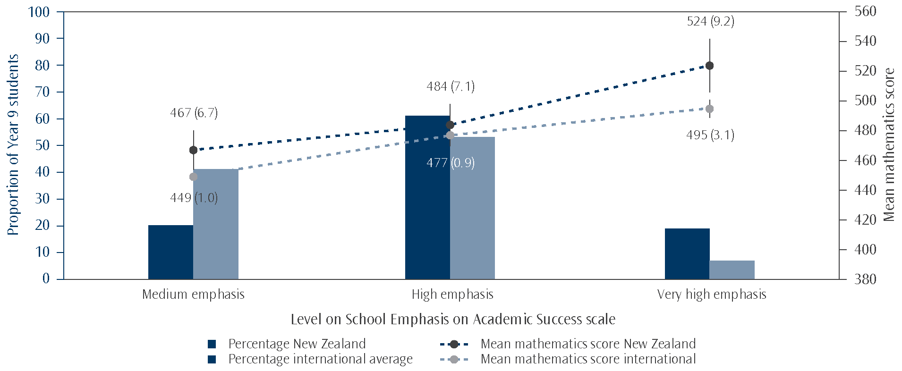
Note: A classification as Very high meant that students in a school had a principal who responded with ‘very high’ for an average of three of the five statements and ‘high’ for the other two. Medium meant students in the school had a principal who responded to an average of no more than three of the five statements as ‘medium’ and the others as ‘high’. Those left over were classified as High.
Source: Adapted from Exhibit 6.2, Mullis, Martin, Foy, and Arora, 2012.

For New Zealand, the overall pattern of those students in schools with higher ratings on the scale having higher average achievement appears to be the same, regardless of whether it was teachers or principals reporting it.
Trends in principal perceptions
The questions given to principals about school climate were first introduced in 2002/03. Between 2002/03 and 2010/11 there were changes for several of the statements regarding school climate and little to no change for the rest. For those statements where there had been change since 2002/03 (teachers’ job satisfaction, teachers’ expectations for student achievement, parental support for student achievement, and students’ desire to do well at school), these were all more positive than they had been in 2002/03.
Student perceptions of school safety and student behaviours
Year 9 students were asked how often they had experienced negative behaviours during the year (behaviours are listed in Table 11.8). They were given the response options never, a few times a year, once or twice a month, and at least once a week.
The most commonly reported negative behaviour was being made fun of or called names (35%). The least commonly reported behaviour was being made to do things they didn’t want to by other students (7%). The proportions of students in 2010/11 that indicated they had experienced these behaviours at least once a month, meaning they indicated it had happened at least once a week or once or twice a month, are shown in Table 11.8.
Table 11.8: New Zealand Year 9 students’ agreement with statements about other students’ behaviour
Statements | Proportion of Year 9 students that replied  once a month or more frequently
I was made fun of or called names | 35 | (0.8)
I was left out of games or activities by other students | 14 | (0.6)
Someone spread lies about me | 19 | (0.7)
Something was stolen from me | 13 | (0.6)
I was hit or hurt by other student(s) | 13 | (0.7)
I was made to do things I didn’t want to do by other students. | 7 | (0.4)
Note: Standard errors are presented in parentheses.

For three of the statements in Table 11.8 (someone spread lies about me, something was stolen from me, and I was made to do things I didn’t want to do by other students), achievement in mathematics was higher for those students who experienced these behaviours less frequently (i.e., responded with a few times a year or never) than for those students who experienced it more frequently. There was no significant difference in mathematics achievement for the statements about being made fun of or called names, being hit or hurt by other student(s), or being left out of games or activities by other students.
Students’ responses to these statements were combined into a continuous scale, the Students Bullied at School scale, to describe the extent to which they experienced bullying behaviours at school. To report the scale in a meaningful way, values on the scale were grouped into three categories. Almost never on the scale meant that the student responded, at most, with never to three of the six statements and a few times a year to the other three, on average. Students who were categorised as experiencing these behaviours about weekly on the scale experienced at least three of the six behaviours once or twice a month and the other three a few times a year, on average. All other students were classified as being bullied about monthly.¹⁴ Note that the titles for these categories, as used internationally, may overstate the frequency of the bullying behaviours as can be seen from these descriptors. This data should be read with caution as the reader could assume that 12 percent of students had reported that they were bullied about weekly. However, the scale is based on individual behaviours and could range from a repeated behaviour on a weekly basis from a group of individuals to three different behaviours, with each behaviour happening on separate occasions only once a month and instigated by different perpetrators.
New Zealand had the same proportion of students in the about weekly category as the international average and slightly fewer in the almost never category (55% versus 59% - see Figure 11.4).
Looking at achievement across the levels of the scale, there was a general pattern of students who were categorised as being bullied less having higher achievement than those who were categorised as being bullied more, as shown by the international average for mathematics (see Table B.4 in Appendix). The biggest difference tended to be between those who were categorised as almost never bullied and those who were categorised as being bullied at school about weekly. For a number of countries, including New Zealand, there was no significant difference in achievement between students categorised in the almost never category and those in about monthly. There were also some countries, such as Thailand and Hong Kong SAR, where there was little difference in mathematics achievement across the three categories.

14 The descriptions here explain the cut points for the category, not the categories themselves. That is, the cut point represents the maximum score that a student could get, on average, and still be assigned to a category. For example, for the About weekly category, the maximum cut score of 7.7 corresponds to students experiencing each of three bullying behaviours once or twice a month and each of the other three a few times a year, on average. Any response corresponding to more frequent bullying behaviour than this will also fall into the About weekly category. Students with a score higher than 9.6 were assigned to the Almost never category.
Figure 11.4: Percentages of students on the Students Bullied at School scale by mean mathematics achievement in TIMSS 2010/11
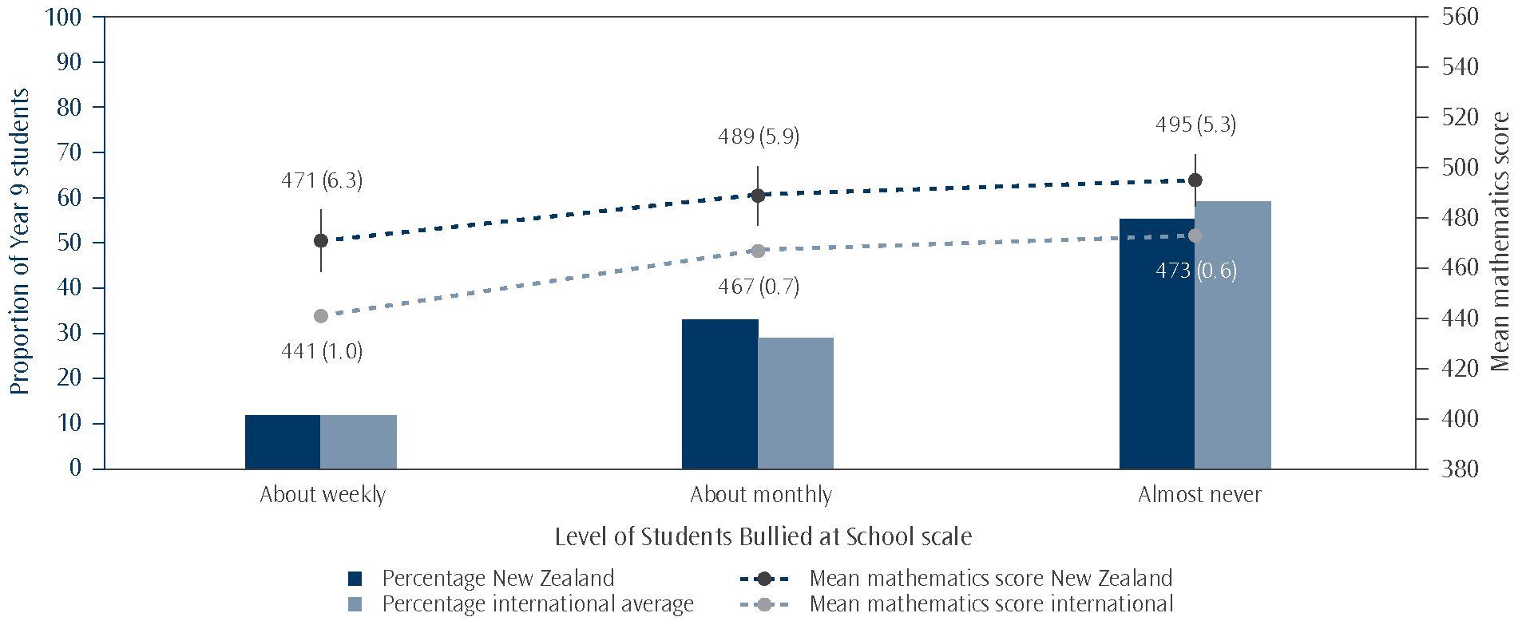
Source: Adapted from Exhibit 6.12, Mullis, Martin, Foy, and Arora, 2012.

Different experiences of bullying behaviours within New Zealand
Bullying behaviours can affect different groups in different ways. Consequently, the analysis below is broken down into gender differences, differences amongst socio-economic groups, and differences amongst ethnic groupings.
Generally, a higher proportion of boys than girls indicated that they had experienced the behaviours monthly or more frequently. The biggest differences were for I was made fun of or called names and I was hit or hurt by other students, with 42 percent and 18 percent of boys respectively responding that they had experienced these behaviours once or twice a month or more frequently, compared with 27 percent and 7 percent of girls. For girls, those who did indicate this level of frequency had significantly lower mathematics achievement than those girls who indicated that they experienced these behaviours less frequently or never. For boys however, achievement was not significantly different for those who responded that they experienced these behaviours with greater frequency for most of the statements.¹⁵
As mentioned previously, the socio-economic status of students has been found to have a strong relationship with achievement and TIMSS asked school principals to report on the economic composition of their school by estimating the proportion of students in their school from economically disadvantaged homes and economically affluent homes. Schools were categorised as being advantaged if more than a quarter of their students were from affluent homes and one quarter or fewer were from disadvantaged homes. Schools that were categorised as disadvantaged had the opposite situation and those schools remaining were classified as neither advantaged nor disadvantaged.
Within each category of the Students Bullied at School scale, the proportions of students from each of the socio-economic groups (economically disadvantaged, neither advantaged nor disadvantaged, and economically affluent) were reflective of their proportion of the population as a whole. In other words, none of the socio-economic groupings were over- or under-represented at each level of the scale. This is further supported by looking at the scale by decile grouping.
The Students Bullied at School scale was also examined by ethnicity. The only ethnic grouping over represented in the about weekly end of the scale was the Pākehā/European grouping. Each ethnic grouping had similar proportions of students who said they almost never experienced the bullying behaviours.

15 The exceptions were Someone spread lies about me and I was made to do things I didn’t want to by other students, where the achievement for boys was either borderline significant or statistically lower for those who indicated that they experienced these once or twice a month or more frequently
Trends in student perceptions about school safety
Questions given to students about school safety have changed since TIMSS was first implemented in 1994. One question from the 1994 cycle remained through to the 2002/03 assessment; a variation on something was stolen from me. Five out of the six questions asked in 2002/03 were also asked in the 2010/11 cycle but the response options were changed between the two cycles. In 2002/03, students were asked to indicate by ticking yes or no if the behaviours listed had happened to them at school during the last month. In the 2010/11 cycle, they were given options for how often the behaviours happened to them at school. To compare the two cycles, Table 11.8 earlier in this chapter shows combined categories at least once a week and once or twice a month as an approximation to the proportions of students who ticked yes for the various behaviours in 2002/03. While the proportions can be compared across the two cycles, it should be viewed with caution, as it is not clear to what degree differences are due to actual changes amongst the students and how much is due to the rephrasing of the questions. For all five behaviours, there were similar or lower proportions in TIMSS 2010/11 (refer to Table 11.9 for details of the 2002/03 percentages). Something of mine was stolen (25 percentage points) and I was hit or hurt by other students (14 percentage points) had the largest drops.
Table 11.9: Proportion of students that experienced each of these behaviours during the last month in
New Zealand in TIMSS 2002/03
Statements | Proportion of Year 9 students
Something of mine was stolen | 38 | (1.2)
I was hit or hurt by other students (e.g shoved, punched or kicked) | 27 | (1.3)
I was made to do things I didn’t want to do by other students | 13 | (0.7)
I was made fun of or called names | 34 | (1.4)
I was left out of activities by other students | 15 | (0.8)
Note: Standard errors are presented in parentheses

Teacher perceptions of school safety and student behaviours
Teachers of Year 9 students were asked to indicate the extent to which they agreed or disagreed with three statements on the general levels of safety they experienced at their schools. The statements listed are in Table 11.10. There were four possible response options given: agree a lot, agree a little, disagree a little, and disagree a lot.
Almost all students in TIMSS were taught by teachers who agreed their school was a safe place, with 97 percent agreeing with the statement I feel safe at this school, as shown in Table 11.10. There was least agreement with the statements the students are well behaved and the students are respectful of the teachers with 21 to 22 percent of students having teachers who disagreed to some extent.
Table 11.10: Extent to which mathematics teachers agreed with statements on school safety in New Zealand in TIMSS 2010/11
Statements on school safety | Proportion of students with teachers agreeing  (agreeing a little and a lot combined)
This school is located in a safe neighbourhood | 93 | (1.6)
I feel safe at this school | 97 | (1.3)
This school’s security policies and practices are sufficient | 93 | (2.0)
The students are well behaved | 79 | (2.8)
The students are respectful of the teachers | 78 | (2.8)
Note: Standard errors are presented in parentheses.
Teachers’ responses to these statements were summarised into a continuous scale, the Safe and Orderly School scale, to describe the extent to which they felt their school was a safe and orderly environment. To report the scale in a meaningful way, values on the scale were grouped into three categories; Safe and orderly, Somewhat safe and orderly, and Not safe and orderly.
Fifty-five percent of New Zealand Year 9 students had mathematics teachers who agreed that their school was a safe and orderly place, which was higher than the international average of 45 percent (see Figure 11.5). The general pattern relating achievement to rating on this scale, as shown by the international average, seems to indicate that the more safe and orderly a school is, the higher the average mathematics achievement of the students (see Tables B.5 in the Appendices). For some countries such as Turkey and Chile, this meant a discernible difference between all three categories for mathematics achievement. There was also a number of countries where there was a difference between the top and bottom categories but achievement for somewhat safe and orderly was not significantly different from not safe and orderly (in Chinese Taipei for example). For some countries, there was no statistically significant difference between the achievement for all three categories, as was the case for New Zealand and Slovenia.
Figure 11.5: Levels on the Safe and Orderly School scale by mean mathematics achievement
in TIMSS 2010/11
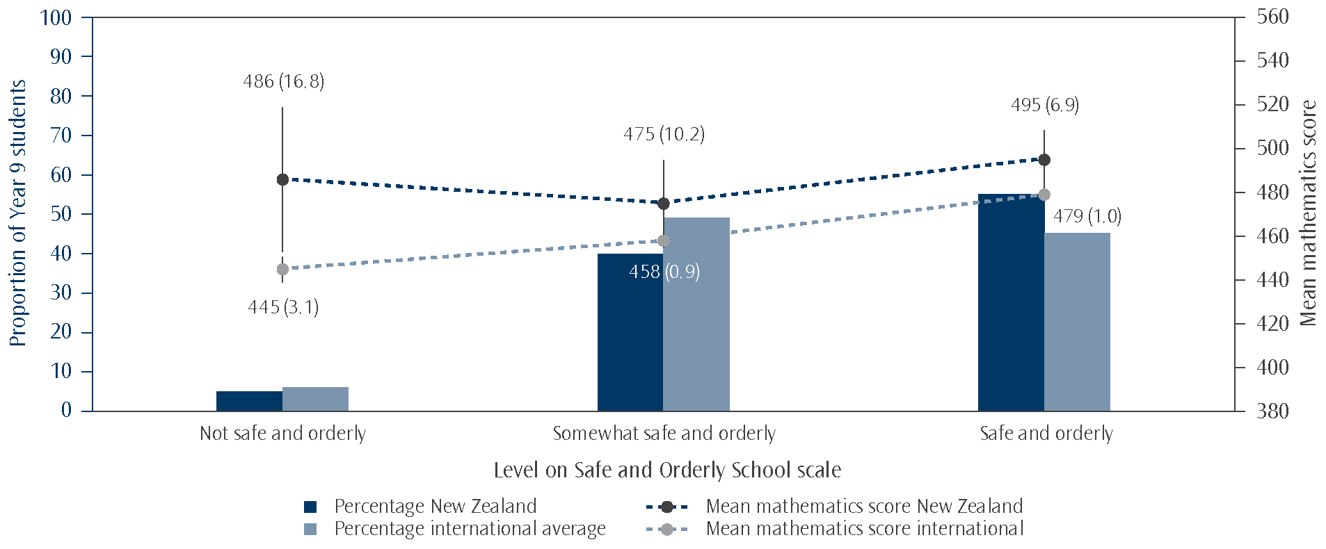
Note: Those students whose teachers at least agreed a lot with three out of the five statements and agreed a little with the other two,
on average, were classified in the Safe and orderly school category. Teachers at most disagreed a little with at least three of the five statements and agreed a little with the other two, on average, for students to be classified as being in schools that were Not safe and orderly. All others were allocated to Somewhat safe and orderly.
Source: Adapted from Exhibit 6.8, Mullis, Martin, Foy, and Arora, 2012.
Trends in teacher perceptions
The first three questions about school safety in Table 11.10 were given to teachers for the first time in 2002/03. Comparisons between that cycle and 2010/11 show no significant change in the proportions of students whose teachers gave positive responses to the individual questions. The other two questions in the table were asked for the first time in 2010/11.
Principal perceptions of school safety and student behaviours
To help foster a healthy learning environment, minimal or no disruption to learning is desirable. In previous cycles, principals were asked how frequently a series of problem behaviours occurred in their school and the severity of the problem. In 2010/11, these were combined to ask how much of a problem these behaviours (listed in Table 11.11) were in the school.
Principals expressed the extent to which these behaviours were a problem amongst Year 9 students in their school with one of the following response options: not a problem, minor problem, moderate problem, or serious problem. The majority of Year 9 students attended schools where these behaviours were perceived by the principal to be a minor problem at the most. Few students had principals that acknowledged any of these behaviours as posing a serious problem in their school. Absenteeism was the behaviour with the highest proportions in the moderate and serious problem categories combined (24%), followed by intimidation or verbal abuse among students (20%), arriving late at school (19%), and classroom disturbance (19%).
Table 11.11: Extent to which principals classified behaviours of New Zealand Year 9 students as a problem
in TIMSS 2010/11
Behaviours | Proportion of Year 9 students in each category  of severity of behaviours
Behaviours | Serious problem |  | Moderate problem |  | Minor  problem |  | Not a  problem
Arriving late at school | 2 | (1.1) | 17 | (4.4) | 60 | (4.5) | 21 | (3.6)
Absenteeism | 5 | (2.1) | 19 | (3.8) | 62 | (4.2) | 15 | (1.9)
Classroom disturbance | <1 | (0.4) | 19 | (3.5) | 69 | (4.6) | 12 | (3.2)
Cheating | 0 | (0.0) | 0 | (0.0) | 47 | (4.1) | 53 | (4.1)
Profanity | 1 | (1.0) | 15 | (2.6) | 64 | (4.0) | 20 | (3.5)
Vandalism | 1 | (0.5) | 5 | (2.0) | 65 | (4.5) | 29 | (4.1)
Theft | <1 | (0.4) | 10 | (3.1) | 70 | (4.1) | 20 | (2.9)
Intimidation or verbal abuse among students | 1 | (0.7) | 19 | (3.6) | 73 | (3.8) | 6 | (1.5)
Physical injury to other students | <1 | (0.4) | 2 | (1.4) | 57 | (4.6) | 40 | (4.6)
Intimidation or verbal abuse of teachers or staff | <1 | (0.4) | 6 | (2.2) | 56 | (4.9) | 38 | (4.6)
Physical injury to teachers or staff | 0 | (0.0) | 1 | (0.7) | 6 | (2.6) | 93 | (2.7)
Note: Standard errors are presented in parentheses.
Proportions in each row should add to 100%; inconsistencies are due to rounding.

Generally, being in a school with less of a problem with the behaviours listed above was associated with higher achievement in mathematics, although this often meant a difference between the top two categories versus the bottom two rather than a difference between each category. There were three exceptions to this, cheating, profanity, and vandalism where there were no significant differences across the categories. However, cheating was not considered much of a problem anyway.
To summarise the extent to which school discipline and safety affects student learning, the TIMSS international team created a continuous scale, the School Discipline and Safety scale, based on principals’ views on the extent to which the ten behaviours listed above occurred among lower secondary students in their schools. To report the scale in a meaningful way, values on the scale were grouped into three categories; moderate problems, minor problems, and hardly any problems.
A number of the higher achieving countries had proportions in the hardly any problems category that were higher than the international average (refer Table B.6 in the Appendices). Kazakhstan had the highest proportion in this category, with 44 percent of students going to schools deemed to have hardly any problems with school discipline and safety. A small proportion of Year 9 students in New Zealand (6%) attended schools whose principals indicated that there were hardly any problems with school discipline and safety and a small minority (9%) attended schools where there were moderate problems. The majority of students were in schools with minor problems.
Figure 11.6: Levels on the School Discipline and Safety scale by mean mathematics achievement
in TIMSS 2010/11
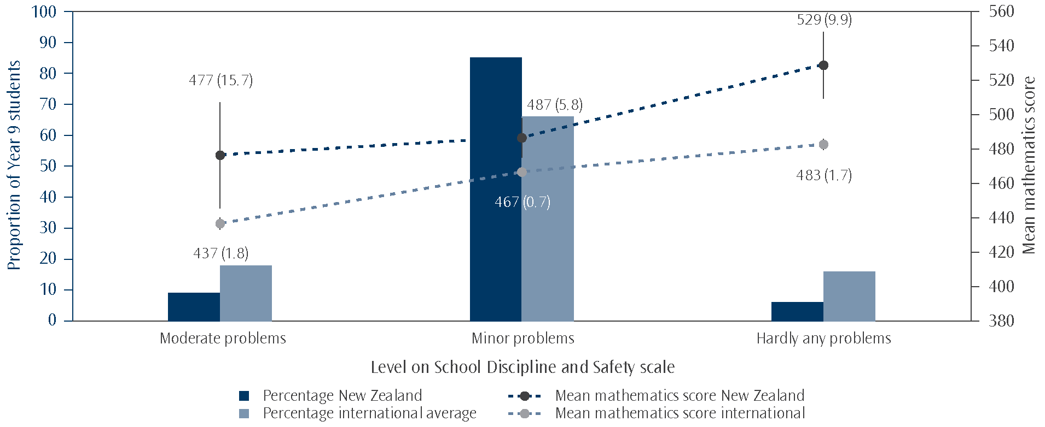
Note: Students whose principals at most reported ‘not a problem’ on average for five out of the ten statements and only ‘minor problems’ for the other five rated as having Hardly any problems on the scale. A rating of Moderate problems corresponded to students whose principals responded at least with ‘moderate problem’ for five of the ten statements and minor problem for the other five, on average.
Source: Adapted from Exhibit 6.10, Mullis, Martin, Foy, and Arora, 2012.

The overall pattern shown by the international average (see Figure 11.6) was that higher achievement is related to higher safety and order. However, several countries showed little variation in achievement scores for mathematics across the categories (Slovenia and Armenia for example).
Trends in principals’ perceptions
The behaviours in Table 11.11 were asked about in the 2002/03 cycle. The question was phrased in a slightly different way in these previous cycles however, asking for the frequency of occurrence of the problems in the school and then how severe they were. Comparing the proportions for the not a problem column, most of the items were not significantly different between the two cycles, seeming to indicate these things were not any more of a problem than previously. For the three items where there was a difference, the greatest change was for cheating, dropping from 71 percent of students having principals who indicated this was not a problem in 2002/03 to 53 percent in 2010/11, followed by vandalism dropping from 44 percent to 29 percent and theft from 33 percent to 19 percent between 2002/03 and 2010/11.
Relationship between home and school
In The Complexity of Community and Family Influences on Children’s Achievement in New Zealand: Best Evidence Synthesis, Biddulph, Biddulph, and Biddulph (2003) state that “A key message emerging from the New Zealand and international research is that effective centre/school-home partnerships can strengthen supports for children’s learning in both home and centre/school settings. What is remarkable about such partnerships is that when they work the magnitude of the positive impacts on children can be so substantial, compared to traditional institutionally-based educational interventions.” ¹⁶

16 This BES contains an extensive synthesis on the effect of community and family on student achievement, as well as the effect of partnerships between these groups and schools/centres, supporting the results that have come from TIMSS.
In New Zealand, Boards of Trustees are required under the National Administrative Guidelines (Ministry of Education) to report to students, parents and the school’s community on individual student achievement, on the achievement of students as a whole, and on groups such as Māori students, evaluating these against established targets.¹⁷ Ka Hikitia, the Māori Education Strategy, also has a strong emphasis on the involvement of parents, families and whānau in students’ learning and engagement. Similarly, the Pasifika Education Plan puts Pasifika learners, their parents, families, and communities at the centre of the education system (Ministry of Education, 2012).
Given the important role that parents, and the interface between parents and teachers/schools, play in enriching their child’s education, the TIMSS study examined parental involvement in various school activities. In TIMSS 2010/11, teachers were asked about their face-to-face interactions with parents and principals were asked if their school had asked parents to be involved in various school activities such as school projects programmes and trips, school committees, and raising funds for the school.
Around 80 percent of students had mathematics teachers who reported that they met or talked individually with parents about students’ progress 1 to 3 times a year (see Table 11.12 below), which probably refers to the standard school practice of parent-teacher interviews. Around 80 percent of students had mathematics teachers who sent home progress reports on students’ learning 1 to 3 times a year; this is likely to correspond with the usual practice of issuing regular student reports.
Table 11.12: Frequency of teachers’ interactions with parents, reported by New Zealand Year 9 mathematics teachers
Teacher-parent interaction | Proportion of Year 9 students whose mathematics teachers indicated how often the interactions with parents occurred
Teacher-parent interaction | Never |  | 1 to 3 times a year |  | 4 to 6 times a year |  | Once or twice a month |  | At least once a week
Meet or talk individually with the students’ parents to discuss his/her learning progress | 3 | (1.4) | 81 | (3.3) | 12 | (2.3) | 3 | (1.1) | 2 | (1.2)
Send home a progress report on the student’s learning | 2 | (1.3) | 80 | (3.2) | 15 | (2.6) | 2 | (0.8) | 2 | (1.2)
Note: Standard errors are presented in parentheses.
Proportions in each row should add to 100%; inconsistencies are due to rounding.

In terms of interactions about education, the most frequent interaction reported on in TIMSS between schools and parents about the school was informing parents about school accomplishments with all New Zealand Year 9 students having principals who said they did this at least two to three times a year (2 to 3 times a year and more than 3 times a year combined). The next most frequent interaction was informing parents about the overall achievement of the school, with more than three-quarters of students having principals who indicated they did this at least two to three times a year. Of the list of general school interactions in TIMSS, these two would be the most likely to be covered by sending out regular newsletters from schools to parents about the notable activities and achievements happening in the school, a practice that seems to be quite common for New Zealand schools.
For interactions regarding individual students, all Year 9 students had principals who indicated that they informed parents about their child’s learning progress at least twice a year and almost all had principals who indicated that they informed parents about the behaviour and well-being of their child with similar frequency. These two interactions, as discussed earlier in relation to the teachers’ responses, along with discussing parents’ concerns or wishes about their child’s learning (93% at least 2 to 3 times a year) could be covered by issuing student reports 3 to 4 times a year, and the interviews between teachers and parents, which normally occur 1 to 2 times a year in New Zealand schools.

17 National Administration Guidelines 2c.
Table 11.13: Frequency of schools’ interactions with parents, as indicated by the New Zealand principals
School-parent interaction | Proportion of Year 9 students whose principals indicated  the interactions with parents occurred:
School-parent interaction | Never |  | Once a year |  | 2 to 3 times a year |  | More than 3 times a year
In general
Inform parents about the overall academic achievement of the school | 1 | (0.6) | 24 | (4.7) | 49 | (4.7) | 27 | (4.3)
Inform parents about school accomplishments | 0 | (0.0) | 0 | (0.0) | 7 | (2.8) | 93 | (2.8)
Inform parents about the educational goals and pedagogic principles of the school | <1 | (0.3) | 28 | (4.5) | 40 | (4.1) | 31 | (4.8)
Inform parents about the rules of the school | <1 | (0.3) | 36 | (5.2) | 37 | (5.0) | 27 | (4.8)
Discuss parents’ concerns or wishes about the school’s organisation | 1 | (0.7) | 40 | (5.7) | 27 | (4.7) | 32 | (5.1)
Provide parents with additional learning materials for their child to use at home | 49 | (5.3) | 15 | (3.4) | 20 | (4.5) | 16 | (3.8)
Organise workshops or seminars for parents on learning or pedagogical issues | 20 | (4.8) | 34 | (4.2) | 36 | (4.6) | 9 | (3.6)
For individual students
Inform parents about their child’s learning progress | 0 | (0.0) | 0 | (0.0) | 58 | (5.0) | 42 | (5.0)
Inform parents about the behaviour and well-being of their child at school | 2 | (2.0) | 1 | (0.7) | 50 | (5.7) | 47 | (5.9)
Discuss parents’ concerns or wishes about their child’s learning | 2 | (2.0) | 5 | (2.2) | 61 | (5.4) | 32 | (4.9)
Support individual parents in helping their child with schoolwork | 6 | (2.3) | 19 | (4.3) | 34 | (5.1) | 41 | (5.4)
Note: Standard errors are presented in parentheses.
Proportions in each row should add to 100%; inconsistencies are due to rounding.

As well as eliciting information on the way schools interact with parents, TIMSS also asked about ways in which schools try to get parents involved with the schools (see Table 11.14). For two out of the three activities, volunteer for school projects, programmes and trips, and raise funds for the school, around 50 percent of students were in schools where the principal asked parents to be involved at least 2 to 3 times a year.
Table 11.14: New Zealand schools’ encouragement of parental involvement in TIMSS 2010/11
Activity | Proportion of Year 9 students whose principals reported they asked parents:
Activity | Never |  | Once a year |  | 2 to 3  times a year |  | More than 3  times a year
Volunteer for school project, programmes and trips | 12 | (4.1) | 36 | (5.0) | 31 | (4.4) | 21 | (3.9)
Serve on school committees | 9 | (2.9) | 48 | (5.0) | 31 | (4.9) | 12 | (2.7)
Raise funds for the school | 17 | (3.4) | 32 | (4.6) | 33 | (3.9) | 18 | (3.6)
Note: Standard errors are presented in parentheses

These were lower proportions than those found for the 2002/03 cycle, although the phrasing of the question was changed between the two cycles. In the 2002/03 cycle, principals were asked “Does your school ask parents to do the following…” and given five different school-related activities to respond to. In 2010/11, they were asked for the frequency with which they asked parents and given three activities. In 2002/03, 67 percent of students had principals who responded in the affirmative when asked if they requested parents volunteer for school projects, programmes and trips, 72 percent for requesting parents to serve on school committees, and 53 percent for help to raise funds for the school.
Interactions between teachers
Teachers as professionals spend time learning and improving their practice throughout their careers. An excellent way to learn is through interactions and collaborations with other teachers. TIMSS asked teachers how often they interact with other teachers, with five types of interaction provided in the questionnaire, as shown in Table 11.15. Four possible response options for the frequency of interactions were: never or almost never, 2 or 3 times a month, 1 to 3 times per week, and daily or almost daily. Teachers’ most common interaction was discussing how to teach a particular topic, with nearly half having teachers who reported doing this at least weekly. The next most common activity was sharing what they have learned about teaching experiences (44% at least weekly). Visiting another classroom to learn more about teaching was the least common interaction by a considerable margin.
Table 11.15: Frequency of interactions among New Zealand Year 9 mathematics teachers in TIMSS 2010/11
 | Proportion of Year 9 students whose mathematics teachers interacted with other teachers:
Types of interactions | Never or almost never |  | 2 or 3 times  a month |  | 1 to 3 times  a week |  | Daily or  almost daily
Discuss how to teach a particular topic | 14 | (2.6) | 39 | (4.5) | 36 | (3.5) | 12 | (2.4)
Collaborate in planning and preparing instructional materials | 21 | (3.3) | 50 | (3.9) | 25 | (3.8) | 4 | (1.3)
Share what I have learned about my teaching experiences | 13 | (2.3) | 44 | (3.9) | 32 | (3.1) | 12 | (2.1)
Visit another classroom to learn more about teaching | 63 | (3.6) | 31 | (3.4) | 5 | (1.5) | <1 | (0.3)
Work together to try out new ideas | 36 | (3.5) | 47 | (3.7) | 14 | (2.0) | 3 | (1.1)
Note: Standard errors are presented in parentheses
Proportions in each row should add to 100%; inconsistencies are due to rounding.

Most of the different interactions did not seem to have particular relationships with achievement but there were a few exceptions. Those students whose mathematics teachers said that they never or almost never visited another classroom to learn more about teaching or worked together to try out new ideas had higher achievement than those who said they did this at least weekly. However, the differences between the individual categories were generally not significant.
Teachers’ responses to the questions about the frequency of their interactions with other teachers were combined into a continuous scale, the Collaborate to Improve Teaching scale. To report the scale in a meaningful way, values on the scale were grouped into three categories; very collaborative, collaborative, and somewhat collaborative.
Figure 11.7: Levels on the Collaborate to Improve Teaching scale by mean mathematics achievement
in TIMSS 2010/11
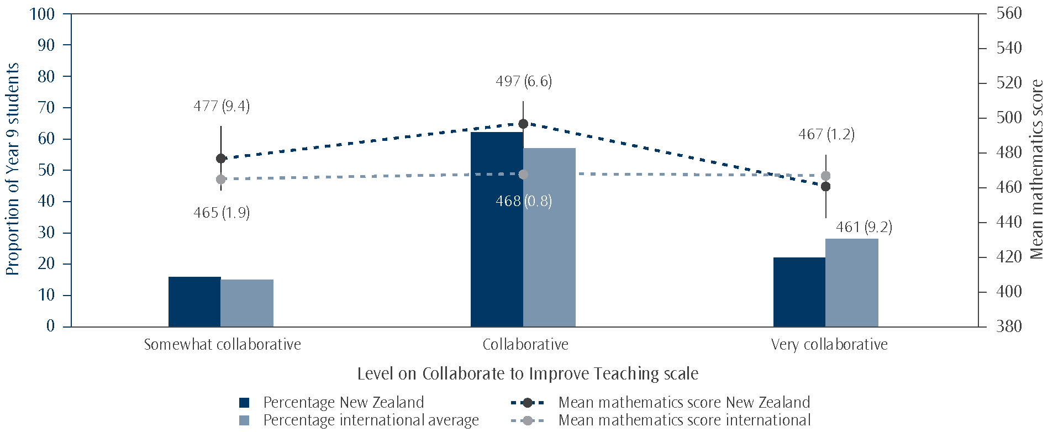
Note: Students who were classified in the Very collaborative portion of the scale had teachers who answered at least three of the five statements with ‘one to three times a week’ and ‘two or three times per month’ for the other two, on average. Those in the Somewhat collaborative category had teachers who responded at most with ‘never or almost never’ to three of the five statements and ‘two or three times per month’ to the other two, on average. All others were classified as Collaborative.
Source: Adapted from Exhibit 8.13, Mullis, Martin, Foy, and Arora, 2012.

Twenty-two percent of New Zealand Year 9 students had mathematics teachers who reported themselves as being very collaborative, lower than the international average of 28 percent. There was little difference internationally in mathematics achievement across the three levels on the scale, on average (see Table B.7 in the Appendices). New Zealand was the only country that had a significant difference in mathematics achievement between students whose teachers were very collaborative and those whose teachers were collaborative (collaborative higher than very collaborative). There was not a significant difference between the top and bottom categories however or between collaborative and somewhat collaborative. Most other countries followed the average pattern of there not being a significant relationship between each level on this scale and mathematics achievement.
Trends in interactions with other teachers
Questions about interactions with other teachers were first introduced in the 2002/03 cycle. However, the questions asked in previous cycles were too different to those asked in 2010/11 to analyse trend data.
Vacancies
Principals were also asked how difficult it was to fill Year 9 teaching vacancies in the two TIMSS subjects as well as any other subjects (in a general category called “other”). They were given the four response options: no vacancies in this subject, easy to fill vacancies, somewhat difficult, and very difficult.
Forty-three percent of New Zealand students had principals that identified filling mathematics teaching vacancies as somewhat or very difficult and 27 percent of students had principals who said it was easy to fill vacancies in this subject. Internationally, these figures were 19 percent for somewhat or very difficult and 23 percent for easy. Thirty percent of New Zealand students had principals who said there were no vacancies in mathematics.
Vacancies for science were less of an issue, with 23 percent of students in schools where the principal said they were somewhat or very difficult to fill. When it came to other subjects (not further specified in the questionnaire), 35 percent of New Zealand students had principals that identified filling teaching vacancies as somewhat or very difficult.
Principals were also asked if they used any incentives to recruit or retain Year 9 teachers for mathematics or other subjects. Suggestions for possible incentives included pay, housing, signing bonus, and/or smaller classes. Less than ten percent of students attended schools where the principal indicated this incentivisation happened for recruitment or retention of Year 9 teachers of any subject (9% for mathematics, 8% for science, and 8% for other subjects). This compares to 20 percent of students internationally (20% for mathematics, 19% for science, and 20% for other subjects).
School and classroom size
School size
The total enrolment of each New Zealand school that participated in TIMSS 2010/11 at the Year 9 level ranged from 36 to 2,586 students, with an average of 1128. Forty-two percent of all New Zealand Year 9 students attended mid-size schools with between 601 and 1200 students, an increase of almost 10 percentage points since 2002/03 (33%). More than a third of students attended large schools with 1201 students or more (38%), and 19 percent were in small schools with fewer than 600 students.
Table 11.16: Proportion of New Zealand Year 9 students and mean mathematics achievement scores
by size of school band in TIMSS 2010/11
School size band | Proportion  of students | Mean mathematics  achievement score
Small (600 or fewer students) | 19 | 461 | (6.4)
Small to Medium (601 to 900 students) | 24 | 480 | (8.4)
Medium to Large (901 to 1200 students) | 18 | 487 | (9.7)
Large (1201 students or more) | 38 | 509 | (12.0)
New Zealand | 100 | 488 | (5.5)
Note: Standard errors are presented in parentheses.
Proportions in the proportion of students column should add to 100%; inconsistencies are due to rounding.

New Zealand secondary schools have increased in size since the first cycle of TIMSS in 1994. Forty-seven percent of students taking part in TIMSS at the Year 9 level were in schools that had 900 students or more in 1994, compared with 56 percent in 2010/11. The proportion of students in small schools of fewer than 600 students was less in 2010/11 than what it was in 1994 (25%).
Students in small schools had significantly lower achievement in mathematics, on average, than those in the two largest size groups but otherwise there were generally not significant differences between groups in either 2010/11 or 1994.
Classroom size
TIMSS asked teachers about the size of their mathematics classes, as larger or smaller classes could influence how the teacher chooses to teach mathematics topics. The average TIMSS class size in New Zealand for mathematics was 26 students in 2010/11, similar to the international average of 28. In the majority of countries, students were in classes with between 20 and 35 students, with the exception of Slovenia and Finland, which had 15 and 19 students per class on average respectively, and Indonesia, Morocco, Singapore, Thailand and Ghana, which had average class sizes of between 36 and 44 students.
It is difficult to disentangle the relationship between class size and achievement. For example, in some countries smaller classes tend to be in rural areas where there are fewer resources, and larger classes in urban areas with more resources. Remedial classes may also be smaller. However, TIMSS studies repeatedly show that high performing Asian countries, such as Singapore and Hong Kong SAR, have some of the largest class sizes. On the other hand, most non-Asian top performing countries tend to have class sizes of fewer than 25 students.
Class sizes in New Zealand have not changed significantly since the first cycle of TIMSS; in 1994, the average class size for mathematics was 23 students, not significantly different to the 26 students in 2010/11.
Limitations to teaching
Mathematics teachers of Year 9 TIMSS classes were asked to what extent certain factors (listed in Table 11.17) limit mathematics teaching in their classes. Responses were given on a four-point scale; not applicable, not at all, some, and a lot. The not applicable category is likely to mean there are no students in the class that meet the criteria. Table 11.17 shows the proportions of students whose teachers indicated that some or all of these factors limited how they taught mathematics to their Year 9 students. Not applicable and not at all were grouped into one category no limitations. In general, most students had teachers who thought that having students in the class with a lack of prerequisite knowledge or skills (85%) put some or a lot of limitations on teaching mathematics, followed by uninterested or disruptive students (83% for the former and 79% for the latter). The factor that seemed to be the least likely to place limitations on teaching was lack of basic nutrition (27%).
Table 11.17: Extent to which New Zealand mathematics teachers indicated these factors limited their teaching in TIMSS 2010/11
Factors | Proportion of Year 9 students whose teachers  indicated the factors presented:
Factors | A lot of limitations |  | Some limitations |  | No limitations
Lack of prerequisite knowledge or skills | 26 | (2.7) | 59 | (3.7) | 15 | (3.5)
Lack of basic nutrition | 2 | (1.0) | 25 | (3.2) | 73 | (3.3)
Not enough sleep | 3 | (1.3) | 59 | (3.8) | 38 | (3.9)
Special needs | 3 | (1.0) | 35 | (2.8) | 62 | (3.0)
Disruptive | 19 | (2.4) | 60 | (3.9) | 22 | (3.6)
Uninterested | 14 | (1.8) | 69 | (3.2) | 17 | (2.6)
Note: Standard errors are presented in parentheses.
Proportions in each row should add to 100%; inconsistencies are due to rounding.

Quality and availability of school buildings and resources
Teachers in TIMSS 2010/11 were asked how much of a problem various issues were in their current school. These issues are listed in Table 11.18. Teachers not having adequate workspace and too many teaching hours had the highest percentages of students with mathematics teachers indicating that these were moderate to serious problems (26% and 24% respectively). Over two-thirds of the students had mathematics teachers who indicated that classrooms being overcrowded was at least a minor problem. The least problematic of these five issues in the opinions of the mathematics teachers were not having adequate instructional materials and supplies, and the school building needing significant repair, with 49 percent and 48 percent of students respectively having mathematics teachers who indicated these were not problems at all.
Table 11.18: How much mathematics teachers perceived various issues were problems in their current schools in New Zealand in TIMSS 2010/11
Issues | Proportion of Year 9 students with teachers who indicated these issues were:
Issues | Not a problem |  | Minor problem |  | Moderate to serious problem
The school building needs significant repair | 48 | (3.9) | 32 | (3.4) | 20 | (3.0)
Classrooms are overcrowded | 31 | (2.9) | 47 | (3.2) | 22 | (2.9)
Teachers have too many teaching hours | 41 | (4.2) | 35 | (3.4) | 24 | (3.1)
Teachers do not have adequate workspace | 39 | (4.7) | 35 | (4.2) | 26 | (3.3)
Teachers do not have adequate instructional materials and supplies | 49 | (4.3) | 33 | (3.7) | 18 | (2.8)
Note: Standard errors are presented in parentheses.
Proportions in each row should add to 100%; inconsistencies are due to rounding.

Mathematics teacher responses to these questions were combined into a continuous scale, the Teacher Working Conditions scale, to describe the extent to which various issues created problems for them. To report the scale in a meaningful way, values on the scale were grouped into three categories.
New Zealand mathematics teachers were relatively positive about their working conditions compared with teachers from other countries, although not as positive as teachers from the United States (see Table B.8 in the Appendices).
In general, the international average indicates that the more positive teachers were on the scale, the higher the average achievement of their students in mathematics (see Figure 11.8). However, New Zealand was one of a group of countries, including Japan and Australia, where there was no significant difference in mathematics achievement across the different levels of positivity.
Figure 11.8: Levels on the Teacher Working Conditions scale by mean mathematics achievement
in TIMSS 2010/11
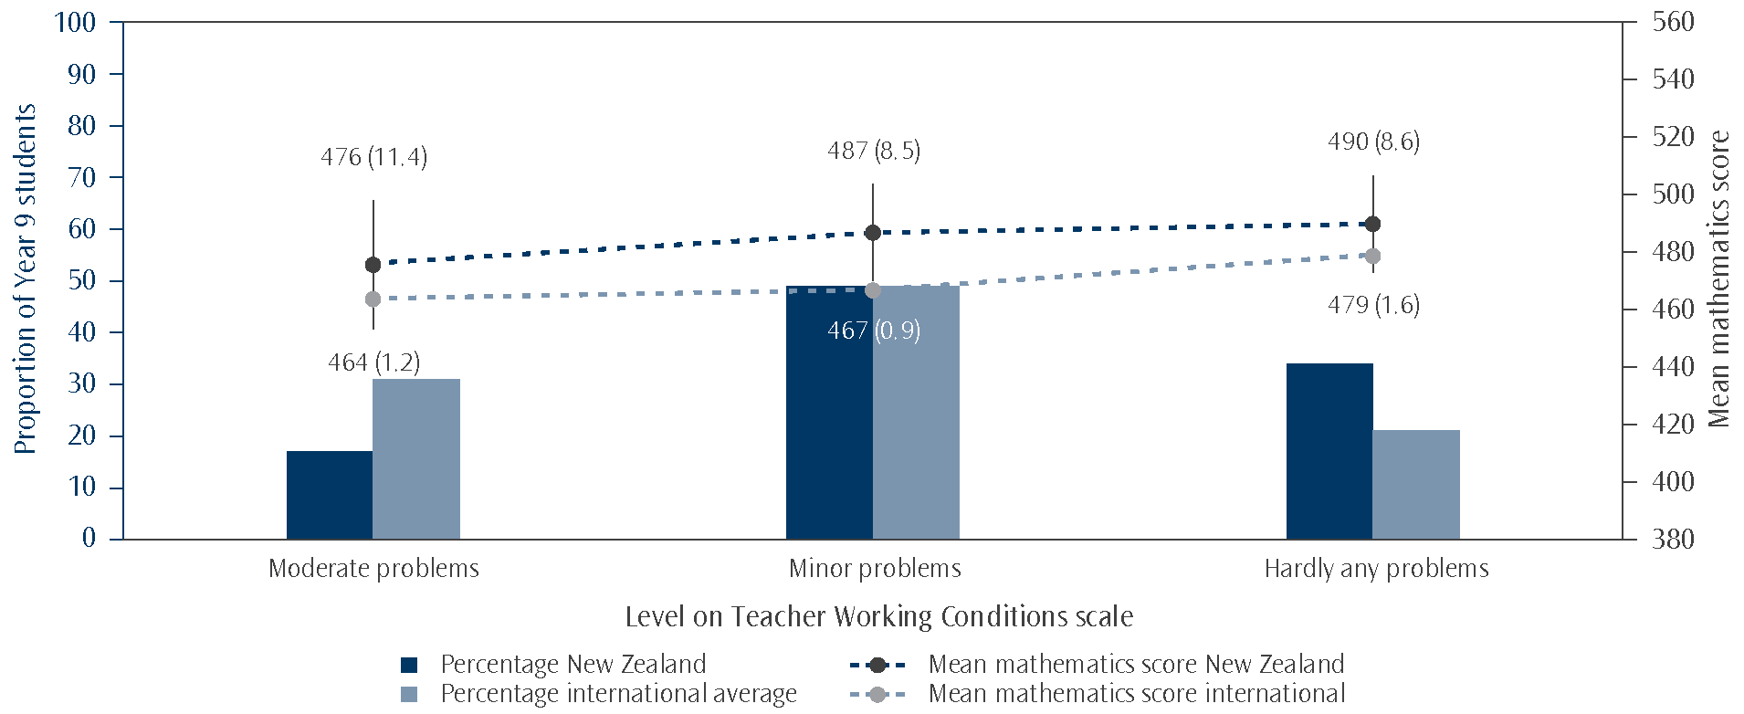
Note: The students who had teachers who selected at most ‘not a problem’ for three out of the five statements and ‘only minor problems’ for the other two, on average, were classified under the Hardly any problems category. Those classified under Moderate problems had teachers who selected at least ‘moderate problem’ for three out of the five statements and ‘minor problem’ for the other two, on average. All the rest were classified under Minor problems.
Source: Adapted from Exhibit 5.11, Mullis, Martin, Foy, and Arora, 2012.

Impact of shortages of resources
Principals were asked to rate whether their school’s capacity to provide instruction was affected by a shortage or inadequacy of any of 12 selected resources using a four-point scale, the response options being none, a little, some, or a lot. The 12 resources are listed in Table 11.19. Of the resources listed, the ones most commonly seen as having an impact on mathematics instructional capability by New Zealand principals was a lack of computers for mathematics instruction (71% impacted at least a little). Twenty-nine percent of students attended schools where their principal did not see the lack of these resources as a hindrance to instruction. A lack of computer software for mathematics was the next most common resource indicated as hindering mathematics instruction (68% impacted at least a little).
Table 11.19: How much principals perceived mathematics instructional capability was limited by lack of resources in New Zealand in TIMSS 2010/11
Resources | Proportion of Year 9 students whose principals indicated  instruction was limited:
Resources | A lot |  | Some |  | A little |  | None
General
Instructional materials | 3 | (1.9) | 11 | (2.7) | 33 | (4.8) | 54 | (4.7)
Supplies | 4 | (2.0) | 8 | (2.3) | 15 | (3.2) | 74 | (4.2)
School buildings and grounds | 7 | (2.7) | 12 | (3.3) | 34 | (4.2) | 48 | (4.1)
Heating/cooling and lighting systems | 5 | (2.4) | 7 | (1.7) | 17 | (3.4) | 72 | (4.2)
Instructional space | 8 | (2.9) | 14 | (3.8) | 27 | (4.1) | 51 | (3.9)
Technologically competent staff | 3 | (1.4) | 17 | (3.4) | 41 | (4.5) | 39 | (4.7)
For mathematics instruction
Teachers with a specialisation in mathematics | 4 | (1.7) | 4 | (2.2) | 30 | (3.2) | 62 | (4.3)
Computers for mathematics instruction | 9 | (2.9) | 23 | (3.9) | 39 | (4.9) | 29 | (4.2)
Computer software for mathematics instruction | 3 | (1.3) | 25 | (3.4) | 40 | (4.2) | 32 | (3.5)
Library materials relevant to mathematics instruction | 2 | (1.0) | 16 | (3.6) | 39 | (5.0) | 44 | (4.4)
Audio-visual resources for mathematics instruction | 1 | (0.8) | 16 | (2.5) | 41 | (4.4) | 42 | (4.4)
Calculators for mathematics instruction | 2 | (1.7) | 10 | (3.0) | 24 | (4.1) | 64 | (4.0)
Note: Standard errors are presented in parentheses.
Proportions in each row should add to 100%; inconsistencies are due to rounding.
This table is based on a selection of resources from the School Questionnaire. Principals were also asked about resources
for science instruction.

Most of the general school resources and the resources for mathematics instruction were also asked about in previous cycles of TIMSS. While there were a few differences between the proportions in 2002/03 versus 2010/11, these had not changed by much.
Computers and software
As shown in Table 11.19, more than 70 percent of New Zealand Year 9 students were in schools where their principal reported that a lack of computers hindered the school’s capacity to provide mathematics instruction at least a little. A lack of computer software for mathematics instruction was also indicated as at least a little hindrance in the schools of almost all the students.
To supplement the questions on computer resources, principals were asked specifically about the number of computers that could be used for instructional purposes (in general, not mathematics specifically) by Year 9 students. Most New Zealand students (88%) were in schools where the number of computers available for use by Year 9 students was large enough that the ratio could be described as one computer for every one to two Year 9 students. However, it should be noted that these may well have to be shared with other year levels.
Teachers and support staff
As shown in Table 11.19, a lack of specialist mathematics teachers hindered the schools of more than a third of students at least a little. Around 60 percent of students attended schools where the principal perceived that a lack of technologically competent staff hindered the school’s capacity to provide instruction at least a little.
Instruction affected by resource shortages
Principals’ responses about how the lack of some of the resources listed in Table 11.19 affect schools’ capacity to provide instruction were combined into a continuous scale: the Instruction Affected by Mathematics Resources Shortages scale. The scales each used the six general school resources and the six subject-specific resources. To report the scale in a meaningful way, values were grouped into three categories: Not affected, Somewhat affected, and Affected a lot.
Forty-four percent of Year 9 students in New Zealand were in schools where principals indicated that resource shortages had not affected mathematics instruction (see Figure 11.9). Fifty-three percent of students were in schools where principals indicated that mathematics resource shortages somewhat affected instruction and three percent of students were in schools where principals indicated that mathematics resource shortages affected instruction a lot. In comparison, fewer students (25%) were in schools internationally, on average, where principals felt that mathematics resource shortages affected instruction not at all.
Figure 11.9: Proportions of students on the Instruction Affected by Mathematics Resource Shortages scale
by mathematics achievement in TIMSS 2010/11
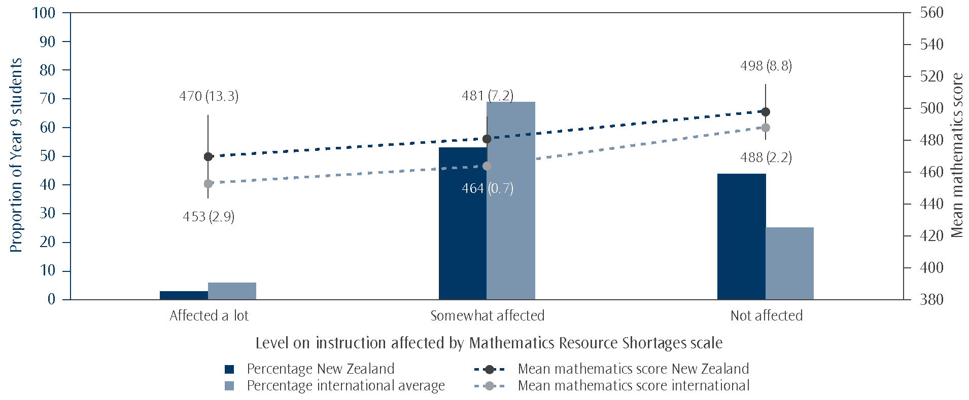
Note: Students with principals who responded at most with ‘not at all’ for six of the twelve resources and ‘a little’ for the other six on average were categorised under Not affected. Students in schools where the principals reported that shortages in at least six out of the twelve resources affected instruction ‘a lot’ and ‘some’ for the other six, on average, are at schools classified as having instruction Affected a lot. All others were in the Somewhat affected category.
Source: Adapted from Exhibit 5.9, Mullis, Martin, Foy, and Arora, 2012.
The general pattern of mathematics achievement for the scale across the three categories, as seen in the international average, is that the less affected the principal reported the school as being by a shortage of mathematics resources, the higher the achievement scores. It is worth noting however that around a third of countries had such small proportions of students in the not affected category that calculating a viable achievement average was not possible and so there was not a third data point to help gauge a trend for those countries. A number of those countries that did have three points were not significantly different across at least two of the categories, New Zealand included (see Table B.9 in the Appendices). There were further exceptions, such as Australia and Singapore, where the achievement for the somewhat affected category was significantly lower than for the other two categories, and Indonesia, where the highest achievement was in the affected a lot category.
Even when broken down by decile groupings,¹⁸ size, and area (rural versus urban) at a national level, the proportion of New Zealand students with principals who reported that mathematics instruction was affected a lot by resource shortages was so small that statistically viable analyses on the mathematics achievement of this group are not possible. However, it is possible to say that those who did indicate that their mathematics instruction was affected a lot came from lower decile, urban schools, and were a mixture of large and small schools.

18 The deciles were grouped as follows: 1 and 2, 3 and 4, 5 and 6, 7 and 8, 9 and 10, and Independent schools were included as a
separate classification.

12. School Leadership
Leaders in schools, through a multitude of possible actions, have the opportunity to influence the learning that takes place there. Recent research has proposed a variety of approaches for exercising school leadership. Davies (2009) offers no less than ten different possibilities including Leithwood and Jantzi’s model of Transformational leadership. This model identifies three categories of leadership practices: setting directions; developing people; and redesigning the organisation.
With a particular focus on the New Zealand context, but drawing on a range of international studies, Robinson, Hohepa and Lloyd (2009) identified five dimensions of school leadership that all have some effect on student achievement: establishing goals and expectations; strategic resourcing; planning, coordinating and evaluating teaching and the curriculum; promoting and participating in teacher learning and development; and ensuring an orderly and supportive environment. The fourth of these dimensions was found to have the biggest effect, and the key finding from this Best Evidence Synthesis was that “the closer educational leaders get to the core business of teaching and learning, the more likely they are to have a positive impact on students” (Robinson et al., 2009, p.47).
This chapter examines a question in TIMSS that collected estimates of the relative time principals spent on a range of activities. The components of the question were defined using research from a variety of sources in response to findings that the school leadership style has an indirect effect on student achievement (Mullis, Martin, et al. 2009). It should be noted that the responses to the question relate only to time spent by principals and so will not reflect tasks which may be taken on by other staff in some schools.
Time spent by principals on leadership activities
In TIMSS 2010/11, principals were asked how much time they had spent on a range of leadership activities in their role as a school principal, ticking either No time, Some time or A lot of time for each activity. The leadership activities identified are shown in Table 12.1 and can be grouped into three broad dimensions: establishing and monitoring the attainment of educational goals; dealing with student behaviour; and developing self and teachers.
The principals of schools with Year 9 students in New Zealand were, on average, less likely than their international counterparts to report spending a lot of time on any of the leadership activities. Those activities where the difference was most pronounced were:
- monitoring teachers’ implementation of the school’s educational goals in their teaching;
- monitoring students’ learning progress to ensure that the school’s educational goals are reached;
- all of the activities dealing with student behaviour;
- initiating a discussion to help teachers who have problems in the classroom; and
- advising teachers who have questions or problems with their teaching.
Table 12.1: Principals’ time spent on leadership activities
 | Percentage of students whose principals spent a lot of time
 | New Zealand | International Average
Goals
Promoting the school’s educational vision or goals | 57 | 64
Developing the school’s curricular and educational goals | 59 | 62
Monitoring teachers’ implementation of the school’s educational goals in their teaching | 30 | 62
Monitoring students’ learning progress to ensure that the school’s educational goals are reached | 42 | 65
Student Behaviour
Keeping an orderly atmosphere in the school | 54 | 75
Ensuring that there are clear rules for student behaviour | 41 | 66
Addressing disruptive student behaviour | 31 | 54
Development
Creating a climate of trust among teachers | 46 | 61
Initiating a discussion to help teachers who have problems in the classroom | 17 | 43
Advising teachers who have questions or problems with their teaching | 16 | 44
Visiting other schools or attending educational conferences for new ideas | 16 | 25
Initiating educational projects or improvements | 37 | 41
Participating in professional development activities specifically for school principals | 20 | 40

TIMSS 2010/11 reveals some clear variations in the way principals report spending their time in different countries. For example, in Japan the average percentages for principals spending a lot of time on each leadership activity range between 8 and 48 percent, while in Korea, which is similarly high-performing, the range is 56 to 89 percent. However, it is not so obvious what the source of this difference might be – does it reflect different expectations of principals or simply different perceptions of what constitutes a lot of time? While acknowledging this subjectivity in the data, the lower than average frequency of principal time spent on addressing student behaviour issues in New Zealand is reassuring.
Time spent on leadership activities and school characteristics
Within New Zealand, neither the socio-economic status nor the size of schools had any particular impact on the time spent by principals on particular leadership activities.
There was no significant difference in the likelihood of reporting a lot of time spent on most of the leadership activities when examined by decile or size of school. There were some differences evident on activities related to student behaviour and to professional development but the groups involved were either too small to draw a valid conclusion or a consistent pattern was not evident.
Time spent on leadership activities and student achievement
For two activities, there were differences observed in achievement between New Zealand students whose principals reported spending no time and those who reported spending some time or a lot of time. However, in each case, there were too few principals in the no time group to reliably compare achievement between these subgroups.
School leaders’ engagement with the core educational activities of their school will take a variety of forms depending on the context. The focus of TIMSS on the amount of time spent offers some insights into the relative priority accorded to various activities by New Zealand principals. It is less useful in judging how well those choices might match the needs of each school, and hence the effectiveness of any particular leadership model.

Conclusion
This report has examined New Zealand’s mathematics achievement in relation to other countries that participated in the study. It looked at trends in New Zealand mathematics achievement at the Year 9 level from 1994 to 2010. An examination of the TIMSS assessment questions in relation to New Zealand’s mathematics curriculum was presented followed by analyses of achievement by sub-groupings (such as gender and ethnicity) and student background factors. Comprehensive coverage of background questions about teaching and learning as well as the school context for learning was also provided. This section will recap these results and pose questions to reflect on them.
Achievement in an international context
New Zealand Year 9 students had mathematics achievement around the middle when compared with other participating countries, lower than 14 countries, similar to 4, and higher than 23 countries. There has been no significant change in the mean mathematics achievement of Year 9 students since the first cycle of TIMSS in 1994/95, although due to a non-significant decrease it is now significantly below the TIMSS scale centre value.
New Zealand lower secondary students performed relatively better on statistics questions (called ‘data display’ in TIMSS) and relatively worse on algebra questions. The cognitive aspects of reasoning and applying were relative strengths for Year 9 students while knowing was a relative weakness.
When compared with other countries, the range of achievement within New Zealand was moderate. This is in contrast to the 15-year-old students assessed in PISA where New Zealand has one of the widest ranges of achievement. There was a relatively high proportion of very low achievers (students who did not reach the low benchmark) in this cycle of TIMSS compared with countries with similar or higher mean mathematics achievement.
Clearly there are strengths and weaknesses reflected in these results. The advantage of this large-scale international assessment is that we can see what other countries have done to improve their systems and learn from them. The TIMSS encyclopaedia (Mullis, Martin, Minnich, et al., 2012) has articles from participating countries, giving summaries of curriculum expectations and details of changes they have made in their system since the beginning of TIMSS in 1994/95. For example, Chinese Taipei, a high-performing country in TIMSS, since 2001 has focussed on assisting disadvantaged students to learn mathematics and on enhancing the interest and self-confidence of all students in learning mathematics and science.
Equity in the New Zealand system
This report has raised some concerns about equity in the New Zealand education system. Year 9 boys had higher mathematics achievement, on average, than girls. Since the previous cycle of TIMSS (2002/03), there has been a significant decrease in achievement for Year 9 girls, and a small non-significant increase for Year 9 boys. This cycle (2010/11) is now the first to show a significant difference between the boys and the girls.
There were advanced achievers and very low achievers in all ethnic groupings. However, there were proportionately more Pākehā/European and Asian advanced achievers compared with the Pasifika and Māori ethnic groupings. There were also more very low achievers among Pasifika and Māori groupings than among Pākehā/European and Asian groupings. There has been a significant decrease in mean achievement among Pākehā/European students since the first cycle of TIMSS in 1994/95.
Regardless of the measure¹⁹ used to assess socio-economic status (SES), students with lower SES had lower achievement than students with higher SES. In particular, on an international measure of the SES of the school attended, students in schools with a greater concentration of affluent students had higher achievement than students in schools with a greater concentration of disadvantaged students. On this measure New Zealand had one of the largest differences in achievement between these two groups.
The Ministry has, as one of its highest priorities, a focus on raising achievement for priority learners (Māori learners, Pasifika learners, learners with special needs, and learners from poor socio-economic backgrounds). The findings from the latest cycle of TIMSS are consistent with those from earlier cycles and from other studies (e.g., PISA and NEMP) and show that the education system is not delivering equitable outcomes for these students. The challenges for all involved in education is how we are going to support these learners to reach their potential. For example, two things the evidence demonstrates are critical for priority learners are the importance of early learning before a child reaches school age and the quality of relationships between the school and parents and whānau.
Student attitudes
Nearly all Year 9 students planned to get some form of qualification, some with expectations at the secondary level and some at tertiary.
Year 9 students in New Zealand were generally positive about learning mathematics. Compared to other countries, on average, similar proportions of New Zealand Year 9 students were confident and valued mathematics, but fewer liked it. Students who were more positive about learning mathematics had, on average, higher achievement than those who were more negative. The self-confidence of students had a stronger relationship with mathematics achievement than how much they liked or valued learning mathematics.
Year 9 boys’ enjoyment, confidence and valuing of learning mathematics were all higher than that of girls in New Zealand. Nearly half of girls reported not liking and not being confident in mathematics.
A greater proportion of Pasifika and Asian students reported liking and valuing learning mathematics, compared with Māori or Pākehā/European students. Asian students were more likely to report high levels of confidence in learning mathematics than students from any of the other ethnic groupings.
Teaching
Instructional hours in mathematics in New Zealand lower secondary classrooms were about average when compared to other countries. As with previous cycles, in this cycle of TIMSS, many students were in classes working at a lower level of the curriculum than was intended. For example, most Year 9 students are expected to be working at level 5 by the end of the year. One of the issues this raises is whether or not the expectations for learners in Year 9 mathematics are set too low and what that means for teaching and learning at the lower secondary level.
More New Zealand lower secondary teachers felt well prepared to teach topics in mathematics compared with their peers in other countries but slightly fewer expressed high levels of confidence in their ability to teach mathematics. As mentioned earlier, New Zealand Year 9 students were moderately confident compared with other countries but fewer reported liking it.

19 SES measures included collection of proxy information from students such as the number of books at home and home possessions as well as measures of the SES of the school such as decile and principals’ estimates of the level of affluence and disadvantage among the school population.
New Zealand teachers tended to require memorisation of facts less frequently than their peers in other countries did. Similarly, they used assessment less frequently than their peers did in other countries, on average. New Zealand mathematics classrooms were less likely to have computers available for instructional use compared with other countries. New Zealand mathematics teachers tended to use textbooks more as a supplement rather than as a basis for instruction. In contrast, teachers in other countries were more likely to use textbooks as a basis for instruction. These findings raise the issue of how computers and textbooks are integrated into teaching and learning to best support students learning mathematics at Year 9.
School climate for learning
Year 9 students generally perceived their school to be a good place to be. More than eight out of ten students agreed that they felt like they belonged at school and were safe there. A higher proportion of girls than boys were positive about school and Pasifika and Asian students were the most positive of the ethnic groupings. However, fewer New Zealand Year 9 students liked being at school compared to the average student internationally.
The proportion of New Zealand Year 9 students experiencing negative behaviours at school was similar to the average internationally. A higher proportion of boys than girls experienced these behaviours but no particular ethnic grouping experienced these negative behaviours more than would be expected based on their proportion of the population.
Teachers and principals were generally very positive about their school climate for learning, including having a safe environment, knowledgeable staff, supportive parents, and well-behaved students. However, principals tended to be slightly less positive about the teaching staff (more likely to say ‘high’ than ‘very high’ compared with the teachers) and more positive about parental support (more likely to say ‘very high’ than ‘high’) than the teachers.
Mathematics teachers of Year 9 students indicated that there were several factors that presented at least some limitations to their teaching, particularly having students with a lack of prerequisite knowledge or skills. More than half of the TIMSS Year 9 students had teachers who perceived various issues were at least a minor problem in their current school, particularly teachers having too many teaching hours or inadequate workspace. New Zealand teachers were relatively positive about their working conditions compared to most other TIMSS countries.
A lack of computers and computer software for mathematics instruction were the resources most commonly seen by principals as having an impact on instruction.
School leadership
Principals of New Zealand schools with Year 9 students in them were, on average, less likely than their international counterparts to report spending a lot of time on any leadership activity. Previous cycles of TIMSS have shown that New Zealand principals spend more of their time on administrative tasks than nearly all other countries.
Final comment
Although Year 9 mathematics results in TIMSS are not as concerning as Year 5 in terms of comparisons with other cycles or other countries, New Zealand Year 5 students will soon be in Year 9. As well as providing us with a snapshot of student achievement in mathematics at middle primary and lower secondary schooling, TIMSS also provides us with valuable information about how the New Zealand education system changes – or does not – over time and in an international context. This allows education stakeholders at all levels of the education system to reflect on the different aspects examined in TIMSS as part of a review of their policies and practices.

Appendices
Sampling Notes for Figure 1.1
1. National Target Population does not include all of the International Target Population.
2. National Defined Population covers 90% to 95% of National Target Population.
3. National Defined population covers less than 90% of National Target population (but at least 77%)
‡ Nearly satisfied guidelines for sample participation rates after replacement schools were included.
ψ Reservations about reliability of average achievement because the percentage of students with achievement
too low for estimation does not exceed 25% but exceeds 15%.
Ж Average achievement not reliably measured because the percentage of students with achievement too low for estimation exceeds 25%.
Results of multiple classifications of ethnicity
Students were asked to identify their ethnicity using 12 categories, the 12th one being ‘Other’ group. In order to have groupings large enough to make reasonable predictions among the population, these twelve categories were summarised into five broad ethnic groupings, Pākehā/European, Māori, Pasifika, Asian, and ‘Other’. Students were able to select more than one ethnic group so students categorised here as Pākehā/European may also be in one of the other four ethnic groupings. When using these overlapping groupings, achievement cannot be compared across ethnic groupings or against an overall New Zealand average.
Table A.1: New Zealand Year 9 mathematics achievement for overlapping ethnic groupings (multiple classification of ethnicity)
Overlapping ethnic grouping – student ticked the listed group and may also have ticked another group | Mean mathematics score
Student ticked Pākehā/European or Other European | 498 | (4.7)
Student ticked Māori | 451 | (5.7)
Student ticked at least one of the Pacific Islands groups | 442 | (8.7)
Student ticked at least one of the Asian groups | 530 | (8.8)
Student ticked Other ethnic group | 483 | (10.4)
Note: Standard errors are presented in parentheses.

International comparisons for school climate
Table B.1: Proportion of students at each level of the School Emphasis on Academic Success (teachers’ reports) scale and mathematics achievement in TIMSS 2010/11
Country | Proportion of students in each level of the School Emphasis  on Academic Success (teachers’ reports) scale
Country | Medium emphasis |  |  |  |  | High emphasis |  |  |  |  | Very high emphasis
Country | % of  students |  |  | Mean  mathematics  score |  |  | % of  students |  | Mean  mathematics  score |  |  | % of students |  | Mean mathematics score
England |  | 24 | (3.9) | 488 | (12.2) |  | 59 | (4.1) | 508 | (7.3) |  | 16 | (2.4) | 526 | (11.0)
United States |  | 32 | (2.4) | 494 | (4.7) |  | 55 | (2.6) | 517 | (4.9) |  | 13 | (2.0) | 538 | (10.1)
Australia |  | 37 | (3.9) | 475 | (7.5) |  | 50 | (3.7) | 515 | (7.7) |  | 13 | (2.4) | 569 | (15.2)
Chinese Taipei |  | 26 | (3.3) | 583 | (5.7) |  | 63 | (3.7) | 612 | (4.7) |  | 11 | (2.2) | 659 | (11.6)
New Zealand |  | 32 | (3.2) | 468 | (9.6) |  | 59 | (3.4) | 491 | (6.8) |  | 9 | (2.1) | 520 | (17.4)
Korea, Rep of |  | 36 | (3.1) | 605 | (4.3) |  | 56 | (3.3) | 615 | (4.4) |  | 8 | (1.5) | 624 | (8.2)
Japan |  | 43 | (4.2) | 557 | (3.5) |  | 52 | (4.2) | 578 | (3.9) |  | 5 | (1.9) | 599 | (14.3)
Singapore |  | 41 | (2.4) | 587 | (6.2) |  | 55 | (2.6) | 625 | (5.1) |  | 4 | (1.1) | 681 | (12.8)
Hong Kong SAR |  | 47 | (4.3) | 553 | (6.9) |  | 50 | (4.5) | 615 | (6.6) |  | 2 | (1.4) | ~ | ~
Finland |  | 47 | (3.8) | 510 | (2.8) |  | 51 | (3.7) | 518 | (3.4) |  | 1 | (0.9) | ~ | ~
International Avg. |  | 47 | (0.5) | 452 | (0.9) |  | 48 | (0.6) | 478 | (0.9) |  | 5 | (0.3) | 506 | (3.4)
Note: Standard errors are presented in parentheses.
The order of this table is based on percentage of students in the Very high emphasis category.
A tilde (~) indicates insufficient data to report achievement.
Source: Adapted from Exhibit 6.4, Mullis, Martin, Foy, and Arora, 2012.

Table B.2: Proportion of students at each level of the Teachers Career Satisfaction scale and mathematics achievement in TIMSS 2010/11
Country | Proportion of students in each level of the Teachers Career Satisfaction scale
Country | Less than satisfied |  |  |  | Somewhat satisfied |  |  |  | Satisfied
Country | % of  students |  | Mean mathematics score |  | % of  students |  | Mean mathematics score |  | % of  students |  | Mean mathematics score
New Zealand | 10 | (2.2) | 479 | (16.0) | 41 | (3.9) | 483 | (7.8) | 49 | (4.2) | 495 | (8.3)
United States | 9 | (1.3) | 503 | (10.4) | 43 | (2.4) | 510 | (4.5) | 48 | (2.4) | 515 | (5.0)
England | 10 | (2.8) | 466 | (20.3) | 44 | (3.9) | 507 | (9.1) | 46 | (4.0) | 513 | (8.0)
Hong Kong SAR | 6 | (1.8) | 547 | (25.9) | 52 | (4.4) | 583 | (6.1) | 42 | (4.3) | 597 | (7.0)
Australia | 15 | (2.8) | 487 | (13.8) | 43 | (3.4) | 505 | (8.3) | 42 | (3.9) | 516 | (8.3)
Chinese Taipei | 10 | (2.4) | 602 | (7.3) | 57 | (3.9) | 610 | (5.2) | 33 | (4.0) | 611 | (7.8)
Singapore | 9 | (1.5) | 597 | (9.6) | 62 | (2.5) | 603 | (5.3) | 29 | (2.5) | 634 | (6.7)
Japan | 12 | (2.5) | 552 | (5.8) | 63 | (3.6) | 566 | (3.7) | 25 | (3.0) | 588 | (5.6)
Korea, Rep of | 22 | (2.7) | 602 | (6.9) | 67 | (2.9) | 616 | (3.5) | 11 | (1.8) | 610 | (8.9)
International Avg. | 7 | (0.3) | 462 | (2.4) | 45 | (0.6) | 464 | (1.0) | 47 | (0.6) | 473 | (0.9)
Note: Standard errors are presented in parentheses.
The order of this table is based on percentage of students in the Satisfied category.
A tilde (~) indicates insufficient data to report achievement.
Source: Adapted from Exhibit 7.16, Mullis, Martin, Foy, and Arora, 2012.
Table B.3: Proportion of students at each level of the School Emphasis on Academic Success
(principals’ reports) scale and mathematics achievement in TIMSS 2010/11
Country | Proportion of students in each level of the  School Emphasis on Academic Success (principals’ reports) scale
Country | Medium emphasis |  |  |  | High emphasis |  |  |  | Very high emphasis
Country | % of  students |  | Mean mathematics score |  | % of  students |  | Mean mathematics score |  | % of  students |  | Mean  mathematics  score
England | 19 | (3.4) | 477 | (14.7) | 56 | (4.7) | 509 | (8.2) | 26 | (3.5) | 525 | (12.3)
Australia | 32 | (3.1) | 476 | (7.4) | 48 | (3.8) | 509 | (5.9) | 20 | (2.7) | 558 | (15.8)
New Zealand | 20 | (3.3) | 467 | (6.7) | 61 | (4.9) | 484 | (7.1) | 19 | (3.8) | 524 | (9.2)
Korea, Rep of | 28 | (3.6) | 597 | (3.8) | 56 | (4.3) | 613 | (3.8) | 16 | (3.2) | 637 | (7.3)
United States | 24 | (2.1) | 486 | (5.4) | 61 | (2.7) | 515 | (3.7) | 15 | (2.0) | 532 | (8.0)
Chinese Taipei | 7 | (1.7) | 579 | (7.7) | 81 | (3.3) | 605 | (3.8) | 12 | (2.8) | 657 | (15.1)
Singapore | 29 | (0.0) | 586 | (7.8) | 60 | (0.0) | 614 | (4.2) | 11 | (0.0) | 651 | (11.2)
Indonesia | 32 | (4.4) | 377 | (5.9) | 60 | (4.8) | 387 | (6.7) | 8 | (2.2) | 417 | (18.8)
Finland | 25 | (3.9) | 501 | (4.3) | 71 | (4.1) | 517 | (2.8) | 4 | (1.8) | 530 | (8.2)
Hong Kong SAR | 47 | (4.3) | 554 | (7.7) | 51 | (4.1) | 608 | (5.9) | 3 | (1.6) | 662 | (40.2)
Palestinian National Authority | 46 | (4.2) | 400 | (6.5) | 52 | (4.1) | 408 | (5.0) | 3 | (1.4) | 404 | (10.8)
Japan | 47 | (4.3) | 556 | (3.8) | 52 | (4.4) | 580 | (4.0) | 2 | (1.1) | ~ | ~
International Avg. | 41 | (0.5) | 449 | (1.0) | 53 | (0.6) | 477 | (0.9) | 7 | (0.3) | 495 | (3.1)
Note: Standard errors are presented in parentheses.
The order of this table is based on percentage of students in the Very high emphasis category.
A tilde (~) indicates insufficient data to report achievement.
Source: Adapted from Exhibit 6.2 , Mullis, Martin, Foy, and Arora, 2012.

Table B.4: Proportion of students at each level of the Students Bullied at School scale
and mathematics achievement in TIMSS 2010/11
Country | Proportion of students in each level of the Students Bullied at School scale
Country | About weekly |  |  |  | About monthly |  |  |  | Almost never
Country | % of  students |  | Mean mathematics score |  | % of  students |  | Mean mathematics score |  | % of  students |  | Mean  mathematics  score
England | 7 | (0.6) | 486 | (11.1) | 24 | (0.7) | 511 | (6.0) | 68 | (1.1) | 509 | (5.6)
Chinese Taipei | 7 | (0.4) | 580 | (5.7) | 26 | (0.8) | 611 | (3.8) | 67 | (1.0) | 612 | (3.7)
Korea, Rep of | 7 | (0.5) | 603 | (5.7) | 28 | (0.9) | 616 | (3.7) | 65 | (1.1) | 613 | (3.1)
Japan | 9 | (0.6) | 562 | (6.0) | 28 | (0.8) | 576 | (3.4) | 63 | (1.2) | 566 | (3.2)
United States | 9 | (0.3) | 496 | (3.3) | 28 | (0.6) | 510 | (3.5) | 63 | (0.7) | 513 | (2.7)
Australia | 11 | (0.7) | 480 | (7.3) | 31 | (1.0) | 504 | (5.3) | 58 | (1.1) | 511 | (5.3)
New Zealand | 12 | (0.5) | 471 | (6.3) | 33 | (0.7) | 489 | (5.9) | 55 | (0.9) | 495 | (5.3)
Hong Kong SAR | 10 | (0.7) | 582 | (8.4) | 36 | (1.0) | 589 | (3.8) | 54 | (1.3) | 585 | (4.2)
Singapore | 12 | (0.5) | 589 | (5.4) | 36 | (0.6) | 609 | (4.0) | 52 | (0.8) | 618 | (3.9)
Thailand | 27 | (0.8) | 424 | (4.5) | 43 | (0.7) | 431 | (4.8) | 30 | (0.8) | 426 | (4.7)
International Avg. | 12 | (0.1) | 441 | (1.0) | 29 | (0.1) | 467 | (0.7) | 59 | (0.2) | 473 | (0.6)
Note: Standard errors are presented in parentheses.
The order of this table is based on percentage of students in the Almost never category.
Source: Adapted from Exhibit 6.12 , Mullis, Martin, Foy, and Arora, 2012.
Table B.5: Proportion of students at each level of the Safe and Orderly School scale and mathematics achievement in TIMSS 2010/11
Country | Proportion of students in each level of the Safe and Orderly School scale
Country | Not safe and orderly |  |  |  | Somewhat safe and orderly |  |  |  | Safe and orderly
Country | % of  students |  | Mean mathematics score |  | % of  students |  | Mean mathematics score |  | % of  students |  | Mean mathematics  score
Singapore | 2 | (0.7) | ~ | ~ | 39 | (2.4) | 596 | (5.8) | 58 | (2.4) | 623 | (5.1)
Australia | 9 | (2.3) | 465 | (17.0) | 36 | (3.9) | 482 | (7.0) | 55 | (4.2) | 530 | (8.3)
New Zealand | 5 | (1.8) | 486 | (16.8) | 40 | (3.5) | 475 | (10.2) | 55 | (3.3) | 495 | (6.9)
United States | 8 | (1.7) | 500 | (13.2) | 38 | (2.1) | 494 | (4.6) | 54 | (2.5) | 526 | (4.3)
Hong Kong SAR | 1 | (0.0) | ~ | ~ | 45 | (4.7) | 564 | (8.2) | 54 | (4.7) | 599 | (6.8)
England | 6 | (1.9) | 505 | (19.1) | 42 | (4.2) | 487 | (10.3) | 53 | (4.5) | 521 | (7.2)
Turkey | 13 | (2.1) | 407 | (7.6) | 49 | (3.3) | 441 | (5.8) | 38 | (2.2) | 483 | (8.3)
Chile | 15 | (3.1) | 376 | (6.9) | 51 | (4.1) | 408 | (4.0) | 34 | (3.4) | 447 | (6.5)
Chinese Taipei | 12 | (2.7) | 593 | (10.9) | 57 | (3.8) | 603 | (5.0) | 31 | (3.7) | 627 | (6.7)
Tunisia | 17 | (2.8) | 424 | (6.1) | 61 | (3.4) | 427 | (4.5) | 22 | (3.1) | 419 | (6.4)
Slovenia | 7 | (1.6) | 502 | (9.3) | 75 | (2.5) | 503 | (2.6) | 19 | (2.4) | 511 | (4.9)
Japan | 15 | (2.6) | 560 | (5.1) | 71 | (3.6) | 567 | (3.1) | 14 | (3.0) | 593 | (10.5)
Korea, Rep of | 13 | (2.3) | 607 | (8.5) | 74 | (2.9) | 611 | (3.6) | 13 | (2.4) | 624 | (8.3)
International Avg | 6 | (0.3) | 445 | (3.1) | 49 | (0.6) | 458 | (0.9) | 45 | (0.5) | 479 | (1.0)
Note: Standard errors are presented in parentheses.
The order of this table is based on percentage of students in the Safe and orderly category.
A tilde (~) indicates insufficient data to report achievement.
Source: Adapted from Exhibit 6.8 , Mullis, Martin, Foy, and Arora, 2012.

Table B.6: Proportion of students at each level of the School Discipline and Safety scale and mathematics achievement in TIMSS 2010/11
Country | Proportion of students in each level of the School Discipline and Safety scale
Country | Moderate problems |  |  |  | Minor problems |  |  |  | Hardly any problems
Country | % of  students |  | Mean mathematics score |  | % of  students |  | Mean mathematics score |  | % of  students |  | Mean mathematics score
Kazakhstan | 0 | (0.0) | ~ | ~ | 56 | (4.1) | 486 | (5.4) | 44 | (4.1) | 488 | (6.9)
Chinese Taipei | 1 | (0.8) | ~ | ~ | 58 | (4.3) | 609 | (4.8) | 41 | (4.2) | 611 | (6.6)
Hong Kong SAR | 1 | (1.0) | ~ | ~ | 73 | (4.5) | 572 | (6.0) | 26 | (4.3) | 629 | (6.4)
Singapore | 1 | (0.0) | ~ | ~ | 74 | (0.0) | 599 | (4.5) | 25 | (0.0) | 645 | (6.6)
Japan | 21 | (3.5) | 550 | (4.4) | 56 | (4.8) | 570 | (4.2) | 23 | (3.9) | 587 | (7.9)
Korea, Rep of | 17 | (3.3) | 601 | (6.9) | 61 | (4.4) | 614 | (3.3) | 22 | (3.4) | 617 | (4.3)
England | 5 | (2.3) | 456 | (31.6) | 76 | (4.3) | 508 | (7.4) | 19 | (3.9) | 519 | (13.0)
United States | 9 | (1.3) | 477 | (10.4) | 78 | (2.1) | 512 | (3.3) | 13 | (1.9) | 524 | (7.5)
Australia | 11 | (1.9) | 479 | (11.4) | 76 | (3.0) | 502 | (4.7) | 13 | (2.3) | 569 | (20.1)
New Zealand | 9 | (2.5) | 477 | (15.7) | 85 | (2.9) | 487 | (5.8) | 6 | (1.5) | 529 | (9.9)
International Avg. | 18 | (0.4) | 437 | (1.8) | 66 | (0.5) | 467 | (0.7) | 16 | (0.4) | 483 | (1.7)
Note: Standard errors are presented in parentheses.
The order of this table is based on percentage of students in the Hardly any problems category.
A tilde (~) indicates insufficient data to report achievement.
Source: Adapted from Exhibit 6.10 , Mullis, Martin, Foy, and Arora, 2012.
Table B.7: Proportion of students at each level of the Collaborate to Improve Teaching scale
and mathematics achievement in TIMSS 2010/11
Country | Proportion of students in each level of the Collaborate to Improve Teaching scale
Country | Somewhat collaborative |  |  |  | Collaborative |  |  |  | Very collaborative
Country | % of  students |  | Mean mathematics score |  | % of  students |  | Mean mathematics score |  | % of  students |  | Mean mathematics score
Bahrain | 8 | (1.9) | 392 | (8.3) | 42 | (3.1) | 413 | (6.0) | 51 | (3.4) | 410 | (4.5)
Qatar | 4 | (0.9) | 488 | (18.5) | 46 | (4.4) | 417 | (8.1) | 51 | (4.4) | 397 | (8.9)
United States | 22 | (2.1) | 520 | (6.4) | 40 | (2.9) | 510 | (4.5) | 39 | (2.7) | 509 | (5.7)
Australia | 12 | (2.1) | 490 | (8.8) | 55 | (4.0) | 509 | (8.1) | 32 | (3.9) | 510 | (10.0)
Jordan | 14 | (2.9) | 380 | (12.4) | 61 | (4.1) | 412 | (5.0) | 24 | (3.6) | 406 | (6.9)
England | 20 | (3.1) | 512 | (16.5) | 57 | (4.2) | 505 | (7.9) | 24 | (3.8) | 502 | (12.4)
New Zealand | 16 | (2.5) | 477 | (9.4) | 62 | (4.2) | 497 | (6.6) | 22 | (3.3) | 461 | (9.2)
Singapore | 13 | (1.8) | 616 | (10.9) | 70 | (2.3) | 610 | (4.8) | 17 | (1.7) | 611 | (9.4)
Japan | 24 | (3.4) | 571 | (5.0) | 61 | (3.8) | 569 | (4.0) | 15 | (2.7) | 572 | (9.1)
Korea, Rep of | 23 | (2.6) | 610 | (6.8) | 62 | (2.9) | 613 | (3.7) | 15 | (2.3) | 613 | (7.5)
Chinese Taipei | 31 | (3.8) | 601 | (8.0) | 56 | (4.4) | 614 | (5.0) | 13 | (2.9) | 610 | (9.4)
Hong Kong SAR | 18 | (3.1) | 608 | (9.1) | 71 | (3.7) | 581 | (5.5) | 11 | (3.0) | 584 | (13.2)
International Avg. | 15 | (0.4) | 465 | (1.9) | 57 | (0.6) | 468 | (0.8) | 28 | (0.5) | 467 | (1.2)
Note: Standard errors are presented in parentheses.
The order of this table is based on percentage of students in the Very collaborative category.
Source: Adapted from Exhibit 8.13 , Mullis, Martin, Foy, and Arora, 2012.

Table B.8: Proportion of students at each level of the Teacher Working Conditions scale and mathematics achievement in TIMSS 2010/11
Country | Proportion of students in each level of the Teacher Working Conditions scale
Country | Moderate problems |  |  |  | Minor problems |  |  |  | Hardly any problems
Country | % of  students |  | Mean mathematics score |  | % of  students |  | Mean mathematics score |  | % of  students |  | Mean mathematics score
United States | 10 | (1.6) | 497 | (8.3) | 41 | (2.4) | 511 | (4.4) | 48 | (2.6) | 515 | (5.0)
New Zealand | 17 | (2.6) | 476 | (11.4) | 49 | (3.9) | 487 | (8.5) | 34 | (4.0) | 490 | (8.6)
Australia | 16 | (3.1) | 489 | (12.7) | 51 | (3.7) | 511 | (8.2) | 32 | (4.0) | 510 | (7.7)
England | 14 | (2.9) | 479 | (13.7) | 55 | (4.4) | 516 | (8.5) | 30 | (4.4) | 500 | (8.2)
Hungary | 20 | (2.8) | 532 | (6.4) | 50 | (3.4) | 498 | (5.8) | 30 | (3.4) | 496 | (6.3)
Singapore | 18 | (2.0) | 598 | (8.9) | 54 | (3.0) | 606 | (5.6) | 28 | (2.0) | 630 | (7.3)
Georgia | 21 | (3.2) | 455 | (7.7) | 57 | (3.6) | 428 | (5.0) | 22 | (3.2) | 420 | (11.7)
Japan | 38 | (4.2) | 563 | (4.3) | 40 | (4.3) | 575 | (5.3) | 22 | (3.5) | 571 | (8.0)
Chinese Taipei | 26 | (3.5) | 625 | (7.7) | 53 | (3.7) | 602 | (4.4) | 21 | (3.4) | 609 | (10.9)
Hong Kong SAR | 23 | (4.1) | 573 | (14.1) | 62 | (4.5) | 585 | (5.8) | 15 | (3.5) | 591 | (14.6)
Korea, Rep of | 56 | (2.9) | 621 | (4.1) | 36 | (2.9) | 600 | (4.7) | 8 | (1.7) | 610 | (10.0)
International Avg. | 31 | (0.5) | 464 | (1.2) | 49 | (0.6) | 467 | (0.9) | 21 | (0.5) | 479 | (1.6)
Note: Standard errors are presented in parentheses.
The order of this table is based on percentage of students in the Hardly any problems category.
A tilde (~) indicates insufficient data to report achievement.
Source: Adapted from 5.11 , Mullis, Martin, Foy, and Arora, 2012.
Table B.9: Proportion of students at each level of the Instruction Affected by Mathematics Resource Shortages scale in TIMSS 2010/11
Country | Proportion of students in each level of the Instruction Affected by Mathematics Resource Shortages scale
Country | Affected a lot |  |  |  | Somewhat affected |  |  |  | Not affected
Country | % of  students |  | Mean mathematics score |  | % of  students |  | Mean mathematics score |  | % of  students |  | Mean  mathematics  score
Singapore | 11 | (0.0) | 625 | (11.4) | 22 | (0.0) | 594 | (7.4) | 67 | (0.0) | 614 | (4.5)
Korea, Rep. of | 2 | (1.1) | ~ | ~ | 40 | (4.3) | 608 | (4.9) | 58 | (4.2) | 615 | (3.2)
Australia | 3 | (1.5) | 516 | (15.5) | 46 | (3.2) | 489 | (5.7) | 51 | (3.5) | 525 | (8.6)
England | 0 | (0.0) | ~ | ~ | 52 | (4.2) | 516 | (8.2) | 48 | (4.2) | 498 | (8.1)
New Zealand | 3 | (1.9) | 470 | (13.3) | 53 | (4.4) | 481 | (7.2) | 44 | (4.3) | 498 | (8.8)
United States | 2 | (0.7) | ~ | ~ | 55 | (2.7) | 502 | (3.9) | 43 | (2.6) | 520 | (4.7)
Hong Kong SAR | 6 | (2.3) | 553 | (32.6) | 54 | (4.8) | 573 | (7.3) | 41 | (4.4) | 605 | (7.8)
Japan | 0 | (0.0) | ~ | ~ | 62 | (4.4) | 563 | (3.0) | 38 | (4.4) | 581 | (5.1)
Chinese Taipei | 3 | (1.3) | 608 | (15.0) | 65 | (4.0) | 609 | (4.2) | 33 | (4.1) | 610 | (8.0)
International Avg. | 6 | (0.3) | 453 | (2.9) | 69 | (0.5) | 464 | (0.7) | 25 | (0.5) | 488 | (2.2)
Note: Standard errors are presented in parentheses.
The order of this table is based on percentage of students in the Not affected category.
A tilde (~) indicates insufficient data to report achievement.
Source: Adapted from Exhibit 5.9 , Mullis, Martin, Foy, and Arora, 2012.

References
Adesope, O. O., Lavin, T., Thompson, T., and Ungerleider, C. (2010). A systematic review and meta-analysis of the cognitive correlates of bilingualism. Review of Educational Research, 80 (2), 207-245.
Biddulph, F., Biddulph, J., and Biddulph, C. (2003). The complexity of community and family influences on children’s achievement in New Zealand: best evidence synthesis. Wellington, Ministry of Education.
Boyd, S., & Barwick, H.(2011). Well-being at school: building a safe and caring school climate that deters bullying (summary booklet). Wellington: New Zealand Council for Educational Research. Retrieved from www.nzcer.org.nz/system/files/wellbeing-at-school-booklet.pdf
Caygill, R., & Kirkham, S. (2008). Trends in year 5 mathematics achievement 1994 to 2006: New Zealand results from three cycles of the Trends in International Mathematics and Science Study (TIMSS). Wellington: Ministry of Education.
Caygill. R., & Sok, S. (2008). PISA 2006 school context of science achievement: how ready are our 15-year-olds for tomorrow’s world? Wellington: Ministry of Education.
Caygill. R., Kirkham, S, Marshall, N. (2013a). Year 5 students’ mathematics achievement in 2010/11: New Zealand results from the Trends in International Mathematics and Science Study (TIMSS) Wellington: Ministry of Education.
Caygill. R., Kirkham, S, Marshall, N. (2013b). Year 5 students’ science achievement in 2010/11: New Zealand results from the Trends in International Mathematics and Science Study (TIMSS) Wellington: Ministry of Education.
Caygill. R., Kirkham, S, Marshall, N. (2013c). Year 9 students’ science achievement in 2010/11: New Zealand results from the Trends in International Mathematics and Science Study (TIMSS) Wellington: Ministry of Education.
CBI. (2010). Ready to grow: business priorities for education and skills; education and skills survey 2010. Retrieved from www.nationalstemcentre.org.uk/res/documents/page/180510100243CBI-EDI%20Education%20and%20Skills%20 Survey%202010.pdf.
Chamberlain, M., (2007). Mathematics and science achievement in New Zealand: summing up New Zealand’s participation in three cycles of TIMSS at Year 9. Wellington: Ministry of Education.
Cho, J. Kim, S. Kim, M. & Rim, H. (2012). Republic of Korea. In Mullis, I. B. S., Martin, M. O., Minnich, C. A., Stanco, G. M., Arora, A., Centurino, V. A, S, & Castle, C. E. (Eds.). TIMSS 2011 encyclopedia: education policy and curriculum in mathematics and science Volume 1: A-K. Chestnut Hill, MA: TIMSS & PIRLS International Study Center, Boston College.
Coelli, M., and Green, D.A. (2012). Leadership effects: school principals and student outcomes. Economics of Education Review, 31(2012)92-109.
Davies, B. (Ed.). (2009). The essentials of school leadership (2nd ed.). Los Angeles: Sage.
Earle, D., (2009). Advanced trade, technical and professional qualifications – trends in supply. Wellington: Ministry of Education.
Elijio, A. (2012). Lithuania. In Mullis, I. B. S., Martin, M. O., Minnich, C. A., Stanco, G. M., Arora, A., Centurino, V. A, S, & Castle, C. E. (Eds.). TIMSS 2011 encyclopedia: education policy and curriculum in mathematics and science Volume 2: L-Z. Chestnut Hill, MA: TIMSS & PIRLS International Study Center, Boston College.
Jen, T. H. Lee, C. D. Chen, K. M. Lin, C. Y. & Lo, P. H. (2012). Chinese Taipei. In Mullis, I. B. S., Martin, M. O., Minnich, C. A., Stanco, G. M., Arora, A., Centurino, V. A, S, & Castle, C. E. (Eds.). TIMSS 2011 encyclopedia: education policy and curriculum in mathematics and science Volume 1: A-K. Chestnut Hill, MA: TIMSS & PIRLS International Study Center, Boston College.
Ministry of Education. (2007). The New Zealand curriculum. Wellington: Learning Media.
Ministry of Education. (2007). Boys’ achievement: a synthesis of the data. Wellington: Learning Policy Frameworks, Ministry of Education.
Ministry of Education (2008). Ka Hikitia – Managing for success: the Māori Education strategy 2008-2012. Wellington: Ministry of Education.
Ministry of Education. (2009). The National Administration Guidelines (NAGs). Wellington: Ministry of Education. Retrieved from www.minedu.govt.nz/NZEducation/EducationPolicies/Schools/PolicyAndStrategy/ PlanningReportingRelevantLegislationNEGSAndNAGS/TheNationalAdministrationGuidelinesNAGs.aspx#NAG2
Ministry of Education. (2012). Pasifika education plan 2013-2017. Wellington: Author.
Ministry of Education. (2009). The National Education Goals (NEGs). Wellington: Ministry of Education. Retrieved from www.minedu.govt.nz/NZEducation/EducationPolicies/Schools/PolicyAndStrategy/PlanningReportingRelevantLegislationNEGSAndNAGS/TheNationalEducationGoalsNEGs.aspx.
Ministry of Education. (2012). Ministry of education statement of intent 2012 - 2017. Wellington: Learning Media.
Ministry of Education. (2012). Statement of intent 2012 – 2017. Wellington: Author.
Ministry of Education. (2012). The National Administration Guidelines (NAGs). Retrieved from www.minedu.govt.nz/theMinistry/EducationInNewZealand/EducationLegislation/TheNationalAdministrationGuidelinesNAGs.aspx#NAG1.
Mullis, I.V.S., Martin, M.O., Foy, P., & Arora, A. (2012). TIMSS 2011 international results in mathematics. Chestnut Hill, MA: TIMSS & PIRLS International Study Center, Boston College.
Mullis, I. V. S., Martin, M. O., Ruddock, G. J., O’Sullivan, C. Y., & Preuscholl, C. (2009). TIMSS 2011 assessment frameworks. Chestnut Hill, MA: TIMSS & PIRLS International Study Centre.
Robinson, V. M. J. (2007). School leadership and student outcomes: identifying what works and why (ACEL Monograph Series No. 41). Winmalee, NSW, Australia: Australian Council for Educational Leaders, Inc.
Robinson, V., Hohepa, M. and Lloyd, C. (2009). School leadership and student outcomes: identifying what works and why. Best evidence synthesis iteration [BES]. Wellington: Ministry of Education.
Tertiary Education Commission. (2012). Initial plan guidance for 2013 plans: guidance for all TEOs. Retrieved from www.tec.govt.nz/Documents/Forms%20Templates%20and%20Guides/2013-Plan-Guidance-for-all-TEOs.pdf
World Bank. (2011). World development indicators 2011. Washington D.C.: Author. http://data.worldbank.org/data-catalog/world-development-indicators/wdi-2011.
Young-Loveridge, J.M. (2010). A decade of reform in mathematics education: results for 2009 and earlier years. Retrieved from http://nssag.minedu.govt.nz/wp-content/uploads/2010/12/A-Decade-of-Reform-in-Mathematics-Education-Paper1.pdf

Definitions and technical notes
This section gives a brief overview of the technical details and definitions applicable to this report. For a comprehensive description of the technical details pertaining to TIMSS see Methods and Procedures in TIMSS and PIRLS 2011 (Martin & Mullis, (Eds.), 2011).
Benchmarks
In order to describe more fully what achievement on the mathematics scale means, the TIMSS international researchers have developed benchmarks. These benchmarks link student performance on the TIMSS mathematics scale to performance on mathematics questions and describe what students can typically do at set points on the mathematics achievement scale. The international mathematics benchmarks are four points on the mathematics scale, the advanced benchmark (625), the high benchmark (550), the intermediate benchmark (475), and the low benchmark (400). The performance of students reaching each benchmark is described in relation to the types of questions they answered correctly.
Exclusions
Each country was permitted to exclude some students for whom the assessment was not appropriate or was difficult to administer. Countries were required to keep the number of excluded students as small as possible, with a guideline of 5 percent of the ‘target’ population as the maximum. Any countries that exceeded this value are indicated in the international exhibits. The target population in New Zealand was Year 9 students.
School-level exclusions in New Zealand consisted of very small schools (fewer than four Year 5 students; fewer than seven Year 9 students), special education schools, the Closed Brethren School, the Correspondence School, and schools that provide more than 50% of their instruction in te reo Māori. Within-school exclusions consisted of special education classes, special needs students, students with insufficient instruction in English, and units within schools that provide more than 50% of their instruction in te reo Māori.
The New Zealand exclusion rate was 4.93% for Year 5 and 3.23% for Year 9.
Mean, medians, and averages
There are three measures of central tendency, but only the mean and the median are used in this report.
The mean of a set of scores is the sum of the scores divided by the number of scores, and is also sometimes referred to as ‘the average’, particularly in the international reports. Note that for TIMSS, as with other large-scale studies, the means for a country are adjusted slightly (in technical terms ‘weighted’) to reflect the total population of Year 9 rather than just the sample.
A median is the middle number when all numbers are put in order.
TIMSS scale centre point
In order to make comparisons, student achievement scores generated in each cycle are placed on the same scale. The scale was established during the second cycle of TIMSS to have a mean of 500 and a standard deviation of 100 based on the mean of country means from 1994. Equating is possible because a proportion of questions are the same in each assessment as the two previous cycles. A score of 500 in 2010/11 is the same as a score of 500 in all previous cycles.
In earlier cycles of TIMSS, an international mean was reported. However as the number of countries participating changed, this mean shifted so that it was difficult to make comparisons across years. In TIMSS 2010/11, only the TIMSS scale centre point of 500 is reported. This is the same as the TIMSS scale average reported in TIMSS 2006/07 but renamed to avoid confusion with a calculated mean of country means.
Minimum group size for reporting achievement data
In this report, student achievement data is not reported where the group size is less than 50 students or less than 10 schools.
Percentile
The percentages of students performing below or above particular points on the scale can be used to describe the range of achievement. The lowest outer limit of achievement reported in ranges is the 5th percentile – the score at which only 5 percent of students achieved a lower score and 95 percent of students achieved a higher score. The highest outer limit is the 95th percentile – the score at which only 5 percent of students achieved a higher score and 95 percent of students a lower score. Therefore 90 percent of the Year 9 student scores lie between the 5th and 95th percentiles.
Sampling
Schools were sampled for PIRLS and TIMSS together so that each was a unique sample. This was done to minimise the burden on individual schools. They were sampled from pre-defined groups. These pre-defined groups, or explicit strata, were based on size of school (small, small Year 5 and large Year 9, and large), language of instruction (Māori-medium schools were explicitly sampled for PIRLS and not for TIMSS), and year levels contained in the school. In order to improve the precision of sampling, the schools were ordered by decile, level of urbanisation, and for Year 9 only, school gender. This methodology meant that the schools selected, better represented the population of schools in New Zealand. Within each school, classes were sampled with equal probability and all Year 9 students within each class were selected.
Scale score points
The design of TIMSS allows for a large number of questions to be used in mathematics and science; each student answers only a portion of these questions. TIMSS employs techniques to enable population estimates of achievement to be produced for each country even though a sample of students responded to differing selections of questions. These techniques result in scaled scores that are on a scale with a mean of 500 and a standard deviation of 100.
Created scales for contextual variables
A new feature of this cycle of TIMSS was that the international researchers used a different methodology to summarise responses to contextual questions given by students, teachers and principals. In previous cycles, responses to a series of contextual questions were given a number and summed. In this cycle, item response theory was applied to the responses so that clustering was taken into account. For example if nearly every student gave a highly positive response to one item then it did not overly contribute to the sum. Each respondent was then given a score which was put on a scale. Cut points on that scale were defined and descriptions provided that detailed the kind of responses given in the original questions.

Significance tests
In this report, all the comparisons that have been made are tested for statistical significance using the t statistic, with the probability of making an incorrect inference set at five percent. To compare the means of two groups of students, the formula to generate the test statistics computed in this report is:
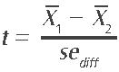

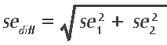
The calculation of se_{diff} , the standard error of the difference, varies depending on whether the groups were sampled independently or not. If the means for two groups that were sampled independently are being compared, for example, boys’ achievement in 1994 and 2006, then the standard error of the difference is calculated as the square root of the sum of the squared standard errors of each mean:
2)

For most of the comparisons, this formula was not applicable and so the se_{diff} is computed more accurately by combining variances using custom-written SAS programs. However, as a rough estimate, the above formula will give a similar result.
Note that in all calculations, unrounded figures are used in these tests, which may account for some results appearing to be inconsistent.
When you are trying to compare a mean (say of New Zealand) to a mean it contributes to (say the international mean) then you cannot use the simple formula (2) for the standard error of the difference. Instead we use the following formula:
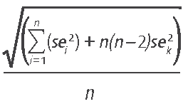
3)

where the se_{i} are the standard errors of all the contributing means (e.g., all countries) and se_{k} is the standard error of the mean that is being compared (e.g., NZ) and n is the number of means overall (e.g., number of countries).
Standard error
Because of the technical nature of TIMSS, the calculation of statistics such as means and proportions has some uncertainty due to (i) generalising from the sample to the total Year 9 school population, and (ii) inferring each student’s proficiency from their performance on a subset of questions. The standard errors provide a measure of this uncertainty. In general, we can be 95 percent confident that the true population value lies within an interval of 1.96 standard errors either side of the given statistic. This confidence interval is represented in graphs by the lines extending in either direction from the points.
Statistically significant
In order to determine whether a difference between two means is actual, it is usual to undertake tests of significance. These tests take into account the means and the error associated with them. If a result is reported as not being statistically significant then, although the means might be slightly different, we do not have sufficient evidence to infer that they are different. All tests of statistical significance referred to in this report are at the 95 percent confidence level.
Weighting
Due to the use of sampling, weights need to be applied when analysing the TIMSS data. Weighting ensures that any information presented more closely reflects the total population of Year 9 students rather than just the sample. The TIMSS weighting takes into account school, class, and student level information and the overall sampling weight is a product of the school, class, and student weights.


