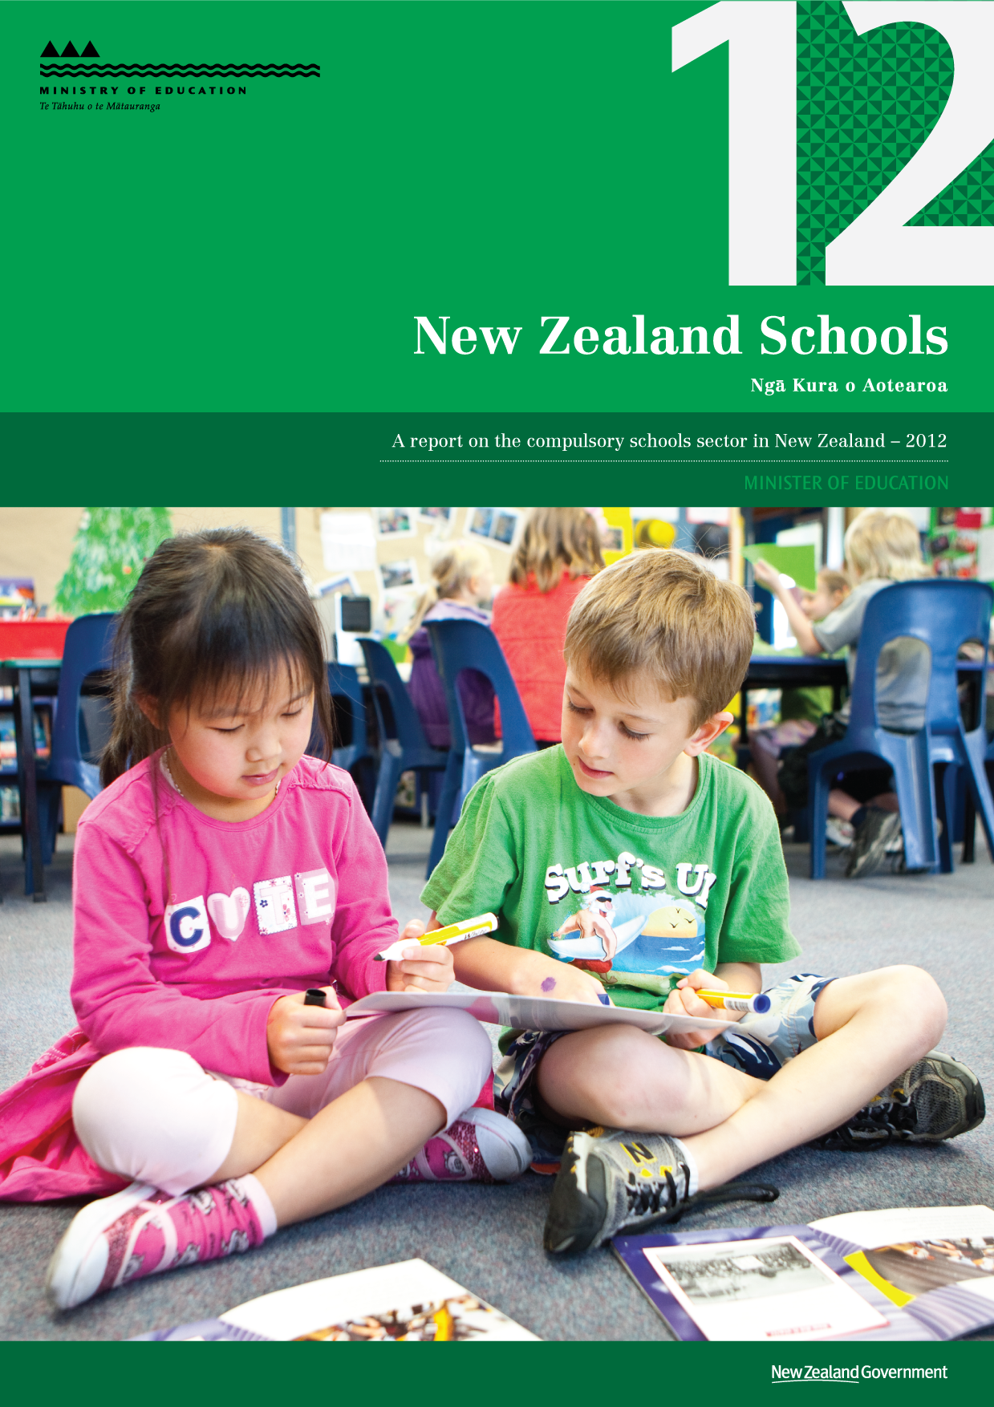
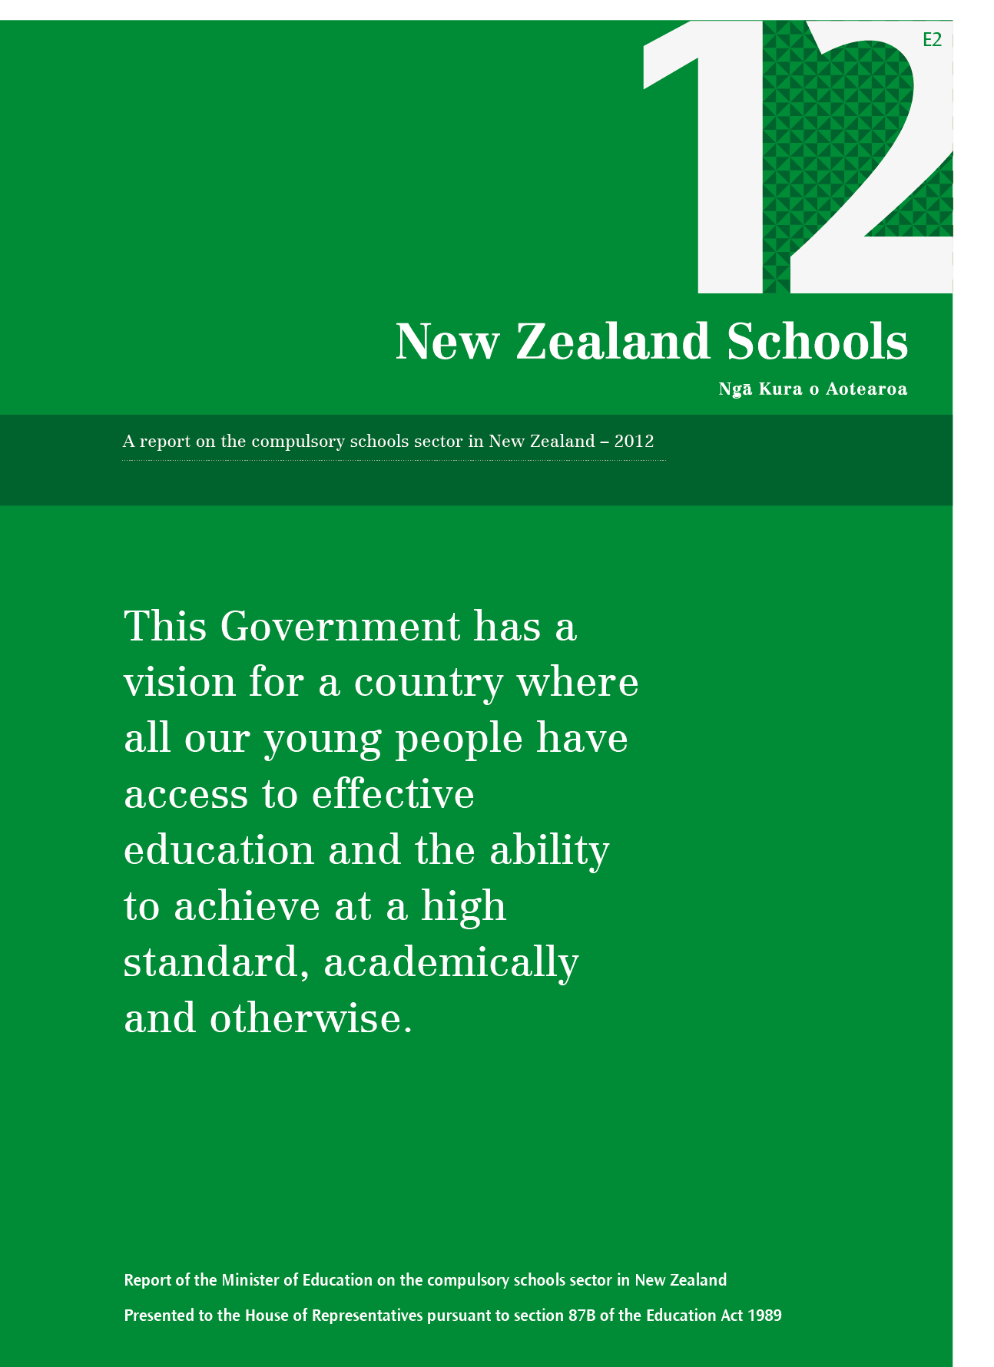

Contents
Foreword 6
Chapter 1: Key features of the 2012 year 7
Background 7
An overview of performance 8
Expectations of schools in 2012 8
Designing and implementing standards for English and Māori medium settings 10
Youth Guarantee 14
Implementing strategies to improve Māori and Pasifika achievement 15
Ultra-Fast Broadband in Schools (UFBiS) 17
Special education developments in 2012 18
The Canterbury earthquakes 19
Novopay 20
Chapter 2: Resourcing 22
School resources 22
Financial performance of New Zealand schools 25
Chapter 3: Foundation skills 29
Reading and writing literacy 29
Reading literacy in primary schooling 29
Reading literacy in secondary schooling 34
Mathematics 38
Mathematics in primary schooling 38
Mathematics in secondary schooling 41
Science 44
Chapter 4: Student outcomes 48
Proportion of 18-year-olds with NCEA Level 2 or equivalent qualification 48
School-leaver qualifications 49
Māori language in education 55
Definitions 56
Chapter 5: Student participation and engagement with learning 57
Youths in Education Employment or Training 57
Non-enrolled students 58
Retention of students in secondary schooling to 17 years 60
Early leaving exemptions 61
Positive Behaviour for Learning 64
Attendance at school 65
Stand-downs and suspensions from school 68
Chapter 6: Quality teaching and education providers 72
Teachers 72
Professional learning and development 73
Student Achievement Function 74
Services and support for children and young people with special education needs 75
School leadership 75
Community representation by school trustees 78
Appendix one 80
Plans to address pressures on school capacity 80
Schools with enrolment schemes in place for part of or all of 2012 82
Appendix 2 89
Statement of Results 89
Non-departmental other expenses 89
References 97

Figures
Figure 1: Schooling options for young people of compulsory school attendance age 7
Figure 2: Nominal and real operational grants to schools, 2002–2012 23
Figure 3: Teacher salary funding to state and state-integrated schools, 2002–2012 24
Figure 4: Direct property funding to schools, 2002–2012 24
Figure 5: Proportion of students meeting the National Standard for Reading, 2011 to 2012 31
Figure 6: Proportion of students meeting Ngā Whanaketanga Reo, by gender, 2012 31
Figure 7: Proportion of students meeting the National Standard for Writing, 2011 to 2012 33
Figure 8: Proportion of 15-year-old students who met the literacy and numeracy requirements for NCEA Level 1, 2008-2012 34
Figure 9: Proportion of 15-year-old students meeting NCEA Level 1 literacy and numeracy requirements, by ethnicity, 2008-2012 35
Figure 10: Proportion of 15-year-old students at Māori medium and English medium schools meeting both the literacy and numeracy requirements for NCEA Level 1, 2008–2012 36
Figure 11: Proportion of 15-year-old students meeting the NCEA Level 1 literacy requirements, by gender, 2008–2012 36
Figure 12: Proportion of students meeting the National Standard for Mathematics, 2011 to 2012 39
Figure 13: Proportion of students meeting Ngā Whanaketanga Pāngarau, by gender, 2012 40
Figure 14: Proportion of 15-year-old students with NCEA Level 1 numeracy, by ethnicity, 2008-2012 42
Figure 15: Proportion of 15-year-old students participating in at least one science subject, 2008-2012 46
Figure 16: BPS Target: Previously predicted, required, and actual attainment rates of 18-year-olds with at least a Level 2 qualification, by ethnicity, 2011-2017 48
Figure 17: Proportion of school leavers with NCEA Level 1 or above, by total response ethnicity, 2009-2012 50
Figure 18: Proportion of school leavers with NCEA Level 1 literacy and numeracy, by total response ethnicity, 2012 51
Figure 19: Proportion of school leavers with NCEA Level 2 or above, by total response ethnicity, 2009-2012 52
Figure 20: Proportion of school leavers with NCEA Level 2 or above, by gender, 2009-2012 52
Figure 21: Proportion of school leavers with University Entrance standard, by total response ethnicity, 2009-2012 53
Figure 22: Proportion of school leavers with University Entrance standard, by gender, 2009- 2012 54
Figure 23: Age-standardised non-enrolment rates per 1,000 students, by ethnicity, 2006–2012 58
Figure 24: Proportion of 15 and 16-year-old students who did not meet NCEA Level 1 literacy and numeracy requirements, 2010-2012 59
Figure 25: Retention rate: proportion of school leavers aged 17 or above, by ethnicity, 2009–2012 60
Figure 26: Proportion of students who were retained at school to the age of 17, by school decile, 2012 61
Figure 27: Early leaving exemption application approval and decline rates, 2000–2012 61
Figure 28: Early leaver exemption rates per 1,000, by ethnicity, 2000–2012 62
Figure 29: Early leaving exemption rates, by ethnicity and school quintile, 2012 63
Figure 30: Absence rates, by gender and current year level, 2012 66
Figure 31: Age-standardised stand-down rates, by ethnicity, 2000–2012 68
Figure 32: Age-standardised stand-down rates, by ethnicity and school quintile, 2012 69
Figure 33: Age-standardised suspension rates, by ethnicity, 2000–2012 70
Figure 34: Age-standardised suspension rates, by ethnicity and school quintile, 2012 70
Figure 35: Number of schools expected to have at least 1 Māori board member versus proportion of schools with fair Māori representation, 1998–2012 78
Figure 36: Number of schools expected to have at least 1 Pasifika board member versus proportion of schools with fair Pasifika representation, 1998–2012 79

Tables
Table 1: School revenue, 2009–2012 25
Table 2: Expenditure of state and state-integrated schools, by main expenditure category, 2009–2012 26
Table 3: Percentage of schools with an operating surplus, 2010–2012 27
Table 4: Percentage of schools in different working capital ratio bands, 2012 27
Table 5: Public equity trends ($), 2010–2012 28
Table 6: Percentage of schools with an increase in public equity, 2012 28
Table 7: All students involved in Levels 1–4a of Māori language education, 2003–2012 55
Table 8: Youths in education, employment or training: 16-year-olds to 18-year-olds, 2012 57
Table 9: Teacher loss rates, by school type, May 2007/08 to May 2011/12 72

Foreword
This Government has a vision for a country where all our young people have access to effective education and the ability to achieve at a high standard, academically and otherwise. We are ambitious for our students, and have set a key target that 85% of 18-year-olds will have achieved NCEA Level 2 (or an equivalent qualification) by 2017. In 2012, 77.2% of 18-year-olds met this target, continuing the progress seen in previous years and exceeding our forecasts. Maintaining high expectations for our students and providing all students with quality education and modern learning environments will ensure our young people will be better prepared for further education and employment.
The 2012 year was one of changes and challenges in the New Zealand schooling system. The Government introduced the Education Renewal Recovery Programme, outlining the future shape of education provision and the schooling network in greater Christchurch. Challenges were faced by schools and teaching staff nation-wide following issues with the implementation of the new education payroll system, Novopay. Schools and kura that use Te Marautanga o Aotearoa were in their first full year of implementation for Ngā Whanaketanga Rumaki Māori.
Our education system relies on teachers, parents and communities being informed about and engaged in their children’s learning. The National Standards are designed to support The New Zealand Curriculum and are aimed at establishing high expectations for students. The release of 2012 aggregate National Standards data, showing improvements in achievement, demonstrates that the teaching professionals in our schools are succeeding in lifting educational achievement.
Schools are performing well for many of our students and good progress is being made towards a number of goals set in recent years, but this report shows that there is still room for improvement. The spread of achievement of our students is wide. Too many pupils do not reach their full potential because we do not engage and support them in their learning. We have over 760,000 students in education in New Zealand and we need to ensure that we get it right for every single one.
The Government’s emphasis will continue to be on lifting educational standards so that the students of today will become the talented adults of tomorrow, contributing to New Zealand’s society and economy in a meaningful way.
I am pleased to present to Parliament New Zealand Schools Ngā Kura o Aotearoa – 2012.
Hon. Hekia Parata
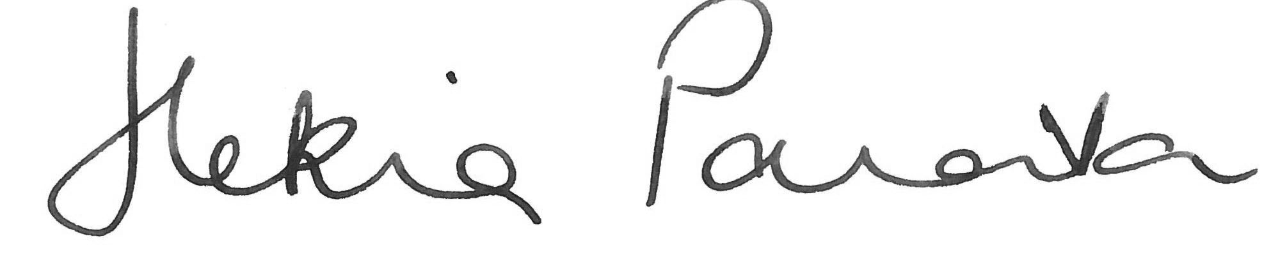
Minister of Education

Chapter 1: Key features of the 2012 year

Background

Schools in 2012
In July 2012 there were 2,558 schools (including 20 Teen Parent Units) with 759,960 students, 52,238 staff and 18,694 Board of Trustee members. A further 6,568 students were home-schooled.
For students to access high quality learning experiences there needs to be a strong network of schools. The network must be able to cope with the diversity of student needs, fluctuations in student numbers and the changing composition of the school-aged population.
The schooling system is loosely divided into two parts: primary education for students aged 5–12 (Years 1–8) and secondary education for students aged 13–18 (Years 9–13). The schooling options are displayed below. Figure 1 also includes the year level of students and, in senior secondary school, the qualification level that most students study towards.
- Schooling options for young people of compulsory school attendance age
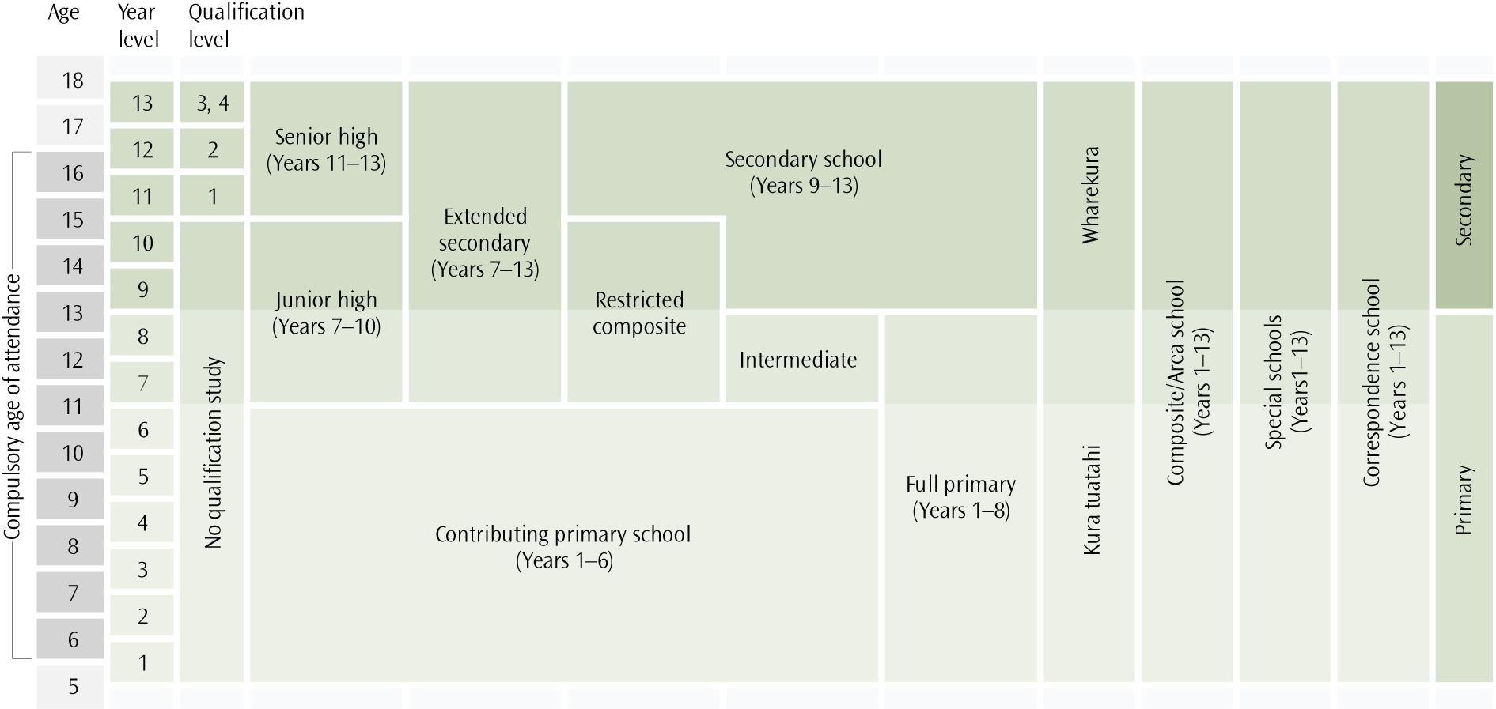
The New Zealand education system does not make distinctions between academic and vocational/technical programmes. The design of The New Zealand Curriculum (Ministry of Education, 2007), Te Marautanga o Aotearoa (Ministry of Education, 2008b) and the National Certificate of Educational Achievement (NCEA) qualifications enable students to select from a range of courses (including industry-based qualifications) in the senior years of secondary school (Years 11–13).
New Zealand provides a free education system through state owned and operated schools. However, both state-integrated and private options exist. State-integrated schools are part of the state system but retain their special character. In 2012, the Government announced the introduction of a third alternative. Partnership Schools | Kura Hourua will be publicly funded schools run by private interests, with more flexibility over setting hours, governance and curriculum, in return for stronger accountability for improving educational outcomes. The first schools are expected to open in 2014.

An overview of performance
- Implementation of the National Standards continued in 2012, with school level data available online for the first time (2011 data). National statistics relating to National Standards indicate that the proportions of students achieving at or above the standard for Reading (77.4%), Writing (70.0%), and Mathematics (73.6%) have increased since 2011.
- Implementation of Ngā Whanaketanga Rumaki Māori for use in kura and Māori medium settings using Te Marautanga o Aotearoa was also continuing in 2012. The 2012 Ngā Whanaketanga Rumaki Māori data are the first to be released publically (released in 2013). National statistics indicate that around 70% of students were achieving at their expected level for Kōrero, Pānui and Tuhituhi, while 60% were achieving as expected for their age in Pāngarau.
- To achieve an NCEA Level 1 qualification, students must fulfil specific requirements for the foundation skills of both literacy and numeracy. The proportion of 15-year-old students meeting these requirements increased on last year, continuing a trend of improvement.
- Qualification outcomes for school leavers continued to improve in 2012. A formal qualification at Level 2 or above is a benchmark which young adults need to achieve as a basic prerequisite for future work or training; 74.3% of 2012 school leavers attained this benchmark, compared to 72.4% of 2011 school leavers. However, outcomes for some student groups remain a concern.
- The Government has set a target of increasing the proportion of 18-year-olds with an NCEA Level 2 or equivalent qualification to 85% by 2017, attained either through school or through tertiary study. In 2012, 77.2% of 18-year-olds had attained this level, an increase from 74.3% in 2011. This suggests that we are on track to reach the 2017 target.
- Age-standardised rates of stand-downs (23.4 per 1000) and suspensions (4.7 per 1000) were at their lowest rate in 13 years.
- Retention rates have been gradually increasing in recent years, increasing from 79.3% in 2009 to 81.4% in 2012. However, there are still substantial differences between girls and boys, and between Māori and non-Māori students.
- Most schools have sound financial management. Schools achieved a combined operating surplus of 0.5% of total revenue, which is a slight decrease on 2011 (0.6%). Almost 94% of all state and state-integrated schools had at least enough current assets to cover their short-term debts. Public equity for these schools increased 2.2% from 2011.

Expectations of schools in 2012
The Minister of Education is required under Section 87B of the Education Act 1989 to report to Parliament each year on the performance of the state schools sector. Through this New Zealand Schools report, the public of New Zealand are kept informed about state schools’ operation and performance. The Government sets the policy framework for the operation of schools in New Zealand and monitors the standard of education delivered within the school network.
Boards of Trustees are responsible for the running of schools. A school’s operation and success depend on the cooperation and interaction of parents, teachers, principal and Board. As Crown entities, schools manage their finances in accordance with the New Zealand equivalent of International Financial Reporting Standards and report annually on their financial position.
Schools have specific requirements set in the National Education Guidelines:
- National Education Goals (NEGs)
- national curriculum documents
- specific curriculum statements
- National Standards
National Administration Guidelines (NAGs).
The NEGs set out the teaching and learning responsibilities of schools (see below). The NAGs set out the principles of administration for school managers and Boards of Trustees in achieving the NEGs.

National Education Goals
NEG 1 | The highest standards of achievement, through programmes which enable all students to realise their full potential as individuals, and to develop the values needed to become full members of New Zealand’s society.
NEG 2 | Equality of educational opportunity for all New Zealanders, by identifying and removing barriers to achievement.
NEG 3 | Development of the knowledge, understanding and skills needed by New Zealanders to compete successfully in the modern, ever-changing world.
NEG 4 | A sound foundation in the early years for future learning and achievement through programmes which include support for parents in their vital role as their children’s first teachers.
NEG 5 | A broad education through a balanced curriculum covering essential learning areas. Priority should be given to the development of high levels of competence (knowledge and skills) in literacy and numeracy, science and technology and physical activity.
NEG 6 | Excellence achieved through the establishment of clear learning objectives, monitoring student performance against those objectives, and programmes to meet individual need.
NEG 7 | Success in their learning for those with special needs by ensuring that they are identified and receive appropriate support.
NEG 8 | Access for students to a nationally and internationally recognised qualifications system to encourage a high level of participation in post-school education in New Zealand.
NEG 9 | Increased participation and success by Māori through the advancement of Māori education initiatives, including education in te reo Māori, consistent with the principles of the Treaty of Waitangi.
NEG 10 | Respect for the diverse ethnic and cultural heritage of New Zealand people, with acknowledgement of the unique place of Māori, and New Zealand’s role in the Pacific and as a member of the international community of nations.

Evidence of the success of the schooling sector in meeting these requirements is gathered from a range of sources, including:
- national-level monitoring
- nationally standardised assessments
- Education Review Office (ERO) reports and national evaluations
- research and development initiatives
international assessments.

Designing and implementing standards for English and Māori
medium settings

National Standards policy
The National Standards and Ngā Whanaketanga Rumaki Māori, along with the associated requirements described in the National Administration Guideline 2A and Section 61 of the Education Act 1989, cover all state and state-integrated schools with Year 1–8 students. National Standards policy in New Zealand is underpinned by a focus on the use of evidence to inform improved practice and learning. Gathering and using assessment information to identify students’ needs and next steps in learning is a foundation of effective education (ERO, 2012d). The standards are not just about what the student knows and can do in terms of discrete knowledge and skills, but also about how they can use what they have learnt in a variety of contexts. They are not intended as a means of sorting and labelling.
The national curriculum consists of The New Zealand Curriculum and Te Marautanga o Aotearoa. Where teaching and learning is guided and directed by The New Zealand Curriculum, schools and kura monitor and report progress and achievement using National Standards. Where teaching and learning guidance and direction is provided by Te Marautanga o Aotearoa, schools and kura use Ngā Whanaketanga Rumaki Māori to monitor and report progress and achievement. Schools and kura that offer learning in both Māori and English medium use both The New Zealand Curriculum and Te Marautanga o Aotearoa; in these cases, the classes are required to use and report against either National Standards or Ngā Whanaketanga Rumaki Māori, as appropriate for individual students.

National Standards
The National Standards describe achievement in reading, writing and mathematics. Teachers consider a range of both formal and informal information drawn from day to day classroom activity, including testing and observation. They use this information to make overall teacher judgements (OTJs) about student progress and achievement in relation to the standards.
In 2012, schools and kura with students that used The New Zealand Curriculum to set their teaching and learning programmes were in their final year of the three-year implementation phase for National Standards. Schools were required to set targets against National Standards in their annual charter updates for the second time in 2012. Of the 99% of schools that had submitted a charter as at December 2012, over 98% included targets set against the National Standards. In addition, nearly all schools provided National Standards data in their annual reports.

National Standards monitoring
The Ministry is using a range of information sources to track the implementation of National Standards, including an independent monitoring and evaluation project involving a representative sample of English medium state schools. This project looks at how schools understand the purpose and content of National Standards, use the National Standards to assess, monitor and report on student progress and achievement, and identify students needing targeted teaching interventions. Three monitoring reports covering implementation in 2010, 2011 and 2012 have been released (see Ward & Thomas; 2011, Ward & Thomas, 2012; Ward & Thomas, 2013). The findings of these reports focus on implementation processes, as well as student achievement information relative to the National Standards.

Trends in implementation 2010–2012
Overall, the most recent monitoring report (Ward & Thomas, 2013) indicates there has been good progress with many core aspects of the implementation of National Standards. Teachers are effectively using their knowledge of the standards to make overall teacher judgements (OTJs). Teachers are also more systematically collecting evidence about student progress and using this to inform their teaching practice. Students rated 'below' or 'well below' the standards are both identified for and receiving targeted teaching interventions.

Other aspects of implementation are still consolidating, including some understandings about the purpose of the standards and their relationship to the curriculum; teachers’ efficiency in making OTJs; the efficiency and effectiveness of school moderation processes; the differentiation of charter targets for specific groups of students; teachers' understandings of what students need to be achieving at their teaching level; and levels of knowledge of effective teaching strategies.

OTJ consistency
At this stage in the implementation of the National Standards, teachers are still developing their capability to make accurate and consistent OTJs. Results from the most recent monitoring report indicate, however, that schools are increasingly making use of good systems, including moderation, to ensure OTJs are consistent. For example, the proportion of schools using formal processes to moderate OTJs increased over the first three years of the standards implementation: 56% of schools used formal processes to moderate reading OTJs in 2010, increasing to 62% in 2012. However, three different pieces of information from the most recent monitoring report raise questions about the consistency of OTJs.

Level of consistency of OTJs over time
Looking at the same 8,500 students’ individual ratings across two years, large proportions were rated higher or lower in 2012 than they were in 2011. The authors say this level of variability seems too great to be due to changes in student achievement alone, and that it is more likely to indicate inconsistency in the judgements themselves.

Differing ratings of Year 7 and 8 students in full primary and intermediate schools
In all three National Standards areas and in all years from 2010 to 2012, higher proportions of year 7 and 8 students in full primary schools were rated ‘at’ or ‘above’ compared to those in intermediate schools. Since other research indicates that achievement in these years does not vary by school type, these findings suggest the standards are being interpreted differently in each setting. This may be an artefact of the relatively broad nature of the standards. With just eight standards at which students can be rated, this may mean some students’ achievement will be overestimated, while others will be underestimated. However, these findings do not mean that all OTJs are inaccurate. While general trends can be identified in the data collected, the authors state that there is no way to estimate the proportion of accurate OTJs or the accuracy of any individual OTJ.

Variable accuracy in ratings of work samples
To assess accuracy of teacher ratings, groups of teachers rated samples of student mathematics and writing work, relative to specific aspects of the standards. Between 2011 and 2012, the overall accuracy of teachers’ ratings of specific writing work samples improved (from 51% to 61%, respectively), while those for mathematics samples dropped slightly (from 61% to 58%, respectively). Although this exercise was only a rough approximation of how teachers make judgements about their own students’ work, it does provide a window on the quality of judgements about student work used as part of the information in making OTJs.
In order to support teachers in making consistent and valid OTJs over time, the Ministry has been developing the Progress and Consistency Tool (PaCT) with input from teachers, school leaders, and sector groups and organisations. The PaCT will provide a framework for tracking student progress in the National Standards in a meaningful, accurate and consistent way, and aims to strengthen teachers’ confidence and capability in making judgements. The PaCT will also provide teachers with a common tool that can be used to moderate OTJs both within and between schools. Testing has been conducted on the use of the PaCT throughout 2013, and it is anticipated that the tool will be available to teachers progressively from 2014.

Reporting to parents, families and whānau
Reporting to parents, families and whānau is an important part of the National Standards initiative. Findings indicate that schools increasingly reported National Standards information to parents, families, and whānau from 2010 to 2012. The proportion of end-of-year reports that referred directly to the National Standards increased over time (79% in 2010 and 91% in 2012), as did the proportion of reports that sufficiently described student achievement in relation to the National Standards (60% in 2010 and 73% in 2012). Irrespective of whether reports had sufficient information about the standards or not, in 2012 less than half (43%) were rated as providing parents, family and whānau with a report that contained clear information (Ward & Thomas, 2013).
ERO assessed the performance of schools in meeting their reporting requirements during Term 4 of 2011 and Term 1 of 2012 (ERO, 2012e). They found that while the percentage of schools meeting reporting requirements had risen between 2010 and 2011, 28% of their sample of 239 schools still failed to meet the reporting requirements in the 2011 school year.

Perspectives of principals and Board of Trustees Chairs
Principals reported high levels of concern about the unintended consequences of National Standards, with the large majority (90%) describing themselves as moderately or very concerned about league tables, narrowing of the curriculum, demotivation of students consistently below the standards, and national testing (Ward & Thomas. 2013). Levels of concern have grown over time, with higher proportions describing themselves as ‘very concerned’ in 2012 than in 2010. Only small proportions of principals rated each of the unintended consequences as unlikely or very unlikely to happen. In general, Board of Trustee Chairs appeared to be much less concerned than principals, and they also rated each of the unintended consequences as less likely to happen than did principals.

Reporting of National Standards data
All schools using National Standards were required to collect information on the number of students at each level of National Standards for the second time in 2012, reporting this data in 2013. Aggregate data was submitted electronically by each school using a standardised worksheet that separated levels of achievement for each stream into four categories: Above, At, Below, and Well Below. Achievement data for the 2012 year that was of sufficient quality to be used in analysis was supplied by just over 80% of schools who were required to provide this information in 2013.
This was the first time that schools were required to submit the information in a standardised format; schools were previously required to report 2011 information in their annual reports, and the data was extracted and collated manually by the Ministry. Consequently, the 2012 National Standards data is significantly less variable, more consistent, and more easily checked for quality than the data supplied in 2011.

Ngā Whanaketanga Rumaki Māori
Ngā Whanaketanga Rumaki Māori are based on learning progressions that describe the skills and knowledge students need in kōrero (oral language), pānui (reading), tuhituhi (writing) and pāngarau (mathematics) to meet the demands of Te Marautanga o Aotearoa. The inclusion of kōrero emphasises the importance Māori medium education places on students having quality oral language proficiency to support their learning.
Ngā Whanaketanga Rumaki Māori are a part of a wider work programme designed to strengthen Māori medium education that includes:
- recruiting and retaining a quality workforce to support Māori medium education
- supporting the implementation of Te Marautanga o Aotearoa and Ngā Whanaketanga Rumaki Māori
- supporting plain language reporting to parents and regular reporting to the wider community, education stakeholders and the Ministry
- building aromatawai and assessment knowledge
- addressing gaps in te reo and pāngarau tools for Māori medium
providing high quality professional development for teachers, principals and Boards of Trustees that is specifically designed for the Māori medium sector.
In 2012, kura and schools with students in Years 1–8 that use Te Marautanga o Aotearoa to set their teaching and learning programmes were in the first year of full implementation for Ngā Whanaketanga Rumaki Māori. While these kura and schools have been required to report the progress and achievement of students to parents twice a year since 2011, targets against Ngā Whanaketanga Rumaki Māori were required to be included in school charters for the first time in 2012, and 2012 data was the first to be collected by the Ministry (in 2013).
In order to assess the scope and quality of implementation in the sector, the Ministry of Education conducted a survey of kaiako (teachers) in Māori medium settings at the end of 2012 (Ministry of Education, 2013b). The focus of this research was on the kaiako experiences of Ngā Whanaketanga Rumaki Māori. Seventy-eight per cent of kaiako reported that they were using Ngā Whanaketanga Rumaki Māori, while 21% reported that they were using National Standards for assessment purposes (some kaiako used both).
A requirement of Ngā Whanaketanga Rumaki Māori is to report to whānau on student progress in relation to Ngā Whanaketanga Rumaki Māori at least twice a year. The judgements included in the report relate not only the discrete knowledge and skills a student has learned, but also how well the student can apply what they have learned within other contexts. In the 2012 kaiako survey, most kaiako (60%) reported that they had already met this requirement, and a further 26% had reported to whānau once and would do so again before the end of 2012. A majority of kaiako (67%) also agreed that Ngā Whanaketanga Rumaki Māori had improved the information that they provided to parents (Ministry of Education, 2013b).
A range of resources and material is being made available to support teachers to make reliable and consistent judgements. These tools include the development of Rukuhia, Rarangahia (an aromatawai position paper), professional learning and development opportunities, and the refreshing of literacy- and numeracy-based resources and tools used to support the collection and collation of student progress and achievement information.
Aromatawai is a series of processes that lead to an understanding about a learning event. It is a way of focussing on the student, what they can do, and their learning journey based on knowledge drawn from a relationship between teachers and students. Aromatawai can represent both whole and parts of students’ learning journeys. Te Waharoa Ararau symbolises the multiple pathways available to students to enjoy and achieve educational success, and allows kura and schools to capture students’ literacy and numeracy aromatawai information:
- Te Waharoa Ararau ā-Kura is a tool that runs parallel to the Progress and Consistency Tool (PaCT), and supports teachers in implementing Ngā Whanaketanga Rumaki Māori. It has been developed for use by all kura and Māori medium settings who use Ngā Whanaketanga Rumaki Māori to set their literacy and numeracy teaching and learning programmes, with the purpose of progressively supporting the consistency of teacher judgements both within and between schools.
- Te Waharoa Ararau ā-Motu is an online resource that has been developed by the Ministry to assist with the reporting of school-wide te reo Matatini and pāngarau achievement information; individual, class, and/or school reports produced in Te Waharoa Ararau ā-Kura can be used to inform the completion of a Te Waharoa Ararau ā-Motu report.

Public achievement information
National Standards and Ngā Whanaketanga Rumaki Māori data contribute to the range of information available as Public Achievement Information (PAI).
The PAI strategy seeks to encourage the effective use of information to support teaching and learning. It also seeks greater public transparency around information about our students, schools and education system. The better informed people are the better able they are to contribute. This is particularly important for parents, family and whānau who have an important role in supporting their child’s learning in partnership with their child’s teacher and their child.
Student achievement data should not be viewed as an end product. The intention is that it be used formatively to inform improvement. Many variables influence student performance and it is important that schools and kura be viewed on the basis of everything they do in engaging and educating students, and in light of broader educational outcomes that are valued for our young people.
National Standards data has been publicly available since 2012 (2011 data). Nga Whanaketanga Rumaki Māori data will be publicly available for the first time from 2013 (2012 data). These data are included within each individual school’s annual report and are accessible by parents and communities. In addition, the Ministry proactively publishes this information because of high levels of interest. The 2012 data is available on the ‘Find a School’ web pages on the Education Counts website at www.educationcounts.govt.nz/find-a-school. This information has also been published by Regional Council, by Territorial Local Authority (TLA), and nationally.
Some additional information provided by schools and kura in their annual report has also been published on the website including: school strengths and identified areas of improvement; the basis for identifying areas for improvement; and planned actions for lifting achievement.
It is important that National Standards data not be used on their own to judge the quality of a school. A range of information needs to be considered to get a complete picture of a school. This could include:
- the school website ― most schools have one
- the school charter and annual report
- the most recent ERO report on the school
- talking with other parents who have children at the school
visiting the school and engaging in discussion with educators and Boards of Trustee members.

Youth Guarantee
The Youth Guarantee initiative is the New Zealand Government’s flagship programme for improving educational opportunities and achievement for 16 and 17 year-olds. It provides new opportunities and choices for students about how and where they study, along with a clear framework of learning pathways.
The goal of Youth Guarantee is that all students will achieve at least NCEA Level 2 or an equivalent tertiary qualification, which evidence suggests is the minimum level of achievement required for success and participation in further study and employment. This contributes to the Ministry’s efforts to accelerate achievement in order to meet the Better Public Services target of 85% of 18-year-olds attaining NCEA Level 2 or above by 2017.
Youth Guarantee is a contributor to several system-wide goals in education, such as: improving student retention and engagement in the senior secondary school; improving overall achievement for Māori, Pasifika, and students with special education needs; and reducing the numbers of young people not in employment, education or training (NEETs).
Youth Guarantee comprises several initiatives that are being progressively implemented throughout the secondary and tertiary sectors. This is taking place with the support of regionally-based networks of training providers, local government, iwi and community organisations to connect and co-ordinate the secondary–tertiary–work interface across communities. These initiatives are:
- the development of coherent vocational pathways and associated teaching and learning resources that are available across the secondary and tertiary sectors. Five initial vocational pathways were developed in 2012 for the following industry sectors:
- construction and infrastructure
- primary industries
- social and community services
- service industries
manufacturing and technology.
- the introduction of a number of fees-free tertiary education places for 16–17-year-olds at levels 1–3; in 2012 there were 7,345 fees-free places allocated to students, up from 2,500 in 2011.
- improved tracking and monitoring of students as they move through the system. In 2011 work began on exploring the ways that various Government agencies can better share information and data to enable accurate tracking of students across the secondary and tertiary sectors. In 2012 the Ministry began supplying data to the Ministry of Social Development to create a risk profile for a young person leaving school, and so that the MSD could prepare to work with the young person to get them back into education, training or meaningful employment.
- the establishment of regional networks in late 2012.
- a series of proposals to strengthen the provision of careers, information, advice, guidance and education (CIAGE), developed following a Governmental review of CIAGE initiated in late 2011.
- the ongoing implementation of secondary–tertiary programmes such as trades academies and service academies. In 2012, 2.340 students enrolled in 22 trades academies - 11 headed by Institutes of Technology and Polytechnic, and 10 by secondary schools. Across the 17 trades academics operational as at 30 June, 2012, a total of 36% (758) students identified as Māori; 51% (1071) as Pākehā; and nine per cent (183) as Pasifika. Male students represented 70% of the total roll. There were a total of 24 operational service academies in 2012, up from 16 in 2011. This increased the total number of available places from 320 to 480.

Implementing strategies to improve Māori and Pasifika achievement
The Government develops strategies to focus the education sector on priority areas. While these are not mandatory, schools are expected to take account of them in their practice. Two of the key strategies in place in 2012 were Ka Hikitia ― Managing for Success: The Māori Education Strategy 2008–2012 (updated 2009) and the Pasifika Education Plan 2009–2012.

Ka Hikitia ― Managing for Success: The Māori Education Strategy 2008–2012
In 2012, there were 173,011 students who identified as Māori. This group makes up 23% of the total New Zealand school roll and is the second-largest ethnic grouping of students, behind Pākehā/European.
Ka Hikitia ― Managing for Success 2008–2012 (Ministry of Education, 2008a) has set the direction for improving outcomes for and with Māori students. Some of the initiatives currently underway to address the system’s underperformance for Māori students include:
- ensuring that schools’ planning and reporting focus effectively on raising Māori student participation, engagement and achievement,
- better information provision to parents, families, whānau and iwi about achievement outcomes in Years 1-8 through the National Standards and Ngā Whanaketanga Rumaki Māori,
providing professional learning and development (PLD) that improves principals and teachers’ effectiveness in raising Māori student achievement (such as effective ways of engaging with Māori and iwi) and better reporting on the value created through the provision of PLD.
Evaluation of the Ka Hikitia ― Managing for Success strategy has shown that effectiveness has been limited by a lack of a coherent implementation approach. A performance audit on the implementation of Ka Hikitia by the Office of the Auditor-General found that ineffective communication both within the Ministry and with schools meant that the implementation of Ka Hikitia was not given its intended priority and was not as effective as it could have been (Office of the Auditor-General, 2013). The findings in relation to the Ka Hikitia strategy itself were positive however, noting that Ka Hikitia reflects the interests and priorities of Māori well and is based on sound educational research and reasoning. It was also noted that Ka Hikitia had clearly contributed to schools strengthening their focus on improving outcomes for Māori students.
In response to the hindered effectiveness of Ka Hikitia ― Managing for Success, an updated strategy plan was in development throughout 2012. Ka Hikitia ― Accelerating Success 2013-2017 will build on the success seen through Ka Hikitia ―Managing for Success and has a stronger focus on successfully putting the strategy into action with all those who play a role in raising Māori achievement. The vision for Ka Hikitia ― Accelerating Success will remain Māori enjoying and achieving education success as Māori. This means ensuring Māori students’ identity, language and culture are valued and meaningfully integrated into their teaching and learning experiences.

Me Kōrero ― Let’s Talk!
As a part of the Ka Hikitia update, the Ministry released an engagement document Me Korero ― Let’s Talk! in 2012, which sought ideas and feedback from external partners, as well as the general public, with results being released in 2013 (Ministry of Education, 2013a). In total, 584 feedback forms were received, largely from parents and whānau (44%) and education professionals (35%). Feedback was also received from Māori students (15%), tertiary education professionals (3.7%), iwi (0.8%) and community/businesses/non-government organisations (1.5%). Overall, responses indicated that parents, whānau and iwi want to be actively involved in their children’s education, but greater efforts need to be made to raise awareness of Ka Hikitia and to provide information, advice and supports to enable people to make the required changes. While there was a strong support for te reo Māori, feedback suggested that challenges still remain regarding the implementation of Ka Hikitia and the access for Māori students to early childhood education, tertiary education and Māori medium education.

Tau Mai Te Reo ― the Māori Language in Education Strategy 2013-2017
Building on the Māori language in education elements of Ka Hikitia ― Accelerating Success is Tau Mai Te Reo ― the Māori Language in Education Strategy 2013-2017. Tau Mai Te Reo expresses the Ministry of Education and education sector agencies’ responsibilities relating to Māori language in terms of the Treaty of Waitangi, legislation and Te Rautaki Reo Māori ― the Government’s Māori Language Strategy. Both strategies will be publicly released in 2013.

Iwi partnerships
The Ministry has been engaging in education relationships with iwi and Māori organisations for more than a decade on matters relating to Māori education, and is committed to working for and with iwi to develop shared investments that give effect to the outcome of raising Māori student achievement in schools. In 2011, a guide to developing excellent relationships with iwi (Whakapūmautia, Papakōwhaitia, Tau Ana ― Grasp, Embrace, Realise) was implemented by the Ministry to support the further development of new and existing iwi relationships.
Since the release of Ka Hikitia ― Managing for Success, the number of education relationships the Ministry has with iwi has increased from 14 in 2007 to 64 in May 2013.
Iwi that have established relationships with the Ministry are carrying out work programmes that reflect their education aspirations. For many iwi, this includes a strong focus on the role that education plays in the revitalisation and sustainability of te reo Māori. They are doing this in different ways, including by developing iwi curriculum and associated learning materials, incorporating their identity, language and culture into the school curriculum or operating early childhood services that convey their unique iwi identity.

Pasifika Education Plan 2009–2012
As at July 1, 2012, 75,000 (or 10%) students were classified as Pasifika according to prioritised collection of ethnicity information. In 2009, the Government released the Pasifika Education Plan 2009–2012 (Ministry of Education, 2009) to focus activity on what will make the most difference for improving educational outcomes for Pasifika students.
The Plan sought to focus action on areas that would make the most difference for Pasifika students:
- building strong learning foundations
- lifting literacy and numeracy achievement by using the National Standards to improve teaching and plain-language reporting to parents
- increasing the number of students achieving higher level school and tertiary qualifications
the importance of supporting Pasifika students’ identities, languages and culture to raise Pasifika achievement.
The Pasifika Education Plan 2009–2012 set targets to monitor success, and progress against these targets have been recorded through an annual report, the Pasifika Education Plan Monitoring Report (eg, Ministry of Education, 2012).
A revised version of the plan, the Pasifika Education Plan 2013–2017, was released in late 2012. This presents the focus for initiatives relating to Pasifika education from 2013 onwards, as well as setting new targets for improving the educational outcomes for Pasifika students.

Ultra-Fast Broadband in Schools (UFBiS)
The education sector is undergoing rapid and significant change in response to the development of new technologies and access to the Internet (Education and Science Committee, 2012). In order to ensure that New Zealand’s students are prepared with 21st-century skills, a number of initiatives have been developed and implemented that address digital literacy. One key initiative is the Ultra-Fast Broadband in Schools (UFBiS) project, launched in 2011.

Connecting schools to ultra-fast broadband
By 2016, 97.7% of schools will receive ultra-fast broadband (UFB) connections enabling speeds of 100 Mbps plus, through Government’s $1.5 billion investment in broadband. The remaining 2.3% of schools, which are in the most remote locations, will receive improved broadband services through terrestrial wireless or fast satellite connection.

Ultra-fast broadband rollout
In May 2011, contracts were signed to complete the roll out of fibre to urban areas by 2016. Enable Networks will deliver UFB access to 108 schools in Christchurch, Rangiora and surrounding areas. The contract with Chorus covers Auckland, the eastern and lower North Island and most of the South Island, connecting 896 schools to fibre. UFB contracts had been agreed previously with Northpower for Whangarei (26 schools), and with the WEL Networks-led consortium for Hamilton, Tauranga, New Plymouth, Whanganui, Tokoroa and Hawera (174 schools).
Fibre deployment to urban areas of New Zealand commenced in August 2011, with Chorus rolling out fibre to Albany, Auckland. At the end of 2012, 368 urban schools had been connected to fibre and it was verified that they were ready for services over fibre.

The Rural Broadband Initiative
On 30 June 2011 the first phase of the Rural Broadband Initiative was officially launched when the first three rural schools were connected to fibre. By the end of 2012 a total of 625 rural schools had been connected to fibre.

School Network Upgrade Project (SNUP)
The Ministry’s School Network Upgrade Project (SNUP) is progressively upgrading electrical and data cabling infrastructure in kura and schools in readiness for fibre. SNUP will optimise internal network performance in kura and schools and enable more staff and students to simultaneously access the Network for Learning.
The majority of SNUP upgrade costs are funded by Government ― 68% for state-integrated schools and 80% for state schools. At the end of 2012, a total of 942 schools had been upgraded since the project started (40% of all eligible schools).Two hundred and thirty-seven schools were upgraded during 2012.

Special education developments in 2012
New Zealand has a focus on fully inclusive education. In 2010, ERO conducted a review of 229 schools that found that 20% of schools demonstrated few inclusive practices, compared to 80% of schools with at least some inclusive practices (ERO, 2010a). ERO completed an additional review of Alternative Education (AE) in 2010, concluding that two-thirds of a sample of 44 secondary schools did not provide enough support for their students in AE (ERO, 2010b).
In response to these findings, the Government has set a target that by 2014, 80% of schools will be demonstrating highly inclusive practice for students with special education needs, with the remaining 20% demonstrating good practice. A recent ERO evaluation reported on primary schools’ progress in relation to this target, finding that 77% out of a sample of 81 primary schools were mostly inclusive, 16% of schools had some inclusive practices, and seven per cent had few inclusive practices (ERO, 2013a).

Success for All ― Every School, Every Child
The Government has agreed to a programme of activities to achieve the 100% inclusive practices target (80% highly inclusive and 20% demonstrating good practice) under the umbrella of Success for All ― Every School, Every Child. This is a commitment to inclusive practice and to continual improvement of systems and teaching for children and young people with special education needs.
The programme of activities in 2012 focused on developing tools and resources that build every school’s capability to be better able to support children and young people with a range of education needs.

Resource Teachers: Learning and Behaviour (RTLB)
At the start of 2012, the Resource Teachers: Learning and Behaviour (RTLB) service and Supplementary Learning Support (SLS) service were amalgamated, with the RTLB service now employing 856 full time equivalent teachers. The service changed focus in 2012 to the development of increasingly effective, evidence-based practices centred on teachers’ and schools’ processes and systems, in order to better support students’ learning and behaviour needs.

Intensive Wraparound Service (IWS)
The Intensive Wraparound Service (IWS) supported 120 children during 2012. A consultation and review of residential special schools and the IWS in 2012 resulted in the closure of MacKenzie Residential Special School in Christchurch at the beginning of 2013, and the development of the new IWS. This provided the opportunity to provide services and support for more children with complex needs, in their local community. Depending on need, children and young people may access one of the three remaining residential special schools (Halswell Residential College in Christchurch, Salisbury School in Nelson, and Westbridge School in Auckland) for a short period of time, as part of a wider programme of support from the IWS.
New information sheets on the IWS have been produced for schools and teachers, and these are available on the Ministry website.

Inclusion Taskforce
The Inclusion Taskforce was established mid-2012 for the purpose of accelerating the achievement of the Government target of 100% of schools demonstrating inclusive practices by 2014. During the second half of 2012, the taskforce’s focus was to raise schools’ awareness of the need to plan for the accelerated achievement of students with special education needs. Support was provided to Boards of Trustees, principals, other school leaders and teachers to review their current practices and develop a plan for students with special education needs. These plans were outlined in school charters submitted in late 2012 and early 2013. As a result, the percentage of schools assessed as having highly effective special education plans rose from 5.4% in 2012 to 11% in 2013. A further 56% were assessed as being at the consolidating effectiveness stage (an increase from 28%), and the percentage of schools assessed as being at the developing effectiveness stage dropped from 67% in 2012 to 33% in 2013.

The Canterbury earthquakes
The earthquakes of September 2010 and February, June and December 2011 have changed the educational landscape in greater Christchurch. They have caused disruption and loss for individuals, whānau, and community. The impact on education provision remains substantial, with most schools being affected by earthquake damage as well as the ensuing migration of people. Following the February earthquake, over 12,000 students left the school they had been attending and enrolled elsewhere ― often at a school outside the region. Many have since returned, but as of March 2013 over 4,100 fewer students were enrolled in greater Christchurch schools compared to March 2010.

Damage to the network
The physical damage to buildings and land has been significant: 207 of the 215 state and integrated schools in greater Christchurch suffered damage as a result of the earthquakes. The Government is investing $1 billion in renewing and modernising the schooling network in greater Christchurch over the next 10 years. This includes building 16 new or relocated schools and undertaking substantial rebuilds of another 30 schools. At the end of that time, Christchurch will have one of the best schooling networks in New Zealand. The majority will be modern schools equipped for modern day teaching practices, with new facilities and advanced infrastructure, including access to ultra-fast broadband, modern information technology, flexible spaces, and energy efficient buildings, with plenty of natural light and fresh air.

Education Renewal Plan
Following consultation with the education sector and the general community, the Ministry released the Educational Renewal Recovery Programme in late 2012. This plan outlined the future shape of education provision in greater Christchurch, as well as informing decisions regarding the restructuring of the greater Christchurch school network.
The Education Renewal proposals involve 38 schools ― some 20 per cent of the 215 schools in greater Christchurch. As at September 2013, all 38 schools have received final decisions; these decisions were reached after nine months of consultation including two consultation periods with each of the affected schools. In summary, 14 schools received decisions to stay open on their current sites; 11 schools received decisions to merge, creating five merged schools; 11 received decisions to close; and two schools chose to close voluntarily. The decisions account for a number of different factors other than earthquake damage, including declining rolls, the age and wear-and-tear of schools, future population growth and school location, as well as the opportunity to establish modern learning environments and ‘build back better’.
The proposals were first announced in September 2012, and two schools chose to close voluntarily after the announcement. Education Minister Hekia Parata announced interim decisions for 31 schools in February 2013, and the first set of final decisions (relating to 12 schools) was released in March 2013. This was followed by the announcement of final decisions for a further 16 schools at the end of May 2013, and an additional eight schools in September 2013.
The decisions announced by the Minister at the end of May were for seven schools to close, and six schools to merge to become three. Three schools (two of them Maori immersion schools) will remain open on their current sites. The seven schools that will close have a combined roll of around 700 students.
In September, the Minister announced decisions for the final eight schools from New Brighton and Aranui. A new community campus catering for Years 1–13 will be opened on the current Aranui High School site in 2017. Four of the existing schools will close, and one school is to remain open on their current site. In addition, three schools will merge to create one merged school.

Novopay
On 20 August 2012, the new schools’ payroll system, Novopay, was introduced nation-wide, with the first pay run occurring on 5 September. This new system encompassed the schooling sector payroll in New Zealand, which is one of the largest and most complex payrolls in Australasia, paying approximately $170 million to around 90,000 people each fortnight. Adding to the complexity created by the large size of the sector, around 30% of the education workforce is employed in flexible positions, which can involve working at multiple different schools and in differing capacities during the same pay period. Due to the highly mobile nature of the education workforce and the associated range of unique employment conditions, some initial issues with Novopay were anticipated, but the actual level of problems and errors relating to school staff members’ pay that resulted after the rollout was significantly larger than what was expected.
Problems with the Novopay system were evident from the first pay round, with approximately 5,000 staff underpaid, approximately 700 staff overpaid, and 15 people not paid at all. Issues with achieving accurate payroll payments were ongoing from that point; while a majority of staff were paid correctly, significant numbers of staff were not receiving the right amount of pay at the right time. The inaccuracies in payments related not just to salary but also included payments made to ACC and superannuation funds, student loan repayments, Kiwisaver contributions, and automatic insurance payments.
In a survey of secondary school staff conducted by the New Zealand Post Primary Teachers’ Association (PPTA), 49.4% of the 4,659 respondents indicated that they had been financially affected by the Novopay system, including owing money to payroll, being owed money by pay roll, or incurring financial costs such as penalties for late bill payments (PPTA, 2013). Submissions received by the Ministerial Inquiry into the Novopay Project in the beginning of 2013 corroborated reports of the impact on New Zealand schools (Ministerial Inquiry into the Novopay Project, 2013). The Ministerial Inquiry found that the issues related to Novopay had significantly impacted the schooling sector, noting that “[t]he Novopay issues have distracted the sector’s attention from its rightful focus ― improving educational outcomes for students.”
A specialised Novopay business unit was established within the Ministry in March 2013 in order to clear the backlog of pay transactions related to Novopay payment issues. A $5 million remediation plan was also launched, focussed on eradicating software bugs and resolving historic issues. In recognition of the impact that Novopay had had on schools, it was announced in May 2013 that a $6 million support package would be put into effect in order to compensate schools for the additional administration hours that had been used in resolving Novopay issues.

Chapter 2: Resourcing

School resources

Background
The majority of government funding in the schooling sector is delivered to educational institutions in the form of operational grants and teacher salaries. There are expenditures where funding is not necessarily provided to schools but students directly benefit from the educational programmes and initiatives. School transport and school property funding are examples of such funding.
Operational grants and teacher salaries are directly transferred to educational institutions or teachers on behalf of educational institutions. The purpose of these funds is running day-to-day operations. With the exception of Secondary Tertiary Alignment Resource (STAR) funding, Boards of Trustees are given full discretion to spend government operational grants in accordance with their approved budget and plans. In addition to the approved Ministry staffing entitlement, schools can hire more teaching staff, which also can be funded through locally raised revenues.
Aside from a few exceptions (where schools have raised funds and contributed financially themselves), the Crown owns all state non-integrated school buildings and land. Direct property funding for building new classrooms and funding major capital works on school property is provided to state non-integrated schools or third parties on behalf of the Crown. Some schools can also receive government funding through participation in various educational programmes or initiatives funded by government.
The Government also gives various kinds of in-kind resourcing, including software licensing, laptops for principals and teachers, other ICT support and professional development. The Government has committed to providing 97% of New Zealand schools with access to ultra-fast broadband by 2016, on the back of its $1.5 billion national fibre rollout, which is being overseen by the Ministry of Economic Development.
Government funding is not the only source of revenue for schools. Schools raise funds locally from parents and communities. They also organise fairs, operate hostels and generate funds through enrolling international students.
The following section focuses on the government resources provided to schools for delivering educational services.

Government funding to schools
New Zealand schools are primarily funded by the Government. The three main components of funding are:
- operational funding, including property maintenance (on which the Government spent $1,239 million in 2012)
- staffing ($3,524 million in 2012), and
property capital works ($391 million in 2012).

Operational funding to schools
Operational funding consists of several components, each with its own formulae and drivers. Detailed descriptions of each component, their drivers and formulae can be found in the Funding, Staffing and Allowance Handbook. Figure 2 shows that total operational funding has increased over the last 10 years, both in nominal and real (2012) terms. Between 2002 and 2012 operational funding provided to schools increased by 12.9% in real terms.
- Nominal and real operational grants to schools, 2002–2012
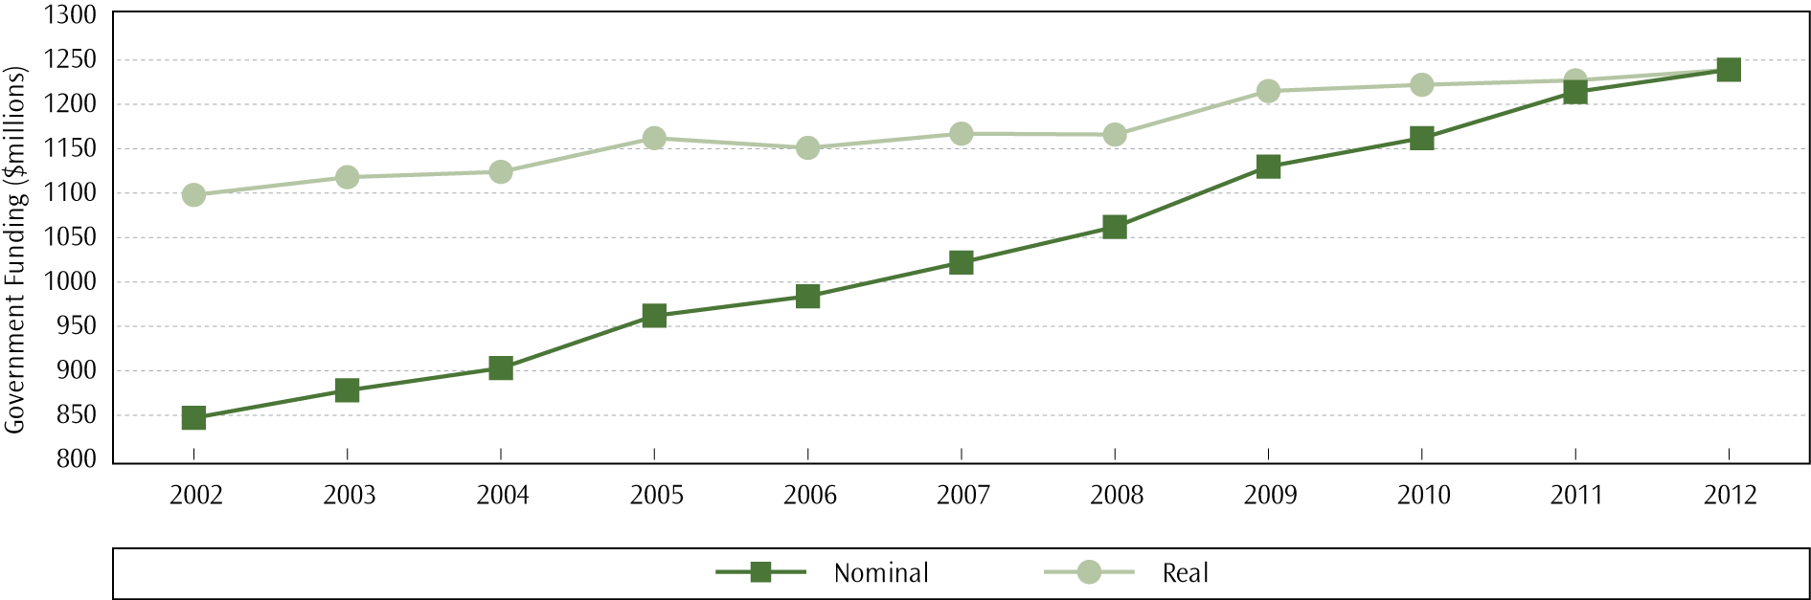

Over the past year operational funding stayed relatively stable, with a 1% increase in real terms. A more detailed breakdown of operational grants to schools is available on the Education Counts website.

Funding for teacher salaries
Teacher salaries are centrally funded, which means the Ministry of Education pays teachers on behalf of schools. Teacher salary funding is based on entitlement staffing, which is derived from the year-level rolls of the school. Detailed descriptions and the calculation process for teacher staffing entitlements can be found in the Funding, Staffing and Allowance Handbook. Figure 3 displays the total funding for teacher salaries from 2002 to 2012, in nominal and real (2012) terms.
Government funding for teacher salaries increased by 70.5% in nominal terms, or by 31.6% in real terms, between 2002 and 2012. Teacher salaries decreased by 0.3% in real terms from 2011, however this figure relates to salaries before the new collective agreements for primary, composite, and secondary schools came into effect in 2013. A more detailed breakdown of salaries funding to schools is available on the Education Counts website.
- Teacher salary funding to state and state-integrated schools, 2002–2012
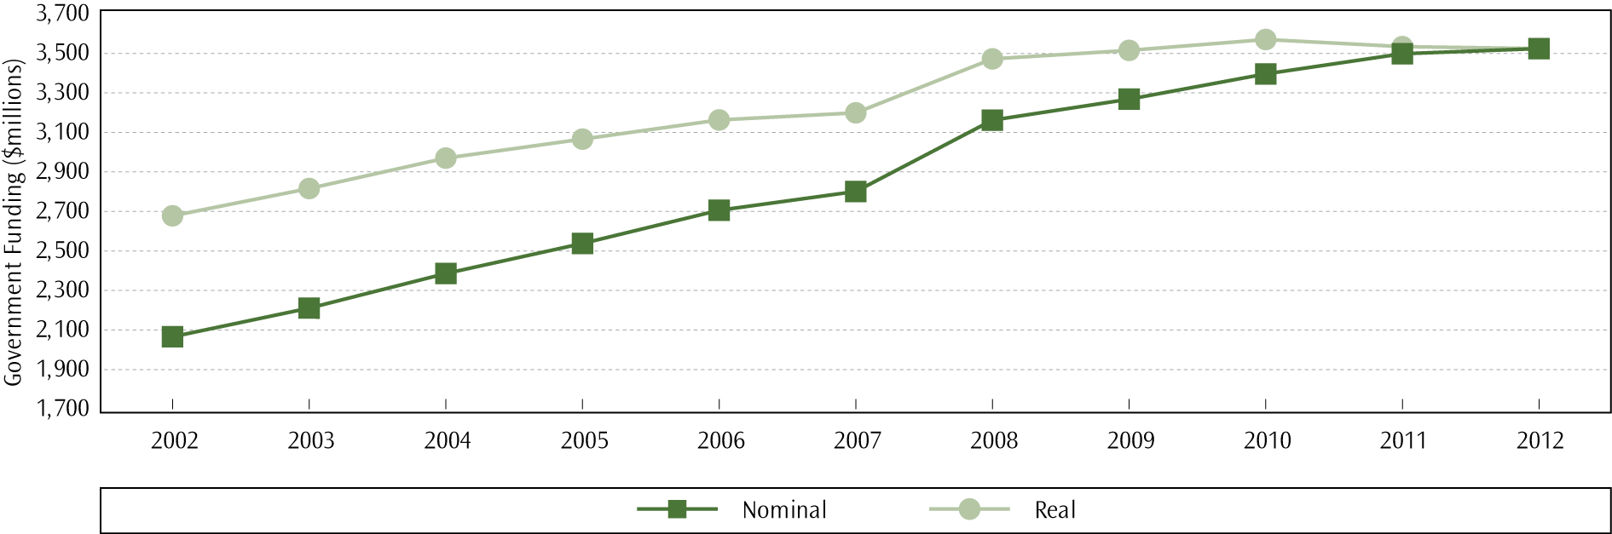

Direct property funding to schools
The Crown owns the buildings and land of state schools, and the proprietors own the buildings and land of state-integrated schools. Both Crown and proprietors must make sure that school property can accommodate current and future enrolments and meet health and safety requirements, and hence facilitate learning. To help ensure this, the Ministry of Education and state schools agree on a five-year school property plan that allocates an amount of funding available to the school over this period. Schools can draw funding for property works each year in accordance with this plan. Figure 4 shows nominal and real direct property funding from 2002 to 2012.
- Direct property funding to schools, 2002–2012
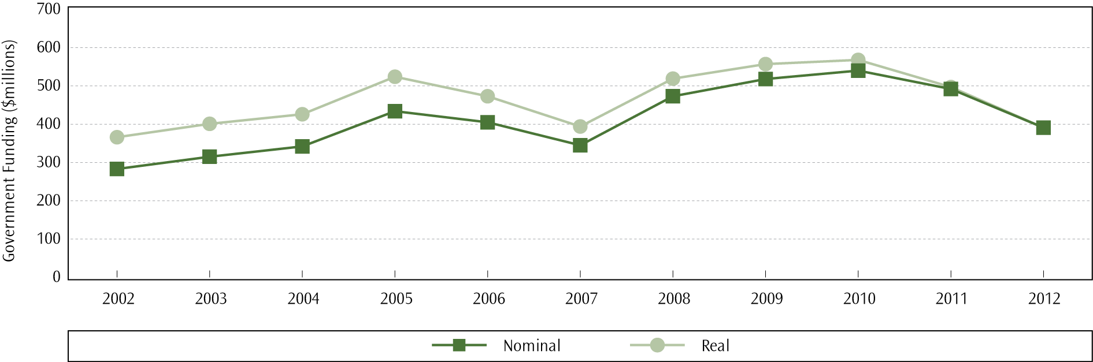

Over the past year, direct property funding decreased by 21.4% in real terms. Between 2002 and 2012, the capital investment in school property increased by 6.6% in real terms. A more detailed breakdown of property funding to schools is available on the Education Counts website.

Financial performance of New Zealand schools

Introduction
A school’s board of trustees is responsible for the management, organisation and administration of a school under Section 75 of the Education Act 1989. State and state-integrated schools provide their end-of-year financial statements to the Ministry of Education after the annual audit.
New Zealand implemented major reforms in the administration of the education sector in the late 1980s and early 1990s. These reforms substantially changed financial management in the education sector, shifting the accountability and authority for spending from the former Department of Education and Regional District Boards to school boards of trustees.
This section of this report presents summary results on the financial performance of state and state-integrated schools. The focus is on revenues and expenditures of schools as well as indicators of sound financial performance. First, the main sources of school revenues and main categories of expenditures are presented. This is followed by a discussion of schools’ financial performance using indicators such as operating surplus, working capital and public equity.

Revenue
The Government provides the large majority of schools’ income, but schools supplement this income in various ways. The total revenue for state and integrated schools between 2009 and 2012, broken down by the main source categories, is presented in Table 1.

Proportion of government funding
The trend in government funding as a proportion of total school revenue is presented in Table 1. The table includes the components of schools’ revenue in gross terms.
- School revenue, 2009–2012
Revenue | 2009 | 2010 | 2011 | 2012 (est)
Government grants ($) | 5,446,244,516 | 5,562,573,955 | 5,840,535,288 | 5,898,163,225
Local funds ($) | 474,809,280 | 473,484,523 | 477,479,852 | 487,535,141
International students ($) | 99,209,939 | 105,124,751 | 110,770,012 | 108,133,134
Investments ($) | 36,449,549 | 39,167,717 | 39,596,027 | 38,667,959
Hostels ($) | 30,140,179 | 30,260,735 | 32,540,125 | 33,440,547
Other revenue ($) | 70,981,481 | 104,838,522 | 112,852,119 | 108,690,337
Total revenue ($) | 6,157,834,944 | 6,315,450,203 | 6,613,773,423 | 6,674,630,343
Proportion of government funding (%) | 88.4 | 88.1 | 88.3 | 88.4
Notes:
Figures are GST exclusive.
Includes use of land and building grants from government and proprietors from 2009 onwards.
The figures in this table for 2012 are estimates based on 1,942 (80%) schools at the time of writing, and estimates based on previous accounts data for 497 remaining schools.
Local funds revenue generated by schools includes donations from parents and community and fundraising activities, not excluding the cost of generating this revenue (see page 26 for information relating to local funds expenditure). In 2012 these sources represented seven per cent of all revenue. A further two per cent of revenue was attributed to income from international students.

Expenditure
Operating a school incurs expenditure in a number of different areas. In 2012, total school expenditure was $6.6 billion, a one per cent nominal increase from the previous year. Table 2 contains the breakdown of school expenditure by main expenditure categories.
- Expenditure of state and state-integrated schools, by main expenditure category,
2009–2012
Expenses | 2009 ($) | 2010 ($) | 2011 ($) | 2012 ($) est
Learning resources | 4,026,962,236 | 4,149,082,116 | 4,304,196,197 | 4,323,825,465
Administration | 371,521,182 | 391,247,174 | 397,613,022 | 403,393,865
Property | 1,265,696,207 | 1,271,565,981 | 1,371,018,467 | 1,410,547,945
Local funds | 221,434,608 | 219,622,018 | 216,427,304 | 222,644,211
Depreciation | 157,684,491 | 162,066,799 | 167,096,287 | 168,716,483
International students | 43,185,843 | 46,031,970 | 51,025,868 | 52,292,790
Hostel | 20,757,383 | 26,875,620 | 27,826,563 | 30,453,216
Loss on asset disposal | 5,617,128 | 6,751,735 | 7,746,848 | 6,948,654
Amortisation of equitable leasehold interest | 659,775 | 628,772 | 648,116 | 1,164,512
Amortisation of software |  | 304,064 | 381,562 | 390,944
Finance costs | 1,497,450 | 1,448,096 | 1,377,824 | 1,343,503
Impairment | 296,965 | 1,346,918 | 2,423,292 | 1,277,224
Other expenses | 16,538,987 | 24,297,004 | 27,184,743 | 20,134,095
Notes:
Figures are GST exclusive.
From 2009 on, includes use of land and building grants from the Government and proprietors.
Learning resources include teachers’ salaries, expenses for teachers’ aides, purchase of materials and equipment for learning and applying the curriculum, and expenses related to extracurricular activities. In 2012 learning resources comprised 65.1% of all school expenditure.
The majority of administration expenses are the salaries of principals and other administrators. Administrative expenses also include the expenses of boards of trustees and all communication- and audit-related expenses. Administration expenses comprised 6.1% of total school expenditure in 2012.
Depreciation includes the depreciation on furniture, equipment and physical assets of schools, and comprised 2.5% of total school expenses in 2012.
Expenses to raise funds from local sources include expenses for trading and fundraising activities. In 2012 these comprised 3.4% of total school expenditure. Administration of international students comprised 0.8% of the total.
Property expenditure includes the salaries of cleaners and caretakers, heating, light and water requirements, expenses related to the upkeep of school grounds, and repairs and maintenance of school sites. In 2012 the property expenditure comprised 21.2% (when use of land and buildings are included) of the total expenditure of schools. Other forms of expenditure comprised 0.9% of total expenditure.

Indicators of sound financial management
A range of financial indicators give some insight into the financial management and performance of schools, including whether they have an operating surplus, sufficient working capital for operations or increasing public equity. The general performance of schools based on these indicators is discussed below.

Operating surplus
The operating surplus is calculated as the difference between total revenue and total expenditure (including depreciation on assets). In general, schools should have an operating surplus or sufficient reserves available to provide for any unexpected expenditure. Schools achieved an estimated combined operating surplus of 0.5% of total revenue in 2012, compared with 0.6% in 2011.
Schools can record an operating deficit in one year due to unexpected or unforeseen expenditure. An operating surplus for multiple consecutive years is an indicator of sound financial management. Table 3 presents the proportion of schools that have reported one, two or three years of operating surplus during the last three years (2010–2012).
- Percentage of schools with an operating surplus, 2010–2012
Surplus | All schools  (%) | Primary schools  (%) | Secondary schools (%) | Other schools  (%)
One year of operating surplus | 27.8 | 28.9 | 23.2 | 22.5
Two years of operating surplus | 30.2 | 29.9 | 31.4 | 27.5
Three years of operating surplus | 24.4 | 23.2 | 27.9 | 45.0
Operating surplus in 2010 | 49.2 | 48.2 | 52.9 | 56.5
Operating surplus in 2011 | 56.3 | 55.3 | 59.6 | 71.1
Operating surplus in 2012 | 55.2 | 54.4 | 57.2 | 72.5

Around half of schools have operated in surplus in each of the last three years. In the last three years, secondary schools were more likely to have a surplus than primary schools.

Working capital
The level of working capital is an indicator of a school’s ability to operate financially and meet debts in the short term. Working capital is normally measured in one of two ways: as a dollar value or as a ratio between current assets and current liabilities.
Table 4 presents the working capital ratios of schools in 2012. Having a working capital ratio of at least 1:1 means that a school is able to pay its short-term debts and operate with some flexibility. For example, if the working capital ratio is 1:35, this means that for every dollar of current liabilities a school owes, they have $1.35 worth of current assets to meet their short-term financial obligations.
- Percentage of schools in different working capital ratio bands, 2012
Working capital ratio | All schools  (%) | Primary schools  (%) | Secondary schools (%) | Other schools  (%)
< 1.0 | 6.2 | 4.9 | 12.8 | 0
< 2.0 | 41.7 | 38.8 | 56.7 | 17.5
< 3.0 | 26.8 | 28.7 | 17.3 | 37.5
3.0 + | 25.4 | 27.7 | 13.2 | 45

Table 4 shows that almost 94% of all state and state-integrated schools have at least enough current assets to cover their short-term debts.

Public equity
Public equity represents the net worth of schools and is calculated as the difference between total assets and total liabilities. Schools in a healthy financial position generally show increasing levels of public equity over time.
Across all state and state-integrated schools, public equity has increased each year for the past six years. Public equity is almost $1,762 million in 2012, which is a 2.2% increase from the previous year. Table 5 shows the trends in total public equity of state and state-integrated schools over the last three years.
- Public equity trends ($), 2010–2012
Year | All schools  ($) | Primary schools  ($) | Secondary schools ($) | Other schools  ($)
2010 | 1,653,380,585 | 894,708,602 | 705,853,521 | 52,818,462
2011 | 1,723,981,251 | 920,329,466 | 747,626,949 | 56,024,836
2012 (est) | 1,761,578,931 | 939,813,890 | 763,789,481 | 57,975,560

Table 6 shows the proportion of schools that have contributed to this increase in public equity.
- Percentage of schools with an increase in public equity, 2012
 | All schools  (%) | Primary schools  (%) | Secondary schools (%) | Other schools  (%)
Equity increase in 2011 | 60.8 | 59.9 | 64.2 | 76.2
Equity increase in 2012 | 58.8 | 58.3 | 60.8 | 66.7
Equity increase in 2011 and 2012 | 40.3 | 39.4 | 44.8 | 47.6
No increase in equity for 2011/12 | 41.2 | 41.7 | 39.2 | 33.3

Chapter 3: Foundation skills
Literacy and numeracy knowledge and skills are vital to ensure students are well equipped to access curriculum content and achieve in all learning areas.

Reading and writing literacy
By international standards, students in New Zealand schools are, on average, performing well in reading literacy at primary and secondary levels. However, there are differences in reading and writing abilities across the different ethnic and socio-economic groups in New Zealand schools, as well as a relatively large gap in performance between the highest and lowest achievers.
One Ministry flagship programme, which has been shown to have a significant positive impact on students’ reading level is ‘Reading Together’. Achievement in reading literacy is strongly linked to achievement across other curriculum areas. Improvements in reading literacy contribute to current and future student achievement across the curriculum. The ‘Reading Together’ programme provides parents with strategies to support their children’s reading at home using the same literacy strategies that are used within their school. The programme is being rolled out in all decile 1–3 schools over 2012–2014.

Reading literacy in primary schooling

Key policies
Several key policies at various stages of development and implementation provide direction to ensure high levels of reading and writing achievement at primary schools:
- The New Zealand Curriculum outlines the use of English to develop reading and communication skills in this language, as well as learning other languages (such as te reo Māori) to extend linguistic understanding.
- Te Marautanga o Aotearoa (the national curriculum for Māori medium) outlines the use of te reo Māori to strengthen kōrero (oral language), pānui (reading) and tuhituhi (writing).
- The National Standards focus on creating a clear picture of what students should be achieving in reading and writing, and at what stage, to support learning across the curriculum.
Ngā Whanaketanga Rumaki Māori describe the kōrero, pānui, tuhituhi and pāngarau skills and knowledge students need in all learning areas across Te Marautanga o Aotearoa, at different points of their year 1 to 8 schooling.

Reading Recovery
Reading Recovery is an early literacy intervention for that aims to reduce reading and writing delay by providing intensive, daily one-to-one literacy instruction to children who are falling behind in reading and writing after one year at school. Reading Recovery also identifies the children who need longer-term literacy support.
In 2012, Reading Recovery supported 11,202 students. Reading Recovery was offered in just under two-thirds (64%) of state and state-integrated schools with six-year-old students. Fourteen per cent (8,166) of six-year-old students enrolled in state and state-integrated schools entered Reading Recovery for the first time in 2012.
Most students (81%) who exited the intervention in 2012 were able to work effectively with their cohort without additional support and were “successfully discontinued”. Twelve per cent of students were referred on for further specialist or long-term literacy support. Girls, New Zealand Pākehā/European students, and students from higher decile schools (8 to 10) were more likely to successfully discontinue than boys, Māori or Pasifika students, or students from decile 1–3 schools (Cowles, 2013).

Resource Teachers of Literacy
Resource Teachers of Literacy (RTLit) are specialist teachers who support staff in schools to meet the needs of students in years 1 to 8 experiencing difficulties with literacy learning. A total of 4,530 students were on the RTLit roll in 2012. RTLit supported students either by indirect support only (44%), where RTLit provide modelling, advice and guidance to classroom teachers; direct support only (17%), composed of individual or small-group tutoring; or a combination of both indirect and direct support (39%).
Consistent with previous years’ trends, more boys (68%) than girls (32%) received RTLit support in 2012. Half of RTLit students were New Zealand Pākehā/European, just over one-third (36%) were Māori, nine per cent were Pasifika and three per cent were Asian. Nearly half (45%) of students were successfully discontinued from the RTLit roll at the end of 2012, 17% were referred on for alternative specialist assistance, 13% were withdrawn and 25% were rolled over to continue their support in 2013 (Cowles, 2013).

Accelerated Literacy Learning
In 2011 the Ministry implemented a range of initiatives under the framework of ‘Programmes for Students’ in order to support schools in improving educational outcomes for students failing to meet the National Standards. These programmes supported principals and programme teachers from selected primary and intermediate schools to design intensive programmes in reading, writing and mathematics for small groups of students over 10–15 weeks.
One of these initiatives was Accelerated Literacy Learning (ALL), a project focussed on accelerating the learning progress of students assessed as ‘well below’ or ‘below’ in National Standards for reading or writing.
The University of Waikato undertook an evaluation of the ‘Programmes for Students’ with schools who took part in the programmes during Term 3, 2011 (Cowie, McGee, Peter, Taylor and Chen, 2012). The evaluation found the majority of students accelerated their learning in reading, writing, and mathematics during the programmes; that is, their achievement increased more in the programmes than would have otherwise occurred in the equivalent classroom time.
The ‘Programmes for Students’ initiatives were implemented again in 2012. In 2012, around 350 schools participated in ALL providing junior literacy, reading and writing programmes for students in years 1 to 8.

National Standards – reading
In 2012, 77.4% of year 1–8 students were at or above the National Standard for reading for their year level. This was an increase of 1.2 percentage points on the proportional of year 1–8 students meeting the National Standard for reading in 2011 (76.2%).
- Proportion of students meeting the National Standard for Reading, 2011 to 2012
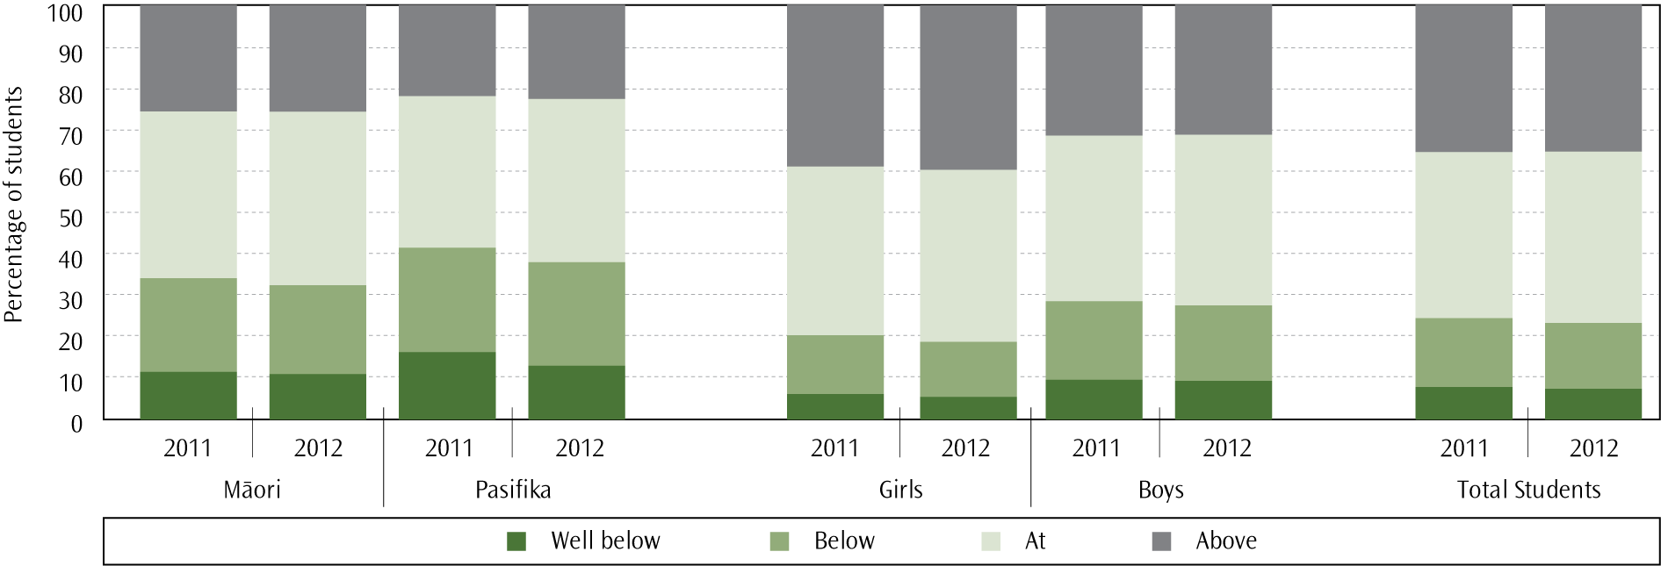

Ngā Whanaketanga Rumaki Māori ― Ngā Whanaketanga Reo
In 2012, students in kura and schools using Ngā Whanaketanga Rumaki Māori were generally achieving at the expected level for kōrero (speaking), pānui (reading) and tuhituhi (writing). Overall achievement was the strongest against the expected outcomes set for pānui, with 75.8% of students Manawa Ora (At) or Manawa Toa (Above). Seventy per cent of students were Manawa Ora or Manawa Toa for tuhituhi, while 65.3% of students achieved at these levels for kōrero.
- Proportion of students meeting Ngā Whanaketanga Reo, by gender, 2012
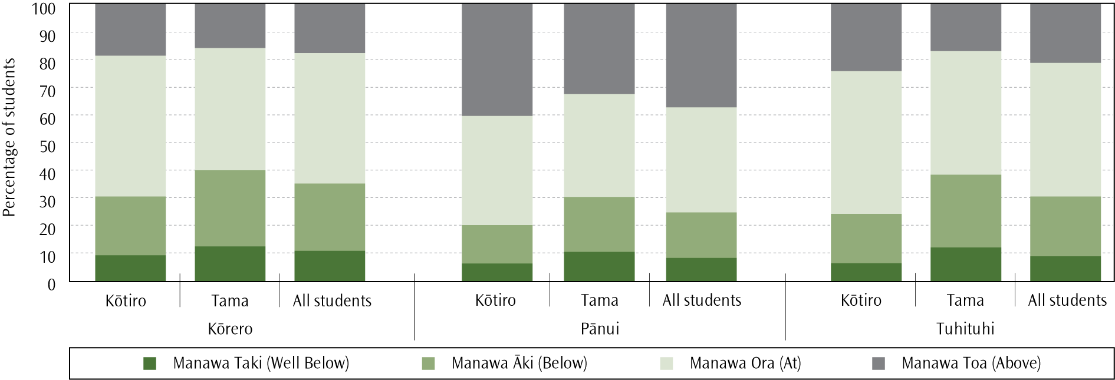

International differences
The Progress in International Reading Literacy Study (PIRLS) has assessed the reading literacy achievement of New Zealand’s year 5 students every five years since 2001. PIRLS assesses reading comprehension processes and skills in two purposes for reading at middle primary level: reading for literary purposes, and reading for informational purposes. The third cycle was completed in 2010/11, with achievement and contextual information collected in 48 countries.
In keeping with the two earlier cycles in 2001 and 2005/06, New Zealand’s mean score for year 5 students was significantly higher than the PIRLS Scale Centrepoint, with the means for 17 countries, including four OECD countries (Belgium (French), France, Norway and Spain), being significantly lower than New Zealand (Chamberlain, 2013). However, 20 countries had significantly higher means than New Zealand including 14 OECD countries, such as United States and England. There was no significant change in mean reading literacy achievement at year 5 over the period 2001–2010/11.
New Zealand was well represented among the best readers internationally, with 14% of year 5 students reaching the PIRLS Advanced International Benchmark; this was close to double the international median of eight per cent. New Zealand was also however slightly over-represented among the weaker readers internationally, with eight per cent of year 5 students not reaching the Low International Benchmark, compared to an international median of five per cent. Failure to reach this benchmark is indicative of student difficulties with locating and reproducing even explicitly-stated information.

Ethnic group differences

National Standards
The proportions of Māori (68.2%) and Pasifika (62.6%) students at or above the reading standard for their year level were both significantly lower than the overall proportion of students at or above the reading standard. The proportion of Pasifika students meeting the reading standard increased by 3.6 percentage points between 2011 and 2012, while the proportion of Māori students increased by 1.7 percentage points over the same time period.

PIRLS 2010/11
Across all ethnic groupings there were students represented at the highest and lowest levels of performance in reading. However, proportionally fewer Māori and Pasifika students achieved at the higher achievement benchmarks. Māori and Pasifika students were also over-represented at the lower benchmarks; 17% of Māori students and 18% of Pasifika students did not reach the Low International Benchmark.
No significant change from 2001 to 2010/11 in the reading achievement was observed for any ethnic grouping. Furthermore, significant differences in reading achievement continued to be found between ethnic groupings, as illustrated by the percentages scoring above the PIRLS Scale Centrepoint. More than 70% of Pākehā/European and Asian students achieved above the PIRLS Scale Centrepoint, whereas just under 50% of Māori students and just under 40% of Pasifika students achieved above this point.

Gender differences

National Standards
Girls were more likely to be At or Above the reading standards for their year level than boys were, with 81.9% of girls at or above, and 73.2% of boys at or above the standard. While the proportions of both genders meeting the reading standard rose between 2011 and 2012, the size of the gender difference also increased slightly between 2011 (8.5 percentage points) and 2012 (8.7 percentage points).
Ngā Whanaketanga Reo
Girls (kōtiro) were more likely to be Manawa Ora or Manawa Toa for kōrero, pānui and tuhituhi than boys (tama). The largest disparity in achievement was reported for tuhituhi, with a difference of 14.2 percentage points between the proportion of kōtiro Manawa Ora or Manawa Toa (76.3%) compared with the proportion of tama (69.6%). A difference of 10.2 percentage points was reported for pānui (80.4% for kōtiro and 70.2% for tama) and 9.4 percentage points for kōrero (69.9% for kōtiro and 60.5% for tama).

PIRLS 2010/11
Both year 5 girls and boys achieved on average above the international means for girls and boys in the PIRLS 2010/11. However, girls tended to achieve higher than boys; the difference between girls and boys was relatively large when compared to the differences in the United States and Canada, but was on a similar level to the differences found in England and Finland. This difference in mean achievement has been found in all previous PIRLS cycles; however, the gap has lessened over time due to small (non-significant) positive shifts in boys’ reading achievement in 2010/11 combined with no change in achievement for girls.

Socio-economic differences
Results from the PIRLS 2010/11 highlighted significant disparities in reading literacy achievement between year 5 students attending high decile schools and those attending low decile schools in New Zealand. While students from both ends of the socio-economic spectrum achieved at the highest reading level, only four per cent of students in decile 1–2 schools reached the Advanced International Benchmark compared to 23% of students in 9–10 decile schools. Students from the lower decile schools were also over-represented amongst our weakest readers, with 22% of year 5 students in decile 1–2 schools not reaching the Low International Benchmark compared with just one per cent of year 5 students in decile 9–10 schools.

Attitudes towards reading
Compared with students in many other countries in PIRLS 2010/11, New Zealand year 5 students liked reading and were motivated to read, however proportionally more year 5 girls liked reading compared to year 5 boys. Year 5 students were much less confident in their reading ability compared to many of their international counterparts, and were slightly less engaged during their reading lessons.

National Standards ― writing
In 2012, 70.0% of year 1–8 students were at or above the National Standard for writing. As in 2011, the writing standards had the lowest proportion of students at or above the standard for their year level out of the reading, writing and mathematics standards. The largest gains were seen in writing standards, however, with an increase of two percentage points in the proportion of students meeting the standard for their year level between 2011 (68.0%) and 2012 (70.0%).
- Proportion of students meeting the National Standard for Writing, 2011 to 2012
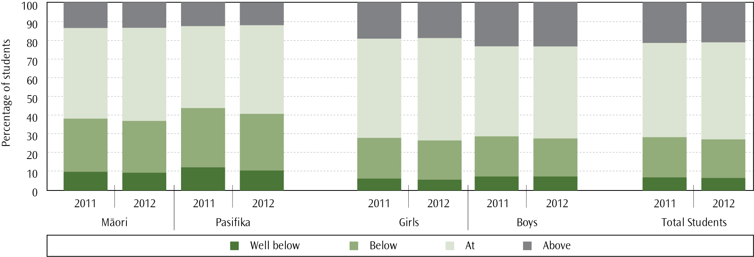

Ethnic group differences
The proportions of Māori (60.2%) and Pasifika (56.8%) students at or above the writing standard for their year level were both significantly lower than the overall proportion of students at or above the writing standard. The proportion of Pasifika students meeting the reading standard increased by 3.0 percentage points between 2011 and 2012, while the proportion of Māori students increased by 2.7 percentage points over the same time period.

Gender differences
As in 2011, girls were much more likely to be at or above the writing standard for their year level than boys were in 2012, with 77.8% of girls at or above, and 62.6% of boys at or above the standard. While the proportions of students meeting the writing standard have risen for both boys and girls, the size of the gender difference also increased between 2011 (13.8 percentage points) and 2012 (15.2 percentage points).

Reading literacy in secondary schooling

NCEA
To achieve National Certificate of Educational Achievement (NCEA) Level 1 qualification, all students must fulfil specific literacy and numeracy requirements. NCEA achievement is reported by student age as at 1 May; the typical assessment level for 15-year-old students is NCEA Level 1.
In 2012, 80.1% of 15-year-old students met the literacy requirements for NCEA Level 1, an improvement on 78.1% in 2011.
- Proportion of 15-year-old students who met the literacy and numeracy requirements for NCEA Level 1, 2008-2012
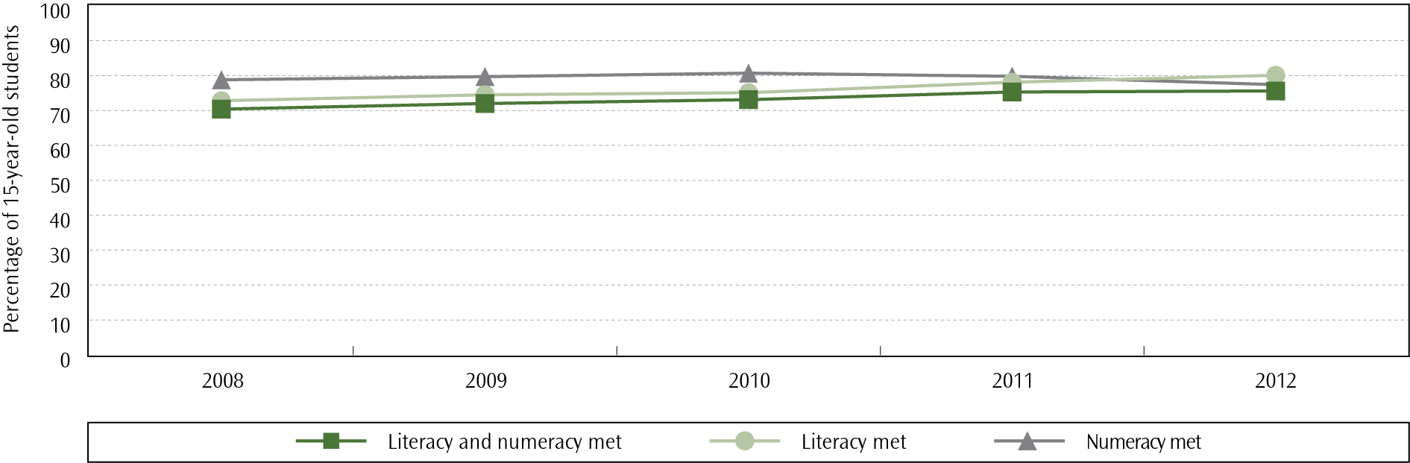

International differences
Every three years since 2000, the Programme for International Student Assessment (PISA) has assessed 15-year-old students’ reading, mathematics and science. In 2009, reading literacy was a major focus. The results for PISA 2009 were released in December 2010.
In PISA 2009 (Telford & May, 2010) New Zealand continued to exhibit high performance in reading literacy at the senior secondary level, with only two of 34 OECD countries (Korea and Finland) achieving significantly higher mean scores than New Zealand. Shanghai-China and Hong Kong-China (two of the non-OECD partner economies that take part) also achieved significantly higher mean scores than New Zealand.
Many New Zealand 15-year-old students are achieving at the top levels of proficiency, more so than the OECD average (41% in the top three levels compared to 28%). However, 14% of New Zealand 15-year-old students did not achieve above the lowest levels of reading literacy in 2009; this was a similar result to Australia and Japan, but smaller than the average across the OECD countries (19%).

Ethnic group differences

NCEA
In 2012, 69.5% of 15-year-old Māori and 74.9% of Pasifika 15-year-old students met the literacy requirements for NCEA Level 1. In comparison, 84.9% of Asian and 83.7% of Pākehā/European 15-year-old students reached this level. Pasifika students made the largest improvement in literacy attainment, with the proportion of Pasifika 15-year-old students meeting requirements for NCEA Level 1 literacy increasing by 5.4 percentage points compared with 2011 (69.5% in 2011).

PISA
In PISA 2009 the mean scores for Pākehā/European and Asian 15-year-old students were significantly higher than the OECD average, while Māori and Pasifika mean scores were significantly lower than the OECD average. Lower proportions of Māori and Pasifika students achieved at the highest levels of proficiency in reading, and they were over-represented at the lower levels when compared with Pākehā/European and Asian students.

Pasifika Education Plan 2013–2017
For the schooling sector, the Pasifika Education Plan 2013–2017 focuses on increasing Pasifika achievement levels in literacy and numeracy, and gaining secondary school qualifications. It sets a target of increasing the percentage of school leavers achieving NCEA Level 1 numeracy and literacy from 80% in 2010 to 95% in 2017. Results from 2012 indicate that progress has been made towards reaching this target, with the figure at 83%.
- Proportion of 15-year-old students meeting NCEA Level 1 literacy and numeracy requirements, by ethnicity, 2008-2012
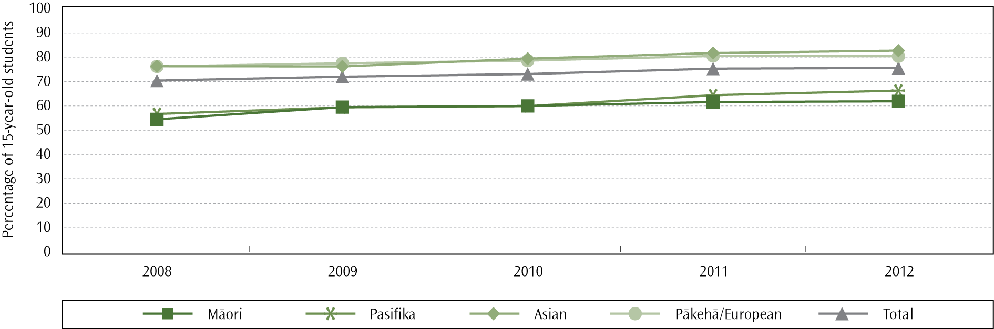
Notes:
For this figure, students who identified in more than one ethnic group have been counted in each ethnic group. Each student has only been counted once in the total.
MELAA refers to Middle Eastern, Latin American/and African.

Ka Hikitia ― Managing for Success (2008–2012)
Ka Hikitia ― Managing for Success (2008–2012) focuses on raising Māori achievement in all areas of education, and as such set a target to improve the proportion of year 11 Māori students achieving the reading literacy and numeracy criteria for NCEA Level 1 to be equal to or better than the proportion of non-Māori by 2012.
The proportion of 15-year-old Māori students meeting requirements for NCEA Level 1 literacy and numeracy was significantly lower than the proportion of 15-year-old non-Māori students meeting these requirements in 2012: 62% compared to 80% respectively. Although parity was not reached in 2012, the size of the difference between Māori students and non-Māori students has reduced by 2.4 percentage points since 2008. Furthermore, the proportion of Māori 15-year-old students meeting literacy and numeracy requirements has increased by 14% over the same time period.
The proportion of Māori in Māori medium settings achieving the literacy requirements for NCEA Level 1 (in either English or te reo Māori) was higher than for Māori students in English medium settings. In 2012, 76.4% of 15-year-old Māori students in Māori medium settings achieved the literacy requirements, compared with 61.9% of Māori candidates in English medium settings and 78.2% of non-Māori candidates. The disparity in achievement between Māori students in Māori medium education and Māori students in English medium education has increased over time, from 8.1 percentage points in 2008 to 14.5 percentage points in 2012. Disparity in literacy and numeracy attainment between Māori students in Māori medium education and non-Māori students in English medium education has decreased over the same time period, however, with equality close to being met in 2012; there was a difference of 11.1 percentage points in 2008, which reduced to 1.8 percentage points in 2012.
- Proportion of 15-year-old students at Māori medium and English medium schools meeting both the literacy and numeracy requirements for NCEA Level 1, 2008–2012
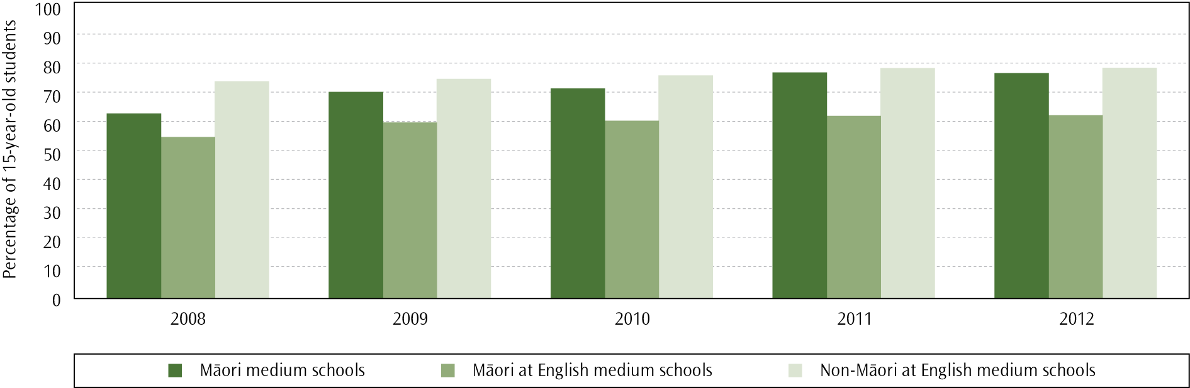

Gender differences
In 2012, 77% of 15-year-old male students and 83.3% of 15-year-old female students achieved the literacy requirements for NCEA Level 1.
- Proportion of 15-year-old students meeting the NCEA Level 1 literacy requirements, by gender, 2008–2012
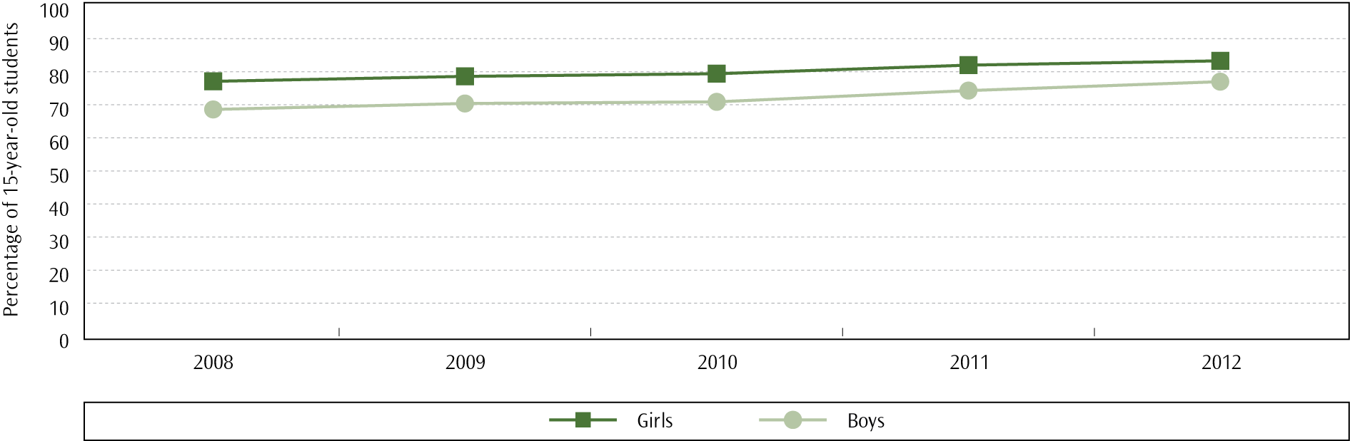

As with NCEA results, 15-year-old New Zealand girls achieved a significantly higher mean reading literacy score than boys in PISA 2009. This gender difference was common to all of the 65 countries participating in PISA 2009 for reading, but New Zealand had a larger gender difference than many other countries.

Socio-economic differences
The gap in NCEA Level 1 literacy attainment between schools from highest and lowest deciles has reduced since 2008; there has been a 30% decrease in the difference between the lowest quintile (deciles 1 and 2) and the highest quintile (deciles 9 and 10). In 2012, however, there remained a large (21.9 percentage point) difference between the NCEA Level 1 literacy attainment percentages of those schools in the lowest two deciles compared to schools from the top two deciles.

Attitudes towards reading
New Zealand 15-year-olds in 2009 were more positive about reading than the average across the 34 OECD countries and they were slightly more positive than they were in PISA 2000. Just over two-thirds of the students read for enjoyment on a daily basis (69%), a similar proportion to PISA 2000 but larger than the OECD average (63%).
Where to find out more

Mathematics

Mathematics in primary schooling
The revised mathematics curriculum documents for English medium (Ministry of Education, 2007) and Māori medium (Ministry of Education, 2008a) are based on research evidence about progressions in students’ thinking and emphasise conceptual development and understanding. The curriculum levels reflect research evidence that shows students need to understand multiplication and division to engage meaningfully with algebra in secondary schooling (Young-Loveridge, 2010). A recent ERO review on mathematics in years 4-8 concludes that many schools could improve the ways in which they review and develop their mathematics curricula, particularly with regard to improving the performance of priority students (ERO, 2013b). Thirty-eight per cent of the 240 schools included in the study were either minimally effective or not effective in their review and design of mathematics curricula.

Accelerated Learning in Mathematics
In 2011, the Ministry implemented a range of initiatives under the framework of ‘Programmes for Students’ in order to support schools in improving educational outcomes for students failing to meet the National Standards. These programmes supported principals and programme teachers from selected primary and intermediate schools to design intensive programmes in reading, writing and mathematics for small groups of students over 10–15 weeks.
One of these initiatives was Accelerated Learning in Mathematics (ALiM), a programme designed to accelerate progress in mathematics for students failing to meet the National Standards in mathematics. The initiative was developed from the Accelerated Learning in Mathematics Pilot Study, which was run in 39 schools during 2010 and found to be successful in raising student achievement in mathematics (Neill, Fisher, & Dingle, 2010).
The University of Waikato undertook an evaluation of the 2011 ‘Programmes for Students’ with schools who took part in the programmes during Term 3, 2011 (Cowie, McGee, Peter, Taylor and Chen, 2012). The evaluation found the majority of students accelerated their learning in reading, writing, and mathematics during the programmes; that is, their achievement increased more in the programmes than would have otherwise occurred in the equivalent classroom time.
The ‘Programmes for Students’ initiatives were implemented again in schools in 2012. Around 340 schools were involved in the ALiM programme in 2012, providing programmes to students in years 1–8. The Ministry also trialled a Mathematics Support Teacher programme in 76 schools in 2012. This programme was developed to support students achieving ‘well below’ the National Standard for mathematics.

National Standards ― mathematics
In 2012, 73.6% of year 1–8 students were at or above the National Standard for mathematics for their year level. This is an increase of 1.4 percentage points on the proportion of students meeting the mathematics standard for their year level in 2011 (72.2%).
- Proportion of students meeting the National Standard for Mathematics, 2011–2012
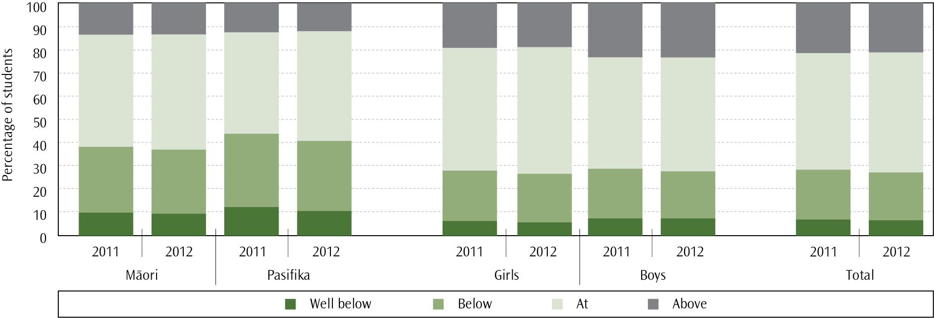

Ngā Whanaketanga Pāngarau
Compared with all other achievement areas, students in kura and schools using Ngā Whanaketanga Rumaki Māori showed the lowest level of achievement for Pāngarau (grouped) in 2012, with 60.0% of students achieving Manawa Ora or Manawa Toa. Of the strands that comprise Pāngarau (grouped), achievement was highest for Te Tau me te Taurangi (60.6% Manawa Ora or Manawa Toa), followed by Te Ine me te Āhuahanga (57.5%) and Te Tauanga me te Tūponotanga (55.3%).

International differences
The Trends in International Mathematics and Science Study (TIMSS) is an international comparative study of mathematics and science achievement at years 5 and 9, conducted on a regular four-year cycle since 1994/95. Students are assessed in two dimensions for both mathematics and science: a content dimension (specifying the subject matter to be assessed) and a cognitive dimension (assessing thinking processes). The fifth cycle of TIMSS was conducted in 2010/11 and included 50 countries at year 5 and 44 countries at year 9.
New Zealand year 5 students had relatively low mathematics achievement in the TIMSS 2010/11 cycle when compared to the international TIMSS scale centre point, with 29 countries (including all other English-speaking countries) achieving higher on average than New Zealand and 16 countries achieving lower on average than New Zealand (Caygill, Kirkham and Marshall, 2013a). While the mean achievement of year 5 students in 2010/11 was not different to the mean achievement in 2006/07, mathematics achievement in 2010/11 was significantly lower than achievement in 2002/03.
Compared to their international counterparts, New Zealand year 5 students displayed a moderate range of achievement, with four per cent of students achieving at the highest level in mathematics (equal to the international median) and 15% of students not reaching the lowest level of achievement. This was, however, a relatively high proportion of low-achieving students when compared to countries with similar proportions of students at the highest level of achievement; in the highest-performing countries, one per cent or less of students did not reach the low international benchmark.

Ethnic grouping differences

National Standards
The proportions of Māori (63.6%) and Pasifika (59.7%) students at or above the mathematics standard for their year level were both significantly lower than the overall proportion of students at or above the mathematics standard. The proportion of Pasifika students meeting the reading standard increased by 3.0 percentage points between 2011 and 2012 while the proportion of Māori students increased by 1.1 percentage points over the same time period.

TIMSS 2010/11
Across all ethnic groupings there were high-performing and low-performing year 5 students but Pākehā/European and Asian students achieved higher mean scores than Māori and Pasifika students in the TIMSS 2010/11 cycle. In addition, comparatively higher proportions of Asian and Pākehā/European students reached the highest TIMSS Benchmark. Māori and Pasifika students were over-represented among the lowest levels of achievement: 29% of both Māori and Pasifika students did not reach the lowest international benchmark, compared to nine per cent of both Asian and Pākehā/European students.
Since the last cycle in 2006/07 there has been a significant decrease in the mathematics achievement of year 5 Asian students, and a significant increase in achievement among Pasifika students; no significant difference was found for Māori or Pākehā/European students.

Gender differences

National Standards
There was little difference between girls (74.1%) and boys (73.0%) in the proportions achieving at or above their year level’s mathematics standard. The apparent difference in achievement between boys and girls increased slightly, however, from 0.8 of a percentage point in 2011 to 1.1 percentage points in 2012.
- Proportion of students meeting Ngā Whanaketanga Pāngarau, by gender, 2012
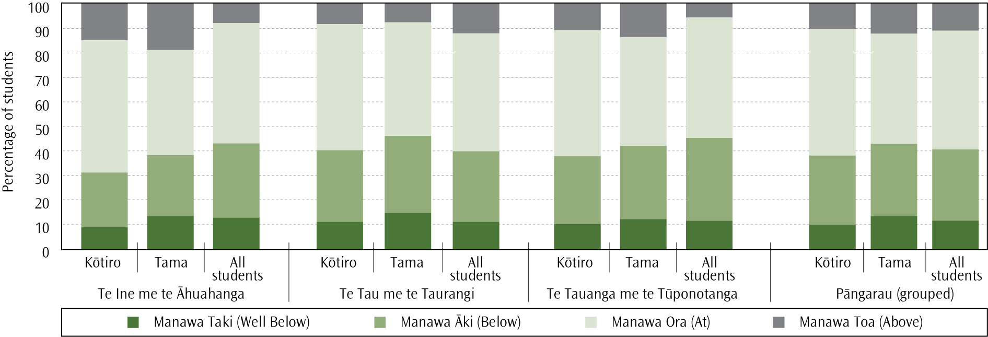

Ngā Whanaketanga Pāngarau
In 2012, kōtiro (62.4%) were more likely to be Manawa Ora or Manawa Toa in Pāngarau (grouped) than tama (57.6%). This is primarily due to the large difference in achievement in Te Tau me te Taurangi, with the percentage of kōtiro Manawa Ora or Manawa Toa (62.5%) 8.2 percentage points greater than the proportion of tama (54.3%). The proportion of tama Manawa Ora or Manawa Toa was higher than the proportion of kōtiro for both Te Ine me te Āhuahanga (a two percentage point difference) and Te Tauanga me te Tūponotanga (1.9 percentage point difference).

TIMSS 2010/11
There was no difference in the average mathematics achievement of year 5 boys and girls in the TIMSS 2010/11 cycle but there was a larger range of achievement for boys than for girls. Both genders were represented among the highest- and lowest-achieving students, with similar proportions of boys and girls reaching the Advanced TIMSS Benchmark, and no significant difference in the proportion of students not reaching the lowest international benchmark (16% of boys and 15% of girls). While no significant change was found when comparing 2010/11 average mathematics achievement to 2006/07 average achievement for either gender, both boys and girls have displayed a significant decrease in mean achievement since 2002/03.

Socio-economic differences
Year 5 students with lower SES had significantly lower mathematics achievement than students with higher SES in TIMSS 2010/11. Not only was average achievement higher for students who attended decile 9–10 schools when compared to students in decile 1–2 schools, there were also significantly more students from decile 9–10 schools achieving at the advanced level. In addition, students with lower SES were over-represented amongst the weaker at mathematics, with 38% of year 5 students in decile 1–2 schools not reaching the lowest international benchmark.

Attitudes towards mathematics
Generally, New Zealand year 5 students had positive attitudes towards learning mathematics as measured by TIMSS 2010/11. Just over 80% of students agreed at least a little that they enjoyed learning maths, and 71% of students disagreed at least a little that maths was boring. Confidence in mathematics ability was positively linked with mathematics achievement. Interestingly, a smaller proportion of New Zealand year 5 students (25%) were confident about their ability to learn mathematics than the international average (34%).

Mathematics in secondary schooling
Mathematics and statistics are compulsory in years 9 and 10. From year 11 it is no longer compulsory but participation rates for 16- and 17-year-old students remain high: 76% of 16-year-old students and 56.3% of 17-year-old students participated in at least one mathematics subject in 2012. In 2012, 77.4% of 15-year-old students achieved the numeracy requirements for NCEA Level 1. This proportion has been decreasing for the past two years, after displaying an increase between 2008 (78.8%) and 2010 (80.7%).

International differences
TIMSS 2010/11 assessed year 9 students’ mathematics ability compared with that of students in 43 other countries (Caygill, Kirkham and Marshall, 2013c). Although New Zealand ranked among the middle of the participating countries in terms of average mathematics achievement in 2010/11 (lower than 14 countries and higher than 23 countries), the average achievement of year 9 students was lower than the mean score for all other English-speaking countries who participated. There has been no significant change in the mean mathematical ability of New Zealand year 9 students since the first TIMSS cycle in 1994/95.

Internationally, New Zealand had a slightly higher proportion of advanced achievers, with five per cent of year 9 students reaching the highest level of achievement (the Advanced Benchmark) compared to the international median of three per cent. New Zealand also had significantly fewer low performing students: 16% of students did not reach the lowest international benchmark, whereas the international median was 25%. There were five per cent or fewer students not reaching this benchmark in the highest-performing countries.

Ethnic grouping differences

TIMSS 2010/11
In TIMSS 2010/11, year 9 Asian students on average performed better at mathematics than Pākehā/European, Māori and Pasifika students. Pākehā/European students were the only ethnic grouping to show a significant decrease in mathematics ability since the first TIMSS cycle in 1994; there were also proportionally more low-achieving Pākehā/European students in this cycle of TIMSS compared to the previous cycle. While high performing students were found in all ethnic groupings, larger proportions of Pākehā/European and Asian students were in the high achieving groups compared with Māori and Pasifika students. Māori and Pasifika students were also over-represented amongst the lowest achievers: 29% of Māori and 34% of Pasifika students did not reach the lowest international benchmark compared with six per cent of Pākehā/European students and three per cent of Asian students.

NCEA
In 2012, 84.5% of Asian 15-year-old students and 81.8% of 15-year-old Pākehā/European students met the requirements for NCEA Level 1 numeracy. Proportionally fewer 15-year-old Māori students (64.9%) and 15-year-old Pasifika students (69.0%) met the requirements for NCEA Level 1 numeracy but in keeping with the downwards trend identified for total students, all ethnic groupings, aside from MELAA, displayed a decrease in the proportion of 15-year-old students meeting numeracy requirements since 2010. The largest proportional decreases were for Māori students (8.1% decrease) and Pasifika students (5.7% decrease) over this time period. In comparison, the proportions of 15-year-old Pākehā/European and Asian students meeting numeracy requirements have dropped by 3.3% and 0.6%, respectively.
- Proportion of 15-year-old students with NCEA Level 1 numeracy, by ethnicity, 2008–2012
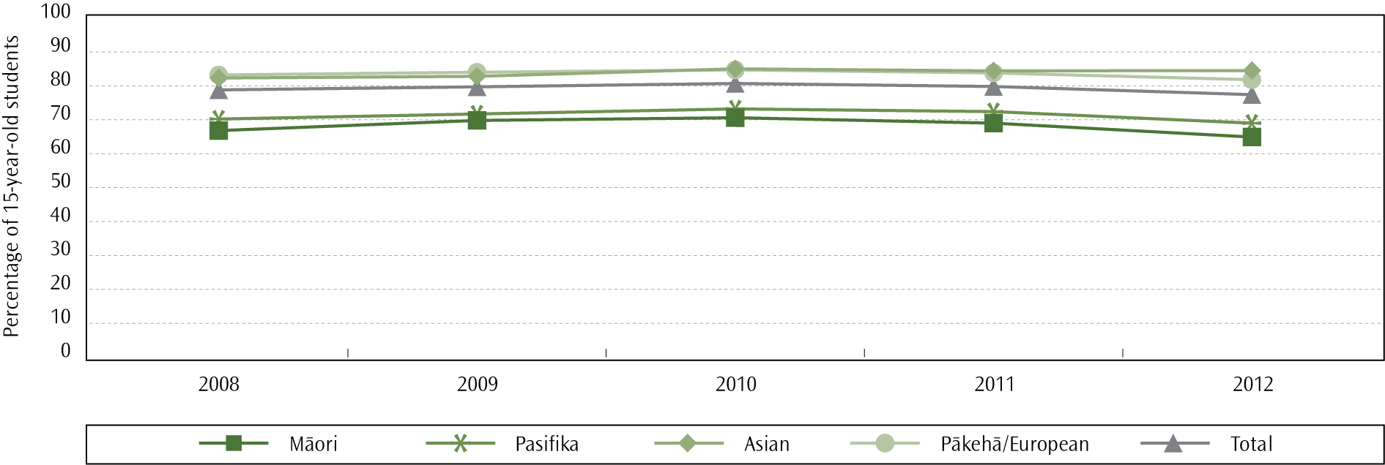
Notes:
For this graph, students who identified in more than one ethnic group have been counted in each ethnic group.

Gender differences

TIMSS 2010/11
New Zealand had close to the largest gender difference in year 9 mathematics achievement of all participating countries in TIMSS 2010/11, with boys achieving higher than girls. This is the first time that there has been a significant gender difference in year 9 mathematics, resulting from a decrease in the mean mathematics achievement of New Zealand girls since the last TIMSS cycle in 2002. Boys have not shown any significant difference in average achievement during this time. There were proportionally more high-achieving boys in the 2010/11 study compared to girls (three per cent of girls and seven per cent of boys at or above the advanced benchmark) but similar proportions of both genders not reaching the lowest international benchmark (18% of girls and 14% of boys).

NCEA
In 2012, more 15-year-old females (80.0%) met the requirements for NCEA Level 1 numeracy compared to 15-year-old males (74.8%). The higher level of achievement amongst females mirrors findings from previous years but the breadth of the disparity in achievement has been increasing over time; the size of the difference was 3.5 percentage points in 2008 and increased to a difference of 5.2 percentage points in 2012. Although the gap in achievement has been increasing, total proportions of 15-year-old students attaining NCEA Level 1 numeracy have been increasing for both genders.

Socio-economic differences
In TIMSS 2010/11, year 9 students with higher SES achieved higher mathematics scores on average than students with lower SES. This included larger proportions of advanced achievers amongst high SES students (8% of students from decile 9–10 schools compared to two per cent from decile 1–2 schools) as well as significantly higher proportions of low SES students not reaching the lowest international benchmark (39% of students from decile 1–2 schools compared to six per cent from decile 9–10 schools).

Attitudes towards mathematics
The attitudes of year 9 students towards mathematics were less positive than the attitudes of year 5 students in TIMSS 2010/11. Just over 60% of year 9 students agreed that they enjoyed learning mathematics, while approximately half agreed that mathematics is boring. Sixteen per cent of year 9 students were confident in their ability to learn mathematics. Both positive attitudes towards mathematics and positive attitudes regarding mathematics ability were linked to higher mathematics achievement on average.
Where to find out more
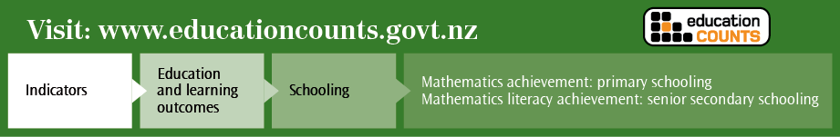

Science
The Prime Minister’s Chief Science Advisor recently released a report on the state of science in New Zealand’s schools. He states that generally the science education system performs well but there are shortcomings for certain parts of society, and there are challenges in keeping up with the changing learning requirements in an increasingly knowledge-based world in which science education is becoming so important (Gluckman, 2011).

Science in primary schooling
A recent ERO review suggests there is room for improvement in the teaching and learning of science for primary aged children (ERO, 2012). Under a third of sampled schools in the review had effective science teaching and learning practices for year 5–8 students and in over 80% of the schools self-review of science programmes was a low priority. Schools that were effective at teaching science had principals and lead teachers enthusiastic about science, who worked together in promoting the subject and who fostered staff knowledge and confidence.

International differences
In addition to assessing mathematics achievement, the TIMSS 2010/11 study assessed the science achievement of New Zealand year 5 students (Caygill, Kirkham & Marshall, 2013b). New Zealand year 5 students had relatively low science achievement when compared to the 52 other countries that took part in the current cycle, with 29 countries achieving higher mean scores (including all other English-speaking countries) and 17 countries performing worse than New Zealand. New Zealand’s mean science achievement was not significantly different to the international scale centre point.
New Zealand has now taken part in five cycles of TIMSS at the year 5 level, beginning with the 1994/95 cycle. After increasing steadily from 1994/95 to 2002/03, the average science achievement of year 5 students has declined over recent years: the average science achievement in 2010/11 was not significantly different to the average achievement in 1994/95 and was significantly lower than the mean performance in 2006/07.
The range of achievement within New Zealand was larger than in nearly all other English-speaking countries that took part in the study. While five per cent of year 5 students reached the International Advanced Benchmark (the same proportion as on average internationally), the percentage of New Zealand students who did not reach the lowest benchmark of achievement (14%) was nearly double the international median (eight per cent).

Ethnic grouping differences
Differences between ethnic groupings were found in the mean science achievement of year 5 students in TIMSS 2010/11, with Pākehā/European and Asian students achieving higher on average than Māori and Pasifika students. Asian students displayed a significant decrease in achievement in 2010/11 compared to average achievement in 2006/07. No other ethnic groupings showed significant changes in achievement over the same time period; however, the average science achievement of Pākehā/European students is significantly lower than the average achievement in the first cycle in 1994/95. Both Māori and Pasifika students have shown a decrease in science achievement compared with average performance in 2002/03, after having shown a significant increase between 1994/95 and 2002/03. Māori and Pasifika students were also disproportionally represented amongst the lowest-achieving students compared to Asian and Pākehā/European students.

Gender differences
No significant differences were found in the mean science achievement of year 5 boys and girls in the TIMSS 2010/11 cycle, although the range of achievement for boys was wider than for girls. Since 2002, there has been a consistent decrease in the mean science achievement for both boys and girls, although this decline has been more pronounced for girls. There were approximately the same proportions of both boys and girls displaying advanced science achievement in 2010/11, with five per cent of girls and six per cent of boys achieving at the highest benchmark of performance. The proportions of students who did not reach the lowest benchmark were also not significantly different.

Socio-economic differences
In TIMSS 2010/11, year 5 students with higher SES achieved higher average science scores than students with lower SES. Although there were high and low achieving students in all decile groupings, there were proportionally many more students from decile 9–10 schools achieving at the high benchmarks (45% of students) compared to students from decile 1–2 schools (seven per cent of students). Students from lower decile schools were also disproportionally represented amongst the lowest achieving students, with 36% of students from decile 1–2 schools not reaching the lowest international benchmark, compared to four per cent of students from decile 9–10 schools.

Attitudes towards science
Eighty-seven per cent of the year 5 students who participated in TIMSS 2010/11 agreed at least a little that they enjoyed learning science, while only 21% of students agreed that science is boring. This represents a higher proportion of students indicating that they enjoy science compared with previous years. The percentage of students who were positive about their ability to learn science was significantly lower, however, with 28% of students being confident with science, and 40% being somewhat confident. Positive attitudes towards both learning science and the ability to learn science were positively linked with science achievement.

Science in secondary schooling

International differences
TIMSS 2010/11 assessed the science achievement of New Zealand year 9 students compared with the achievement of lower secondary students in 43 other countries (Caygill, Kirkham and Marshall, 2013d). Overall, New Zealand performed well in terms of average science achievement. The mean science score for New Zealand students was significantly higher than the international centre point, and the mean achievement of 25 other countries. Ten countries scored higher on average than New Zealand, including the United States and England.
New Zealand has now participated in four cycles of TIMSS since 1994/95, and there has been no significant change in average science achievement during this time. In the 2010/11 study, New Zealand had proportionally more advanced achievers than the international median, with nine per cent of year 9 students achieving at the highest international benchmark compared with four per cent internationally. There was also a significantly lower proportion of very low achievers, with 10% of students not reaching the lowest level of performance, compared to an international median of 21%.

Ethnic grouping differences
In 2012, 59.8% of Māori and 60.5% of Pasifika 15-year-old students achieved 14 or more credits in NCEA Level 1 science compared to 78.4% of Pākehā/European and 80.7% of Asian students. Participation in science has increased for Māori students since 2008, but there was a decrease in participation rates for Pasifika students in 2012. For Māori, 66.4% of 15-year-old students participated in science, up from 60.6% in 2008. In 2012, 67.0% of Pasifika students participated in science compared to a 62.6% participation rate in 2008 and 68.1% in 2011.
- Proportion of 15-year-old students participating in at least one science subject, 2008–2012
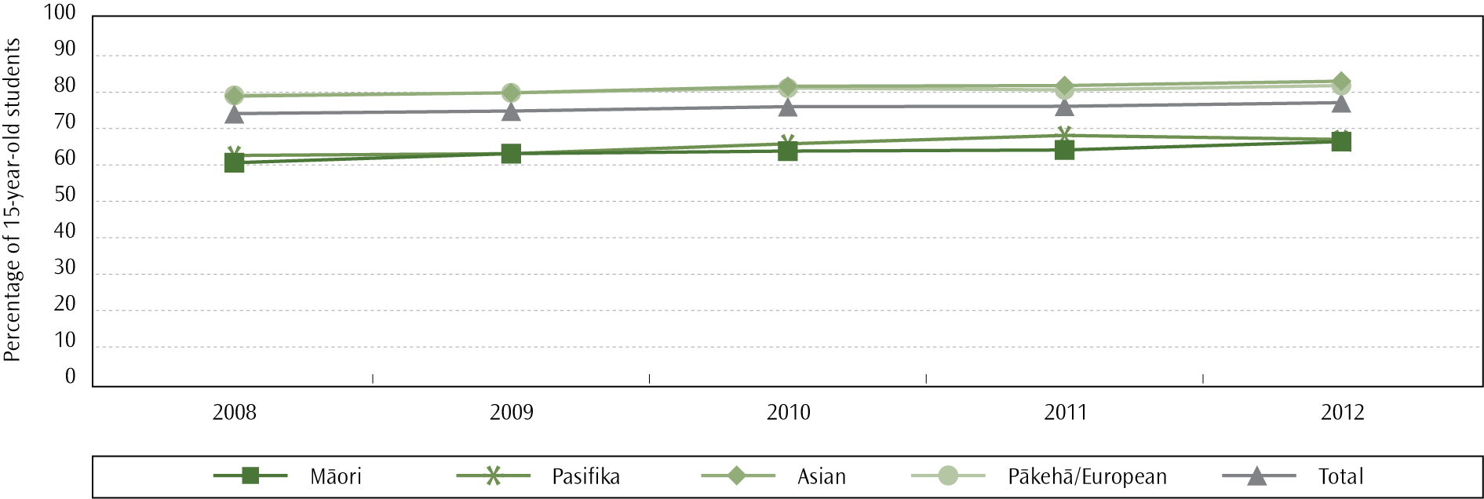
In TIMSS 2010/11, Asian and Pākehā/European students achieved higher average science scores compared with the average scores of Māori students; Māori students, in turn, achieved higher mean scores than Pasifika students. While the mean science achievement for Asian students has increased since the first cycle in 1994, between 2002 and 2010 there has been a significant decrease in average science achievement for Māori and Pasifika students. Pasifika students displayed a significant increase in average achievement between 1994/95 and 2002/03.
There were high achieving students in all ethnic groupings but there were proportionally more advanced achievers amongst Asian and Pākehā/European students compared with Māori and Pasifika students. There was also significant disparity between the proportions of students in the low achieving group, with 21% of Māori students and 30% of Pasifika students not reaching the lowest international benchmark. Four per cent of Asian students and five per cent of Pākehā/European students were in this low performing group.

Gender differences
A significant difference in science achievement between year 9 boys and girls was found in TIMSS 2010/11, with boys having higher average science achievement than girls. This is the first time since 1994 that a significant gender difference has been found, and it is largely the result of a large decline in the average science achievement of girls since 2002. In addition to achieving higher overall, there were proportionally more boys than girls among the highest achieving students, with 12% of boys and six per cent of girls reaching the most advanced levels of science achievement. Both boys and girls had similar proportions of students in the lowest achieving group; nine per cent of boys and 11% of girls did not reach the lowest international benchmark of performance.

Socio-economic differences
In TIMSS 2010/11, year 9 students with higher SES achieved higher mean science scores than students with lower SES. There were high and low achieving students in all decile groupings but students in higher decile schools were disproportionately represented among the group of high science achievers: 14% of students in decile 9–10 schools achieved at or above the advanced benchmark, whereas only three per cent of students in decile 1–2 schools reached the same level of performance. There was also disparity in the proportions of low achievers from each decile grouping, with 30% of students in decile 1–2 schools not reaching the lowest international benchmark in science compared with three per cent of students in decile 9–10 schools.

Attitudes towards science
Year 9 students in TIMSS 2010/11 were generally positive about science education, with 71% of students agreeing that they enjoyed learning science, but a significant proportion of students also considered science to be boring (43%). Positive attitudes towards ability to learn science was linked with higher average science achievement, however only 14% of students were classified as being confident in their ability to learn science.
Where to find out more
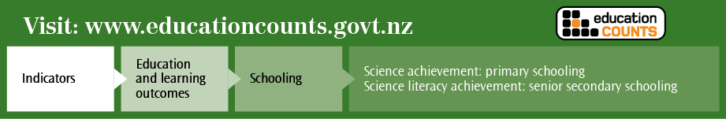

Chapter 4: Student outcomes
A successful school produces school leavers who are motivated, self-directed, lifelong learners. Completion of senior secondary education is associated with a range of economic and social benefits (see Scott & Smart, 2005; Earle, 2009).
To enter degree-level tertiary education in most institutions, students under 25 must attain 42 NCEA Level 3 credits, 28 of which must be in subjects that are part of an approved list of University Entrance subjects.

Proportion of 18-year-olds with NCEA Level 2 or equivalent qualification
The Better Public Services programme is an initiative to increase the efficiency and productivity of the public services. As part of the programme the Government has set a target of increasing the proportion of 18-year-olds with an NCEA Level 2 or equivalent qualification to 85% by 2017, attained either through school or through tertiary study.
Figure 16 shows actual 2011 and 2012 Level 2 attainment rates, 2011 forecasted attainment rates, and the 2011 calculations of the extra percentage of the total 18-year-old projected population that would need to achieve Level 2 to hit the 85% target. It is predicted that, in 2017, an extra 3.8% of 18-year-olds would need to achieve to reach this target, over and above the forecast improvement. This equates to around an extra 2,200 students.
- BPS Target: Previously predicted, required, and actual attainment rates of 18-year-olds with at least a Level 2 qualification, by ethnicity, 2011–2017
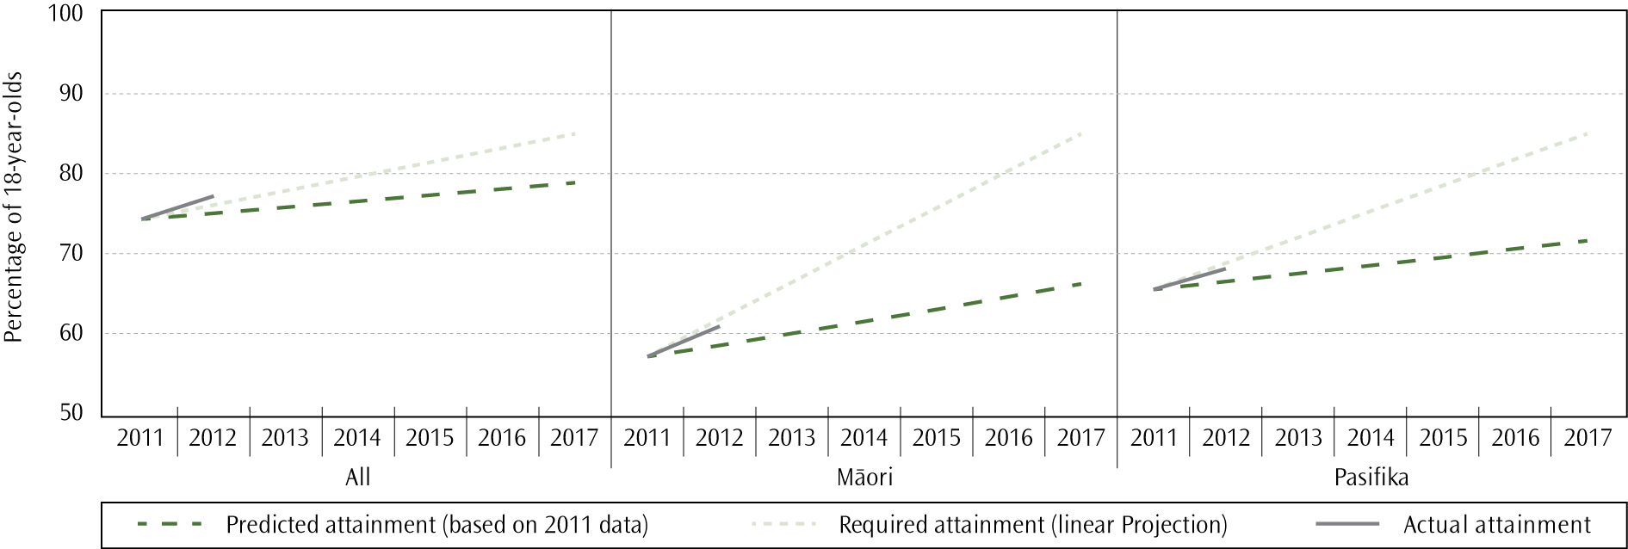
Note:
For this analysis, total response ethnic group has been used,
In 2012, 77.2% of 18-year-olds had attained NCEA Level 2 or an equivalent qualification. This represents an increase of 2.9 percentage points on the 2011 percentage (74.3%), exceeding the required growth rate of 1.8 percentage points needed to meet the 2017 target. This increase means that in order to stay on target, a growth rate of at least 0.7 of a percentage point is required in 2013; this equates to an additional 352 18-year-olds achieving NCEA Level 2 or above (compared to 2012 results). An estimated 92% of these students attained their qualification in a schooling setting and eight per cent completed this qualification in a tertiary setting.
The proportions of Pasifika (68.1%) and Māori (60.9%) 18-year-olds attaining NCEA Level 2 or above in 2012 were below the proportions required to reach the 85% target in 2017 (68.8% for Pasifika 18-year-olds and 61.8% for Māori 18-year-olds). Accelerated achievement was, however, displayed by both ethnic groups, with the proportions achieving NCEA Level 2 or above in 2012 being higher than the proportions predicted based on previous trends (66.5% for Pasifika and 58.5% for Māori); the proportion of Māori 18-year-olds attaining NCEA Level 2 or above increased by 3.8 percentage points between 2011 and 2012, and the proportion of Pasifika 18-year-olds increased by 2.6 percentage points over the same time period.
In mid-2012 a taskforce was set up by the Ministry to assist with the acceleration of student achievement towards the target of 85% of 18-year-olds achieving NCEA Level 2 or above by 2017. During 2012, a small pilot was run in secondary schools as a part of this work programme, aiming to implement strategies to accelerate achievement for underachieving students. The strategies included individual mentoring and academic coaching, quality information-sharing across the school, and help with study skills. Results were positive, with over 60% of supported Māori and Pasifika students achieving NCEA Level 2. This pilot has been extended in 2013, focusing on the 30% of schools that had over 70% of 16 and 17-year-old Māori and Pasifika students who did not achieve NCEA Level 2 in 2012. The work outlined in Chapter One that is being undertaken by the Youth Guarantee project also contributes to the Ministry’s efforts to accelerate achievement in order to reach the 2017 target.
Efforts in this area have also focused on family and whānau, with more than 3,600 parents and caregivers attending NCEA and the Whānau workshops since September 2011. These workshops, delivered in partnership by the New Zealand Qualifications Authority, the Ministry of Education and Careers New Zealand, explain to whānau how NCEA works, how their children can achieve it, and how they can most effectively help their children and work with their schools to raise achievement.

School-leaver qualifications
People with higher levels of qualification are more likely to participate in the labour market, face lower risks of unemployment, have greater access to further training, and receive higher earnings on average.

School leavers with NCEA Level 1 or above
In 2012, 85.2% of all school leavers attained at least NCEA Level 1. This is just under one percentage point higher than the proportion of school leavers who attained at least NCEA Level 1 in 2011 (84.3%); since 2009 (80.7%) there has been an increase of 5.5% in school leavers who attain at least NCEA Level 1. Continuing a historic trend, female school leavers (87.1%) achieved at a higher rate than their male counterparts did (83.4%). The total number of school leavers recorded in 2012 was 60,019.

Ethnic group differences
When looking at total responses for ethnic group, in 2012 Asian students had the highest proportion of school leavers attaining at least NCEA Level 1 (92.9%), which was 3.5 percentage points higher than the percentage of Pākehā/European (89.4%) students. Pasifika (78.8%) and Māori (70.5%) students had the lowest rates of achievement.
Looking at the ethnic group trends, the largest proportional increase in those attaining at least NCEA Level 1 has been in Māori school leavers, with an increase of 11.3% between 2009 (63.3%) and 2012 (70.5%). Pasifika school leavers have also shown improvement, with an increase of 7.0% between 2009 (73.7%) and 2012 (78.8%). This can be compared to the European/Pākehā school leavers, who had a smaller proportional increase in NCEA Level1 achievement of 4.6% between 2009 (85.5%) and 2012 (89.4%). While this indicates that the disparities between the different ethnic groups are reducing, the disparity is still large for Māori and Pasifika students.

In a 2011, mid-term review of Ka Hikitia ― Managing for Success a target was set to reduce the percentage of Māori students leaving secondary school without a qualification from 34% in 2010 to 24% in 2015. Progress was made against this target in 2012, with 29.5% of Māori students leaving school without a qualification, a reduction of 1.1 percentage points compared to the proportion in 2011 (30.6%).
- Proportion of school leavers with NCEA Level 1 or above, by total response ethnicity, 2009–2012
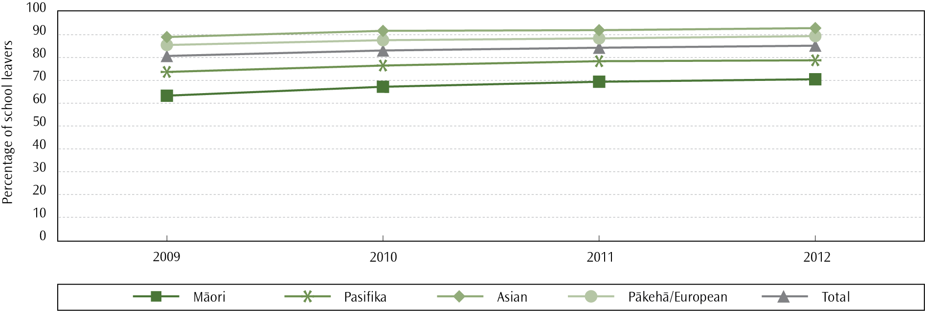
Note:
For this indicator students who identified in more than one ethnic group have been counted in each ethnic group.
MELAA = Middle Eastern Latin American and African.

Socio-economic differences
There is a positive correlation between the socio-economic mix of the school and the percentage of school leavers attaining at least an NCEA Level 1 qualification. Schools in the lowest deciles (1 and 2) draw their students from communities with the highest degree of socio-economic disadvantage. In 2012, 95.4% of students from schools in the highest deciles (deciles 9 and 10) left school with at least an NCEA Level 1 qualification compared to 73.7% in the lowest two deciles. This is a difference of 29.4%. The gap has closed from a difference in achievement of 35.5% between the highest and lowest deciles in 2009.

NCEA Level 1 Literacy and Numeracy
In 2012, 87.8% of all school leavers achieved NCEA Level 1 literacy and numeracy. Consistent with previous years, female school leavers (89.5%) achieved at a higher rate than their male counterparts (86.3%).
Asian students had the highest proportion of school leavers achieving NCEA Level 1 literacy and numeracy, with 94.0% in 2012, which was 2.4 percentage points higher than the proportion of European/Pākehā (91.6%). Pasifika (82.5%) and Māori (75.1%) students had the lowest proportions achieving, however the gap in achievement rates has been decreasing slightly over time for both groups.
A key target in the Pasifika Education Plan 2013–2017 is to increase the proportion of Pasifika school leavers leaving with NCEA Level 1 literacy and numeracy qualifications from 80% in 2010 to 95% in 2017. In 2012, 82.5% of Pasifika school leavers attained NCEA Level 1 literacy and numeracy, which is two per cent higher than the proportion in 2010 (80.8%), but only 0.1 of a percentage point higher than the proportion in 2011 (82.4%). In comparison, the proportion of non-Pasifika school leavers achieving NCEA Level 1 literacy and numeracy was 88.5% in 2012, a 1.4% increase on the proportion in 2010 (87.3%). The current trend suggests that achievement will need to be accelerated for Pasifika school leavers in order to meet the 95% target in 2017.
A clear positive correlation can be seen between the socio-economic mix of the school the student attended and the percentage of school leavers achieving NCEA Level 1 literacy and numeracy. In 2012, 96.6% of students from schools in deciles 9 and 10 left school achieving NCEA Level 1 literacy and numeracy. This was 23.4% higher than deciles 1 and 2 (78.3%).
- Proportion of school leavers with NCEA Level 1 literacy and numeracy, by total response ethnicity, 2012
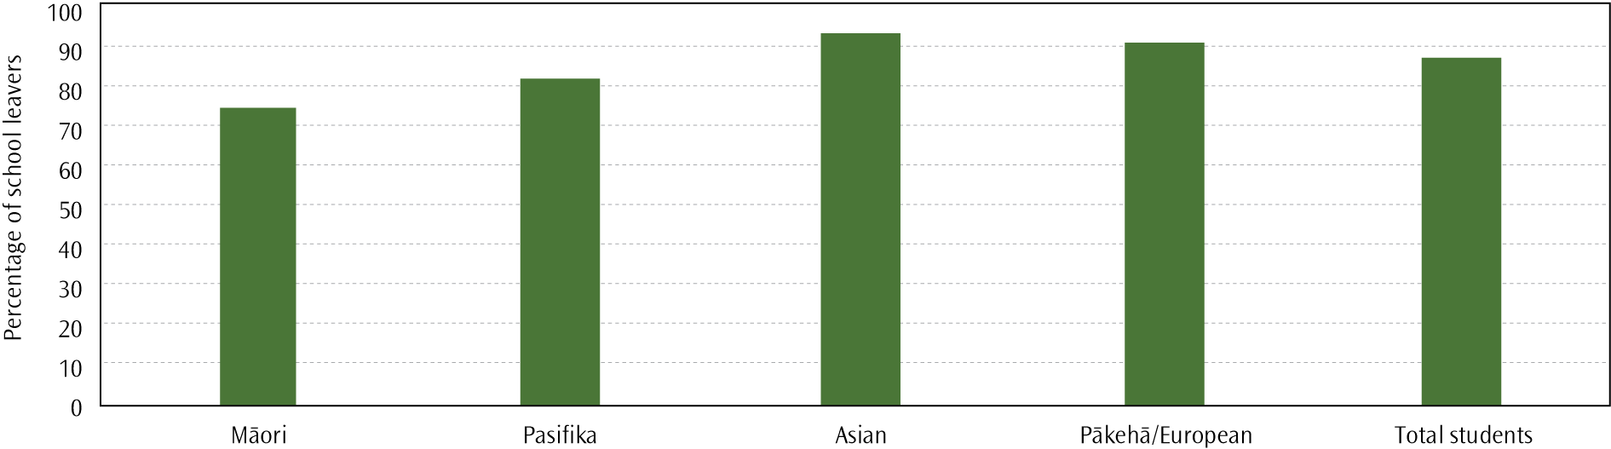
Note:
For this indicator, students who identified in more than one ethnic group have been counted in each ethnic group.

School leavers with NCEA Level 2 or a higher qualification
A formal school qualification at Level 2 or above is a benchmark that young adults need to achieve to have a basic prerequisite for further education and training and for many entry-level jobs. In 2012, 74.3% of school leavers attained at least NCEA Level 2, a 1.2 percentage point increase on the proportion of school leavers achieving at this level in 2011 (72.4%). The proportion of school leavers attaining at least NCEA Level 2 in 2012 was also 10.2% higher than the 2009 figure (67.5%). Sixty-six per cent of school leavers with NCEA Level 2 or above also achieved a University Entrance standard.

Ethnic group differences
Using total response ethnicity, Asian students had the highest proportion of school leavers attaining at least NCEA Level 2 in 2012 (87.0%), which was seven percentage points higher than European/Pākehā (79.6%). There is a substantial gap between these and the proportion of Pasifika (64.8%) and Māori (54.6%) school leavers attaining at least NCEA Level 2. The largest proportional increases in those attaining at least NCEA Level 2 has been in Māori school leavers, with an increase of 19.3% between 2009 (45.7%) and 2012, and Pasifika school leavers, with an increase of 14.6% between 2009 (56.5%) and 2012. In comparison, European/Pākehā school leaver had a proportional increase of 9.5% between 2009 (72.7%) and 2012.
The gap between the proportions of Māori and non-Māori school leavers with NCEA Level 2 or above is slowly closing; but greater, and faster, improvement is required for Māori students. Ka Hikitia ― Managing for Success 2008–2012 identified a need to increase the proportion of Māori school leavers with NCEA Level 2; a 2011 mid-term review of Ka Hikitia set a target to increase the proportion of Māori students leaving schools with NCEA Level 2 or above from 48% in 2010 to 65% in 2015. Progress was made towards this target in 2012 (54.6% of Māori school leavers attained NCEA Level 2 or above, compared with 52.2% in 2011). Progress was also made in reducing the disparity between Māori and non-Māori school leavers. In 2009, non-Māori school leavers were 59.2% more likely to obtain NCEA Level 2 or above than Māori school leavers (45.7% for Māori school leavers and 72.8% for non-Māori school leavers). In 2012, achievement levels have increased for both groups, to 54.6% for Māori school leavers and 79.5% for non-Māori school leavers, but the non-Māori leavers were still 45.7% more likely to achieve Level 2 or above.
- Proportion of school leavers with NCEA Level 2 or above, by total response ethnicity, 2009–2012
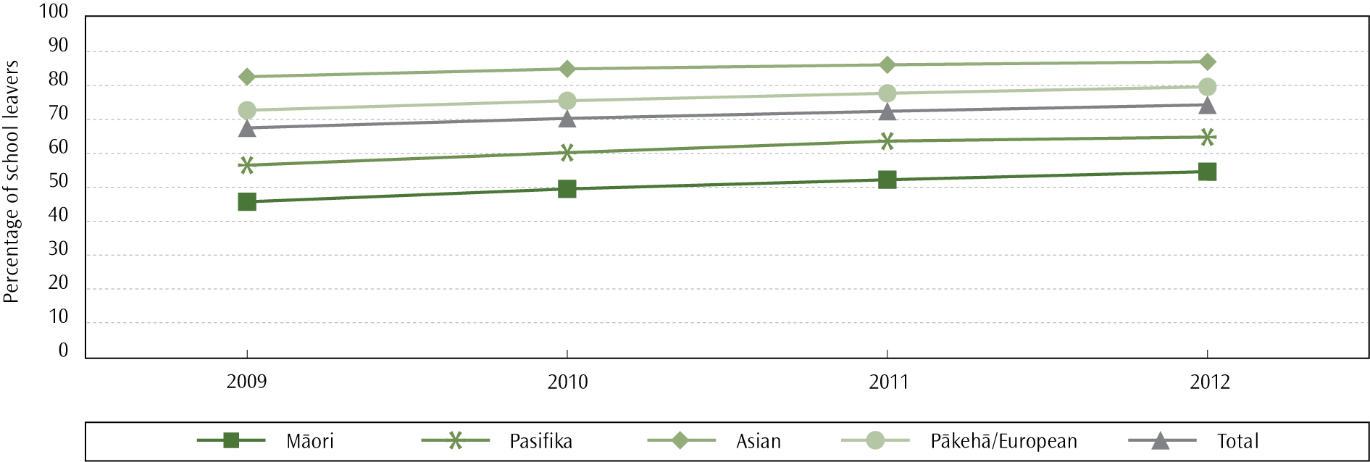
Note:
For this indicator, students who identified in more than one ethnic group have been counted in each ethnic group.
The gap between the proportions of Pasifika and non-Pasifika school leavers with NCEA Level 2 or above is also closing. In 2009 non-Pasifika school leavers were 22% more likely to obtain NCEA Level 2 or above than Pasifika school leavers, compared with 17% more likely in 2012.The proportion of Pasifika students attaining NCEA Level 2 was 56.5% in 2009, 60.2% in 2010, 63.6% in 2011 and 64.8% in 2012.
In 2012 ERO released its third report on improving education outcomes for Pasifika students. This report related to data collected from a sample of schools in late 2010 and early 2011. They found results consistent with reports in 2009 and 2010, with little progress made over the period. Although some schools had positive practices relating to Pasifika outcomes, there was a lack of system-wide change to respond to Pasifika students. The majority of schools sampled did not have specific plans in place to engage with Pasifika parents or communities (ERO, 2012a).
- Proportion of school leavers with NCEA Level 2 or above, by gender, 2009–2012
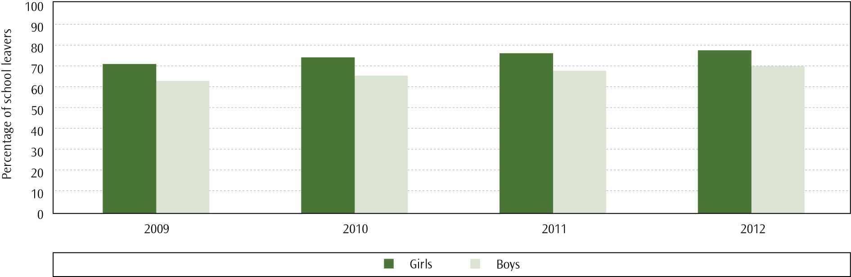

Gender differences
Female school leavers (78.2%) achieved at a higher rate than their male counterparts (70.6%), being 11% more likely to attain at least NCEA Level 2.

Socio-economic differences
In 2012, 89.6% of students from schools in the highest deciles (deciles 9 and 10) left school with at least NCEA Level 2. This was 54% higher than the lowest two deciles (58.1%). This difference is a decrease from 2009 when there was a difference of 70% between the two highest and two lowest deciles.

School leavers achieving University Entrance standard
Students leaving school having achieved University Entrance requirements and/or attaining NCEA Level 3 or above can be considered to have successfully completed their final year of schooling. In 2012, 48.7% of school leavers achieved at least a University Entrance standard, an increase from 46.0% in 2011.
One of the aims of the Tertiary Education Strategy 2010–2015 (Ministry of Education, 2010b) is to increase the number of under-25-year-olds achieving degree-level qualifications, particularly those from Māori and Pasifika ethnic groups. Achieving this goal depends on school leavers gaining University Entrance requirements and eligible students choosing to progress to tertiary study and completing their qualifications. A recent study (Engler, 2010) found that 70% of school leavers with at least NCEA Level 3 chose to go to bachelor-level study, 13% of leavers chose to study below bachelor level, and the remainder did not continue on to tertiary study in New Zealand. In general, students with higher school achievement were more likely to progress to bachelor-level study, but higher-achieving Māori and Pasifika students and students from low-decile schools were less likely to progress to bachelor-level study.

Ethnic group differences
In 2012, using total response ethnicity, Asian students had the highest proportion of school leavers achieving a University Entrance standard (70.3%), which was 30% higher than that of Pākehā/European students (54%). Pasifika (33.2%) and Māori (26.7%) students had the lowest proportions achieving the standard. The proportion of Māori school leavers qualified to attend university increased by 39.6% between 2009 (19.1%) and 2012. In comparison, the proportion of non-Māori school leavers qualified to attend university increased by 14.6% over the same time period (47.5% in 2009 and 54.4% in 2012). Despite this, the disparity in achievement was still large in 2012, with non-Māori school leavers being just over twice as likely to be qualified to attend university as Māori school leavers.
A 2011 mid-term review of Ka Hikitia ― Managing for Success set a target to increase the proportion of Māori school leavers qualified to attend university from 20% in 2010 to 26% by 2015. The proportion of Māori school leavers qualified to attend university in 2012 (26.7%) was 2.7 percentage points higher than the proportion in 2011 (24.0%), indicating that progress is being made towards the 2015 target.
- Proportion of school leavers with University Entrance standard, by total response ethnicity, 2009–2012
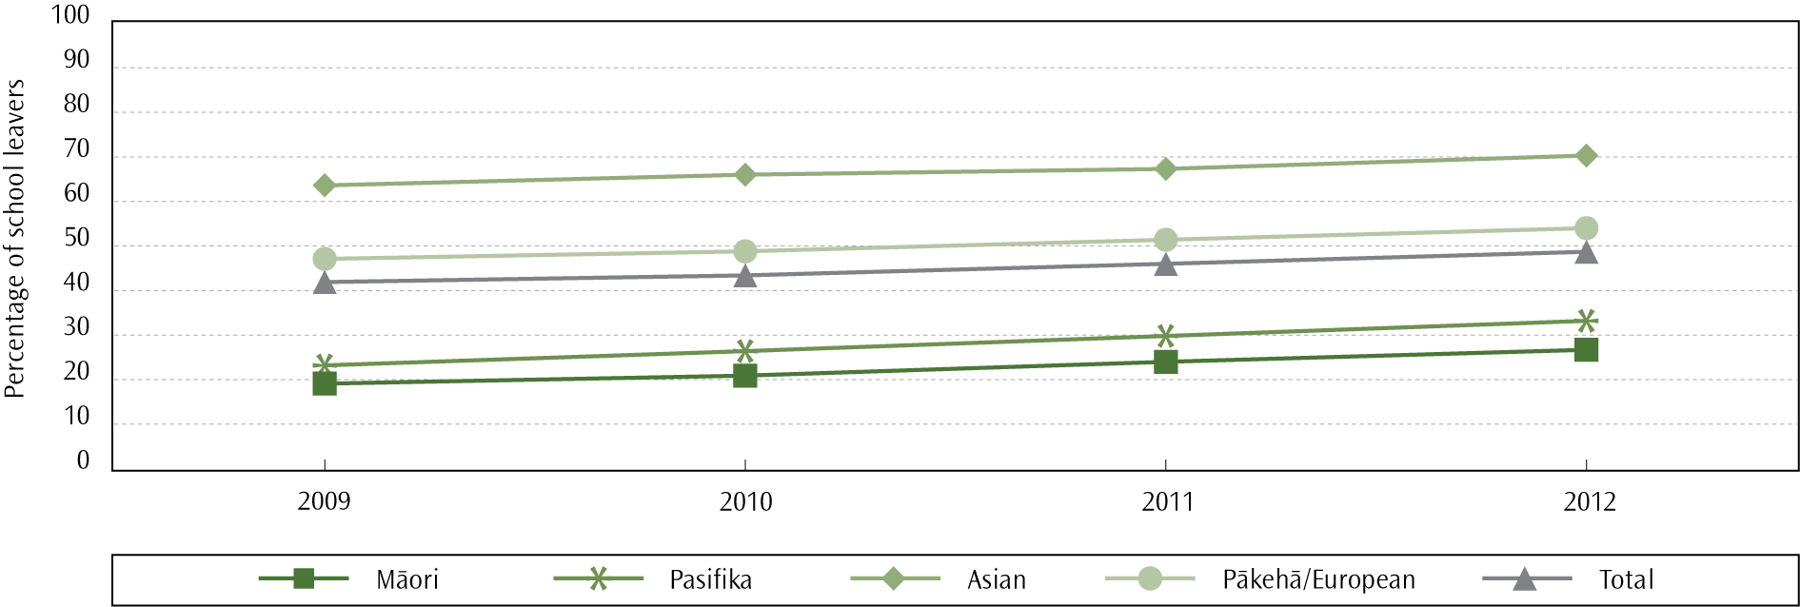
Note:
For this indicator, students who identified in more than one ethnic group have been counted in each ethnic group.
A key target in the Pasifika Education Plan 2013–2017 is to increase the proportion of Pasifika students leaving school with a University Entrance standard, to achieve at least parity with non-Pasifika school leavers in 2017. In 2012, 33.2% of Pasifika school leavers were qualified to attend university, compared with 50.5% of non-Pasifika school leavers, meaning that non-Pasifika school leavers were 1.5 times more likely to achieve a University Entrance standard than Pasifika school leavers. This disparity in achievement has reduced in recent years, from a 20.8 percentage point difference in 2009 (23.2% Pasifika and 44.0% non-Pasifika) to a 17.3 percentage point difference in 2012. This is largely due to a greater improvement for Pasifika in the proportion of school leavers qualified to attend university from 2009 to 2012; a 43% increase for Pasifika, and a 14.9% increase for non-Pasifika.

Gender differences
A higher proportion of female school leavers gained a University Entrance standard in 2012 than male school leavers: 56.3% of females compared to 41.4% of males. This achievement gap has been consistently increasing annually; a difference of 12 percentage points was found in 2009, increasing to a difference of 15 percentage points in 2012.
- Proportion of school leavers with University Entrance standard, by gender, 2009– 2012
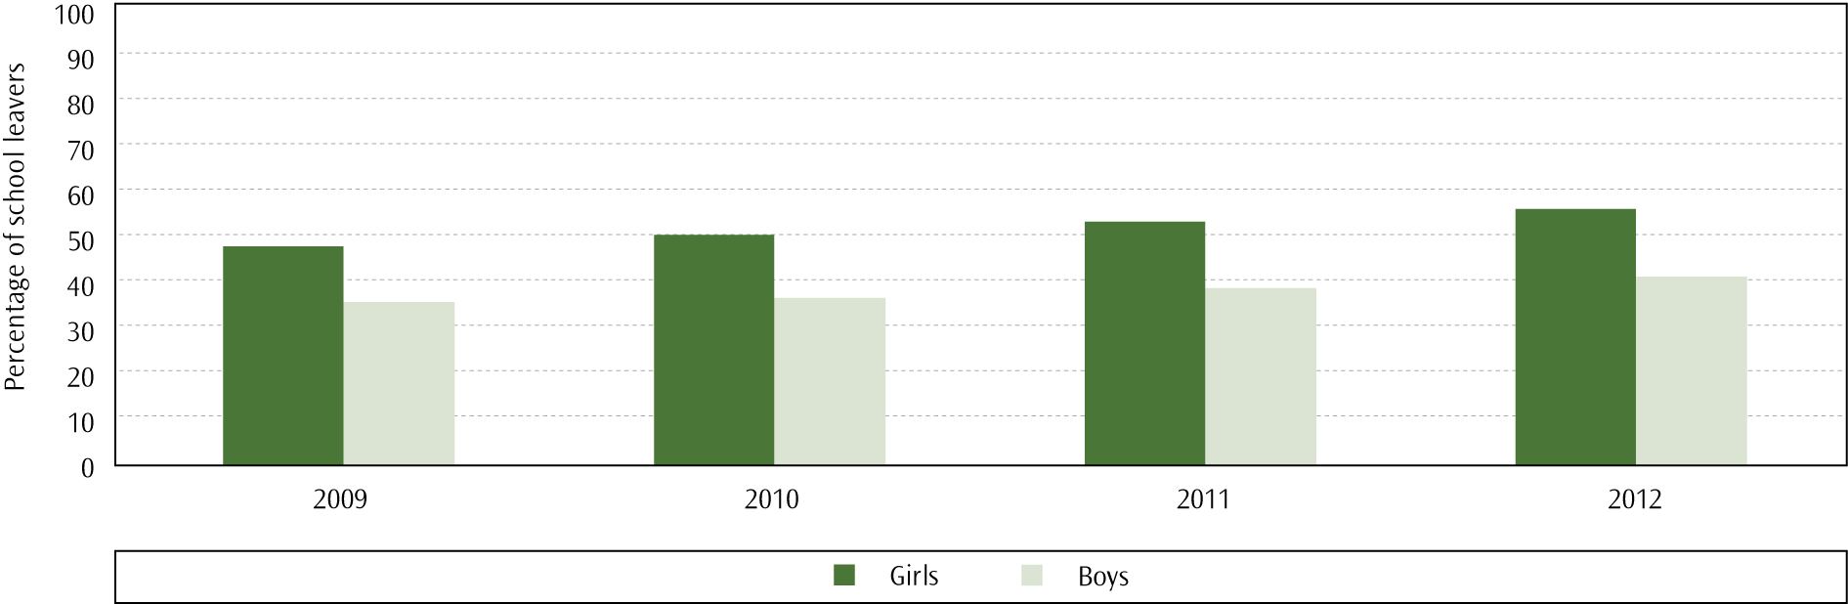

Socio-economic differences
In 2012, students from schools in the highest deciles (9 and 10) were 2.6 times more likely to leave school having achieved a University Entrance standard compared with students from schools in the lowest decile schools. Their achievement rates were 70.6% and 26.9%, respectively. This gap has dropped slightly from 2009, when students from the higher deciles were 3.1 times more likely to achieve the standard than students from the lowest deciles.
Where to find out more
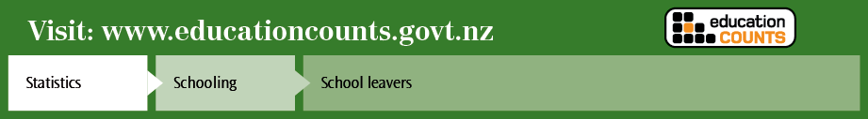

Māori language in education
Students learn te reo Māori by participating either in Māori language classes in English medium schools or in Māori medium education where they learn in immersion settings.

Enrolments in Māori medium education
Students can be taught with varying levels of the curriculum in te reo Māori. For the purposes of this analysis, Māori medium education is defined as students taught in Māori between 51% and 100% of the time. Two levels of Māori language learning are included in this definition (Levels 1–2, see Table 7). The number of students in each level of learning in Māori medium education has fluctuated over the last decade, with the number of students involved in Māori medium education in 2012 increasing by 1.5% compared to 2011. Of the 16,792 students engaged in Māori medium education in 2012, 97.4% identified as Māori. As at 1 July 2012, 276 schools offered Māori medium education.
- All students involved in Levels 1–4a of Māori language education, 2003–2012
Level of learning | 2003 | 2004 | 2005 | 2006 | 2007 | 2008 | 2009 | 2010 | 2011 | 2012
Level 1: 81–100% | 12,209 | 12,580 | 12,755 | 12,235 | 11,991 | 11,774 | 11,634 | 11,738 | 11,818 | 11,816
Level 2: 51–80% | 4,658 | 5,360 | 5,119 | 5,187 | 5,424 | 5,157 | 5,161 | 4,587 | 4,729 | 4,976
Sub-total | 16,867 | 17,940 | 17,874 | 17,422 | 17,415 | 16,931 | 16,795 | 16,325 | 16,547 | 16,792
Level 3: 31–50% | 6,024 | 5,345 | 5,761 | 5,450 | 5,154 | 4,795 | 4,649 | 4,904 | 4,807 | 4,936
Level 4(a): up to 30% | 6,191 | 6,294 | 5,279 | 6,469 | 5,926 | 7,007 | 6,727 | 6,303 | 5,640 | 5,357

Ka Hikitia
Ka Hikitia ― Managing for Success (2008–2012) set targets to monitor the achievement of goals for Māori language in education, as follows:
- Goal: increase the proportion of school leavers from Māori immersion and bilingual schools with University Entrance or above from 39.4% in 2006 to be equal to or better than the proportion of non-Māori English medium students by 2012.
- Progress: this goal was met in 2012, with the proportion of Māori students from Māori medium schools who left school qualified to attend university (55.5%) being equal to the proportion of non-Māori students from English medium schools (55.5%). It was also much higher than the proportion of Māori school leavers attaining a university entrance standard nationally (26.7%).
- Goal: increase the proportion of all Year 11 students studying Te Reo Rangatira as a proportion of all Year 11 students studying te reo (Te Reo Māori as well as Te Reo Rangatira) from 7.4% in 2006 to 10% by 2012.
- Progress: in 2012, there were 21,245 students learning Te Reo Māori in English medium settings for at least three hours per week. This is an increase of 5.5% from 2011. The proportion of Year 11 te reo students studying Te Reo Rangatira increased from 5.9% in July 2011 to 6.3% in July 2012, but this still falls below both the Ka Hikitia target of 10% and the proportion in 2006 (7.4%).
- Goal: keep the current participation rate of all (primary and secondary) students engaged in Māori language education at 21%.
Progress: the proportion of primary and secondary students engaged in Māori language education has increased from 19.8% in 2011 to 20.8% in 2012. This is the largest proportion of students engaged in Māori language education since 2006 but it is still slightly below the Ka Hikitia target of 21%.

Definitions
Kura kaupapa Māori | Kura established under Section 155 of the Education Act 1989, as a kura supported by Te Rūnanganui o Ngā Kura Kaupapa Māori o Aotearoa with the learning programmes based on Te Aho Matua – Māori philosophies.
Kura Māori | Kura established under Section 156 of the Education Act 1989, as a special character school delivering Māori medium education.
Kura teina | Not fully an independent school established under Section 155 of the Education Act 1989, development/establishment stage, aligned to a kura Tuakana (a kura kaupapa Māori that acts as a mentor with primary responsibility for the kura teina).
Māori language education | All education that teaches Māori language skills and delivers education in and through te reo Māori.
Māori medium | Teaching that includes use of te reo Māori. Students are taught curriculum subjects in either both te reo Māori and English or in te reo Māori only. Māori medium includes all level one and two schools and classes. Level one and two classes teach through the medium of Māori from 51 to 100% of the time.
Wharekura | Secondary level kura.
Where to find out more
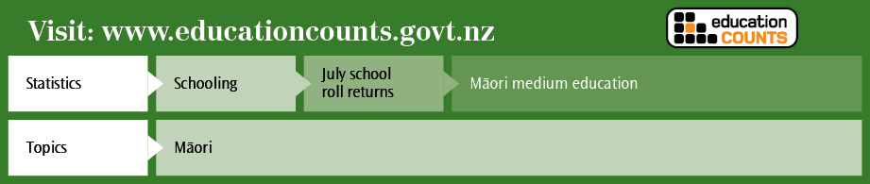

Chapter 5: Student participation and engagement with learning
Schools must effectively involve students in learning to ensure their educational success. The Competent Learners @ 16 project (Wylie & Hodgen, 2007) found that although both high- and low-achieving students had the same average attitudinal scores at age five, subsequent experiences of school and learning often had a significant impact on how positive different students felt about their schooling and future prospects.
Students who become disengaged from school often begin to do so before the age of 12 (Wylie, Cameron, Twist, McDowell, & Fisher, 2009). Disengagement accelerates at secondary school, particularly for Māori and Pasifika boys (Gibbs & Poskitt, 2010), and lower engagement in learning and positivity about subjects is often reflected in lower rates of achievement.

Youths in Education Employment or Training
Table 8 provides information about senior secondary school aged young people at the transition period between secondary school and further education or employment.
- Youths in education, employment or training: 16-year-olds to 18-year-olds, 2012
Location/status | 16 year-olds | 17 year-olds | 18 year-olds
Secondary school (excl. STAR, Gateway) | 43,311 | 35,607 | 8,594
Teen Parent Units | 67 | 135 | 123
STAR | 3,003 | 3,104 | 680
Gateway | 6,113 | 5,104 | 413
Home schooling | 369 | 229 | 142
Total secondary schooling | 52,863 | 44,179 | 9,952
Youth Training | 3,616 | 3,813 | 689
Skill enhancement/training opportunities | 8 | 210 | 1,303
Workplace-Based Learning (excl. MA) | 880 | 1,925 | 3,115
Modern Apprenticeships | 370 | 1,149 | 2,087
Tertiary (excl. Workplace-Based Learning) | 971 | 3,069 | 21,246
Total tertiary education | 5,845 | 10,166 | 28,440
Total in education and training | 58,708 | 54,345 | 38,392
Employed | 576 | 4,229 | 15,672
Not in Education Employment or Training (NEET) | 719 | 3,081 | 8,122
Resident population (excl. long term study permits) | 60,003 | 61,655 | 62,186
Notes:
This NEET is calculated by multiplying the number of individuals not in education or training by the proportion of “not studying” who are unemployed.
This is not the Government’s official measure of NEET. It is an analysis based on census data provided by education services.
Employment and study status are sourced from the Household Labour Force Survey (HLFS).
STAR = Secondary Tertiary Alignment Resource.

In 2012, an estimated 82.4% of the 16–18 year-old population in New Zealand was in either secondary or tertiary education or training, while 11.1% were employed and 6.5% were not in education, employment or training. This represents an increase of 0.9 of a percentage point in the proportion of 16–18 year-olds in education or training compared with 2011 (81.5%), and an increase of 0.7 of a percentage point in the proportion in employment compared with 2011 (10.5%). Correspondingly, the proportion of 16–18 year-olds not in education, employment or training in 2012 (6.5%) was 1.5 percentage points less than the proportion in 2011 (8.0%). The largest shift in the proportion not in education, employment or training was displayed by the 17-year-old age group, reducing from 6.9% in 2011 to 5.0% in 2012.

Non-enrolled students
The Ministry of Education is responsible for upholding the Education Act 1989, which states that attendance at school is compulsory for New Zealand citizens and residents from age 6 until they turn 16.
When a student of compulsory school age has left a school and has not enrolled in another school within 20 consecutive school days, the Ministry is notified via the school student enrolment register (ENROL). The Ministry, along with an external contracted provider, then works to locate these students and, where necessary, assist their return to education. Staff work alongside students, their families, schools and other agencies to discuss and facilitate a return to education.
In 2012 there were 3,209 cases of non-enrolment investigated and closed by the Ministry. These cases were caused by 3,051 students, with 148 students having two episodes and five students having three episodes. Of the 3,209 cases, 2,483 were resolved by students returning to school, 620 by enrolling students at an alternative education centre and 106 by granting students an early leaving exemption.
- Age-standardised non-enrolment rates per 1,000 students, by ethnicity, 2006–2012
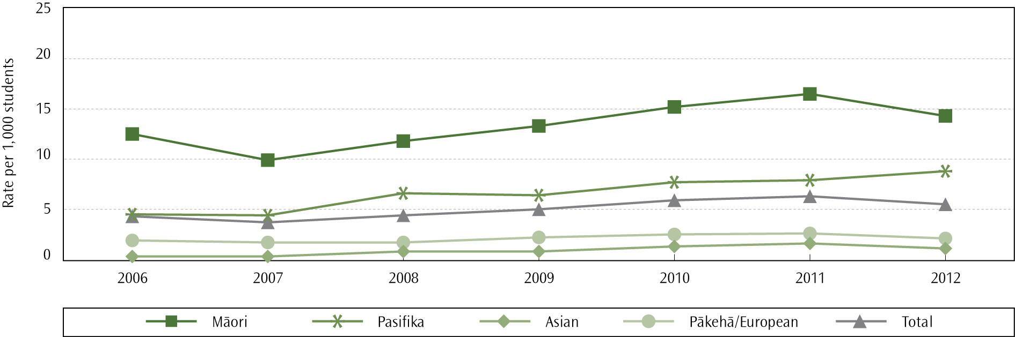

Ethnic group differences
The age-standardised rate was highest for Māori students (14.3 non-enrolments per 1,000 students). The age-standardised rate for Pasifika students (8.8 per 1,000 students) was lower than for Māori students but higher than for European/Pākehā students (2.1 per 1,000 students). The age-standardised rate for Asian students was 1.1 non-enrolments per 1,000 students.

Gender differences
For the first time since 2006 there was no difference in rates between male and female students. The age-standardised rate was 5.5 non-enrolments per 1,000 students for both genders. Historically, males have tended to have a slightly higher rate than females.

Socio-economic differences
Schools in the lowest quintile (deciles 1 and 2) draw their students from communities with the highest degree of socio-economic disadvantage. In 2012, students whose most recent enrolment was in a quintile 1 school were 16 times more likely to be reported non-enrolled than students from quintile 5 schools. In 2012, 66% of non-enrolment notifications were from schools of quintile 1 or 2.

Achievement
Achievement results for 2012 show that 15- and 16-year-old students with a non-enrolment notification between 2010 and 2012 were less likely to meet the NCEA Level 1 literacy and numeracy requirements.
Of the 4,334 15-year-old students with a non-enrolment history whose achievement data could be obtained, 88% did not meet the NCEA Level 1 literacy and numeracy requirements, compared to 26% of 15-year-old students who maintained school presence. A similar gap in performance was observed in the 16-year-old students.
- Proportion of 15- and 16-year-old students who did not meet NCEA Level 1 literacy and numeracy requirements, 2010–2012
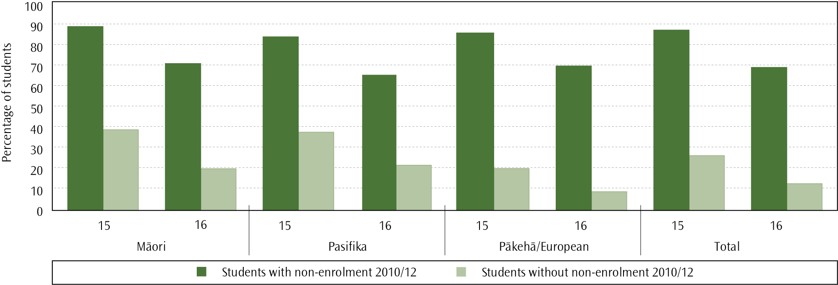

Retention of students in secondary schooling to 17 years
Completion of upper secondary education is associated with a range of economic and social benefits both in New Zealand and across the OECD. Retention to senior secondary schooling is linked to higher levels of skills and knowledge required for participation in our increasingly knowledge-based society (OECD, 2013).
The risk of unemployment for those with no school qualifications or only Year 11 qualifications is higher than for those with Year 12 or Year 13 qualifications (Norton et al, 2000). The positive effect of each additional year of schooling on incomes is estimated to range from 5 to 10%.
In 2009, 79.3% of students stayed at school to their 17th birthday. In 2012 this rate had improved by two percentage points to 81.4%, which was also greater than the proportion of students staying at school until age 17 in 2010 and 2011 (80.6% in both years).
- Retention rate: proportion of school leavers aged 17 or above, by ethnicity, 2009–2012
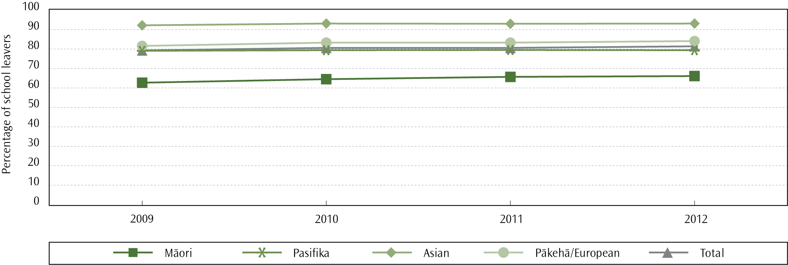
Note:
For this indicator, school leavers who identified with more than one ethnic group have been counted in each ethnic group, aside from the total where each individual was counted once only.

Ethnic group differences
In 2012, Māori students had the lowest proportion of students remaining at school to age 17 (66.1%). In comparison, the retention rate was 79.4% for Pasifika students and 84.1% for Pākehā/European students. Asian students had the highest retention rate (93.1%).
Many Māori students become disengaged with schooling quite early (see Early leaving exemptions below). While Māori students have displayed a 5.5% increase in the proportion of 17-year-old students remaining at school since 2009, the gap between Māori and non-Māori students has not shown any clear signs of closing in the last four years.

Gender differences
In 2012, girls were more likely to stay at school until 17 than boys (83.9% compared to 78.9%). The size of this gender gap decreased from 6.3 percentage points in 2011 to 4.9 percentage points in 2012. This was due to an increase in the proportion of boys staying at school until age 17, with no change in the proportion of girls.

Socio-economic differences
There is a clear relationship between decile and the percentage of school leavers aged 17 or above. Schools in the highest quintile (deciles 9 and 10) draw their students from communities with the lowest degree of socio-economic disadvantage. Students from these schools are 1.3 times more likely to remain at school until the age of 17 than students from the lowest quintile (deciles 1 and 2).
- Proportion of students who were retained at school to the age of 17, by school decile, 2012
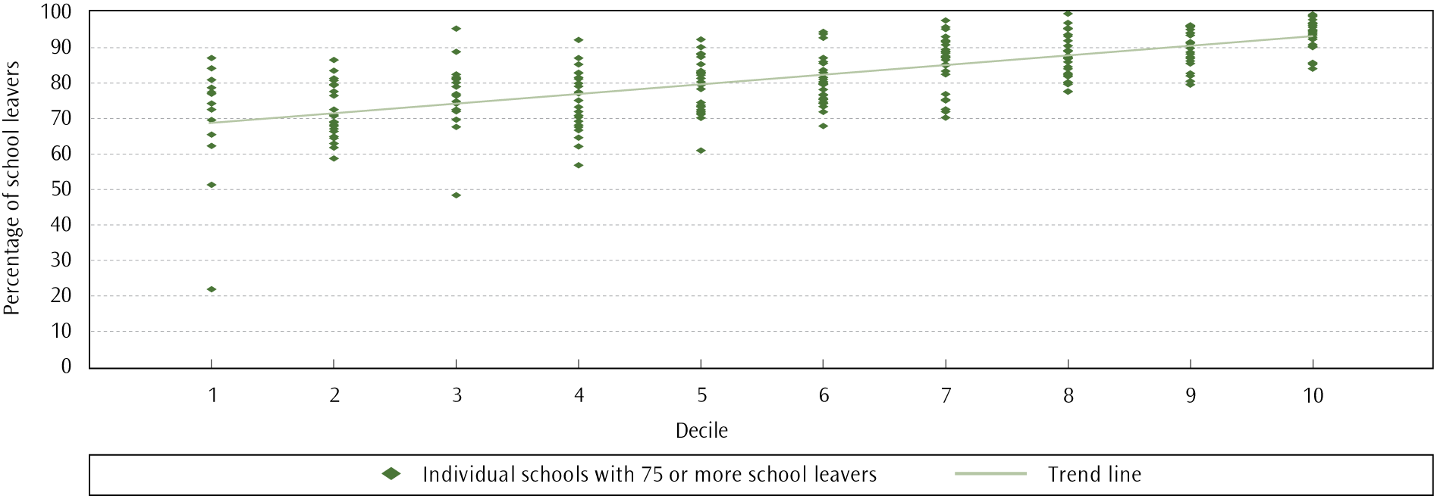

Early leaving exemptions
Enrolment in school is compulsory for all students aged between six and 16 years. However, parents of 15-year-old students may apply to the Ministry of Education for an exemption from schooling because of educational problems, conduct, or the unlikelihood of the student benefiting from attending available schools. Parents are required to give details about training programmes or employment that the student would move on to in the event of an early leaving exemption being granted.
There were 313 early leavers in 2012 (5.4 per 1,000 15-year-old students). This is 74 fewer early leavers than in 2011 and continues a consistent decreasing trend in numbers since 2005, when there were over 4,000 early leavers.
- Early leaving exemption application approval and decline rates, 2000–2012
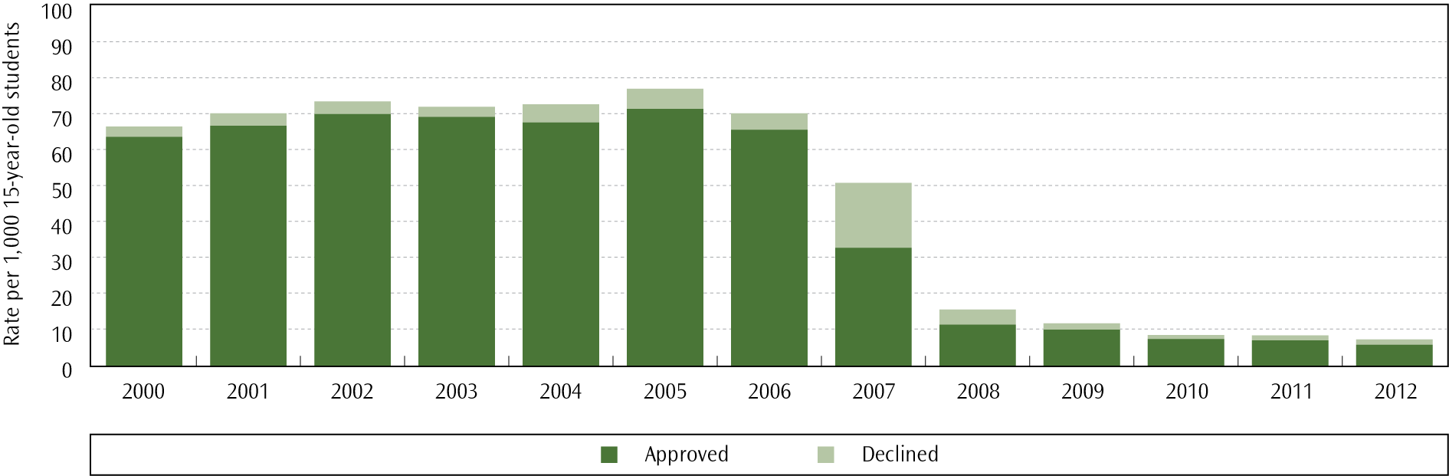

In May 2007 the Ministry of Education strengthened its early leaving application and approval process in order to reduce the number of early leaving exemptions and, thereby, the associated social and economic disadvantages that face those students who leave school early. The process involved:
- imposing a stricter interpretation of the early leaving legislative criteria, which set a high threshold for early leaving eligibility
- ensuring direct contact between parents and Ministry staff at the first stage in the early leaving process, to actively discourage early leaving and to support parents to find ways of keeping their children engaged in learning
promoting alternatives to early leaving, such as a combination of school- and work-based learning.
These approaches have been successful. Between 2006 and 2012, the early leaving exemption rate has dropped by 91.7% from 65.3 to 5.4 early leavers per 1,000 15 year-old students, respectively.

Ethnic group differences
The decline in rates of early leaving exemptions between 2006 and 2012 was similar for all ethnic groups: 91.2% for Māori, 94.1% for Pasifika, 92.2% for Pākehā/European and 96.5% for Asian students. Māori students have higher rates of early leaving exemptions compared with students from other ethnic groups: in 2012, the early leaving exemption rate for Māori students (13.0 per 1,000 15-year-old students) was over three times higher than the rate for Pākehā/European (3.8 per 1,000 15 year-old students), and four times higher than the Pasifika rate (3.2 early leavers per 1,000 15 year-old students).
- Early leaver exemption rates per 1,000, by ethnicity, 2000–2012
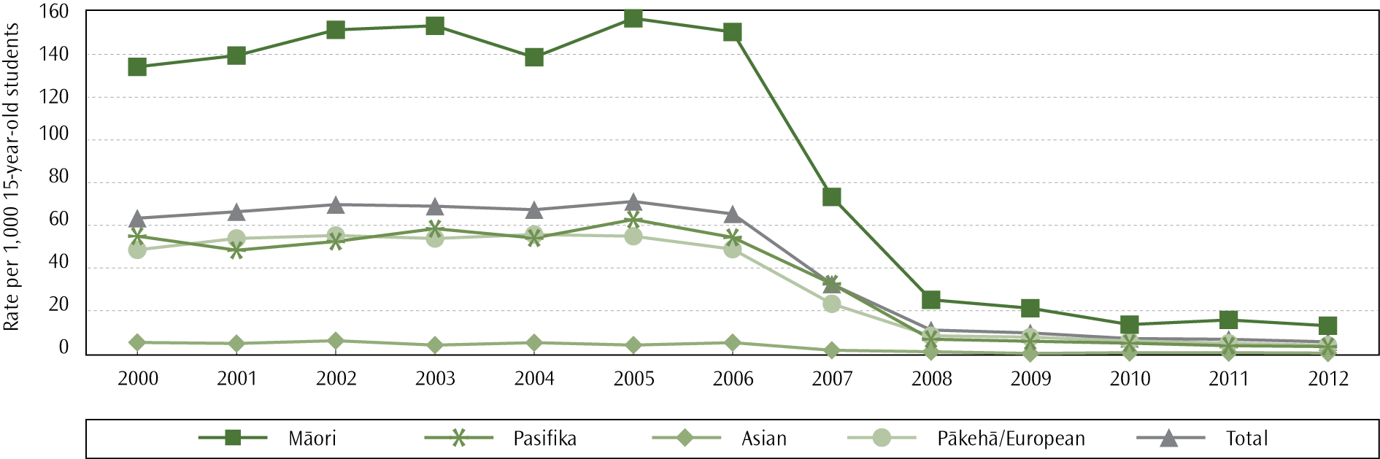

Gender differences
The gender disparity in numbers of early leavers decreased slightly in 2012, with 64% of all early leavers being male, compared to 74% in 2011. The female rate in 2012 was 4.0 per 1,000 15-year-old students, while the male rate was 6.8 per 1,000 15-year-old students.

Socio-economic differences
There is a correlation between the socio-economic mix of the school that students attend and early leaving exemption rates. Schools in the lowest quintile (deciles 1 and 2) draw their students from communities with the highest degree of socio-economic disadvantage. In 2012, the early leaving exemption rate for students from these schools was over nine times higher than the rate for students in the highest quintile (ie, deciles 9 and 10): 8.5 per 1,000 15-year-old students in quintile 1, compared to 0.9 per 1,000 students in quintile 5 schools. Quintile 2 schools had a rate only slightly lower than quintile 1 (7.2 per 1000 15-year-olds), with rates for quintile 3 (5.7 per 1000) and quintile 4 (4.7 per 1000) dropping as socio-economic advantage increased.
- Early leaving exemption rates, by ethnicity and school quintile, 2012
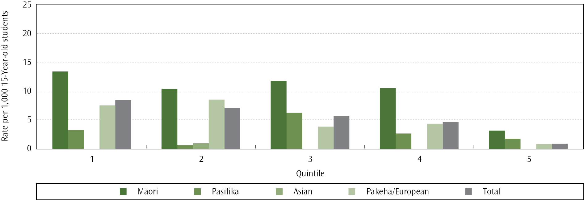

Where to find out more

Positive Behaviour for Learning
The Positive Behaviour for Learning (PB4L) programmes and initiatives aim to improve the behaviour and wellbeing of children and young people.

PB4L School-Wide

The framework
PB4L School-Wide is a long-term approach to improve the culture, learning and teaching environment across the whole school. School-Wide facilitators help schools put in place practices and organisational systems to support positive behaviour.
Students are taught in very specific terms what behaviours are expected of them, and there is a consistent response to these behaviours across the whole school. The approach means moving away from seeing individual students as the problem, and towards changing the environment around them to support positive behaviour. The focus is on:
- preventing problem behaviour
- developing students’ social skills
- reinforcing desired behaviours
- consistently addressing and reducing inappropriate behaviours
using evidence-based assessment and problem-solving to address concerns.

The statistics
As at 31 December 2012, 289 schools were participating in School-Wide. Through the Prime Minister’s Youth Mental Health project, the Government has boosted funding for PB4L School-Wide to make it available to all secondary schools over the next three years. This will bring the total number of schools participating in PB4L School-Wide to 628 by 30 June 2016.

PB4L Incredible Years Teacher

The programme
The Incredible Years Teacher programme is for teachers of children aged 3–8 years. It helps teachers:
- manage their classrooms
- reduce classroom aggression
motivate students to learn social skills and co-operate with their peers.
Additionally, the programme focuses on ways teachers can collaborate with parents to support their school involvement and promote consistency between home and school.

The statistics
A total of 2,280 teachers participated in this professional development programme in 2011/2012. Since the programme started in 2010, 3,720 teachers have participated, a third of these from the early childhood sector.

PB4L Incredible Years Parent

The programme
The Incredible Years Parent programme is a 14–18 session programme for parents of children aged 3–8 that helps parents manage problem behaviour and create a home environment conducive to positive educational outcomes.
The programme teaches parents to:
- make time to play and spend time with their children and let their children lead the play
- encourage the behaviours they would like to see, through setting clear rules and boundaries and using praise and encouragement
selectively use consequences such as ignoring, loss of privileges and time out.

The statistics
In 2011/2012, 3,997 parents/caregivers participated in the programme. Since the introduction of the programme in 2010, 5,824 parents have completed the course.

Wellbeing@School
In May 2012 the Wellbeing@School website was made available to schools. The Ministry commissioned the New Zealand Council for Education Research (NZCER) to develop this tool to help schools review whether they provide a safe and caring climate. Wellbeing@School (www.wellbeingatschool.org.nz) provides school leaders with a well-researched process, including student and teacher surveys, to look at the policies, systems and practices in their school that deter bullying and promote positive behaviour.

Attendance at school
The Education Act 1989, the Attendance Regulations 1951 and the National Administration Guidelines require that children between the ages of six and 16 be enrolled at school. Parents must ensure children attend school whenever it is open for instruction unless there is a good reason for them to be absent. Parents/caregivers can be prosecuted if their child is away from school without good reason.
Many schools are now using electronic attendance registers (eARs) as part of their student management systems to help them record attendance. By the end of 2012, 1,695 schools were approved to use eARs. This has increased by 176 schools since the end of 2011 (when 1,519 schools were approved to use eARs).
The use of the Early Notification text messaging system, which provides parents with real-time information on their children’s attendance and achievement, increased to approximately 435 schools by the end of 2012.
At the end of 2012, the Ministry finalised contracts with 11 providers to implement a new integrated Attendance Service nation-wide, with a total funding of $9.53m in 2012/13. This programme combines the previous national Non-Enrolled Truancy Service and 77 District Truancy Services into one integrated service. The Attendance Service is supported by the Attendance Service Application (ASA), an electronic referral system that records unjustified absence and non-enrolment referral information in one place, and builds a case history for each student referred by schools to the Attendance Service providers. The new Attendance Service started in all schools in Term 1, 2013.

National absence rates
The most recent survey of attendance was undertaken in Term 2, 2012 (Mallari & Loader, 2013). All state and state-integrated schools were invited to participate, with attendance data being received from 2,166 schools (a response rate of 88%). National absence rates were estimated based on one week of Term 2, 11–15 June.
In 2012, the estimated national absence rate was 9.6%. This was lower than the previous two surveys (10.2% in 2011 and 11.6% in 2009). The total unjustified absence, or truancy, rate was 3.8% (compared to 4.0% in 2011 and 4.2% in 2009).

Age (current year level) and gender
Absence rates change dramatically by year level. Both the total absence rate and the total unjustified absence rate increase rapidly during secondary school. The rate of total unjustified absence for students in Years 1–8 was low at 2.1% for both genders. In Years 9–13, however, the total unjustified absence rates increased from 3.9% in Year 9 to 11.4% in Year 13 for females, and from 4.1% to 12.5% for males. These findings are similar to the absence rates in previous years (with a slight downwards trend in absence rates overall); however, the total unjustified absence rate for Year 13 males increased by 0.6 of a percentage point between 2011 (11.9%) and 2012 (12.5%).
- Absence rates, by gender and current year level, 2012
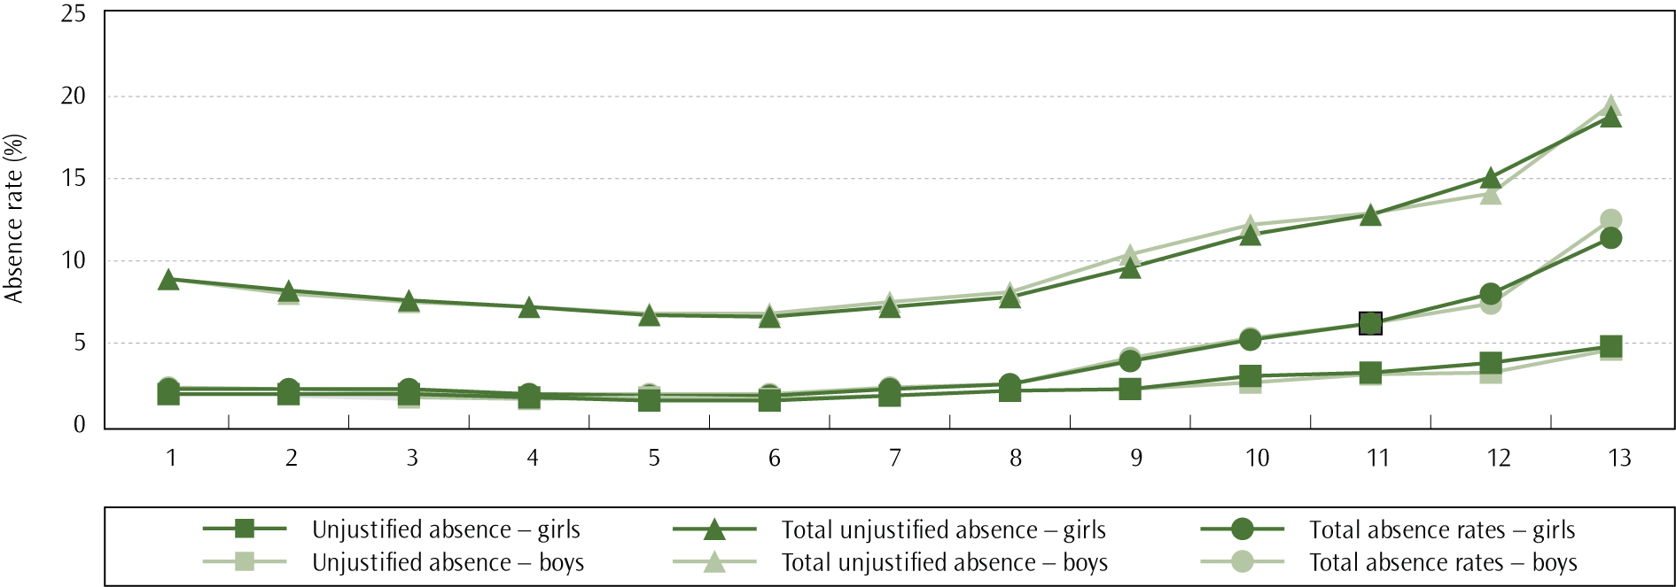
Note:
Year 13 includes students in years 13, 14 and 15.
The Youth’12 survey (Clark et al., 2013) on student opinion found that the rate of student self-reported truancy increased rapidly with age. Fourteen per cent of students aged 13 or less reported having wagged or skipped school for a whole day in the previous 12 months, with this proportion increasing to 31.4% for those aged 17 years and above.

Ethnic group differences
Māori and Pasifika students have higher absence rates than Pākehā/European and Asian students. In 2012 total unjustified absence rates were 6.0% for Māori students and 5.4% for Pasifika students (compared with 6.5% and 6.6%, respectively, in 2009). The total unjustified absence rates for Pākehā/European students (2.8%) and Asian students (2.5%) were similar to 2009 (3.0% and 2.9%, respectively).

Socio-economic differences
Low decile schools draw their students from communities with the fewest socio-economic resources. In 2012, justified absences were similar across all deciles (at approximately six per cent). However, decile 1 and 2 schools had a total unjustified absence rate of 6.3% and 6.4%, respectively, compared to 2.4% in decile 9 schools and 1.9% in decile 10 schools.

Frequent truants
The rate of frequent truants was also estimated. A student was classified as a frequent truant if they had three or more unjustified absences during the survey week. The national rate of frequent truants was 1.0%, remaining unchanged from 2011. This means that in 2012 1.0% of all students were unjustifiably absent from school at least three times during the survey week. There was no difference between genders in the frequent truant rate in 2012 (1.0% for both).
One of the targets of Ka Hikitia ― Managing for Success (Ministry of Education, 2008a) was to reduce the frequent truant rate of Māori students in Years 9 and 10. In March 2011, a mid-term review was conducted, and the target was revised to decrease the frequent truant rate of Year 9 and 10 Māori students from 2.8% in 2010 to 2% by 2015. The frequent truant rate for Year 9 and 10 Māori students in 2012 was 2.4%, which is on track to meet this target.
The 2012 frequent truant rate for Year 9 and 10 Pasifika students increased by 0.1 of a percentage point (1.3% in 2011 and 1.4% in 2012), but was still lower than the rate in 2006 (3.1%).
As in previous years, the rates for Māori and Pasifika students were higher than the rates for non-Māori and non-Pasifika students (0.7% and 1.1%, respectively).
Where to find out more

Stand-downs and suspensions from school
Stand-downs and suspensions affect a student’s opportunity to learn and interrupt the continuity of learning. Suspensions may lead to students:
- accessing correspondence schooling, where there may be fewer direct learning supports
- entering alternative education provisions, where there may not be access to highly trained teaching staff
dropping out of the education system
Stand-downs and suspensions are associated with a wide range of concerning youth behaviours ― including drug and alcohol abuse and violence ― which disrupt the learning of the individuals concerned and are disruptive and unsafe for peers in the school community.

Stand-downs from school
The age-standardised stand-down rate increased from 25.6 stand-downs per 1,000 students in 2000 to 30.8 per 1,000 in 2006, but has decreased by 24.0% since then to 23.4 per 1,000 in 2012. There were 16,712 stand-down cases in 2012, which were received by 13,040 different students. This equates to 1.8% of the student population in state and state integrated schools receiving stand-downs. Of those students stood down, 78.9% were stood-down only once during 2012. In 2012, 74.1% of stand-downs took place in secondary schools. Only 8.0% of secondary schools did not use stand-downs, compared to 60.0% of primary schools.

Ethnic group differences
Schools are standing down more Māori students than students from any other ethnic group. In 2012, the age-standardised stand-down rate for Māori students (42.8 per 1,000) was 1.5 times as high as Pasifika students (27.7 per 1,000) and 2.4 times as high as Pākehā/European students (17.5 per 1,000). The stand-down rate for Asian students is the lowest of all ethnic groups (6.0 per 1,000).
- Age-standardised stand-down rates, by ethnicity, 2000–2012
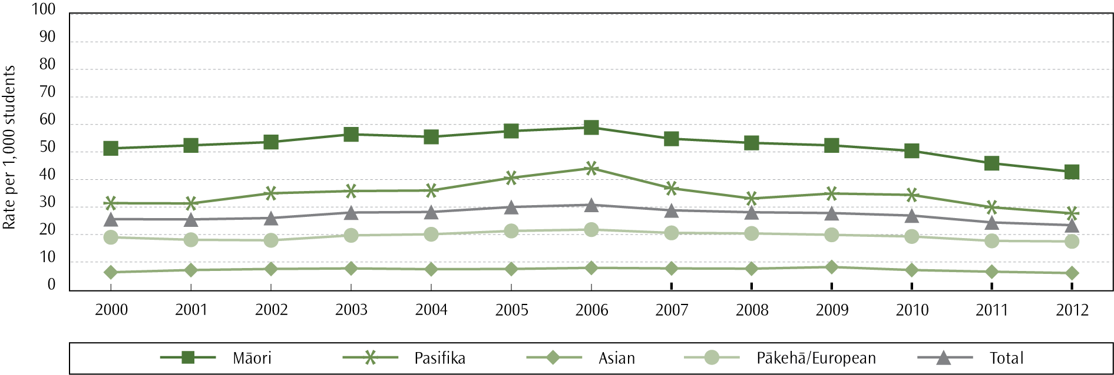

Gender differences
Over time, male students have consistently received stand-downs far more frequently than female students. In 2012, the age-standardised stand-down rate for males (32.8 per 1,000 students) was 2.4 times higher than the female rate (13.5 per 1,000).

Age differences
The majority of stand-downs occurred for students aged 13 to 15, accounting for 58.6% of all stand-downs. The rate was highest for age 14 (66.9 stand-downs per 1,000 students). Analysis is undertaken using age-standardised rates.
- Age-standardised stand-down rates, by ethnicity and school quintile, 2012
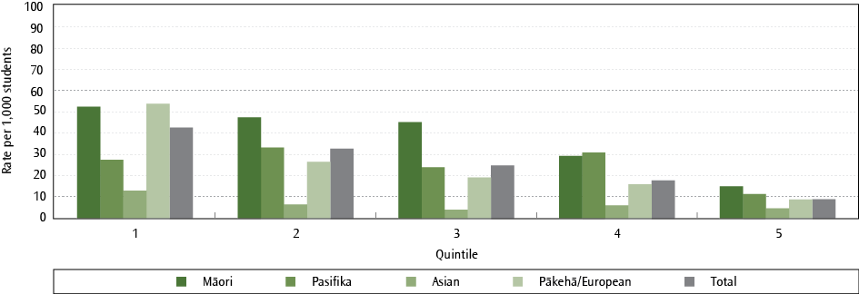

Socio-economic differences
Students in schools in the lowest quintile (deciles 1 and 2) are 4.7 times more likely to be stood-down from school than students in the highest quintile (deciles 9 and 10).

Suspensions from school
The incidence of suspensions has decreased by 39.7% over the last 13 years, from an age-standardised rate of 7.8 suspensions per 1,000 students in 2000, to 4.7 per 1,000 in 2012. This is the lowest suspension rate in the 13 years of recorded data. There were 3,357 suspension cases in 2012 which were received by 3,061 different students. This equates to 0.4% of the total student population receiving suspensions; 90.9% of these students were suspended only once in 2012.
In 2012, 17.3% of all state and state-integrated secondary schools did not use suspensions, compared to 85.3% of all primary schools.
- Age-standardised suspension rates, by ethnicity, 2000–2012
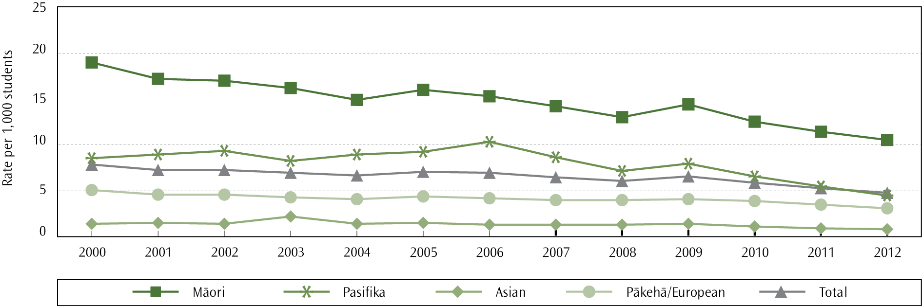

Ethnic group differences
Schools are suspending more Māori students than students from any other ethnic group. In 2012, the age-standardised suspension rate for Māori students (10.5 suspensions per 1,000) was over twice as high as for Pasifika students (4.4 per 1,000) and 3.5 times as high as for Pākehā/European students (3.0 per 1,000). However, the suspension rates for Māori are decreasing (from 19.0 per 1,000 in 2000, to 10.5 in 2012). The suspension rate for Asian students (0.7 per 1,000) remains the lowest in New Zealand.
The Pasifika Education Plan 2013–2017 has set a target to reduce the rate of Pasifika suspensions from 5.4 suspensions per 1,000 in 2011 to 3.6 per 1,000 in 2017. Progress was made towards this target in 2012, with the rate of suspensions for Pasifika students reducing by 1.0 percentage points, from 5.4 per 1,000 in 2011, to 4.4 per 1,000 in 2012. This represented the greatest proportional reduction in suspension rate for a single ethnic group in 2012 (17.8%).
- Age-standardised suspension rates, by ethnicity and school quintile, 2012
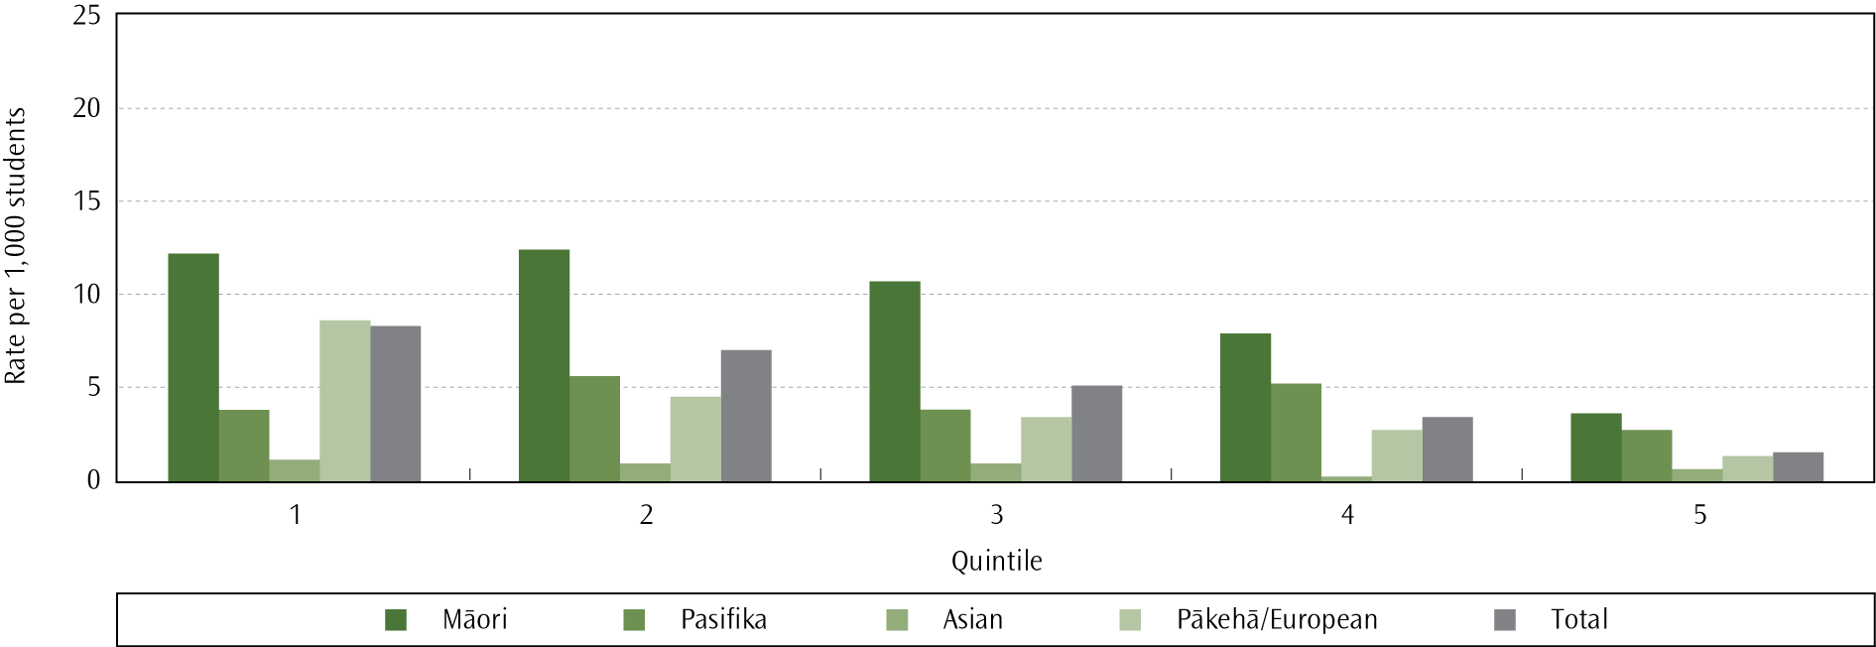

Gender differences
Males receive suspensions far more frequently than females. In 2012, the male age-standardised suspension rate (6.7 per 1,000) was 2.5 times that of females (2.6 per 1,000). This pattern is similar to the relationship seen for stand-downs.

Age differences
The majority of suspensions occurred for students aged 13 to 15, accounting for 67.4% of all suspensions. The rate was highest for students aged 14 (16.7 suspensions per 1,000 in 2012).

Socio-economic differences
Students from schools in quintile 1 (deciles 1 and 2) are 5.3 times more likely to be suspended from school than students in the highest quintile (deciles 9 and 10). When considering age-standardised suspension rates by quintile, the general pattern for the different ethnic groups largely remains. Age-standardised suspension rates are highest for Māori and Pasifika in each quintile, except in quintile 1 schools where the Pākehā/European rate (8.7 suspensions per 1,000) is higher than that of Pasifika students (3.9 per 1,000). This is similar to the relationship seen for stand-downs.
Where to find out more
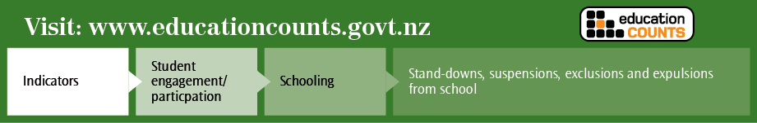

Chapter 6: Quality teaching and education providers
Quality teaching results from a combination of the effectiveness of study for teaching qualifications, the school culture around effective teaching and student achievement, inquiry and ongoing learning, and in-service professional learning and development (PLD).

Teachers
The ratio of teachers to students in state schools has grown since 2000. The number of full-time teacher equivalents (FTTEs) increased by four per cent between 2006 and 2012. Teachers’ influence on students’ learning success is moderated by a number of factors, such as students’ prior learning, but it is clear that within schools teaching has the greatest influence on achievement (Alton-Lee, 2003; Benseman, Sutton, & Lander, 2005; May, Hill, & Tiakiwai, 2004; Wylie, Thompson, & Lythe, 2004).

Number of teachers
Funding for teacher places in state and state-integrated schools is largely determined by the number of students and the year level of those students. In 2012, there were 47,293 FTTEs in state and state-integrated schools. Just over half of these positions (52%; 24,698) were in primary schools, 40% (18,864) in secondary, with six per cent (2,672) in composite schools and 2% (1,060) in special schools. Since 2006, the growth in secondary schools (2%; from 18,471 to 18,864) has been lower than in primary (4%; from 23,738 to 24,698) and composite schools (19%; from 2,253 to 2,672).
The majority of the teaching workforce are women. In 2012, 71% (33,692 of 47,493) of teachers were women (up from 31,891 or 70% in 2006). In primary schools, the percentage of female teachers has grown since 2006 from 81% to 82% (20,194 of 24,698), and in secondary schools the percentage of female teachers has grown since 2006 from 56% to 57% (10,819 of 18,864).

Teacher losses
Teacher losses, for statistical purposes, refer to all permanent teachers who have left the teaching profession, or who are on leave without pay. For the purposes of this report, a teacher is considered ‘lost’ if they were teaching in May of one year but are not teaching in May the following year. Of the 42,043 permanent teachers in May 2011 in state and state-integrated schools, 3,840 were not teaching in May 2012, giving a loss rate of nine per cent.
- Teacher loss rates, by school type, May 2007/08 to May 2011/12
 | Primary | Secondary | Total
2007/08 | 11.3% | 10.2% | 10.8%
2008/09 | 9.3% | 9.8% | 9.5%
2009/10 | 8.6% | 8.2% | 8.4%
2010/11 | 9.6% | 8.9% | 9.2%
2011/12 | 9.3% | 8.5% | 9.1%
Note:
Composite, special, and correspondence schools are included in the total, but are not included under primary or secondary.

Beginning teachers
The number of new teachers in schools depends on the demand for teachers, the number of teacher education graduates available, and a school’s preference for, or need for, more experienced teachers. The first few years of teaching are critical to developing newly qualified teachers into effective teachers and to retaining them in the teaching profession. Assistance for new teachers, including in particular mentoring programmes, has a positive impact on teachers and their retention (Ingersoll & Kralik, 2004).
At the start of the 2012 school year, 1,794 first-year beginning teachers were in state and state-integrated schools. While this is a slight increase on the number of first-year teachers in 2011 (1,766), beginning teachers make up a smaller proportion of teachers in primary (3.8%) and secondary (3.3%) schools when compared to 2008 figures (5.0% and 4.1%, respectively) (Lee, 2012).

Professional learning and development
Quality teaching has a significant influence on a range of student outcomes (Hattie, 2009). High-quality teaching is dependent on good initial training and ongoing in-service professional development. Internationally, teacher professional learning and development (PLD) is a key area of investment and a lever for improvement.
During 2012, Ministry-funded professional learning and development programmes were targeted to schools with the highest needs. They focused on generating equity and raising achievement for Māori students, Pasifika students and students with special education needs.
Some of the other key professional learning and development programmes were:

Te Kotahitanga
Te Kotahitanga is a professional development programme that has a focus on raising Māori achievement. There were 37 Te Kotahitanga schools in 2012. The purpose of Te Kotahitanga is to improve classroom and school practices in order to build culturally responsive contexts for learning built upon relationships of mutual trust and respect.
Recent evaluation suggests that Te Kotahitanga has been successful both in improving the learning environment for Māori students, and maintaining gains in Māori student achievement through successive phases of the project (Bishop, Berryman, Wearmouth, Peter & Clapham, 2012). The Human Rights Commission (2012) considers Te Kotahitanga to be a programme that shows promise, not only in terms of increasing achievement for Māori but also in addressing some of the underlying ethnic inequalities that harm Māori student achievement.

Te Kauhua
Te Kauhua is based on the understanding that when schools collaborate with whānau, hapū and iwi, they can improve educational outcomes for their Māori students. Through partnership with whānau, hapū and iwi, schools can develop and build an understanding of culturally responsive school and classroom practice. Te Kauhua was redesigned in 2010, and four iwi and one school participated in Phase 4 in 2012.

Ako Panuku
Ako Panuku is a professional development programme that responds to Māori secondary teacher workload. It was developed in response to the 1999 Ministerial Review, which found that Māori teachers in secondary schools often undertake additional formal and informal responsibilities beyond their immediate teaching work. These responsibilities include the support of Māori students generally, and assistance in the cultural life of the department, school and school community. Ako Panuku courses help teachers to improve their classroom practice, increase their Māori language proficiency and improve their working knowledge of new curricula.
There are currently 1,300 teachers identified in the client group, which includes all Māori teachers in secondary schools and wharekura across all learning areas. In December 2012 there were 1,214 teachers registered with Ako Panuku. An assessment of Ako Panuku completed by ERO in 2012 found that a majority of teachers were positive about their involvement in the programme (ERO, 2012).

The Pasifika School Community Parent Liaison project
The Pasifika Education Plan 2013–2017 has a key goal to improve Pasifika educational success by ensuring that Pasifika parents, families and communities are better informed, more knowledgeable and demanding consumers of education services.
The Pasifika School Community Parent Liaison project is designed to improve learning outcomes for Pasifika students by:
- promoting evidence-based quality teaching for Pasifika students
- improving school and teacher liaison with Pasifika parents and communities
ensuring that a target is included in each school’s charter relating to improved Pasifika student learning outcomes (along with the resources committed to this), and that a comment on progress towards the targeted outcomes is part of each school’s annual report.
An evaluation of the project has led to a redesign phase intended to strengthen outcomes for Pasifika students. The one school cluster remaining in the project completed normal exit procedures at the end of the 2012 calendar year. The newly designed project is expected to be ready for implementation in 2014.

Teachers’ Refresher Course Committee
The Teachers’ Refresher Course Committee delivers courses nationally ‘for teachers by teachers’, with the purpose of empowering teachers to reflect on and improve their teaching practice in order to enhance learning. In 2012, 1,173 teachers participated in 12 courses nation-wide.

Student Achievement Function
The Student Achievement Function (SAF) is a team of 50 highly experienced education practitioners within the Ministry who work directly with schools and kura to help them accelerate student achievement, particularly for priority groups, and build school capability to continue doing so after the SAF engagement has finished. Each engagement lasts for approximately 26 weeks. From its launch in early 2011 to the end of 2012, SAF had worked with 357 (largely primary) schools and kura, serving 37,396 Māori students, 19,317 Pasifika students, 2,503 students with special education needs, and 48,508 other students.
SAF outcomes were reviewed in 2013 using evidence from approximately 10% of the schools and kura SAF had worked with to November 2012 (Ministry of Education, 2013c). In the 34 SAF schools and kura assessed, 37% of Māori students, 28% of Pasifika students, three per cent of students with special education needs, and 35% of other underachieving students were reported as being lifted up to standard during or soon after the SAF engagement. Overall proportions of students meeting the separate standards rose from 49% to 66% for Reading, 54% to 70% for Writing, and 44% to 63% for Mathematics. Over half of the schools and kura reviewed identified evaluative capability as their primary capability-building focus; evaluative capability includes understanding the nature and extent of student need, and how to assess whether there has been a change in student achievement.

Services and support for children and young people with special education needs
The Ministry of Education each year provides specialist services and support to more than 35,000 children and young people with special education needs aged up to 21 years, and funds schools to support a further 40,000-60,000 children and young people with moderate special education needs. In 2012, the Ministry of Education provided:
- early Intervention services to 12,457 children
- communication services to 6,222 children and young people
- behaviour services to 3,615 children and young people
- Ongoing Resourcing Scheme funding to 8,225 children and young people
- School High Health Needs funding for 689 children and young people
assistive technology to 1,047 children and young people.

Traumatic incidents
Special Education responded to 122 traumatic incidents in 2012, and supports schools to plan for traumatic incidents. Traumatic incidents can be the sudden death or serious injury of students or staff members, lost or missing students, or floods, fires and other threats to the safety of children and staff.

A selection of other special education developments in 2012
- The Boards of Trustees at van Asch and Kelston Deaf Education Centres combined in 2012 to provide a more consistent and cohesive overview of education provision for deaf and hearing impaired students.
- There has been a further increase in the number of trained Resource Teachers: Vision and Resource Teachers: Deaf, and an increase in the number of Resource Teachers: Learning and Behaviour (RTLB) gaining study awards and starting training.
- The Ministry supported a second cohort of students to undertake the Postgraduate Diploma in Specialist Teaching in 2012. This qualification and course was developed by the Ministry, Massey University and the University of Canterbury, and first offered in 2011. Teachers taking part in this course of study go on to specialise in one of six areas: autism spectrum disorder; learning and behaviour; early intervention; hearing impairment; vision impairment; or gifted and talented.

School leadership
School leadership, including principals, senior and middle managers, teacher leaders and school trustees, is one of the most frequently identified indicators and drivers of effective teaching practice and student achievement. The School Leadership and Student Outcomes: Identifying What Works and Why Best Evidence Synthesis Iteration [BES] identified five leadership dimensions that contribute to improved outcomes for students across English and Māori medium schools (Robinson et al., 2009). The dimensions are:
- Establishing goals and expectations.
- Resourcing strategically.
- Planning, coordinating and evaluating teaching and the curriculum.
- Promoting and participating in teacher learning and development.
Ensuring an orderly and supportive environment.
Three further dimensions were derived from the analysis of indirect evidence of leadership. These are the focus on educationally powerful connections; engagement in constructive problem talk; and the selection, development, and use of smart tools.

Supply and retention
A recent New Zealand Council for Educational Research (NZCER) report on principal vacancies and appointments in 2008 and 2009 found that most schools with vacancies could shortlist four or five applicants (Wylie, 2010). Preliminary 2009 survey data showed a median of nine applicants per school, ranging from 1 to 30. NZCER’s national survey data also indicated that principals have been staying longer in their positions. Only 12% of the principals responding to a 2003 survey said their current school had had only one principal in the last 10 years. This had risen to 28% by 2009.

Raising achievement for priority students
In 2012, ERO analysed 15 national evaluation reports and pulled together recurrent themes across those reports on how teaching, leadership and management practices posed barriers to learning or, alternatively, promoted the learning of priority students (ERO, 2012a).
In the most successful schools, the trustees, leaders and teachers had an uncompromising focus on fostering students’ interests and strengths, and on addressing their learning needs. Leaders had well coordinated, evidence-based systems for supporting teacher professional learning, and ensured thoughtful management of the curriculum. Leaders also focused on addressing individual teachers’ professional learning needs by identifying how, through their practices, teachers could better meet the learning needs of students.
The report suggested that more work could be done by school leaders to create opportunities for teachers to investigate and analyse the relationship between achievement and teaching practice, in order to create a shared responsibility for student achievement. In addition, more effort is required by school leadership to ensure that schools are developing and managing their curricula in ways that are responsive to students. This would help to foster a learning environment in which students are valued partners in learning, and the focus of teachers and leaders centers on the needs, interests and strengths of the students.
ERO also concluded that school assessment and evaluation processes need to be more responsive to information about students. Leaders need to actively guide teachers to use effective assessment practices so that they have knowledge of students’ achievement and progress. To achieve this, many leaders need to develop their capacity to use achievement data for monitoring students’ achievement and for school self-review.

Linking appraisal and professional development
Leadership practices within schools are key points of influence for improving the quality of teaching and outcomes for priority students. School leaders have a pivotal role in focusing each leadership dimension in ways that result in improved teaching and learning.
The Ministry supports Māori medium leadership, first-time principals, aspiring principals, and middle and senior leaders. Leaders are supported through a range of national programmes and smart tools. The following are national programmes aimed at each of these groups.
- The First-time Principals Programme (FTPP) is an induction programme for developing the professional and personal skills and capabilities of new school leaders. It aims to help principals work effectively with their colleagues and communities to further improve teaching and learning in New Zealand’s schools. In March 2012, FTPP had 130 participants from the 2011 cohort and 73 new principals starting the 18-month programme. Management support is provided for all first time principals.
- He Kākano builds the capability of principals and other school leaders to provide culturally responsive pedagogical and relational leadership that lifts the performance of the school for and with Māori students and whānau. It was delivered to 88 secondary and area schools (including the Correspondence School) across the country during 2012.
- The National Aspiring Principals Programme (NAPP) prepares middle and senior leaders for principalship, with the aim of building a quality pool of applicants for school leadership. In 2012, 206 middle and senior leaders took part in the programme. In a recent national survey conducted by NZCER, 11% of principals reported that they had come to their first principalship through the NAPP (Wylie, 2013).
- Leadership and Assessment facilitators employed by the University of Auckland and the University of Waikato supported the middle and senior leaders of 151 schools across New Zealand in 2012 for in-depth PLD in reading, writing and mathematics, and a further 126 schools had flexible support.
The Linking Minds alumni programme provides four scholarships nationally that support emerging leaders from the early childhood and compulsory schooling sectors in their first five years of teaching.
Where to find out more

Community representation by school trustees
Boards of Trustees of state and state-integrated schools must hold elections for parent and staff representatives every three years. Triennial elections were held in 1998, 2001, 2004, 2007 2010, and 2013. Membership fluctuates in the intervening years due to casual vacancies, by-elections, mid-term elections and annual student representative elections (for year 9 and above). School leadership and governance should reflect the nature of the school community if decisions are to be appropriate and effective for students’ educational success.
If different groups in a community actively participate in the planning, development and delivery of educational services, those services are more likely to be appropriate and effective. Representation on Boards of Trustees is a way for parents and whānau to contribute to decision-making about the education of their children. It also gives parents an opportunity to share their expertise and build schools’ understanding of the life context and specific requirements of different groups of children.
In December 2012, there were 1,901 schools with a sufficient number of Māori students that, for the students to be fairly represented, we would expect to have at least one Māori parent on the school Board of Trustees.. The proportion of these schools that had fair Māori representation increased from 32% in 1998 to 37% in 2012.
The number of Māori parent representatives in the remaining 1,193 schools (63%) does not reflect the number of Māori students in these schools. However, demographics, such as family size, may contribute to this under representation. Based on the Population Census 2006, for every school-aged Māori child (5-19 years old) there are 1.24 Māori adults aged 25 to 49. In comparison, there are 1.81 Pākehā/European adults for every Pākehā/European child.
- Number of schools expected to have at least 1 Māori board member versus proportion of schools with fair Māori representation, 1998–2012
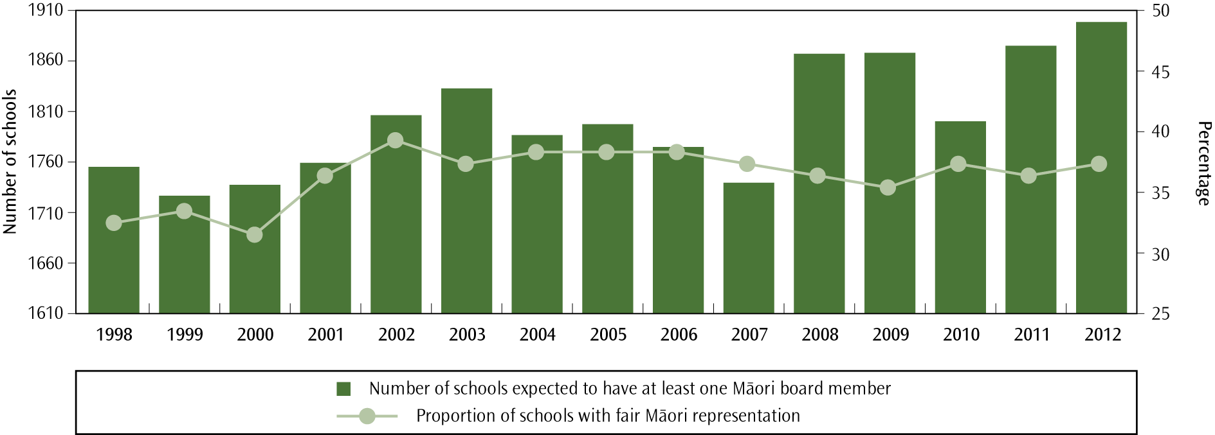

In 2012, there were 472 schools with a sufficient number of Pasifika students such that we would expect these students to be represented by at least one Pasifika parent on the school Board of Trustees. This expectation is based on both the number of Pasifika students and the number of positions on the Board.
One of the targets included in the Pasifika Education Plan 2013–2017 is to increase Pasifika participation on School Boards of Trustees to be proportionate to the number of Pasifika students at the school. The proportion of schools with the expected level of Pasifika representation increased from 26% in 1998 to 35% in 2012. The number of Pasifika parent representatives in the remaining 308 schools (65%) does not reflect the number of Pasifika students in these schools. As with Māori, demographics such as family size are a possible contributor to this under-representation. Based on the Population Census 2006, for every school-aged Pasifika child (5–19 years old) there are 1.17 Pasifika adults aged 25–49. In comparison, there are 1.81 Pākehā/European adults for every Pākehā/European child.
- Number of schools expected to have at least 1 Pasifika board member versus proportion of schools with fair Pasifika representation, 1998–2012
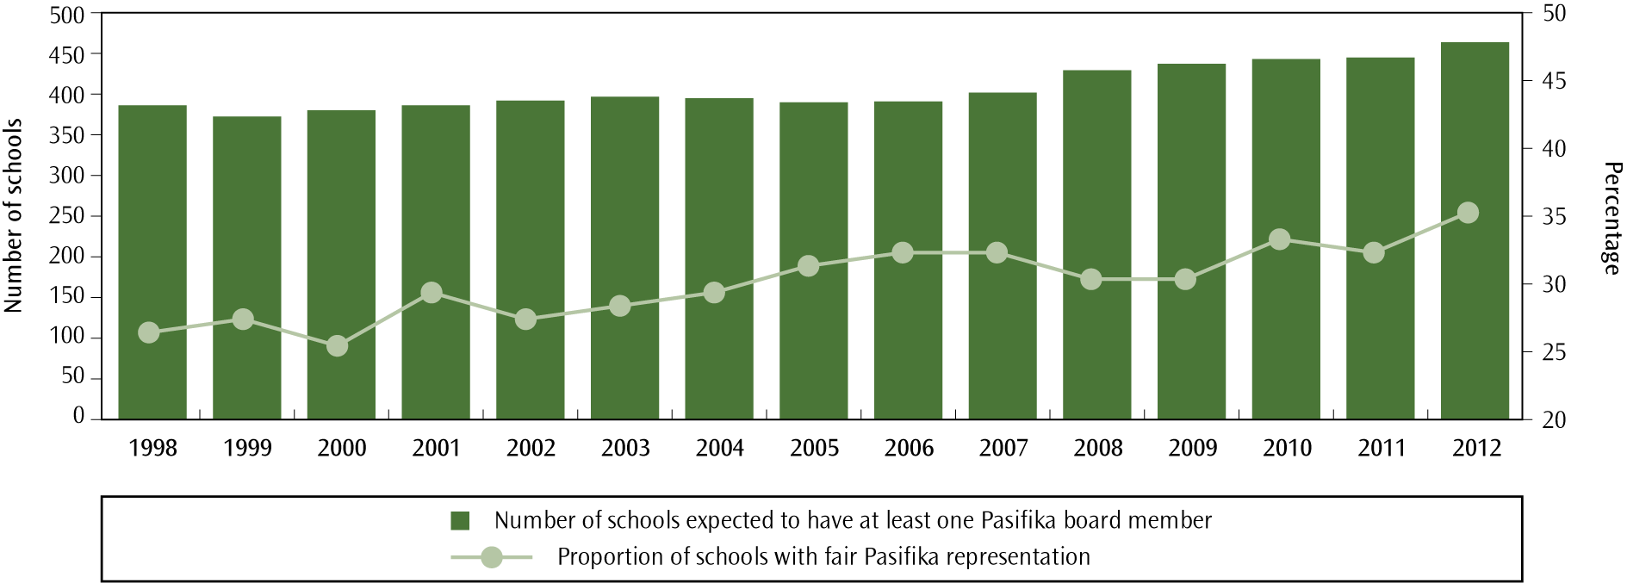

Appendix one

Plans to address pressures on school capacity

Under Section 11Q of the Education Act 1989, the Ministry of Education is required to report on its plans to manage pressures on school capacity and to list the schools that have enrolment schemes in place.
The Ministry provides three main responses to school roll growth that places pressure on school capacity. Where growth has resulted from an influx of students from areas served by other schools, a school is usually required to implement an enrolment scheme to ensure it is able to meet its commitment to local students. Roll trends and demographics are monitored, and schools are alerted when an enrolment scheme may need to be considered. Where there is genuine local growth from the natural catchment area of the school, particularly in an area where enrolment schemes already exist, additional classrooms are usually provided. In areas of major population growth, demographic information guides planning for new schools, with sites purchased well in advance of projected need.

Northern Region
Many areas in Auckland are experiencing significant population growth in line with the Auckland Regional Growth Strategy, with which the Ministry’s new schools programme is closely aligned.
The programme of construction of new schools in Auckland continues. Hingaia Peninsular School opened in 2012. A primary and a secondary school are currently being built at Hobsonville, using a Public Private Partnership (PPP) model. Hobsonville Point Primary School opened at the beginning of 2013 and Hobsonville Point Secondary School will open in 2014. Planning is also underway for an additional primary school and junior high school at Ormiston. These are planned to open in 2015and 2016 respectively.
Increased demand is also being managed through the use of enrolment schemes and the provision of additional classrooms. During 2012, 61 schemes were reviewed, one was amended and none were abandoned. Six new schemes were implemented. For the 2012 calendar year, roll growth reports recommended that a total of 90 new roll-growth classrooms be provided to schools.

Central North Region
In early 2010, structural issues relating to some Prefabricated Modular Classroom (PMC) buildings were identified as being a significant structural risk across the Hawke’s Bay. The Hawke’s Bay PMC situation will provide the opportunity to consider how schooling may be strengthened from a wider perspective. A project group has been established within the Ministry to manage the implementation, once the process has been agreed with the Minister.
There are no areas of significant demographic change in the Hawke’s Bay and most change relates to areas of decline and the need to consider how schooling should be reorganised. Most changes will occur through the Ministry’s response to schools affected by the PMC earthquake-prone buildings reinstatement project.
The focus area of growth in the Bay of Plenty is in Pyes Pa (The Lakes), where the Ministry owns land for future schooling. Consideration for a new school in this area has been placed on the Central North Region’s five-year planning priority schedule.
In Kawerau and Murupara the decisions relating to the reorganisation of schooling are now in the implementation stages. The Ministry continues to support the respective school Boards of Trustees through this process.
The Minister announced new schooling proposals for the north-east of Hamilton on 8 March 2013. Consultation for a new contributing primary school in north-east Hamilton has commenced and the consultation for the intermediate/secondary level schooling proposals will be undertaken over August and September 2013.
Demographic changes across the Local Authority Districts in the Central North Region continue to be monitored through the regional planning process. Areas of minor change in relation to growth and decline are responded to through the implementation of enrolment schemes, or provision of additional classroom capacity.

Central South Region
The Central South Region has continued to operate with reasonably stable rolls. There were only a few areas of growth in the primary school-aged population that caused roll pressure on some schools in the region. Additional (roll growth) accommodation and/or an enrolment scheme were implemented as appropriate.
Across the region approximately 130 schools operate an enrolment scheme and the Ministry engaged with each Board in the annual review of their scheme. From these reviews, schemes were abandoned at two primary schools and three enrolment schemes were amended. There were six new enrolment schemes introduced at primary schools during 2012. Enrolment schemes have generally been effective in assisting Boards to manage their rolls.
Maximum Roll Increases for state-integrated schools were approved for three schools in the Region. As these school networks are under roll pressure, the approvals add a little extra capacity in the network.
Two small rural schools were closed in 2012 and the new Amesbury School in the Wellington suburb of Churton Park opened from Term 1, 2012. Other major change proposals included approvals for one decapitation (Rewa Rewa School) to become Year 1-6, one recapitation (Manakau School) to become Year 1-8 and late in the year an approval for the integration of Wanganui Collegiate School.

Southern Region
Enrolment patterns across Christchurch City and the neighbouring districts of Waimakariri and Selwyn continue to be disrupted as a result of the earthquakes in September 2010 and February 2011. The Minister began consultation on closures and mergers of schools in affected areas in 2012.
Twelve classrooms were constructed at Clearview Primary in Rolleston ready for the start of the 2013 school year. The enrolment scheme home zone for Remarkables Primary School was reduced in size to manage the risk of overcrowding at the school and additional classrooms have also been provided. Planning a new school in Wakatipu Basin was progressed, with an anticipated opening date of 2015.
Three new enrolment schemes were implemented during 2012 due to continued localised population growth within the region. No schools abandoned enrolment schemes.

Schools with enrolment schemes in place for part of or all of 2012
Institution number | School name | Date enrolment scheme was approved | Adjacent school with enrolment scheme exists
3700 | Abbotsford School | 23/08/2005 | Yes
1680 | Aberdeen School | 20/12/1999 | Yes
1195 | Adventure School | 23/06/2008 | No
82 | Aidanfield Christian School | 8/09/2005 | No
6948 | Albany Junior High School | 30/10/2004 | Yes
1202 | Albany School | 24/10/2000 | Yes
563 | Albany Senior High School | 22/07/2008 | Yes
6929 | Alfriston College | 5/05/2003 | Yes
1203 | Alfriston School | 30/09/1999 | Yes
1681 | Allandale School | 10/11/2010 | No
3274 | Allenton School | 31/05/2002 | No
3276 | Amberley School | 24/01/2007 | No
614 | Amesbury School | 7/03/2011 | No
96 | Aorere College | 4/09/2009 | Yes
253 | Aotea College | 30/07/2001 | Yes
2802 | Arakura School | 12/12/2005 | No
1208 | Ardmore School | 23/09/1999 | Yes
3930 | Arrowtown School | 7/01/2002 | Yes
2543 | Arthur Miller School | 27/02/2004 | Yes
1689 | Ashbrook School | 20/12/1999 | Yes
3284 | Ashgrove School | 24/01/2003 | Yes
3285 | Ashley School | 7/03/2008 | No
53 | Auckland Girls' Grammar School | 25/08/1999 | Yes
54 | Auckland Grammar | 1/12/1999 | Yes
1211 | Auckland Normal Intermediate | 13/10/1999 | Yes
2152 | Auroa School | 1/10/2008 | No
78 | Avondale College | 3/08/1999 | Yes
1212 | Avondale Intermediate | 31/10/2002 | Yes
1213 | Avondale Primary School (Auckland) | 28/09/1999 | Yes
3287 | Avonhead School | 22/10/1999 | Yes
324 | Avonside Girls' High School | 3/05/1999 | Yes
1691 | Awakeri School | 20/12/1999 | Yes
2544 | Awapuni School (Gisborne) | 19/11/2004 | No
3709 | Balaclava School | 19/03/2009 | No
3711 | Balmacewen Intermediate | 16/08/2010 | No
1219 | Balmoral School (Auckland) | 29/11/1999 | Yes
3289 | Banks Avenue School | 26/05/2004 | Yes
2112 | Barton Rural School | 31/08/2004 | No
6960 | Baverstock Oaks School | 25/08/2004 | Yes
1220 | Bayfield School | 7/09/1999 | Yes
3291 | Beckenham School | 22/10/1999 | Yes
3292 | Belfast School | 29/01/2008 | No
2157 | Bell Block School | 21/12/2011 | No
1225 | Belmont Intermediate | 3/10/2011 | Yes
1695 | Berkley Normal Middle School | 20/09/2007 | Yes
1697 | Bethlehem School | 13/12/2002 | Yes
2810 | Birchville School | 25/07/2006 | No
1231 | Birkenhead School | 23/09/1999 | Yes
3295 | Blaketown School | 2/11/2007 | No
2546 | Bledisloe School | 14/11/2008 | Yes
1232 | Blockhouse Bay Intermediate | 29/08/2008 | Yes
1233 | Blockhouse Bay School | 8/09/1999 | Yes
1234 | Bombay School | 14/08/2002 | Yes
1235 | Botany Downs School | 12/03/2004 | Yes
6930 | Botany Downs Secondary College | 20/12/2002 | Yes
2813 | Boulcott School | 30/06/2000 | Yes
20 | Bream Bay College | 14/12/2007 | Yes
Institution number | School name | Date enrolment scheme was approved | Adjacent school with enrolment scheme exists
2547 | Bridge Pa School | 29/06/2004 | Yes
3183 | Brightwater School | 26/07/2010 | No
1236 | Brookby School | 30/11/1999 | Yes
3185 | Brooklyn School (Motueka) | 12/07/2011 | Yes
2816 | Brooklyn School (Wellington) | 6/09/1999 | Yes
3303 | Broomfield School | 16/11/2005 | No
1237 | Browns Bay School | 7/10/1999 | Yes
1239 | Buckland School | 29/10/1999 | Yes
1240 | Bucklands Beach Intermediate | 9/08/1999 | Yes
1241 | Bucklands Beach Primary School | 12/02/2010 | Yes
319 | Burnside High School | 4/06/1999 | Yes
3306 | Burwood School | 5/11/1999 | Yes
1700 | Cambridge East School | 15/03/2005 | Yes
142 | Cambridge High School | 23/05/2011 | Yes
1242 | Campbells Bay School | 6/10/1999 | Yes
211 | Campion College | 17/07/2006 | No
3308 | Carew Peel Forest School | 25/01/2008 | No
2345 | Carlton School | 7/08/2008 | No
35 | Carmel College | 16/05/2007 | Yes
2820 | Carterton School | 21/11/2012 | No
2821 | Cashmere Avenue School | 12/07/2004 | Yes
340 | Cashmere High School | 27/05/1999 | No
3310 | Cashmere Primary School | 29/11/1999 | Yes
2418 | Central Normal School | 18/12/2003 | Yes
1581 | Chapel Downs School | 24/11/1999 | Yes
1244 | Chelsea School | 23/09/1999 | Yes
3314 | Chisnallwood Intermediate | 16/09/2005 | No
327 | Christchurch Boys' High School | 4/06/1999 | Yes
328 | Christchurch Girls' High School | 27/05/1999 | Yes
3318 | Christchurch South Intermediate | 4/12/2008 | No
1246 | Churchill Park School | 19/10/1999 | Yes
2824 | Churton Park School | 23/04/2001 | Yes
3321 | Clarkville School | 22/11/1999 | No
1247 | Clayton Park School | 23/03/2001 | Yes
6980 | Clearview Primary | 27/08/2009 | No
1248 | Clendon Park School | 29/06/2005 | Yes
1249 | Clevedon School | 6/11/2006 | Yes
2826 | Clifton Terrace Model School | 24/08/1999 | Yes
2549 | Clive School | 14/06/2004 | Yes
2827 | Clyde Quay School | 3/05/2005 | Yes
3725 | Clyde School | 6/12/2007 | Yes
1252 | Coatesville School | 23/06/1999 | Yes
3323 | Cobham Intermediate | 22/10/1999 | Yes
1253 | Cockle Bay School | 5/08/1999 | Yes
2352 | Coley Street School | 7/09/2006 | No
2353 | College Street Normal School | 17/08/2004 | Yes
386 | Columba College | 19/07/2004 | Yes
2354 | Colyton School | 14/05/2008 | Yes
1255 | Conifer Grove School | 19/10/1999 | Yes
1256 | Cornwall Park District School | 25/11/1999 | Yes
3324 | Cotswold School | 22/11/1999 | No
357 | Craighead Diocesan School | 10/07/2006 | No
3729 | Cromwell Primary School | 22/11/2002 | Yes
3325 | Cust School | 31/03/2006 | Yes
346 | Darfield High School | 25/08/2006 | Yes
3326 | Darfield School | 18/10/2006 | Yes
1709 | David Street School | 7/07/2003 | No
Institution number | School name | Date enrolment scheme was approved | Adjacent school with enrolment scheme exists
1710 | Deanwell School | 30/04/2007 | Yes
1260 | Devonport School | 27/11/2009 | Yes
1635 | Discovery One School | 27/08/2001 | Yes
2832 | Discovery School | 24/08/2004 | Yes
1650 | Drummond Primary School | 27/08/2007 | Yes
1263 | Drury School | 9/08/1999 | Yes
1192 | Dunedin Rudolf Steiner School | 11/07/2008 | No
3331 | Dunsandel School | 12/02/2010 | No
2355 | Durie Hill School | 8/10/2006 | No
3733 | East Taieri School | 12/12/2006 | No
2834 | Eastern Hutt School | 17/10/2001 | Yes
1265 | Edendale School (Auckland) | 1/03/2010 | Yes
3947 | Edendale School (Southland) | 22/08/2008 | No
79 | Edgewater College | 22/07/2003 | Yes
1266 | Edmonton School | 1/11/2002 | Yes
1268 | Ellerslie School | 27/09/1999 | Yes
349 | Ellesmere College | 8/08/2006 | Yes
3334 | Elmwood Normal School | 22/11/1999 | Yes
1168 | Emmanuel Christian School | 9/11/2005 | No
3189 | Enner Glynn School | 14/05/2010 | No
64 | Epsom Girls Grammar School | 25/08/1999 | Yes
1270 | Epsom Normal School | 26/11/1999 | Yes
2557 | Eskdale School | 28/10/2004 | Yes
2837 | Evans Bay Intermediate | 9/09/2002 | Yes
1164 | Everglade School | 30/09/1999 | Yes
1715 | Fairfield Intermediate | 19/06/2008 | No
3736 | Fairfield School (Dunedin) | 20/08/2001 | Yes
2838 | Fairfield School (Levin) | 21/09/1999 | No
2839 | Fairhall School | 22/11/1999 | Yes
1272 | Farm Cove Intermediate | 20/12/1999 | Yes
1273 | Favona School | 30/03/2011 | Yes
197 | Feilding High School | 22/11/2006 | No
3338 | Fendalton Open Air School | 25/11/1999 | Yes
3707 | Fenwick School | 10/08/2007 | Yes
2842 | Fernlea School | 7/04/2006 | No
2843 | Fernridge School | 18/11/2003 | Yes
3340 | Fernside School | 5/09/2001 | No
2117 | Fernworth Primary School | 31/01/2007 | Yes
1275 | Finlayson Park School | 23/07/1999 | Yes
1276 | Flanshaw Road School | 22/12/2011 | Yes
2560 | Flaxmere Primary School | 13/10/2004 | Yes
1278 | Forrest Hill School | 4/10/2010 | Yes
175 | Francis Douglas Memorial College | 11/07/2005 | No
2168 | Frankley School | 7/04/2000 | No
1721 | Frankton School | 31/08/2011 | Yes
135 | Fraser High School | 16/10/2000 | Yes
1279 | Freemans Bay School | 24/06/2008 | Yes
3344 | Freeville School | 22/12/2004 | Yes
200 | Freyberg High School | 3/07/2006 | Yes
2563 | Frimley School | 14/01/2003 | Yes
3740 | George Street Normal School | 14/02/2011 | Yes
2107 | Geraldine Primary School | 21/02/2008 | No
2564 | Gisborne Central School | 21/04/2011 | Yes
1282 | Gladstone School (Auckland) | 29/09/1999 | Yes
2845 | Gladstone School (Masterton) | 11/10/2006 | No
1283 | Glamorgan School | 7/10/1999 | Yes
1284 | Glen Eden Intermediate | 22/10/1999 | Yes
1285 | Glen Eden School | 10/06/2008 | Yes
1723 | Glen Massey School | 7/03/2011 | No
Institution number | School name | Date enrolment scheme was approved | Adjacent school with enrolment scheme exists
1011 | Glenbervie School | 9/08/1999 | No
65 | Glendowie College | 20/08/1999 | Yes
1294 | Glendowie School | 19/10/1999 | Yes
3347 | Gleniti School | 30/07/2001 | Yes
3352 | Glentunnel School | 26/10/2006 | Yes
6070 | Golden Sands School | 15/06/2010 | Yes
3741 | Goldfields School (Cromwell) | 11/12/2009 | Yes
1727 | Goodwood School | 30/05/2006 | Yes
1728 | Gordonton School | 12/12/2011 | Yes
3956 | Gore Main School | 15/12/2011 | No
2848 | Gracefield School | 8/08/2005 | Yes
2111 | Grantlea Downs School | 14/10/2004 | No
42 | Green Bay High School | 31/05/2012 | No
1299 | Greenhithe School | 30/11/2011 | Yes
1729 | Greenpark School (Tauranga) | 21/07/2003 | Yes
1301 | Grey Lynn School | 21/02/2005 | Yes
2850 | Greytown School | 17/10/2003 | No
336 | Hagley Community College | 13/09/1999 | Yes
1302 | Halsey Drive School | 8/09/1999 | Yes
3366 | Halswell School | 22/11/1999 | Yes
131 | Hamilton Boys' High School | 10/08/1999 | Yes
132 | Hamilton Girls' High School | 9/08/1999 | Yes
1733 | Hamilton West School | 1/05/2007 | Yes
3367 | Hampstead School | 28/08/2007 | Yes
3370 | Harewood School | 11/11/2004 | Yes
1303 | Harrisville School | 6/09/2006 | Yes
443 | Hastings Christian School | 30/11/2006 | No
228 | Hastings Girls' High School | 19/06/2003 | Yes
2570 | Hastings Intermediate | 2/08/2010 | No
2854 | Hataitai School | 21/09/1999 | Yes
112 | Hauraki Plains College | 2/12/2003 | Yes
1304 | Hauraki School | 13/06/2012 | No
1735 | Hautapu School | 26/05/2004 | No
2572 | Havelock North Intermediate | 18/06/2002 | No
2573 | Havelock North Primary School | 28/07/1999 | Yes
3747 | Hawea Flat School | 3/12/2007 | No
3371 | Heathcote Valley School | 22/10/1999 | Yes
3372 | Heaton Normal Intermediate | 8/11/1999 | Yes
3963 | Heddon Bush School | 3/09/2007 | Yes
45 | Henderson High School | 24/06/2008 | Yes
1307 | Henderson Intermediate | 1/08/2001 | Yes
1308 | Henderson North School | 7/10/1999 | Yes
1311 | Henderson Valley School | 7/10/1999 | Yes
3194 | Henley School (Nelson) | 4/12/2002 | No
2172 | Highlands Intermediate | 27/02/2007 | Yes
138 | Hillcrest High School | 9/08/1999 | Yes
1739 | Hillcrest Normal School | 5/11/2008 | No
1312 | Hillpark School | 30/09/1999 | Yes
1313 | Hillsborough School | 20/09/1999 | Yes
1740 | Hilltop School | 20/12/1999 | Yes
341 | Hillview Christian School | 1/06/2004 | No
588 | Hingaia Peninsula School | 15/06/2011 | Yes
1741 | Hinuera School | 12/06/2012 | Yes
2578 | Hiruharama School | 29/04/2002 | No
1314 | Hobsonville School | 25/09/2003 | Yes
1316 | Holy Cross Catholic School (Henderson) | 6/05/2008 | Yes
557 | Holy Family School (Wanaka) | 25/07/2008 | No
3379 | Hoon Hay School | 25/09/2000 | Yes
3381 | Hororata School | 19/02/2007 | Yes
Institution number | School name | Date enrolment scheme was approved | Adjacent school with enrolment scheme exists
1746 | Horotiu School | 6/11/2003 | Yes
1747 | Horsham Downs School | 15/07/2009 | No
2861 | Houghton Valley School | 16/09/2005 | No
87 | Howick College | 6/09/1999 | Yes
1318 | Howick Intermediate | 29/05/2003 | Yes
1749 | Hukanui School | 20/12/1999 | Yes
2366 | Hunterville Consolidated School | 6/11/2007 | Yes
1018 | Hurupaki School | 12/09/2005 | No
2862 | Hutt Central School | 5/05/2006 | No
2863 | Hutt Intermediate | 5/10/1999 | Yes
261 | Hutt Valley High School | 21/12/1999 | No
3384 | Ilam School | 27/07/2001 | Yes
2581 | Ilminster Intermediate | 29/04/2002 | Yes
3966 | Invercargill Middle School | 15/11/2005 | Yes
224 | Iona College | 2/04/2004 | Yes
2865 | Island Bay School | 7/11/2005 | No
552 | James Hargest College | 13/05/2005 | Yes
387 | John McGlashan College | 7/07/2004 | Yes
532 | John Paul College | 5/02/2007 | Yes
2866 | Johnsonville School | 7/01/2004 | Yes
1756 | Kaharoa School | 21/08/2001 | No
2369 | Kai Iwi School | 27/06/2008 | No
3388 | Kaiapoi Borough School | 2/03/2006 | Yes
314 | Kaiapoi High School | 19/10/2007 | Yes
3389 | Kaiapoi North School | 1/07/2005 | No
3753 | Kaikorai School | 15/02/2007 | Yes
2370 | Kairanga School | 14/04/2011 | No
2372 | Kaitoke School (Wanganui) | 10/07/2007 | Yes
1030 | Kamo School | 14/11/2006 | Yes
3393 | Kaniere School | 14/12/2006 | No
2871 | Kapanui School | 7/09/1999 | Yes
1325 | Karaka School | 1/08/2006 | Yes
229 | Karamu High School | 24/04/2002 | Yes
2874 | Karori Normal School | 14/12/1999 | Yes
2875 | Karori West Normal School | 27/04/2010 | No
3394 | Karoro School | 12/05/2009 | No
1326 | Kaukapakapa School | 17/12/2009 | Yes
1327 | Kauri Park School | 29/05/2003 | Yes
1032 | Kaurihohore School | 21/04/2009 | Yes
1328 | Kaurilands School | 3/08/1999 | Yes
536 | Kavanagh College | 14/02/2003 | Yes
1329 | Kedgley Intermediate | 30/08/1999 | Yes
2876 | Kelburn Normal School | 5/05/2006 | No
2877 | Kelson School | 7/08/2006 | No
1332 | Kelvin Road School | 27/04/2004 | Yes
5 | Kerikeri High School | 30/08/1999 | Yes
1034 | Kerikeri Primary School | 20/08/1999 | No
2880 | Kilbirnie School | 17/01/2006 | No
1777 | Kimihia School | 5/04/2011 | Yes
1333 | Kingsford School | 23/10/2007 | Yes
1779 | Kio Kio School | 1/12/2006 | No
3397 | Kirwee Model School | 21/08/2006 | Yes
1781 | Knighton Normal School | 20/12/1999 | No
6939 | Kohia Terrace School | 10/12/1999 | Yes
1334 | Kohimarama School | 2/12/1999 | Yes
2385 | Kopane School | 10/10/2008 | No
2882 | Koputaroa School | 17/12/2001 | No
2883 | Korokoro School | 12/10/2006 | No
1784 | Koromatua School | 22/02/2008 | Yes
Institution number | School name | Date enrolment scheme was approved | Adjacent school with enrolment scheme exists
1336 | Koru School | 30/08/1999 | Yes
1337 | Kowhai Intermediate | 19/10/1999 | Yes
3402 | Ladbrooks School | 18/06/2004 | No
1789 | Leamington School | 12/09/2011 | Yes
3410 | Leeston School | 23/11/2009 | No
2182 | Lepperton School | 14/02/2005 | No
4117 | Liberton Christian School | 30/08/2004 | Yes
3975 | Limehills School | 6/12/2002 | Yes
347 | Lincoln High School | 4/06/1999 | No
3412 | Lincoln Primary School | 14/11/2001 | No
230 | Lindisfarne College | 6/04/2004 | Yes
3415 | Linwood North School | 24/11/2008 | No
3419 | Loburn School | 3/03/2005 | No
27 | Long Bay College | 12/09/2005 | Yes
1342 | Long Bay School | 7/12/2006 | Yes
3594 | Longbeach School | 26/05/2008 | No
2590 | Lucknow School | 19/03/2002 | Yes
2892 | Lyall Bay School | 4/12/2012 | No
75 | Lynfield College | 27/07/1999 | Yes
1791 | Lynmore Primary School | 27/05/2002 | No
3423 | Lyttelton Main School | 21/02/2012 | Yes
3424 | Lyttelton West School | 21/02/2012 | Yes
41 | Macleans College | 25/08/1999 | Yes
3201 | Mahana School | 1/07/2005 | Yes
2592 | Mahora School | 21/05/2002 | Yes
24 | Mahurangi College | 31/05/2012 | No
2893 | Maidstone Intermediate | 15/08/2000 | No
1343 | Mairangi Bay School | 7/10/1999 | Yes
3425 | Mairehau School | 21/09/2004 | Yes
2593 | Makaraka School | 18/06/2006 | Yes
3982 | Makarewa School | 11/04/2008 | No
2595 | Makauri School | 13/05/2005 | No
1796 | Malfroy School | 30/10/2012 | No
2896 | Manakau School | 21/11/2012 | No
2390 | Manchester Street School | 11/08/2012 | Yes
2597 | Mangapapa School | 24/08/2009 | No
2899 | Mangaroa School | 7/12/2004 | Yes
1038 | Mangawhai Beach School | 23/11/2004 | Yes
1346 | Mangere Bridge School | 29/10/1999 | Yes
1347 | Mangere Central School | 23/10/2007 | Yes
1348 | Mangere East School | 30/08/1999 | Yes
2189 | Mangorei School | 18/10/2000 | No
1354 | Manurewa Central School | 30/09/1999 | Yes
99 | Manurewa High School | 29/11/1999 | Yes
3768 | Maori Hill School | 17/12/2009 | Yes
3203 | Mapua School | 1/07/2005 | Yes
566 | Maraekakaho School | 14/11/2008 | No
1357 | Maraetai Beach School | 19/08/2008 | Yes
2094 | Marian Catholic School (Hamilton) | 15/07/2008 | No
343 | Marian College | 15/02/2011 | Yes
1592 | Marina View School | 2/12/1999 | Yes
1362 | Marshall Laing School | 8/09/1999 | Yes
3429 | Marshland School | 10/05/2002 | Yes
43 | Massey High School | 18/12/2000 | Yes
1363 | Massey Primary School | 19/10/1999 | Yes
1813 | Matamata Primary School | 15/09/2010 | No
1043 | Matarau School | 1/12/2009 | No
1365 | Matipo Road School | 1/10/2012 | No
1820 | Matua School | 17/12/2007 | Yes
Institution number | School name | Date enrolment scheme was approved | Adjacent school with enrolment scheme exists
2968 | Maungaraki School | 27/01/2006 | No
1821 | Maungatapu School | 16/03/2007 | No
1367 | Maungawhau School | 26/11/1999 | Yes
1050 | Maunu School | 24/12/2007 | Yes
1370 | Meadowbank School | 27/09/1999 | Yes
1371 | Mellons Bay School | 6/10/1999 | Yes
3434 | Merrin School | 22/10/1999 | Yes
3436 | Methven School | 9/05/2008 | No
335 | Middleton Grange School | 2/05/2006 | Yes
1375 | Milford School (Auckland) | 6/10/1999 | Yes
2199 | Mimi School | 9/08/2012 | No
2916 | Miramar North School | 6/04/2001 | No
553 | Mission Heights Junior College | 15/05/2008 | Yes
570 | Mission Heights Primary School | 15/05/2008 | Yes
2403 | Mosston School | 29/03/2005 | Yes
3206 | Motueka South School | 29/11/1999 | Yes
2404 | Mount Biggs School | 17/09/1999 | No
348 | Mount Hutt College | 29/06/2006 | Yes
69 | Mt Albert Grammar School | 22/05/2000 | Yes
1382 | Mt Carmel School (Meadowbank) | 4/11/2008 | Yes
2918 | Mt Cook School (Wellington) | 8/12/2010 | No
1378 | Mt Eden Normal School | 26/11/1999 | Yes
1838 | Mt Maunganui School | 27/01/2008 | Yes
3443 | Mt Pleasant School | 1/11/2005 | Yes
74 | Mt Roskill Grammar | 3/08/1999 | Yes
1383 | Mt Roskill Intermediate | 29/07/2002 | Yes
1384 | Mt Roskill Primary School | 17/09/1999 | Yes
3441 | Mt Somers Springburn School | 18/02/2008 | No
1386 | Murrays Bay Intermediate | 10/08/1999 | Yes
1387 | Murrays Bay School | 13/10/2011 | Yes
3991 | Myross Bush School | 10/03/2003 | Yes
216 | Napier Boys' High School | 21/06/2002 | Yes
2618 | Napier Central School | 3/12/2012 | No
217 | Napier Girls' High School | 3/06/2001 | Yes
2619 | Napier Intermediate | 2/09/2009 | No
1841 | Nawton School | 14/12/2000 | Yes
2620 | Nelson Park School | 30/09/2002 | No
1842 | Netherton School | 22/06/2012 | No
1389 | New Lynn School | 24/10/2007 | Yes
2406 | Newbury School | 23/10/2003 | No
268 | Newlands College | 14/05/2004 | No
1391 | Newmarket School | 26/11/1999 | Yes
1843 | Newstead Model School | 21/01/2011 | No
1392 | Newton Central School | 2/11/2007 | Yes
2205 | Ngaere School | 23/03/2001 | No
1844 | Ngahinapouri School | 9/02/2001 | Yes
2927 | Ngaio School | 6/02/2001 | No
1847 | Ngapuke School | 21/01/2008 | Yes
1850 | Ngatea School | 9/08/2010 | No
2206 | Norfolk School | 26/08/2005 | No
3447 | North Loburn School | 4/09/2006 | Yes
32 | Northcote College | 30/05/2003 | Yes
1395 | Northcote School (Auckland) | 1/12/2011 | Yes
2931 | Northland School | 14/02/2001 | Yes
3450 | Oaklands School | 22/11/1999 | Yes
2208 | Oakura School | 19/05/2004 | No
2933 | Ohau School | 15/10/1999 | Yes
1856 | Ohinewai School | 20/12/2010 | No
3451 | Ohoka School | 7/03/2001 | Yes
Institution number | School name | Date enrolment scheme was approved | Adjacent school with enrolment scheme exists
1857 | Ohope Beach School | 12/12/2008 | No
7 | Okaihau College | 1/12/1999 | Yes
1860 | Omanu School | 19/07/2004 | No
2214 | Omata School | 6/11/2007 | Yes
1863 | Omokoroa School | 25/01/2005 | No
86 | Onehunga High School | 9/08/1999 | Yes
1399 | Onehunga Primary School | 25/11/1999 | Yes
108 | Onewhero Area School | 24/03/2010 | Yes
2629 | Ongaonga School | 31/03/2006 | No
269 | Onslow College | 21/09/1999 | Yes
1401 | Opaheke School | 9/08/1999 | Yes
2936 | Opaki School | 24/11/2003 | No
3455 | Opawa School | 19/11/1999 | Yes
2937 | Opiki School | 20/10/2009 | No
1867 | Opoutere School | 25/10/2011 | No
1404 | Oratia School | 7/10/1999 | Yes
25 | Orewa College | 30/08/2004 | Yes
1407 | Orewa School | 21/04/2006 | Yes
564 | Ormiston Senior College | 19/04/2010 | Yes
2631 | Ormond School | 31/03/2006 | Yes
378 | Otago Girls' High School | 7/06/1999 | Yes
88 | Otahuhu College | 9/08/1999 | Yes
21 | Otamatea High School | 17/11/2008 | No
3073 | Otari School | 4/12/2011 | No
4000 | Otatara School | 20/05/2011 | Yes
6946 | Oteha Valley School | 25/11/2003 | Yes
1877 | Otorohanga South School | 23/05/2011 | Yes
120 | Otumoetai College | 9/08/1999 | Yes
1878 | Otumoetai Intermediate | 1/07/2003 | Yes
3464 | Ouruhia Model School | 22/11/1999 | No
3795 | Outram School | 14/11/2009 | No
1884 | Pahoia School | 1/10/2005 | Yes
2638 | Pakowhai School | 12/02/2004 | Yes
80 | Pakuranga College | 23/09/1999 | Yes
1417 | Pakuranga Intermediate | 19/09/2002 | Yes
202 | Palmerston North Boys' High School | 8/07/2005 | No
203 | Palmerston North Girls' High School | 20/05/1999 | No
2419 | Palmerston North Intermediate | 15/12/1999 | No
2946 | Papakowhai School | 12/02/2007 | No
1421 | Papakura Central School | 10/08/2005 | Yes
1423 | Papakura Normal School | 5/12/2001 | Yes
6963 | Papamoa College | 27/01/2011 | Yes
1885 | Papamoa School | 9/07/2005 | Yes
316 | Papanui High School | 2/05/2006 | Yes
3467 | Paparoa Street School | 26/11/1999 | Yes
1426 | Papatoetoe Central School | 6/08/1999 | Yes
1427 | Papatoetoe East School | 9/08/1999 | Yes
95 | Papatoetoe High School | 5/08/1999 | Yes
1428 | Papatoetoe Intermediate | 30/08/1999 | Yes
1429 | Papatoetoe North School | 9/08/1999 | Yes
1430 | Papatoetoe South School | 9/08/1999 | Yes
1431 | Papatoetoe West School | 9/08/1999 | Yes
2948 | Paraparaumu Beach School | 15/07/2002 | Yes
248 | Paraparaumu College | 23/04/2002 | No
2950 | Paremata School | 3/11/1999 | Yes
2424 | Parkland School (P North) | 1/11/2007 | Yes
2641 | Parkvale School | 28/11/2003 | Yes
1436 | Parnell School | 27/09/1999 | Yes
1438 | Patumahoe Primary School | 21/06/2007 | Yes
Institution number | School name | Date enrolment scheme was approved | Adjacent school with enrolment scheme exists
2953 | Pauatahanui School | 23/06/2005 | No
1892 | Peachgrove Intermediate | 24/10/2002 | Yes
1893 | Pekerau School | 11/05/2007 | No
3737 | Pembroke School (Oamaru) | 31/05/2007 | No
2644 | Peterhead School | 22/11/2002 | No
1439 | Pigeon Mountain School | 25/11/1999 | Yes
1894 | Pillans Point School | 20/12/1999 | Yes
2957 | Pinehaven School | 27/02/2009 | No
6932 | Pinehill School (Browns Bay) | 27/10/1999 | Yes
1897 | Pirongia School | 18/02/2002 | Yes
2959 | Plateau School | 6/09/2006 | No
2960 | Plimmerton School | 18/06/1999 | Yes
6921 | Point View School | 9/09/1999 | Yes
1442 | Pokeno School | 24/06/2008 | Yes
1445 | Ponsonby Intermediate | 16/10/2002 | Yes
1446 | Ponsonby Primary School | 7/09/1999 | Yes
255 | Porirua College | 27/01/2010 | No
2965 | Poroutawhao School | 10/07/2006 | Yes
2648 | Port Ahuriri School | 27/05/2009 | No
2966 | Postgate School | 10/12/2012 | No
2650 | Poukawa School | 19/04/2006 | No
3478 | Prebbleton School | 24/11/2003 | Yes
1440 | Pt Chevalier School | 28/09/1999 | Yes
1441 | Pt England School | 23/07/1999 | No
1902 | Puahue School | 12/05/2010 | No
1448 | Puhinui School | 9/08/1999 | Yes
2651 | Pukehamoamoa School | 18/06/2007 | Yes
2652 | Pukehou School | 16/05/2007 | Yes
1449 | Pukekawa School | 14/05/2008 | Yes
1450 | Pukekohe East School | 24/08/2004 | Yes
103 | Pukekohe High School | 16/07/2002 | Yes
1451 | Pukekohe Hill School | 29/10/1999 | Yes
1452 | Pukekohe Intermediate | 1/08/2006 | Yes
1454 | Pukeoware School | 1/12/1999 | Yes
1907 | Puketaha School | 4/07/2003 | Yes
2654 | Puketapu School (Hawkes Bay) | 11/04/2003 | Yes
1455 | Puni School | 6/04/2000 | Yes
1916 | Pyes Pa Road School | 20/11/2011 | Yes
3479 | Queenspark School | 21/02/2003 | Yes
1456 | Ramarama School | 27/11/2009 | Yes
6944 | Randwick Park School | 1/11/1999 | Yes
1457 | Rangeview Intermediate | 27/05/2004 | Yes
3481 | Rangiora Borough School | 28/11/2008 | No
312 | Rangiora High School | 8/03/2006 | No
418 | Rangiora New Life School | 28/11/2008 | No
28 | Rangitoto College | 1/12/1999 | Yes
2972 | Raroa Normal Intermediate | 30/05/2005 | No
2974 | Raumati Beach School | 14/05/2007 | No
2975 | Raumati South School | 30/11/2010 | No
1194 | Red Beach School | 19/10/1999 | Yes
3483 | Redcliffs School | 8/11/1999 | No
1459 | Redhill School | 28/08/2007 | Yes
1460 | Redoubt North School | 14/05/2008 | Yes
3484 | Redwood School (Christchurch) | 17/08/2004 | Yes
2663 | Reignier Catholic School | 7/07/2008 | No
6783 | Remarkables Primary School | 28/08/2009 | Yes
1461 | Remuera Intermediate | 19/10/1999 | Yes
1462 | Remuera School | 22/12/1999 | Yes
2978 | Renwick School | 18/05/2011 | Yes
Institution number | School name | Date enrolment scheme was approved | Adjacent school with enrolment scheme exists
6978 | Reremoana Primary School | 12/07/2005 | Yes
334 | Riccarton High School | 16/06/1999 | Yes
1463 | Richmond Road School | 21/12/2004 | Yes
3216 | Richmond School (Nelson) | 14/06/2012 | Yes
4006 | Rimu School | 30/08/1999 | Yes
2437 | Riverdale School (P North) | 21/10/1999 | Yes
1464 | Riverhead School | 5/02/2009 | Yes
2981 | Riverlands School | 22/11/1999 | Yes
1594 | Riverview School | 30/08/2011 | No
3217 | Riwaka School | 25/08/2003 | No
1467 | Robertson Road School | 23/12/2008 | Yes
23 | Rodney College | 26/07/2008 | No
3488 | Rolleston School | 21/05/2003 | Yes
1470 | Roscommon School | 17/12/2003 | Yes
3812 | Rosebank School (Balclutha) | 1/10/2001 | Yes
102 | Rosehill College | 6/09/1999 | Yes
2440 | Ross Intermediate | 3/06/2009 | No
1927 | Roto-O-Rangi School | 10/08/2007 | Yes
1930 | Rotokauri School | 20/12/1999 | Yes
1933 | Rotorua Intermediate | 23/10/2002 | No
6976 | Rototuna Primary School | 10/09/2002 | Yes
1351 | Royal Oak Intermediate School | 28/11/2002 | Yes
1475 | Royal Oak School | 19/10/1999 | Yes
3493 | Roydvale School | 11/05/2006 | Yes
2669 | Ruahine School | 5/05/2006 | No
1938 | Rukuhia School | 19/07/2012 | Yes
2441 | Russell Street School | 3/09/2001 | Yes
3496 | Russley School | 5/06/2007 | Yes
40 | Rutherford College | 17/06/2003 | Yes
59 | Sacred Heart College (Auckland) | 3/03/2006 | Yes
174 | Sacred Heart Girls' College (N Plymouth) | 16/02/2006 | Yes
4014 | Salford School | 12/11/2002 | Yes
491 | Sancta Maria College | 20/11/2003 | Yes
1479 | Sandspit Road School | 26/09/2009 | Yes
2987 | Seatoun School | 1/01/2001 | No
3501 | Sefton School | 1/11/2006 | No
6945 | Selwyn Ridge School | 6/12/2001 | No
1480 | Shelly Park School | 16/12/2003 | Yes
1481 | Sherwood School (Auckland) | 3/04/2008 | Yes
321 | Shirley Boys' High School | 29/05/1999 | Yes
3504 | Shirley School | 21/09/2004 | Yes
1482 | Silverdale School | 7/09/2007 | Yes
2990 | Silverstream School | 24/08/2004 | No
1251 | Sir Edmund Hillary Collegiate Junior Sch | 10/10/2006 | Yes
1217 | Sir Edmund Hillary Collegiate Middle Sch | 10/10/2006 | Yes
97 | Sir Edmund Hillary Collegiate Senior Sch | 10/10/2006 | Yes
6759 | Snells Beach Primary School | 12/06/2008 | No
2991 | Solway School | 20/11/2003 | Yes
3506 | Somerfield School | 18/12/2006 | Yes
6760 | Somerville Intermediate School | 10/12/1999 | Yes
1149 | Sonrise Christian School | 20/11/2006 | No
2993 | South Featherston School | 30/09/2004 | No
2446 | South Makirikiri School | 6/09/1999 | No
3508 | South New Brighton School | 23/10/2008 | No
3509 | Southbridge School | 10/02/2010 | No
3510 | Southbrook School | 30/05/2001 | No
452 | Southern Cross Campus | 20/11/2002 | Yes
404 | Southland Boys' High School | 10/07/2006 | Yes
405 | Southland Girls' High School | 10/07/2006 | Yes
Institution number | School name | Date enrolment scheme was approved | Adjacent school with enrolment scheme exists
3512 | Spreydon School | 19/02/2007 | Yes
2996 | Springlands School | 12/06/2007 | Yes
3516 | Springston School | 31/03/2006 | Yes
3517 | St Albans Catholic School (Christchurch) | 6/07/2006 | Yes
3518 | St Albans School | 12/12/2003 | Yes
315 | St Bedes College | 12/04/2011 | Yes
3521 | St Bernadette's School (Hornby) | 8/08/2006 | No
3835 | St Clair School | 2/12/1999 | No
47 | St Dominic's College (Henderson) | 1/08/2006 | Yes
1489 | St Heliers School | 29/11/1999 | Yes
380 | St Hildas Collegiate | 4/08/2004 | Yes
1490 | St Ignatius Catholic School (St Heliers) | 13/09/2006 | Yes
226 | St John's College (Hastings) | 24/08/2006 | Yes
4131 | St John's Girls' School (Invercargill) | 21/03/2003 | No
2450 | St John's Hill School | 3/09/2001 | No
222 | St Joseph's Maori Girls' College | 5/12/2004 | No
3530 | St Joseph's School (Kaikoura) | 15/12/2006 | No
3531 | St Joseph's School (Papanui) | 14/12/2004 | No
4016 | St Joseph's School (Queenstown) | 21/10/2002 | No
2678 | St Joseph's School (Waipukurau) | 7/07/2008 | No
1499 | St Leonards Road School | 9/12/1999 | Yes
3534 | St Martin's School | 18/11/1999 | Yes
1958 | St Mary's Catholic School (Rotorua) | 12/12/2007 | Yes
265 | St Oran's College | 1/01/2007 | No
252 | St Patrick's College (Silverstream) | 30/08/2006 | No
3537 | St Patrick's School (Bryndwr) | 15/06/2004 | No
3541 | St Paul's School (Dallington) | 16/05/2004 | Yes
1643 | St Paul's School (Massey) | 6/07/2006 | Yes
1627 | St Paul's School (Richmond) | 18/02/2003 | Yes
1510 | St Thomas School (Auckland) | 19/10/1999 | Yes
331 | St Thomas of Canterbury College | 2/12/2008 | No
1511 | Stanhope Road School | 18/08/2009 | Yes
1512 | Stanley Bay School | 15/02/2002 | Yes
1514 | Star of the Sea School (Howick) | 10/11/2006 | Yes
1663 | Stella Maris Primary School | 18/07/2008 | Yes
565 | Stonefields School | 10/05/2010 | Yes
6937 | Summerland Primary | 8/10/2001 | Yes
3546 | Sumner School | 25/08/2006 | Yes
1516 | Sunnybrae Normal School | 19/10/1999 | Yes
1515 | Sunnyhills School | 6/10/1999 | Yes
1518 | Sunnynook School | 6/10/1999 | Yes
1520 | Sutton Park School | 3/05/2010 | Yes
3547 | Swannanoa School | 21/10/2004 | Yes
6742 | Tahatai Coast School | 26/11/1999 | Yes
3839 | Tahuna Normal Intermediate | 5/05/2004 | No
3549 | Tai Tapu School | 27/06/2005 | Yes
495 | Taieri College | 27/07/2006 | No
231 | Taikura Rudolf Steiner School | 9/03/2009 | No
3841 | Tainui School | 12/07/2005 | No
1523 | Takanini School | 18/06/2007 | Yes
36 | Takapuna Grammar School | 13/10/1999 | Yes
1524 | Takapuna Normal Intermediate | 9/08/1999 | Yes
1976 | Tamahere Model Country School | 21/12/2004 | Yes
2685 | Tamatea Intermediate | 14/11/2003 | Yes
2686 | Tamatea School | 10/06/2009 | No
58 | Tangaroa College | 13/09/2004 | Yes
215 | Taradale High School | 16/06/2004 | Yes
2687 | Taradale Intermediate | 19/04/2002 | Yes
2688 | Taradale School | 16/05/2003 | Yes
Institution number | School name | Date enrolment scheme was approved | Adjacent school with enrolment scheme exists
3228 | Tasman School | 25/04/2005 | Yes
1107 | Tauhoa School | 12/10/2011 | Yes
1529 | Taupaki School | 4/12/2000 | Yes
121 | Tauranga Boys' College | 9/08/1999 | Yes
122 | Tauranga Girls' College | 9/08/1999 | Yes
1990 | Tauranga Intermediate | 24/01/2000 | Yes
1991 | Tauranga Primary School | 21/02/2000 | Yes
1994 | Tauriko School | 20/12/1999 | Yes
1995 | Tauwhare School | 5/04/2011 | Yes
257 | Tawa College | 4/07/1999 | Yes
3034 | Tawa Intermediate | 30/07/1999 | No
6940 | Te Akau ki Papamoa Primary School | 26/11/1999 | Yes
3037 | Te Aro School | 5/11/2003 | Yes
2002 | Te Awamutu Primary School | 29/03/2011 | Yes
1532 | Te Hihi School | 1/09/2004 | Yes
3038 | Te Horo School (Otaki) | 16/05/2011 | No
2005 | Te Kauwhata Primary School | 20/12/2010 | No
2007 | Te Kowhai School | 7/10/2003 | Yes
1888 | Te Kura o Te Paroa | 20/12/1999 | Yes
2697 | Te Mata School (Havelock North) | 28/03/2003 | Yes
2010 | Te Mata School (Raglan) | 13/04/2012 | No
6741 | Te Matauranga | 22/08/2003 | Yes
2020 | Te Rapa School | 6/09/2001 | Yes
577 | Te Totara Primary School | 29/08/2007 | No
2025 | Te Waotu School | 19/02/2003 | Yes
3555 | Templeton School | 28/06/2004 | No
6947 | The Gardens School | 1/10/2001 | Yes
3844 | The Terrace School (Alexandra) | 13/08/2010 | Yes
4028 | Thornbury School | 28/07/2008 | No
3040 | Thorndon School | 30/09/2002 | Yes
3557 | Thorrington School | 22/10/1999 | Yes
1535 | Three Kings School | 19/10/1999 | Yes
3561 | Tinwald School | 31/10/2007 | No
1536 | Tirimoana School | 8/05/2000 | Yes
2467 | Tiritea School | 14/08/2006 | Yes
4029 | Tisbury School | 26/07/2004 | Yes
3045 | Titahi Bay School | 1/07/2012 | No
1537 | Titirangi School | 9/08/1999 | Yes
2038 | Tokoroa North School | 22/09/1999 | No
212 | Tolaga Bay Area School | 8/12/2004 | No
1538 | Torbay School | 6/10/1999 | Yes
1028 | Totara Grove School | 12/09/2012 | No
143 | Trident High School | 31/08/2001 | Yes
3050 | Tua Marina School | 26/10/1999 | Yes
2711 | Twyford School | 25/05/2002 | Yes
483 | Unlimited Paenga Tawhiti | 24/05/2005 | No
6955 | Upper Harbour Primary School | 8/08/2005 | Yes
250 | Upper Hutt College | 18/11/2003 | No
3053 | Upper Hutt School | 22/10/2004 | Yes
1540 | Valley School | 29/10/1999 | Yes
1541 | Vauxhall School | 14/04/2003 | Yes
1544 | Victoria Avenue School | 27/09/1999 | Yes
3565 | View Hill School | 24/11/1999 | No
1546 | Viscount School | 14/10/2009 | Yes
3055 | Wadestown School | 26/01/2011 | Yes
6922 | Waiheke Primary School | 10/08/2004 | Yes
2048 | Waihi Beach School | 20/08/2011 | No
4035 | Waihopai School | 13/12/2004 | Yes
3056 | Waikanae School | 26/01/2004 | Yes
Institution number | School name | Date enrolment scheme was approved | Adjacent school with enrolment scheme exists
1548 | Waikowhai Intermediate | 1/07/2003 | Yes
3570 | Waikuku School | 24/11/2009 | No
3571 | Waimairi School | 13/08/2001 | Yes
1550 | Waimauku School | 8/12/1999 | Yes
296 | Waimea College | 27/07/2005 | Yes
3233 | Waimea Intermediate | 25/07/2007 | Yes
2721 | Wainui Beach School | 3/12/2008 | No
1552 | Wainui School | 30/11/2007 | Yes
3059 | Wainuiomata Primary School | 20/12/2005 | No
3060 | Wainuioru School | 29/07/2005 | No
2065 | Waipahihi School | 11/06/2010 | Yes
241 | Wairarapa College | 3/07/1999 | No
44 | Waitakere College | 22/08/2003 | Yes
1557 | Waitakere School | 28/11/2007 | Yes
1558 | Waitoki School | 3/12/1999 | Yes
1559 | Waiuku Primary School | 24/08/2004 | Yes
1560 | Wakaaranga School | 11/01/2002 | Yes
3234 | Wakefield School | 23/08/2010 | No
189 | Wanganui High School | 6/08/1999 | No
2477 | Wanganui Intermediate | 19/08/2003 | No
3861 | Warepa School | 24/10/2008 | Yes
1562 | Waterlea Public School | 25/11/1999 | Yes
3068 | Waterloo School | 30/10/1999 | Yes
4047 | Waverley Park School | 6/12/2002 | Yes
3585 | Weedons School | 10/12/1999 | Yes
275 | Wellington College | 1/07/1999 | Yes
274 | Wellington East Girls' College | 4/06/2004 | No
272 | Wellington Girls' College | 5/08/1999 | Yes
273 | Wellington High School & Com Ed Centre | 5/11/2003 | Yes
2479 | West End School (P North) | 30/05/2003 | Yes
3586 | West Eyreton School | 4/04/2005 | Yes
3587 | West Melton School | 15/11/2005 | Yes
2077 | Westbrook School | 27/01/2011 | Yes
3589 | Westburn School | 22/10/1999 | Yes
151 | Western Heights High School | 27/01/2011 | Yes
1567 | Western Heights School (Auckland) | 7/10/1999 | Yes
Institution number | School name | Date enrolment scheme was approved | Adjacent school with enrolment scheme exists
48 | Western Springs College | 5/07/2005 | Yes
37 | Westlake Boys' High School | 29/10/1999 | Yes
38 | Westlake Girls' High School | 13/10/1999 | Yes
1568 | Westmere School (Auckland) | 29/09/1999 | Yes
2480 | Westmere School (Wanganui) | 22/11/2006 | No
3864 | Weston School | 6/03/2007 | Yes
3236 | Westport South School | 25/09/2012 | No
1570 | Weymouth School | 23/07/1999 | Yes
2481 | Whakarongo School | 21/01/2004 | No
144 | Whakatane High School | 31/08/2001 | Yes
2082 | Whakatane Intermediate | 23/09/2005 | No
6763 | Whangaparaoa College | 1/07/2004 | Yes
1571 | Whangaparaoa School (Auckland) | 31/08/2008 | No
2736 | Whangara School | 27/02/2007 | Yes
1129 | Whangarei Intermediate | 10/09/1999 | Yes
1130 | Whangarei School | 27/04/2007 | Yes
2087 | Whatawhata School | 11/12/2012 | No
2088 | Whenuakite School | 22/12/2008 | No
1572 | Whenuapai School | 20/09/1999 | Yes
1573 | Willow Park School | 19/10/1999 | Yes
6959 | Willowbank School (Howick) | 21/11/2000 | Yes
2484 | Winchester School (P North) | 8/06/2004 | Yes
3074 | Windley School | 6/07/2001 | No
3967 | Windsor North School | 6/08/2008 | Yes
3596 | Windsor School (Christchurch) | 5/11/1999 | Yes
4052 | Winton School | 4/04/2008 | Yes
1576 | Wiri Central School | 4/09/2007 | Yes
3075 | Witherlea School | 1/01/2004 | Yes
3600 | Woodend School | 28/06/2006 | Yes
225 | Woodford House | 2/04/2004 | Yes
1577 | Woodhill School | 3/03/2006 | Yes
1578 | Woodlands Park School | 4/10/2010 | Yes
2093 | Woodstock School | 10/04/2006 | No
3077 | Worser Bay School | 2/09/2008 | No
3602 | Yaldhurst Model School | 10/09/2001 | Yes

Appendix 2

Statement of Results
This appendix provides Statements of Results for the following non-departmental other expenses appropriations:
- Primary Education
- Secondary Education
Special Needs Support.
These appropriations provide the bulk of the funding allocated to schools including teacher salaries.
The appendix also includes a Statement of Service Performance for non-departmental output expense Secondary-Tertiary Interface.
The Statements of Results and Statements of Service Performance include:
- actual performance measured against the objectives established at the beginning of the year for each appropriation
operating costs for each appropriation.

Non-departmental other expenses

Primary Education

Scope of Appropriation
Delivering the curriculum for Years 0 to 8 (new entrant to Form 2) to pupils of State, integrated, private schools and The Correspondence School. Provides roll-based operations funding to schools, teacher and management salaries, support costs and supplementary funding programmes.

Intended Impacts, Outcomes or Objectives
Early achievement of core skills.

Description of Activities
This expense includes the number of students and teachers in the primary education sector, the quality of the management and governance of the schools in the sector, the timeliness of their operations, and their financial expenses.

Results ― Non-Financial
Results | 2011/12  Actual  Standard | 2012/13  Budgeted  Standard | 2012/13  Actual  Standard
Quantity
Number of students to receive the curriculum as at census date of 1 July. | 475,908 | 480,000 - 485,000 | 478,615
Average number of Full-time Teacher Equivalents teaching in primary schools (excluding The Correspondence School and private schools). | 27,533 | 25,800 | 27,623
Quality
Percentage of State and integrated schools that meet legislative requirements of performance and standards required by the Education Act 1989 by:
- having a charter in effect prepared under section 61 of the Act | 2012 Calendar year  64 schools failed to meet the standard as at 6 September (97% met the standard). | 99.5% of registered State and integrated schools have such a charter or are working with the Ministry to meet the requirements of the Act. | 2013 Calendar year  18 schools failed to meet the standard as at 4 September (99.2% met the standard).
- being governed by boards of trustees | 99.4% of all registered State and integrated schools were governed by boards of trustees. | Less than 0.5% of registered State and integrated schools will have a Commissioner appointed to manage the school under Section 78N of the Act. | 99.5% of all registered State and integrated schools were governed by boards of trustees.
Timeliness
Schools to remain open for the delivery of the curriculum in terms of the National Education Guidelines. | With the exception of schools affected by the Canterbury earthquakes, in 2011 no schools were open for fewer than 390 half-days.  The 2012 year is yet to finish. At this stage all schools are on track to open for no fewer than 388 half-days. | No fewer than 388 half-days in 2012 and 384 half-days in 2013. | With the exception of Christchurch schools that were granted a teacher only day during the consultation process for closure and merger proposals, in 2012 no schools were open for fewer than 388 half-days.  The 2013 year is yet to finish. At this stage all schools are on track to open for no fewer than 384 half-days.

Results ― Financial
Expenses | 2011/12  Actual  $000 | 2012/13  Estimates  $000 | 2012/13  Supp Estimates  $000 | 2012/13  Actual  $000
Total Appropriation | 2,696,374 | 2,814,406 | 2,785,758 | 2,774,189
Salaries Funding | 2,020,431 | 2,103,150 | 2,053,132 | 2,054,617
Operations and Other Funding | 675,943 | 711,256 | 732,626 | 719,572

The increase in appropriation for 2012/13 compared to 2011/12 was mainly owing to a combination of:
- higher number of full-time teacher equivalents
- changes to school operations grants as approved in Budget 2012 and previous Budgets
- increased effective average rates for teachers and principals and expected incremental creep
- redistribution of salaries funding over the non-departmental other expense appropriations for Primary Education, Secondary Education and Special Needs Support
- increased uptake of KiwiSaver and an increase in the KiwiSaver subsidy rate from 2013
- funding for running boards of trustees elections
- ongoing support for students to meet literacy and numeracy standards
changes to the number of days included in each financial year as determined by respective term dates.
The decrease in funding during 2012/13 was mainly owing to a combination of:
- lower than expected national school roll projections
- reduced Accident Compensation Corporation rates from 1 July 2012 and savings achieved from the previous year
- lower than expected subsidies for KiwiSaver
- savings against support for students to meet literacy and numeracy standards reallocated to departmental output expense Support and Resources for Education Providers to support implementation of Novopay
- provision for Novopay school support package
- higher than expected average teacher salary rates
additional support for the recovery of the education sector in Christchurch, Waimakariri and Selwyn from the impact of the Christchurch earthquakes.
Expenditure at the end of 2012/13 was less than budget mainly due to:
- bulk operating grant with provisions such as network contingency being under-utilised
demand-driven programmes, such as Relief Initiatives and Relieving Central Fund, being under-utilised.

Secondary Education

Scope of appropriation
Delivering the curriculum for years 9–13 (forms 3–7) to pupils of State, integrated, private schools and The Correspondence School. Provides roll-based operations funding to schools, teacher and management salaries, support costs and supplementary funding programmes.

Intended impacts, outcomes or objectives
Attainment of useful qualifications.

Description of Activities
These expenses include the number of students and teachers in the secondary education sector, the quality of the management and governance of the schools in the sector, the timeliness of their operations, and their financial expenses.

Results ― Non-financial
Results | 2011/12  Actual  Standard | 2012/13  Budgeted  Standard | 2012/13  Actual  Standard
Quantity
Number of students to receive the curriculum as at census date of 1 March. | 286,408 | 276,000 – 277,000 | 285,854
Number of Full-time Teacher Equivalents teaching in secondary schools (excluding The Correspondence School and private schools). | 19,659 | 20,400 | 19,388
Quality
Percentage of State and integrated schools that meet legislative requirements of performance and standards required by the Education Act 1989 by:
- having a charter in effect prepared under section 61 of the Act. | 2012 Calendar year  21 schools failed to meet the standard as at 6 September (95.5% met the standard). | 99.5% of registered State and integrated schools have such a charter or are working with the Ministry to meet the requirements of the Act. | 2013 Calendar year  12 schools failed to meet the standard as at 4 September (97.5% met the standard).
- being governed by boards of trustees. | 98.6% of all registered State and integrated schools were governed by boards of trustees. | Less than 0.5% of registered State and integrated schools will have a Commissioner appointed to manage the school under Section 78N of the Act. | 99.4% of all registered State and integrated schools were governed by boards of trustees.
Percentage of Māori and Pasifika youth aged between 15 and 19 years not in education or work will reduce in comparison to the current percentage. | Māori = 16.0%  Pasifika = 9.8%  September quarter 2011 (most recent available) | <10% | 15-to-24-year-olds:  Māori = 21.1%  Pasifika = 17.8%  June quarter 2013
Percentage of Māori and Pasifika students leaving school with NCEA Level 2 or above will increase in comparison to the current percentage. | Māori = 52.2%  Pasifika = 63.6% | Māori >55%  Pasifika >75% | Māori = 54.6%  Pasifika = 64.8%
Timeliness
Schools to remain open for the delivery of the curriculum in terms of the National Education Guidelines. | With the exception of schools affected by the Canterbury earthquakes, in 2011 no schools were open for fewer than 380 half-days. The 2012 year is yet to finish.  At this stage all schools are on track to open for no fewer than 380 half-days. | No fewer than 380 half-days in 2012 and 380 half-days in 2013. | With the exception of Christchurch schools that were granted a teacher only day during the consultation process for closure and merger proposals, in 2012 no schools were open for fewer than 380 half- days.  The 2013 year is yet to finish. At this stage all schools are on track to open for no fewer than 380 half-days.

Results ― Financial
Expenses | 2011/12  Actual  $000 | 2012/13  Estimates  $000 | 2012/13  Supp Estimates  $000 | 2012/13  Actual  $000
Total Appropriation | 2,005,760 | 2,066,366 | 2,056,493 | 2,049,588
Salaries Funding | 1,461,745 | 1,492,401 | 1,478,946 | 1,483,581
Operations and Other Funding | 544,015 | 573,935 | 577,547 | 566,007

The increase in appropriation for 2012/13 compared to 2011/12 was mainly owing to a combination of:
- changes to school operations grants as approved in Budget 2012 and previous Budgets
- changes to the number of days included in each financial year as determined by respective term dates
- higher number of full-time teacher equivalents
- additional costs arising from recent settlements of collective agreements
- increased uptake of KiwiSaver and an increase in the KiwiSaver subsidy rate from 2013
- increased effective average rates for teachers and principals and expected incremental creep funding for running boards of trustees elections
- redistribution of salaries funding over the non-departmental other expense appropriations for Primary Education, Secondary Education and Special Needs Support
forecast reductions in student rolls.
The decrease in funding during 2012/13 was mainly owing to a combination of:
- a transfer to a new non-departmental output expense appropriation Secondary-Tertiary Interface to implement a single cash-based resourcing model for secondary-tertiary programmes that will better enable funding to follow students
- provision for settlement of the 2013-2015 Secondary Teachers' Collective Agreement
- provision for Novopay school support package
additional support for the recovery of the education sector in Christchurch, Waimakariri and Selwyn from the impact of the Christchurch earthquakes.
Expenditure at the end of 2012/13 was less than budget mainly due to:
- no set up grants being required for new schools
provisions such as network contingency within operation funding being under-utilised.

Special Needs Support

Scope of appropriation
Providing additional resources to enable students with special education needs to participate in education including supplementary resources for special education needs, residential services, English for Speakers of Other Languages and alternative education programmes.

Intended impacts, outcomes or objectives
- Increased and sustained participation in high-quality early childhood education
- Early achievement of core skills
Attainment of useful qualifications

Description of activities
These expenses include the quantity and quality of various special needs support services, the timeliness with which these support services are delivered, and the financial expenses relating to the services.

Results ― Non-financial
Results | 2011/12  Actual  Standard | 2012/13  Budgeted  Standard | 2012/13  Actual  Standard
Quantity
Numbers of Resource Teachers: Learning and Behaviour. | 709 headcount | 700 - 800 | 878 headcount  862.2 FTTE
Numbers of students in residential care. | 268 students | 300 - 400 | 228 students
Number of English for Speakers of Other Languages students funded. | 32,487 (April 2012) | 32,000 - 35,000 | 31,741 (April 2013)
Link alienated young people to alternative educational programmes. | 3,667 | 2,500 - 4,000 | 3,368
Feedback from key Royal New Zealand Foundation for the Blind stakeholders is reflected in production and service improvements. | 100% | 100% | 100%
Items requested by individuals are supplied by Royal New Zealand Foundation for the Blind within a month. | 100% | 100% | 100%
Number of students supported through the Special Education Equipment Fund. | 1,202 | 600 - 900 | 1,498
New schools participating in the school-wide framework. | 89 | 120 | 119
Teachers participating in the Incredible Years teacher programmes. | 2,277 | 2,440 | 2,631
Number of students supported through the wraparound service. | 100 | 75-100 | 196
Quality
Resources targeted and delivered according to documented criteria. | 100% | 100% | 100%
Timeliness
Resources for services will be delivered according to documented timeframes. | 100% Compliance | 100% Compliance | 100% Compliance

Results ― Financial
Expenses | 2011/12  Actual  $000 | 2012/13  Estimates  $000 | 2012/13  Supp Estimates  $000 | 2012/13  Actual  $000
Total Appropriation | 323,226 | 338,221 | 339,765 | 331,763
Salaries Funding | 168,993 | 177,146 | 173,612 | 168,875
Operations and Other Funding | 154,233 | 161,075 | 166,153 | 162,888

The increase in appropriation for 2012/13 compared to 2011/12 was mainly owing to a combination of:
- higher levels of forecast staffing entitlements
- progressing implementation of the Positive Behaviour for Learning programme
- redistribution of salaries funding over the non-departmental other expense appropriations for Primary Education, Secondary Education and Special Needs Support
- changes to school operations grants as approved in Budget 2012 and previous Budgets
- provision for a change programme for Residential Special Schools
support for Youth Mental Health initiatives.
The increase in funding during 2012/13 was mainly owing to:
- the additional costs of amalgamating the Supplementary Learning Support teachers and the Resource Teacher: Learning and Behaviour service, including potential redundancy and redeployment costs partially funded by a transfer from non-departmental output expense Professional Development and Support
- transfers to 2013/14 mainly for delays in projects related to the Positive Behaviour for Learning initiative
the expansion of the intensive wraparound service under departmental output expense Interventions for Target Student Groups following closure of McKenzie School and changes to the rolls of several other residential special schools.
Expenditure at the end of 2012/13 was less than budget mainly due to:
- fewer teacher full-time equivalents than expected
- lower than expected demand for the English for Speakers of Other Languages programme
reduced residents funding from one residential school closure (McKenzie Residential School) and adjustments made to notional rolls for the remaining residential schools.

Non-departmental output expense

Secondary-Tertiary Interface

Scope of Appropriation
This appropriation is limited to delivery of programmes of learning at the secondary-tertiary interface, including programmes offered in partnership by schools and tertiary education organisations.

Intended Impacts, Outcomes or Objectives
Attainment of useful qualifications.

Description of Activities
These expenses include the number of places purchased in the secondary-tertiary programme and financial expenses relating to the programme.

Service Performance ― Non-financial
Results | 2011/12  Actual  Standard | 2012/13  Budgeted  Standard | 2012/13  Actual  Standard
Quantity
Numbers of secondary-tertiary programme places purchased | n/a – programme appropriation began in January 2013. | 3,700 places in 2013 | 3,367 places as at mid-2013.

Service Performance ― Financial
Expenses | 2011/12  Actual  $000 | 2012/13  Estimates  $000 | 2012/13  Supp Estimates  $000 | 2012/13  Actual  $000
Total Appropriation | n/a | n/a | 23,046 | 20,150
Schools | n/a | n/a | 16,137 | 13,241
Tertiary Education Commission | n/a | n/a | 6,909 | 6,909

This appropriation was established from 1 January 2013 through transfers from non-departmental other expense Secondary Education, and Vote Tertiary Education non-departmental output expense Tertiary Education Grants and Other Funding to implement a single cash-based resourcing model for secondary-tertiary programmes that will better enable funding to follow students.
The initial level of demand for the programme was slightly lower than anticipated resulting in some under-utilised places.

References
Alton-Lee, A. (2003). Quality teaching for diverse students in schooling: best evidence synthesis. Wellington: Ministry of Education.
Benseman, J., Sutton, A., & Lander, J. (2005). Working in the light of evidence as well as aspiration: a literature review of the best available evidence about effective adult literacy, numeracy and language teaching. Report prepared for the Ministry of Education. Auckland: Auckland Uniservices Ltd.
Biddulph, J. (1983). A group programme to train parents of children with reading difficulties to tutor their children at home. MA research report: University of Canterbury, Christchurch.
Biddulph, J. & Tuck, B. (1983). Assisting parents to help their children with reading at home. Paper presented to the New Zealand Association for Research in Education: Wellington.
Bishop, R., Berryman, M., Wearmouth, J., Peter, M., & Clapham, S. (2012). A summary of Te Kotahitanga: maintaining, replicating and sustaining change in phase 3 and 4 schools: 2007–2010. Wellington: Ministry of Education.
Caygill, R., Kirkham, S., & Marshall, N. (2013a). Year 5 students’ mathematics achievement in 2010/11: New Zealand results from the Trends in International Mathematics and Science Study (TIMSS). Wellington: Ministry of Education.
Caygill, R., Kirkham, S., & Marshall, N. (2013b). Year 5 students’ science achievement in 2010/11: New Zealand results from the Trends in International Mathematics and Science Study (TIMSS). Wellington: Ministry of Education.
Caygill, R., Kirkham, S., & Marshall, N. (2013c). Year 9 students’ mathematics achievement in 2010/11: New Zealand results from the Trends in International Mathematics and Science Study (TIMSS). Wellington: Ministry of Education.
Caygill, R., Kirkham, S., & Marshall, N. (2013d). Year 9 students’ science achievement in 2010/11: New Zealand results from the Trends in International Mathematics and Science Study (TIMSS). Wellington: Ministry of Education.
Chamberlain, M. (2013). PIRLS 2010/11 in New Zealand: An overview of findings from the third cycle of the Progress in International Reading Literacy Study (PIRLS). Wellington: Ministry of Education.
Chamberlain, M., & Caygill, R. (2013). Key findings from New Zealand’s participation in the Progress in International Reading Literacy Study (PIRLS) and Trends in International Mathematics and Science Study (TIMSS) in 2010/11. Wellington: Ministry of Education.
Clark, T.C., Fleming, T., Bullen, P., Crengle, S., Denny, S., Dyson, B., Utter, J., & The Adolescent Health Group (2013). The Health and Wellbeing of New Zealand Secondary School Students: Prevalence Tables from the Youth’12 National Youth Health and Wellbeing Survey. Auckland: The University of Auckland.
Cowie, B., McGee, C., Peter, M., Taylor, M., & Chen, J. (2012). Evaluation of Literacy and Mathematics Additional Learning Programmes for Students 2011. Wellington: Ministry of Education.
Cowles, S. (2013). Annual Monitoring of Reading Recovery: the Data for 2012. Wellington: Ministry of Education.
Earle, D. (2009). Skills, qualifications and wages: an analysis from the Adult Literacy and Life Skills Survey. Wellington: Ministry of Education.
Education and Science Committee (2012). Inquiry into 21st century learning environments and digital literacy. Wellington: New Zealand House of Representatives.
Engler, R. (2010). School leavers’ progression to bachelors-level study. Wellington: Ministry of Education.
ERO (2010a). Including Students with High Needs. Wellington: Education Review Office.
ERO (2010b). Secondary Schools and Alternative Education. Wellington: Education Review Office.
ERO (2012a). Ako Panuku: An evaluation of the programme’s effectiveness. Wellington: Education Review Office.
ERO (2012b). Evaluation at a Glance: Priority Learners in New Zealand schools. Wellington: Education Review Office.
ERO (2012c). Improving Education Outcomes for Pacific Learners. Wellington: Education Review Office.
ERO (2012d). Literacy and Mathematics in Years 9 and 10: Using Achievement Information to Promote Success. Wellington: Education Review Office.
ERO (2012e). Reporting to Parents: National Standards Years 4 to 8. Wellington: Education Review Office.
ERO (2012f). Science in the New Zealand Curriculum: Years 5 to 8. Wellington: Education Review Office.
ERO (2013a). Including Students with High Needs: Primary Schools. Wellington: Education Review Office.
ERO (2013b). Mathematics in Years 4 to 8: Developing a Responsive Curriculum. Wellington: Education Review Office.
Gibbs, R., & Poskitt, J. (2010). Student engagement in the middle years of schooling (Years 7-10): a literature review. Report to the Ministry of Education. Wellington: Ministry of Education.
Gluckman, P. (2011). Looking ahead: science education for the twenty-first century. Auckland: Office of the Prime Minister’s Science Advisory Committee.
Hattie, J. (2009). Visible Learning: a synthesis of over 800 meta-analyses relating to achievement. New York, NY: Routledge.
Human Rights Commission (2012). A fair go for all? rite tahi tātou katoa? Addressing structural discrimination in public services. Aotearoa: Human Rights Commission.
Ingersoll, R. & Kralik, J. (2004). The impact of mentoring on teacher retention: what the research says. Denver, CO: Education Commission of the States.
Lee, M. (2012). Monitoring teacher supply: Survey of staffing in New Zealand schools at the beginning of the 2012 school year. Wellington: Ministry of Education.
Mallari, M., & Loader, M. (2013). Attendance in New Zealand Schools 2012. Wellington: Ministry of Education.
May, S., Hill, R., & Tiakiwai, S. (2004). Bilingual/immersion education: Indicators of good practice. Final report to the Ministry of Education. Wellington: Ministry of Education.
Ministerial Inquiry into the Novopay Project (2013). Report of the Ministerial Inquiry into the Novopay Project. Wellington: New Zealand House of Representatives.
Ministry of Education (2007). The New Zealand Curriculum. Wellington: Ministry of Education.
Ministry of Education (2008a). Ka Hikitia ― Managing for success: the Māori Education Strategy 2008-2012. Wellington: Ministry of Education.
Ministry of Education (2008b). Te Marautanga o Aotearoa. Wellington: Ministry of Education.
Ministry of Education (2009). Pasifika Education Plan 2009-2012. Wellington: Ministry of Education.
Ministry of Education (2010). Tertiary Education Strategy 2010-2015. Wellington: Office of the Minister for Tertiary Education.
Ministry of Education (2012). Pasifika Education Plan Monitoring Report: 2010. Wellington: Ministry of Education.
Ministry of Education (2013a). Me Kōrero ― Let’s Talk! Summary of Online Feedback March 2013. Wellington: Ministry of Education.
Ministry of Education (2013b). Māori Medium Kaiako Survey. Wellington; Ministry of Education.
Ministry of Education (2013c). SAF Outcomes for 2012: Highlights. Wellington: Ministry of Education.
Neill, A., Fisher, J., & Dingle, R. (2010). Exploring mathematics interventions: Exploratory evaluation of the accelerating learning in mathematics pilot study. Report to the Ministry of Education. Wellington: Ministry of Education.
Norton, P., Sanderson, K., Booth, T., & Stroombergen, A. (2000). A literature review of the effect of school resourcing on educational outcomes. Report to the Ministry of Education.
OECD (2013). Education at a glance 2013. Paris: OECD.
Office of the Auditor-General (2013). Education for Māori: Implementing Ka Hikitia – Managing for Success. Wellington: Office of the Auditor-General.
PPTA (2013). Novopay Impacts: Pay period 24, 2013. NZPPTA Report. Wellington: NZPPTA.
Robinson, V., Hohepa, M., & Lloyd, C. (2009). School leadership and student outcomes: identifying what works and why. Wellington: Ministry of Education.
Scott, D., & Smart, W. (2005). What factors make a difference to getting a degree in New Zealand? Wellington: Ministry of Education.
Telford, M., & May, S. (2010). PISA 2009: our 21st century learners at age 15. Wellington: Ministry of Education.
Ward, J. & Thomas, G. (2011). National Standards: School Sample Monitoring & Evaluation Project, 2010. Wellington: Ministry of Education.
Ward, J. & Thomas, G. (2012). National Standards: School Sample Monitoring & Evaluation Project, 2011. Wellington: Ministry of Education.
Ward, J. & Thomas, G. (2013). National Standards: School Sample Monitoring and Evaluation Project, 2010-2012. Wellington: Ministry of Education.
Wylie, C. (2010). Principal vacancies and appointments, 2008-9. Wellington: NZCER Press.
Wylie, C. (2013). Secondary schools in 2012: Main findings from the NZCER national survey. Wellington: NZCER Press.
Wylie, C., Cameron, M., Twist, J., McDowell, S., & Fisher, J. (2009). Conditions for school innovation and transformation. Paper presented to the 22nd International Congress for School Effectiveness and Improvement (ICSEI), Vancouver, Canada.
Wylie, C., & Hodgen, E. (2007). Growing independence: Competent Learners @ 16: competency levels and development over time. Wellington: Ministry of Education.
Wylie, C., Thompson, J., & Lythe, C. (2004). Competent children at 12. Report to the Ministry of Education. Wellington: NZCER Press.
Young-Loveridge, J. (2010). A decade of reform in mathematics education: results for 2009 and earlier years: findings from the New Zealand Numeracy Development Projects (2009). Wellington: Ministry of Education.

All government funding components are exclusive of GST. The base year for real funding is 2012. The figure for property capital works is an estimate from cash payments made during 2012 and includes both capital and operating expenditure.
This handbook is available electronically from the Ministry of Education website: www.minedu.govt.nz.
See: www.educationcounts.govt.nz/statistics/schooling/funding/47696.
The Progress in International Reading Literacy Study (see Chamberlain & Caygill, 2013).
The Programme for International Student Assessment (see Telford & May, 2010).
Biddulph (1983) and Biddulph & Tuck (1983), based on the findings of an evaluation found that Reading Together had an effect size of 2.25 on learners level of reading comprehension.
Significant refers to statistical significance.
The Ministry of Education and NZQA have changed the literacy requirement for NCEA Level 1 from eight credits to 10 credits and the numeracy requirement for NCEA Level 1 from eight credits to 10 credits. The changed requirements were in full effect in 2012. NCEA Level 1 literacy and numeracy requirements will also need to be met in order to achieve NCEA Level 2 from 2013, and NCEA Level 3 from 2014.
PISA assessments were administered in English only. As a consequence no students from wharekura took part in the study.
Organisation for Economic Cooperation and Development.
Pāngarau (grouped) is an aggregate of the multiple ways kura and schools have submitted their pāngarau information. The grouping is an average of achievement in the different pāngarau strands: Pāngarau (by itself), Te Tau me te Taurangi (Number/Algebra), Te Ine me te Āhuahanga (Measurement/Geometry) and Te Tauanga me te Tūponotanga (Statistics/Probability).
Participation, in this context, is the number of learners attaining a minimum of one credit, as a proportion of the total number of learners.
Achievement, in this context, refers to the number of learners with 14 or more credits in the subject, as a proportion of the number participating in that subject.
For this analysis, total response ethnic group was used.
Participation, in this context, is the number of students attaining a minimum of one credit, as a proportion of the total number of students.
School leaver data for 2009–2011 may differ from data presented in previous years, as students who left and then returned to school after April 1 in a given year were removed from the relevant year’s school leaver data set before processing in 2013. Prior to this, these students were counted as school leavers.
This outcome should not be confused with the Better Public Service target (page 48). The target relates to 18-year-old achievement rather than achievement at the end of schooling.
School achievement is measured for each student relative to all other students taking the same subjects in the same year. Higher-achieving students gained more credits with Excellence and Merit grades.
Some students in the study population identified with multiple ethnic groups or changed the ethnic groups they identified with over time. To explore trends within ethnic groups, the report used the definitions never, ever, or solely belonging to an ethnic group.
Target based on an old classification system for the education medium of schools. Classification is now Māori medium, mixed medium, or English medium.
Target based on prioritised ethnicity and a more restrictive historical definition of school leavers.
Ethnic differences analysis for non-enrolled students uses prioritised ethnicity.
Ethnic differences analysis for early leaving exemption uses prioritised ethnicity.
Ethnic differences analysis of absence rates uses prioritised ethnicity.
As a consequence of a serious breach of school rules, a school principal can order a student to stand down from school for a period of up to five school days. A stand-down, for any student, can total no more than five school days in any term, or 10 days in a school year. Students return automatically to school following a stand-down. For very serious breaches of school rules, a principal may suspend a student from attending school until the school Board of trustees decides on the consequence for the student. The Board may decide to lift the suspension with or without conditions, to extend the suspension or, in the most serious cases, to exclude or expel the student.
Ethnic differences analysis for stand-downs and suspensions uses prioritised ethnicity.
A new, more inclusive methodology is currently being developed to provide a better indicator of teacher loss. One flaw of the current methodology is that teachers who are still in the profession, but for whatever reason, were not teaching during a traditional May snapshot are considered a loss from the previous year, when they could start again in June. The new methodology will address this and other issues.
This expectation is based both on the number of Māori students and the number of positions on the Board.
Using prioritised ethnicity data collection.
All schools that have students in years 0–8 are included.
That had any students in funding years 1–8.
That had any students in funding years 1-8
All schools that have students in years 9–13 are included.
That had any year 9–13 students.
That had any students in funding years 9–13
The Ministry of Business, Innovation and Employment have changed the way they report NEETs – they have aligned with the official measure that Statistics New Zealand now reports. They now treat caregivers as NEET.
The Ministry now report NEETs for 15-to-24 age band because of the highly variable nature of the 15-to-19 band.
Results for this standard are now reported using a new definition of school leavers and a move from paper-based collection to electronic collection. For this reason, the result reported for 2011/12 differs slightly from the figure reported previously: 60.9% for Māori and 71.8% for Pasifika.

