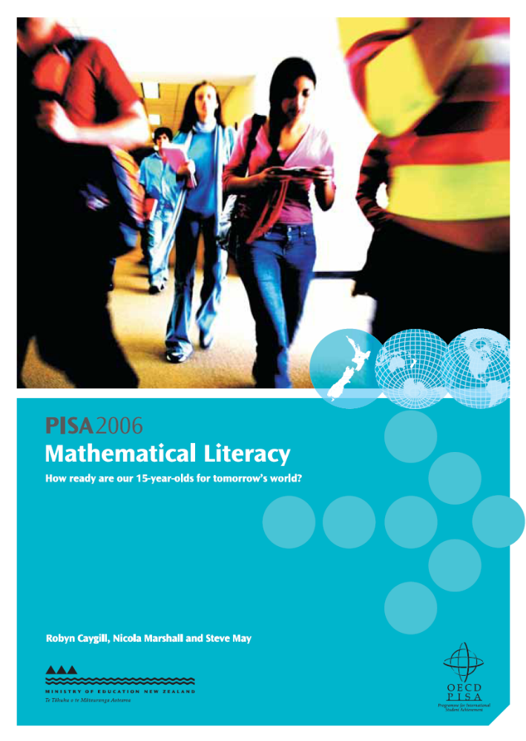

An overview of PISA

What is PISA?
The Programme for International Student Assessment (PISA) is an international standardised study that assesses and compares how well countries are preparing their 15-year-old students to meet real-life opportunities and challenges.

What does PISA assess?
PISA assesses three key areas of knowledge and skills − reading literacy, mathematical literacy and scientific literacy − and has a focus on one of these literacy areas each time PISA is administered. The focus of PISA 2006 is science. The term ‘literacy’ is used to emphasise that the assessment is not restricted to assessing how well students have mastered the content of a specific school curriculum. Instead, PISA focuses on assessing students’ ability to apply their knowledge and skills, and their ability to make decisions in real-life situations. PISA defines this approach as assessing “[t]he knowledge, skills, competencies and other attributes embodied in individuals that are relevant to personal, social and economic well-being” (OECD 2006, p. 11).

What additional information is gathered?
Background information is also gained in each PISA cycle from questionnaires completed by students and school principals. In addition, in PISA 2006 parents completed a questionnaire. These questionnaires allow for the relationship between contextual information and achievement to be examined.

How often is PISA administered?
PISA is administered every three years, beginning in 2000. Reading was the main focus in the first cycle. In 2003 the focus was mathematical literacy, and in 2009 it will be reading literacy again. Rotating the major focus for each administration of PISA provides in-depth and detailed information on the subject of major focus along with an ongoing source of achievement data on the two minor subjects.

Who participates in PISA?
Around 400,000 15-year-old students from 57 countries, including the 30 Organisation for Economic Co-operation and Development (OECD) member countries, participated in PISA 2006. In New Zealand 4,824 students from 170 schools took part. Students and schools were randomly selected. A two-tiered stratified sampling method was used to ensure the sample was representative. Students were sampled from schools of different sizes and decile groupings, and from urban and rural schools. As a result, every 15-year-old had roughly the same chance of selection.

Why participate in PISA?
PISA assesses students who have completed around 10 years of compulsory schooling, which means the PISA results are an important source of information in New Zealand. PISA measures progress towards the Government’s goals of:
- building an education system that equips New Zealanders with 21st century skills, and
- reducing systemic underachievement in education.
PISA not only allows measurement of New Zealand’s progress on these goals over time, but also allows measurement of New Zealand’s performance relative to other countries in equipping students with skills and reducing disparities in achievement. The PISA data provide evidence to inform policy and practice in literacy, numeracy and curriculum development.

Who organises PISA?
PISA is an initiative of the OECD and a collaborative effort of the participating countries. A consortium is responsible for developing and overseeing PISA 2006 at the international level. This consortium is led by the Australian Council for Educational Research (ACER), and consists of the Netherlands National Institute for Educational Measurement (Citogroup), Westat (USA), the Educational Testing Service (ETS, USA), and the Japanese National Institute for Educational Policy Research (NIER, Japan). In New Zealand, the Comparative Education Research Unit within the Ministry of Education’s Research Division is responsible for PISA.

How did countries ensure the PISA data were of high quality?
A number of quality assurance procedures were put in place, both nationally and internationally, to ensure the data were of as high a quality as possible. These included: rigorous training of staff; high-quality documentation; monitoring of sampling procedures; quality checks and monitoring at a number of stages, including during administration of the tests; multiple coding and data entry procedures; and data cleaning and checking procedures. Further details of international procedures can be found in the PISA 2006 technical report (OECD, in press), or in the technical notes (OECD, n.d.).

Acknowledgements
I am very grateful to the 45 schools that participated in the field trial and the 170 schools that participated in the main study. Without the support of schools (principals and staff), students and parents, this study would not be possible. The efforts of these participants have provided New Zealand with a valuable resource.
The fieldwork for the main study, which lies behind this and other reports using PISA data, was undertaken during June and July 2006. Data collection and management went smoothly thanks to Abby Nurse (PISA 2006 Research Administrator) and Jeremy Praat (PISA 2006 Data Manager).
I would like to thank my fellow members of the PISA 2006 Steering Group for providing valuable advice to PISA, particularly during the development phase: Adrienne Alton-Lee, Martin Connelly, Avril Gaastra, Claire Harkess, Janet Hay, Rosemary Hipkins, Richard Harker, Earl Irving, John Laurenson, Robert Lynn, Debra Masters, Stephanie Nichols, Lisa Rodgers, and Leilani Unasa.
The authors of this report, Robyn Caygill, Nicola Marshall and Steve May deserve recognition for their efforts in working with a very complex dataset and delivering a quality report. On behalf of the authors I would also like to acknowledge Malcolm Hyland, John Laurenson, Lesieli Tongati'o, and Fred Bishop for their helpful comments in reviewing this report; and the Research Division’s publication team, Christabel Dillon and Raelene Butters, for their assistance in the publication process.
Finally, I would like to extend my sincere gratitude to Maree Telford, National Project Manager of PISA 2006 and Steve May, Principal Research Analyst. Their dedication to the project helped to lay a solid foundation for this and future research endeavours using PISA data.

Lynne Whitney
Senior Manager
Research Division

Table of Contents
An overview of PISA 2
Key findings 6
Introduction 8
Student performance in mathematical literacy 12
Gender 16
Ethnicity, language and immigrant status 18
Socio-economic status 26
Conclusion 28
Appendices 29
References 38
Definitions and technical notes 39
Further information 41

Key findings

Overall
- The mean mathematical literacy performance of New Zealand’s 15-year-old students in PISA 2006 was above the OECD mean.
- Only 5 out of the other 56 participating countries had significantly higher mean performances than New Zealand.
- There was no significant change in mathematical literacy performance of New Zealand’s 15-year-old students between 2003 and 2006.
- Compared to other OECD countries, a relatively larger proportion of New Zealand students were highly proficient in mathematical literacy and a relatively smaller proportion had low proficiency in mathematical literacy.
- The five top-performing countries had larger proportions of students achieving the highest level of proficiency and smaller proportions of students with low proficiency compared with New Zealand.

Gender
- New Zealand boys had higher mean mathematical literacy performance than New Zealand girls; this difference was primarily due to the larger proportion of boys achieving at the highest proficiency levels.

Ethnicity
- Pākehā/European and Asian students had higher mean mathematical literacy performance than their Pasifika and Māori counterparts.
- Both high and low performers were found in all ethnic groupings. A larger proportion of Asian students, and to a lesser extent Pākehā/European students, achieved high proficiency levels in mathematical literacy, while a larger proportion of Pasifika students, and to a lesser extent Māori students, performed at a low level of proficiency in mathematical literacy.

Home language and immigrant status
- There was no difference between the mean mathematical literacy performance of 15-year-old students who usually spoke English at home and those who usually spoke another language.
- Immigrant students, comprising 21 percent of the 15-year-olds, had similar mathematical literacy achievement on average as their non-immigrant counterparts in New Zealand.

Socio-economic status
- Overall, the mathematical literacy performance of New Zealand 15-year-old students increased as their socio-economic status increased. A larger proportion of Māori and Pasifika students were in the lowest socio-economic status grouping compared to their proportions in the population.

Introduction
This report examines the mathematical literacy results for New Zealand students from PISA 2006. The international findings for PISA 2006 were published by the OECD in two volumes in 2007 (OECD 2007a and 2007b). A summary of key New Zealand results from this study was published in December 2007 (Telford & Caygill 2007). Other reports in this series will focus on reading literacy, scientific literacy, school contexts, and attitude and engagement factors.
This report begins by providing an overview of the mathematical literacy domain, including what was assessed and how the results can be interpreted. Following this, the overall performance of New Zealand’s 15-year-olds in PISA 2006 is examined in comparison with other participating countries and over time. Finally, results for groups within the New Zealand population are presented according to different characteristics: gender, ethnic grouping, immigrant status, language spoken at home, and socio-economic status.

Definition of mathematical literacy
The PISA assessment frameworks (OECD 2006) define mathematical literacy as follows.
Mathematical literacy is an individual’s capacity to identify and understand the role that mathematics plays in the world, to make well-founded judgements and to use and engage with mathematics in ways that meet the needs of that individual’s life as a constructive, concerned and reflective citizen.
Mathematical literacy questions in PISA are designed to cover a range of knowledge, skills, and abilities. The knowledge component of mathematical literacy includes knowledge of mathematical terminology, facts and procedures, while skills in performing mathematical operations and methods are also assessed. The ability to pose, formulate, solve and interpret problems using mathematics in a variety of situations or contexts is a crucial component of mathematical literacy. Within the mathematical literacy domain, each problem in the assessment has three components: the context, the mathematical content, and the competencies that students bring to answering questions.

How mathematical literacy was measured in PISA 2006
Each student was assessed for two hours with a pencil-and-paper test containing both multiple-choice and constructed-response questions. Background information was also collected by way of questionnaires completed by students, parents and school principals. Students were given one of thirteen assessment booklets containing different combinations of science, mathematics and reading tasks. Less testing time overall was provided for the two minor domains, mathematical and reading literacy, than the major domain, scientific literacy.
The overall pool of mathematics tasks comprised a mix of tasks covering the three components of context, content, and competencies. In terms of the mathematical content of a question, each of the content areas was roughly one-quarter of the questions (23% space and shape, 23% uncertainty, 27% quantity, and 27% change and relationships). The context of these questions included questions from an educational or occupational setting (17%), a personal setting (19%), a scientific setting (25%), and a public setting (38%). In terms of the competencies involved, roughly one-quarter (23%) of questions required reproduction of practised knowledge, half of the questions required connections to be made in taking problem-solving to situations that are not routine, and just over one-quarter (27%) required reflections to be made by the student about the processes needed or used to solve a problem.

Selected test questions
Figures A.1 to A.6 in Appendix 2 present examples of the types of questions used in PISA to assess mathematical literacy. Proportions of New Zealand students who correctly answered each question in PISA 2003 are given, along with results from a selection of countries. These items were released to the public after the 2003 cycle and so were not included in the PISA 2006 assessment. However, they do illustrate the difficulty of questions in PISA and are linked to proficiency levels (see below for an explanation).

How is PISA reported?
In PISA 2003, student performance in mathematics was reported separately for each of the four content areas − space and shape, uncertainty, quantity, and change and relationships − as well as the combined mathematics scale. In PISA 2006, however, because mathematics was a minor focus and had a smaller proportion of the testing time, results are only reported on a single combined scale. An OECD mean score of 500 points was established for PISA 2003 as the benchmark against which mathematics performance has since been measured.

Description of proficiency levels
In 2003, PISA developed proficiency levels to illustrate the range in mathematical literacy across 15-year-old students. These proficiency levels describe the types of tasks students achieving at each level were able to do and were linked to score points on the achievement scale. (See Table 1 for a brief description of the levels, with the associated score points at the boundary of the levels; also see Appendix 3 for a detailed proficiency description.) Note that students were considered to be proficient at a particular level if, on the basis of their overall performance, they could be expected to answer at least half of the questions in that level correctly. Typically, students who were proficient at higher levels had also demonstrated their abilities and knowledge at lower levels.

What can PISA results tell us?
PISA allows us to compare the performance of New Zealand 15-year-olds in mathematical literacy against that of their counterparts in 56 other countries. The minor domain results offer an update on overall performance rather than the in-depth analysis permitted by major domain results. Because the results from the 2006 assessment are only a second data point for mathematical literacy, any changes are indicative rather than indications of a longitudinal trend.
Two main measures will be examined in this report:
- the mean scores of particular groups of students on the combined mathematical literacy scale;
- the proportions of students within particular groups achieving at each proficiency level.

Table 1: Summary of PISA mathematical literacy proficiency levels
Level | What students proficient at this level can typically do:
6 | Complete tasks requiring advanced mathematical thinking and reasoning  - Apply insight and a mastery of symbolic and formal mathematical operations and relationships to develop new approaches and strategies for attacking novel situations  - Formulate and precisely communicate their actions and reflections regarding their findings, interpretations, arguments, and the appropriateness of these to the original situations  Lower score limit of Level 6 669.3
5 | Complete complex mathematics tasks  - Develop and work with models for complex situations, identifying constraints and specifying assumptions  - Select, compare and evaluate appropriate problem-solving strategies  - Work strategically using broad, well-developed thinking and reasoning skills, appropriate linked representations, symbolic and formal characterisations, and insight  Lower score limit of Level 5 607.0
4 | Complete difficult mathematics tasks  - Work effectively with explicit models for complex concrete situations  - Select and integrate different representations, including symbolic, linking them directly to aspects of real-world situations  - Utilise well-developed skills and reason flexibly  Lower score limit of Level 4 544.7
3 | Complete mathematics tasks of moderate complexity  - Execute clearly described procedures, including those that require sequential decisions  - Select and apply simple problem-solving strategies  - Interpret and use representations based on different information sources  Lower score limit of Level 3 482.4
2 | Complete basic mathematics tasks  - Interpret and recognise situations in contexts that require no more than direct inference  - Extract relevant information from a single source and make use of a single representational mode  - Employ basic algorithms, formulae, procedures or conventions  Lower score limit of Level 2 420.1
1 | Complete simple mathematics tasks  - Answer questions involving familiar contexts where all relevant information is present and the questions are clearly defined  - Identify information and carry out routine procedures according to direct instructions  - Perform actions that are obvious and follow immediately from the given stimuli  Lower score limit of Level 1 357.8
Below 1 | Not complete, at least 50% of the time, the simplest mathematics tasks which PISA seeks to measure
Source: Adapted from OECD 2007a. See Appendix 3 for the detailed proficiency level map.

Student performance in mathematical literacy

Means and distributions of performances
As shown in Figure 1, the mean mathematical literacy performance of New Zealand 15-year-olds was 522 scale score points, significantly above the mean for the 30 OECD countries (hereafter referred to as the OECD mean). The mean mathematical literacy scores for New Zealand in 2003 and 2006 are not significantly different. Figure 1 also includes other participating countries, with an indication of whether their results were higher, similar or lower than those for New Zealand. The 15-year-old students in only five countries − Chinese Taipei (549), Finland (548), Hong Kong-China (547), Korea (547), and the Netherlands (531) − had significantly higher mean mathematical literacy achievement than New Zealand 15-year-olds. This is the same group of countries as in 2003, with the addition of Chinese Taipei, a new participant in PISA in 2006.
Students in Switzerland (530), Canada (527), Macao-China (525), Liechtenstein (525), Japan (523), Belgium (520), and Australia (520) had similar mean scores to New Zealand 15-year-old students (that is, tests of significance showed no statistical difference). Students in the United Kingdom (495) and the United States (474) had significantly lower mean mathematics literacy than in New Zealand.
Figure 1 also shows the distribution of achievement across 15-year-olds within each country. The outer limits of achievement among New Zealand 15-year-old students range from 368 scale score points at the 5th percentile to 674 at the 95th percentile. Presentation of the percentiles demonstrates that there is a range in mathematical literacy achievement in New Zealand: from students that would be considered average in lower-achieving countries to those that would be considered exceptional in nearly all countries. An examination of this range shows that in comparison to other countries there was a relatively wide range of achievement in New Zealand (306). Finland (266), Macao-China (276), Canada (281) and Australia (289) were among the countries with narrower ranges of achievement than New Zealand. However, the range in Hong Kong-China (306) was the same as that of New Zealand, while Chinese Taipei had a much wider range (333).
Although the range from the 5th to the 95th percentiles is shown, it may be more beneficial to look at the interquartile range, as the 5th and 95th percentiles tend to have a greater degree of uncertainty associated with them. The interquartile range for New Zealand in 2006 is 129, similar to the OECD average (125) and to the interquartile ranges found in Hong Kong-China (128), the Netherlands (129) and Korea (127). This range is also similar to that found in 2003 (138). Of the other high-performing countries, Finland had a lower interquartile range (111), and Chinese Taipei had a larger one (148).
Interpretation of percentiles
The percentages of students performing below or above particular points on the scale are shown for each country. The lowest outer limit is the 5th percentile – the score at which only 5% of students achieved a lower score. The highest outer limit is the 95th percentile – the score at which only 5% of students achieved a higher score. The middle 50% of students achieved scores between the 25th and 75th percentiles, shown on Figure 1 as the darkly shaded section of each bar.
Figure 1: Means and distributions of mathematical achievement in PISA 2006
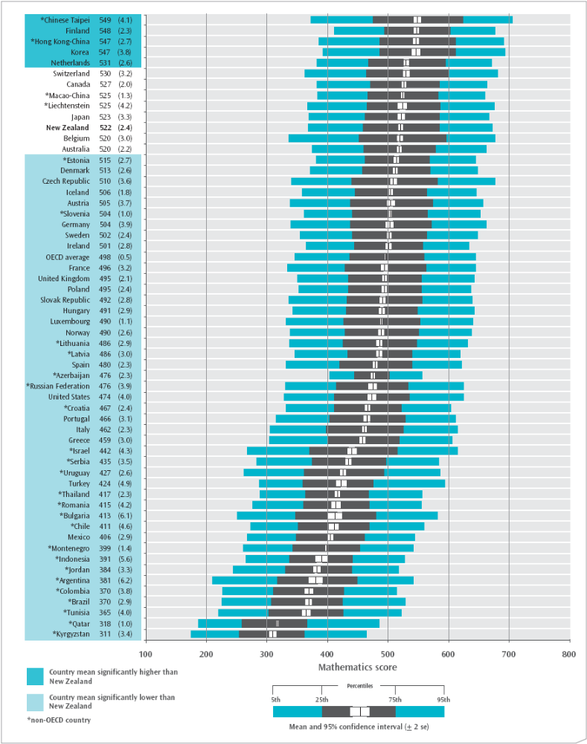
Note: * denotes non-OECD (partner) countries. These countries are not included in the OECD average.

Proficiency levels and relative performances across countries
Nearly six percent of New Zealand students were proficient at the highest proficiency level, Level 6, and were deemed capable of advanced mathematical thinking and reasoning. A further 13 percent of students were proficient at the second highest level, Level 5. At the lower end of the spectrum, ten percent of students were proficient at Level 1; these students were deemed capable of answering questions involving familiar contexts and clearly defined questions. Four percent of students achieved below proficiency Level 1, and were therefore deemed unlikely to demonstrate success on the most basic type of mathematics that PISA seeks to measure. The proportions of students achieving at each proficiency level have not changed since 2003.
As illustrated in Figure 2, a larger proportion of New Zealand students (6% and 13%), when compared with the average internationally, were found in the top two proficiency levels (3% and 10% for Levels 6 and 5, respectively, on average for OECD countries). The Czech Republic (18%), Japan (18%), Liechtenstein (18%), Canada (18%), Belgium (22%), and the Netherlands (21%) had similar proportions of students in the top two proficiency levels, while Chinese Taipei (32%), Hong Kong-China (28%), Finland (24%), Korea (27%), and Switzerland (23%) had significantly higher proportions in these top two levels.
Compared to other countries, New Zealand had a high proportion of students proficient at least at Level 3, with two-thirds proficient at this level or higher. Other OECD countries with notably large proportions of students (higher than two-thirds) proficient at Level 3 or higher include Korea, Switzerland, Canada, Finland, the Netherlands and Japan.
There has been some concern in New Zealand about the ‘tail of under-achievers’. Lower achievers can be defined in PISA as those who performed at Level 1, which means they can only complete simple mathematical tasks, and those who performed below Level 1 on the PISA mathematics questions. At this end of the proficiency scale it is most desirable to have a small proportion or no students performing at this level. New Zealand had fewer lower achievers than on average across OECD countries, with 14 percent performing at Level 1 or below compared with 21 percent on average across OECD countries. However, a number of countries had a smaller proportion of students performing at Level 1 or below, notably the higher-performing countries such as Finland (6%), Korea (9%), Hong Kong-China (10%), Macao-China (11%), the Netherlands (12%), and Chinese Taipei (12%). In comparison, Australia had a similar proportion of students performing at Level 1 or below (13%), while the United Kingdom (20%) and the United States (28%) had much larger proportions of students performing at these levels.
Although New Zealand’s overall performance is very high in comparison with most other participating countries, a relatively wide spread of achievement persists. In seeking to understand the reasons for this distribution in mathematical literacy it is important to put the achievement of students in context. In the following sections, the distributions of mathematical literacy achievement are compared for major sub-groupings in the population in order to build a better understanding of factors associated with variations in student achievement.
Figure 2: Percentage of students at each of the mathematical literacy proficiency levels
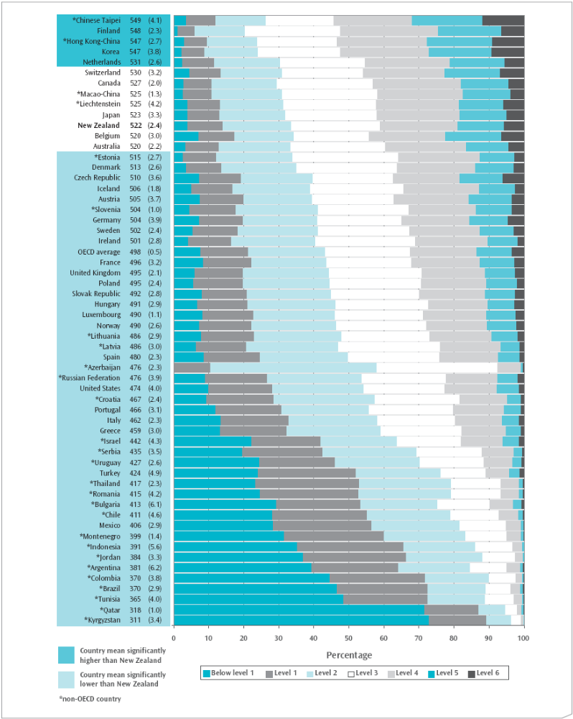
Note: * denotes non-OECD (partner) countries. These countries are not included in the OECD average.

Gender
On average, boys had higher mathematical literacy than girls, with a difference between their means of 11 scale score points. This pattern of a gender difference in favour of boys was also found in 2003 and was observable for many OECD countries. Across OECD countries the average gender difference in favour of boys was 11 score points. Hong Kong-China, the Netherlands, and Finland also had significant gender differences in favour of boys, while in Korea there was no significant difference between boys and girls.
As can be observed from Figure 3, the distribution of scores for New Zealand 15-year-old boys is wider than for girls. The wider range for boys is primarily due to the higher achievement scores among the better-performing boys at the top of the range.
Figure 3: Distributions of gender differences for mathematical achievement in PISA 2006
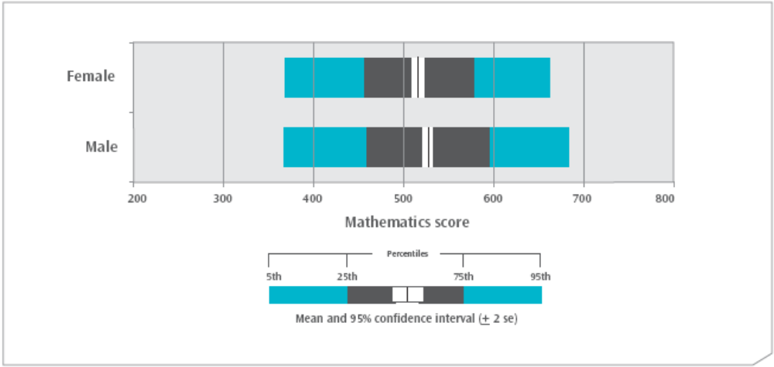
As shown in Figure 4, a significantly larger proportion of boys (7%) were proficient at the highest proficiency level, Level 6, when compared with girls (4%). That is, a larger proportion of boys than girls were deemed capable of advanced mathematical thinking and reasoning. Similarly, a higher proportion of boys were proficient at the second-highest level, Level 5 (15%) when compared with the girls (12%). Combining the proportions of students at the three highest proficiency levels, levels 4, 5, and 6, 44 percent of boys performed at or above these levels compared with 38 percent of girls. However, at the lower end of the spectrum, the same proportion of boys and girls were proficient at Level 1 and below (4% below Level 1 and 10% at Level 1 for both boys and girls).
Figure 4: Percentage of male and female students at each of the mathematical literacy proficiency levels
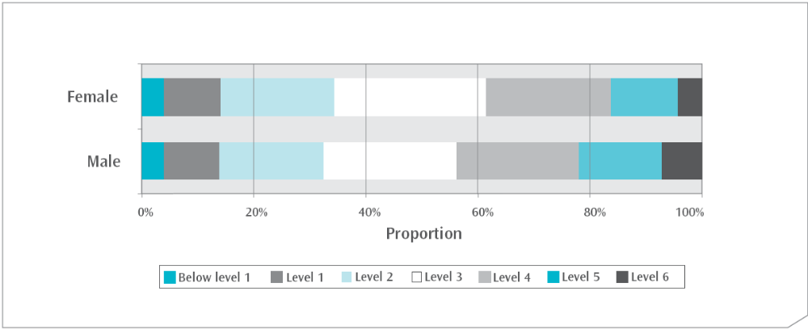
By way of comparison, New Zealand Years 5 and 9 boys and girls in the Trends in International Mathematics and Science Study (TIMSS-02/03), conducted in 2002, did not have any observable differences in achievement in mathematics (see Chamberlain 2007 and Caygill, Sturrock & Chamberlain 2007). The results from TIMSS may indicate that policies to reduce disparities between boys and girls are having a positive effect and if so, a reduction in the size of the gender difference may be expected in PISA in 2009.

Ethnicity, language and immigrant status
This section will examine the achievement of students in PISA across different ethnic groups, by language used at home, and by immigrant status.

Ethnicity
Five broad ethnic classifications are used to describe ethnicity in New Zealand. They are: Pākehā/European, Māori, Pasifika, Asian, and ‘Other’ ethnic groupings. The majority of students in New Zealand are Pākehā/European (62%) or Māori (18%). Asian (11%) and Pasifika (7%) make up most of the rest of the ethnic groupings, with only two percent of students categorised in the Other ethnic grouping.
Previous international studies (for example, PISA 2000, see Sturrock & May 2002; TIMSS-02/03, see Chamberlain 2007) have shown that average mathematics achievement varies across ethnic groups. Although the variation in achievement is not caused by ethnicity per se, education policies have been introduced in an attempt to realise the potential of students. Specific areas of focus for the Ministry of Education (Ministry of Education 2007) include the achievement of Māori and Pasifika students. The results at the Year 5 level in TIMSS-02/03 (Caygill et al. 2007) have shown an increase in mathematics performance on average for Māori and Pasifika students since the first cycle in 1994/1995.
In PISA 2006, Asian (548) and Pākehā/European (539) students had significantly higher mean achievement than did their Māori (479) and Pasifika (463) counterparts. Māori students performed significantly higher in mathematical literacy than Pasifika students. No significant difference was observed between Pākehā/European and Asian students.
In comparison with 2003, there is no significant improvement in achievement for any group. However, Pākehā/European students in 2006 (539) performed significantly lower than their counterparts in 2003 (546). The average achievement difference between Pākehā/European students and their counterparts in other groupings has shrunk between 2003 and 2006, partially attributable to this drop in achievement for Pākehā/European students and partially attributable to small non-significant rises in achievement in the other groupings. The small changes in achievement can be seen in Figure 5, although the error bars suggest most of these changes were not significant.
Note that these 2006 data represent only the second data point for measuring change, because 2003 was the first PISA assessment to cover all content domains of mathematics. PISA 2009 (data released in 2010) will provide an opportunity to gather a third data point in this series.
Figure 5: Changes in mathematical achievement for ethnic groupings in PISA between 2003 and 2006
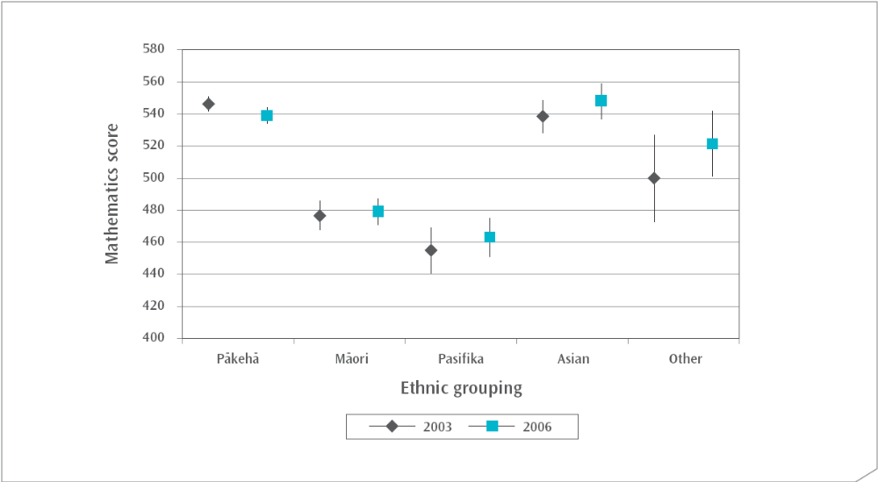
Although there is a difference in mean achievement between ethnic groupings, interestingly the range of achievement for Pākehā/European, Māori, and Pasifika students is remarkably similar (the range is defined as the difference between the 95th and 5th percentiles). Thus the picture of achievement within each of these three ethnic grouping is similar, albeit with a shift relative to the mean (see Figure 6).
Figure 6: Distributions of mathematical achievement in PISA 2006 for ethnic groupings of students
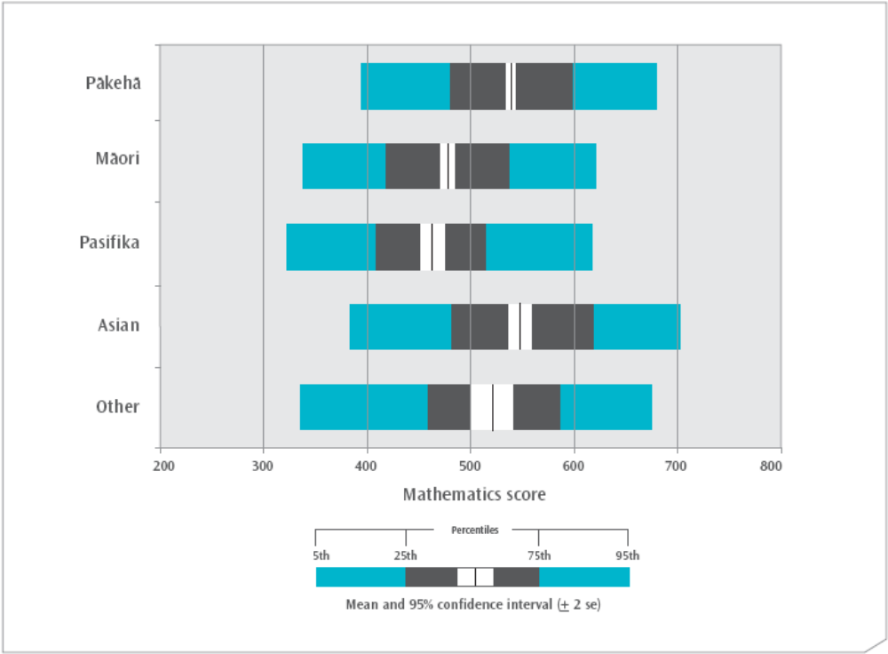
When examining the proficiency levels, a range of achievement was observed in all ethnic groupings. Within all ethnic groupings there were students who achieved at the highest proficiency level; that is, they demonstrated the ability to complete tasks requiring advanced mathematical thinking and reasoning. Similarly, within all ethnic groupings there were students who achieved at the lowest proficiency level; that is, they did not demonstrate the ability to complete a reasonable amount of the simplest mathematics tasks which PISA seeks to measure.
A higher proportion of Asian students were proficient at the highest level (11%) compared with any other ethnic grouping (Pākehā/European 7%, Other 7%, Māori 1%, and Pasifika 1%). Around half of all Asian (52%) and Pākehā/European (48%) students achieved at or above Level 4, as shown in Figure 7.
At the lower end of the spectrum, a greater proportion of Pasifika (11%) and Māori (8%) students performed below Level 1, compared with six percent of students in the Other grouping, and two percent each of Pākehā/European and Asian students. Combining the proportions of students below Level 1 and in Level 1, nearly one-third of Pasifika (30%) and one-quarter of Maori (26%) students performed at the lowest levels in the PISA assessment and were unable to demonstrate the ability to correctly complete much beyond simple mathematical tasks. In comparison, nine percent of Pākehā/European, 11 percent of Asian, and 16 percent of Other ethnic students demonstrated proficiency at or below Level 1.
Figure 7: Percentage of students in each ethnic grouping at each of the mathematical literacy proficiency levels
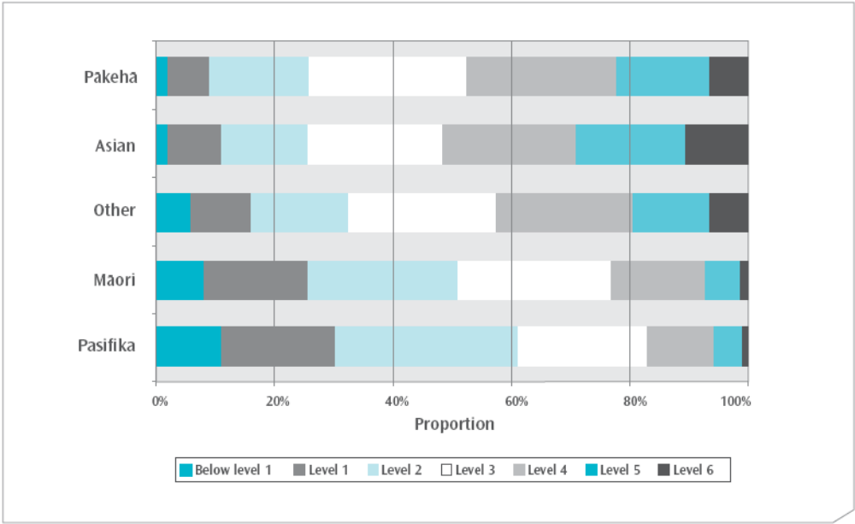
It is clear from the proficiency level proportions that Māori and Pasifika students were over-represented at the lowest levels of proficiency. However, in terms of actual numbers, Pākehā/European students made up the single largest group of low achievers. Figure 8 shows the ethnic composition of the 14 percent of students who achieved at Level 1 or below. Of these, well over a third, or 5.5 percent of all students, were Pākehā/European.
Figure 8: Percentage of students in each ethnic grouping in the group of lower achievers
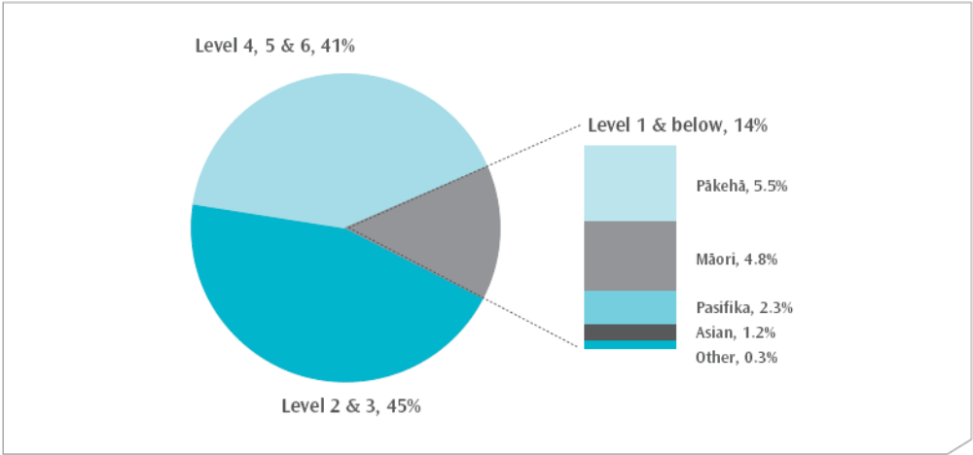

Girls and boys within ethnic groupings
With the exception of the Pākehā/European grouping, there was no significant difference between the boys and the girls within the ethnic groupings. In the Pākehā/European grouping, the mean achievement of boys was significantly higher than that of girls. Figure 9 presents the mean mathematics performances for girls and boys within each ethnic grouping. This figure shows that for both boys and girls, the relative performances between ethnic groupings are the same.
Figure 9: Mean mathematics performance for girls and boys within ethnic groupings
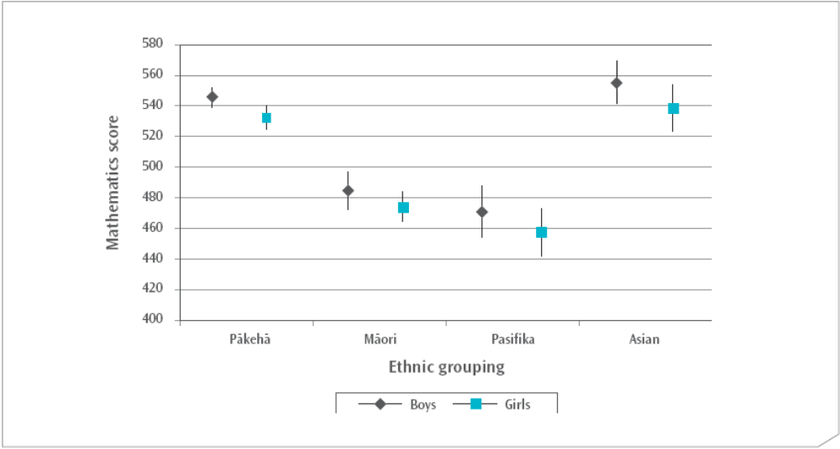

Language spoken at home
Another factor influencing the performance of students of different ethnic groupings may be the language spoken at home. Students in PISA were asked: “What language do you speak at home most of the time?”, and this was then classified as either the language of the test (in New Zealand this was English) or other language for the purposes of international comparisons. Approximately 9 out of every 10 New Zealand students responded that English was the language they spoke most at home, while approximately 1 out of every 10 responded that it was a language other than English.
There was no difference in mean mathematical achievement between students who usually spoke English at home and students who usually spoke another language at home in New Zealand (see Figure 10). This was different from the majority of OECD countries, where on average those who spoke the official language of instruction at home had a higher mean achievement than those who spoke another language at home (a difference of 50 score points across OECD countries). In Australia and Canada, like New Zealand, there was no difference in achievement between those who spoke the language of the test and those who spoke another language.
Comparing this result from 2006 with that found in 2003, a change is apparent. In PISA 2003 there was a significant difference between English speakers and those who mostly spoke another language at home, with English speakers demonstrating higher mathematical achievement on average. Figure 10 also appears to show a wider distribution of scores, although only the 95th percentile figure is statistically different when comparing the two language groupings.
Figure 10: Distributions of mathematical achievement in PISA 2006 for students, by the language spoken at home
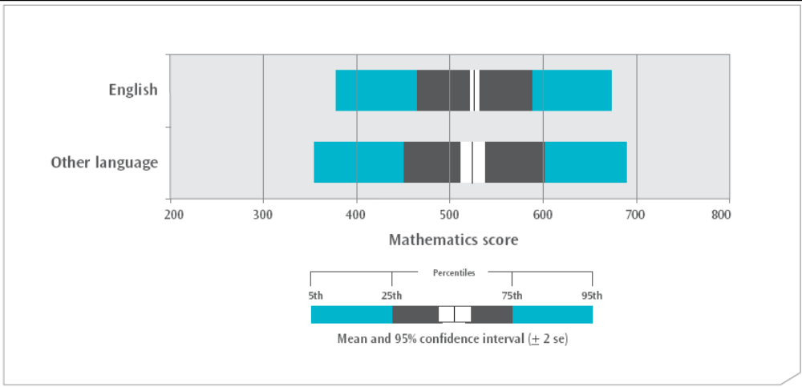
Note: While the distribution looks wider for ‘Other language’ there is a lot of uncertainty for this result, as demonstrated by large standard errors, particularly for the 5th percentile (se of 15.0).
When examining the achievement of students at the different proficiency levels, as shown in Figure 11, small differences between students in language groupings can be observed, but none are statistically significant.
Figure 11: Percentage of students in each language spoken at home grouping at each of the mathematical literacy proficiency levels
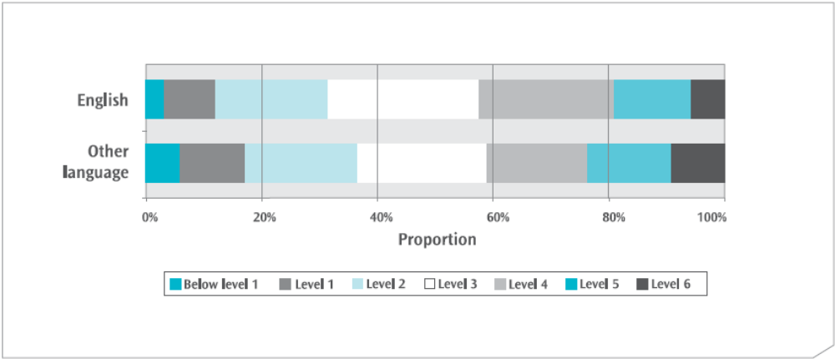

Immigrant status
Using reports from students on their country of birth and the country of birth of their parents, the OECD divided students into three categories to denote their immigrant status: native students, second-generation students, and first-generation students. The title native students was used where at least one of the students’ parents was born in New Zealand, second-generation students were those who were born in New Zealand but both of whose parents were not, while first generation was used for students where both they and their parents were born outside of New Zealand. The majority of students were native (79%), with seven percent of students second generation and 14 percent first generation. These proportions have not changed significantly since 2003.
Mathematical literacy achievement was not significantly different for native New Zealand students compared with their first- and second-generation counterparts. However, first-generation students had significantly higher mean achievement than second-generation students; this is a similar finding to that observed in 2003. There are no statistically significant differences between the percentiles shown in Figure 12.
Figure 12: Distribution of mathematical achievement in PISA 2006 for students, by immigration classification
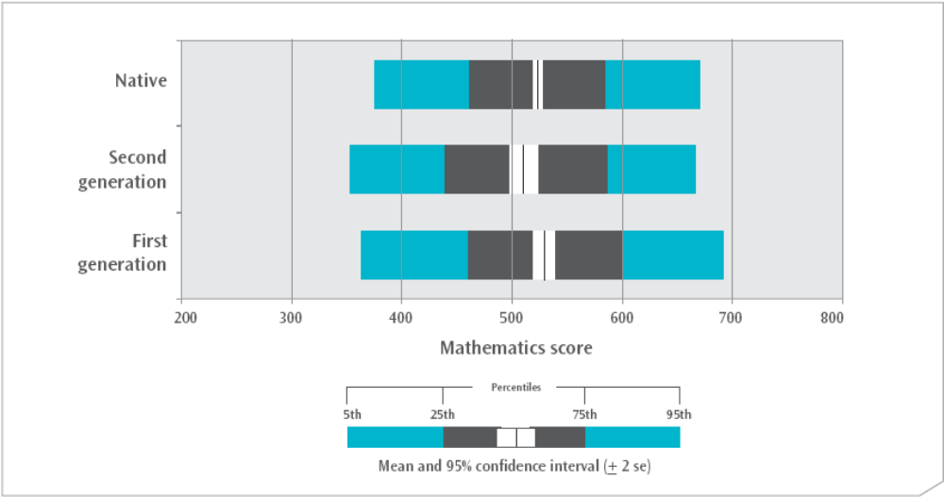
Note: While the distribution looks wider for ‘First generation’ students, differences are not significant.
Examining the proficiency levels for these three groupings, as shown in Figure 13, reveals small differences between the three groupings, but none of these differences are statistically significant.
Figure 13: Percentage of students in each immigration classification at each of the mathematical literacy proficiency levels
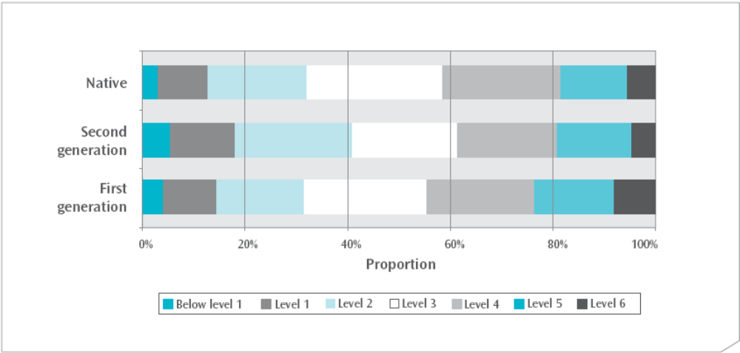

Socio-economic status
PISA 2006 asked a number of questions relating to students’ home backgrounds. Different combinations of questions can be used to create indices that summarise information about students’ economic and social background. Socio-economic status is generally determined by factors such as occupational status, education and wealth. The PISA index of economic, social and cultural status (ESCS) was based on information from students on parental occupations, parental education, and home possessions; access to possessions at home was used as a surrogate measure of wealth.
New Zealand students were higher on the ESCS index on average than students across the OECD countries; however students from 13 OECD countries, including Finland, the Netherlands, Australia, the United States, and the United Kingdom, were higher on this index than those in New Zealand.
Figure 14 illustrates the mathematics achievement of students at each quarter of the index. Students were assigned to the Lowest SES group if they were in the lowest approximately quarter of the ESCS index, while students in the High SES group were in the highest quarter of the index. As shown in Figure 14 student mathematical achievement increased, on average, with increasing levels of economic, social and cultural status, as measured by the ESCS index.
Figure 14: Mean mathematical achievement in PISA 2006 for students, by level on the ESCS index
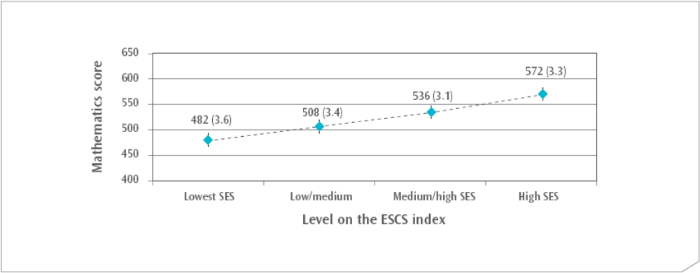
Note: Each level of the ESCS index is defined by quarters, so that the High SES group is approximately the top quarter of students on the ESCS index, while the Lowest SES group is approximately the lowest quarter of students.

Socio-economic status by ethnic grouping
Given the strength of the relationship between socio-economic status and achievement, a factor influencing the performance of students of different ethnic groupings may be disparities in socio-economic status. As shown in Figure 15, a higher proportion of Pākehā/European students were in the High SES grouping than might be expected from their population size, while a lower proportion were in the Lowest SES grouping. In contrast, a higher proportion of Māori and Pasifika students were in the Lowest SES grouping than might be expected from their population size, while a lower proportion were in the High SES grouping.
Figure 15: Proportions of students in each ethnic grouping in the lowest and highest levels on the ESCS index
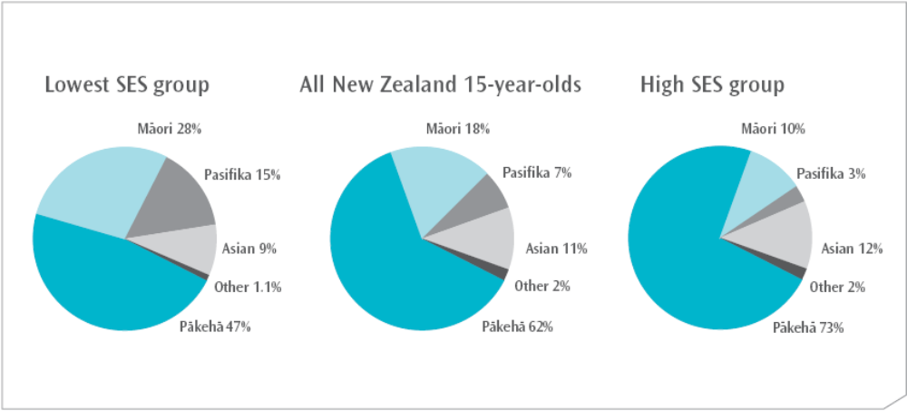

Conclusion
This report has examined the overall mathematical literacy performance of New Zealand’s 15-year-olds in PISA 2006 in comparison to other participating countries, and over time. In both PISA 2003 and PISA 2006, average achievement in mathematical literacy for New Zealand 15-year-olds was high in comparison to other countries. However, compared to the five top-performing countries, New Zealand had a larger proportion of students who demonstrated low levels of proficiency in mathematical literacy.
Comparisons of student achievement for different groups within the New Zealand population showed disparities in performance. Gender, ethnic grouping, immigrant status, and socio-economic status were background factors of New Zealand 15-year-old students associated to some extent with differences in performance in mathematical literacy. This report does not attempt to demonstrate any causal links between achievement and background factors, nor has it made any attempt to isolate which of these factors is the most important in predicting achievement. Further analyses of the data are needed to address these questions.
The challenge presented to the New Zealand education system by disparities among groupings is at the centre of many current education policies. The Ministry of Education’s current focus is on presence, engagement and achievement (Ministry of Education 2007). In primary schooling, building strong early foundations, with an emphasis on literacy and numeracy, is seen as critical for all students. To this end, the Numeracy Development Projects, targeted at both primary and secondary schooling, are currently being implemented to improve student performance in mathematics through improving the professional capability of teachers.
Education policies also focus on the specific background characteristics of students. Educators are encouraged to assume that all students can and will achieve, and to teach in a way that relates effectively to the backgrounds and aspirations of students. Ka Hikitia (Ministry of Education 2008a) and the Pasifika Education Plan (Ministry of Education 2006) both focus on realising the potential of Māori and Pasifika students.
The PISA 2006 results demonstrate that many of New Zealand’s 15-year-old students are already well prepared to apply their mathematical literacy skills effectively in their future lives.

Appendices

Appendix 1: Countries in PISA and structure of the PISA assessment cycle
Table A.1: Countries participating in PISA 2006
Argentina* | Australia | Austria
Azerbaijan* | Belgium | Brazil*
Bulgaria* | Canada | Chile*
Colombia* | Croatia* | Czech Republic
Denmark | Estonia* | Finland
France | Germany | Greece
Hong Kong-China* | Hungary | Iceland
Indonesia* | Ireland | Israel*
Italy | Japan | Jordan*
Korea | Kyrgyzstan* | Latvia*
Liechtenstein* | Lithuania* | Luxembourg
Macao-China* | Mexico | Montenegro*
The Netherlands | New Zealand | Norway
Poland | Portugal | Qatar*
Romania* | Russian Federation* | Serbia*
Slovak Republic | Slovenia* | Spain
Sweden | Switzerland | Chinese Taipei*
Thailand* | Tunisia* | Turkey
United Kingdom | United States | Uruguay*
Note: * denotes non-OECD countries.
Table A.2: Structure of PISA assessment cycle
Year | Reading literacy | Mathematical literacy | Scientific literacy
2000  Total item pool | Major domain  270 minutes | Minor domain  60 minutes | Minor domain  60 minutes
2003  Total item pool | Minor domain  60 minutes | Major domain  210 minutes* | Minor domain  60 minutes
2006  Total item pool | Minor domain  60 minutes | Minor domain  120 minutes | Major domain  210 minutes
Notes: Each student is assessed on a selection of items from each domain, for a total of 120 minutes.
*In 2003, a separate problem-solving assessment area was included, which was allocated 60 minutes of the total testing time.

Appendix 2: Sample questions from PISA 2003
Figure A.1: Level 6 mathematics question – Carpenter
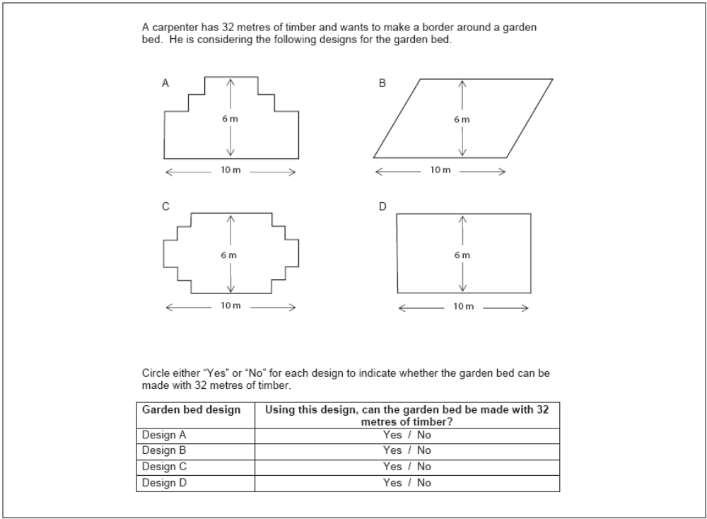

Content area: | Space and shape
Difficulty: | Linked to 687 score points
Scoring:
Full credit: | Yes, no, yes, yes in that order
Partial credit: | Any three of the above correct.

Country | Percent correct
Finland | 22 (1.1)
Hong Kong-China | 40 (1.5)
Korea | 35 (1.4)
Netherlands | 24 (1.3)
New Zealand | 21 (1.1)
Australia | 23 (1.1)
United Kingdom | 15 (0.9)
United States | 15 (1.0)
Note: Standard errors appear in parentheses.
Figure A.2: Level 5 mathematics question – Test scores
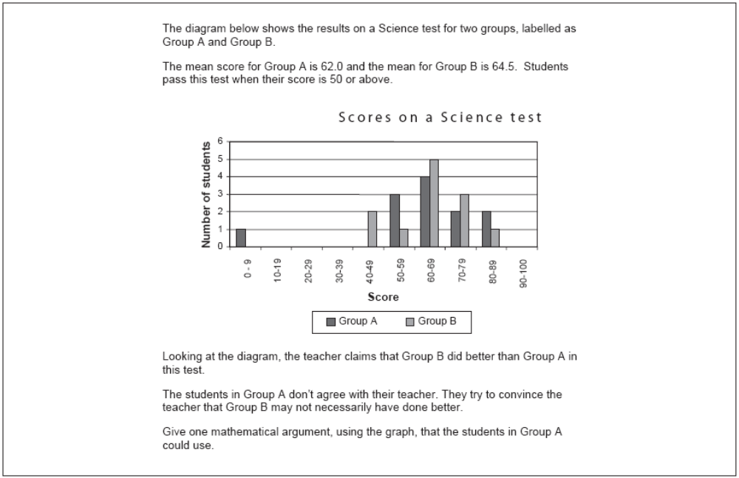

Content area: | Uncertainty
Difficulty: | Linked to 620 score points
Scoring:
Full credit: | One valid argument given. Valid arguments could relate to the number of students passing, the disproportionate influence of the outlier, or the number of students with scores in the highest level.

Country | Percent correct
Finland | 35 (1.3)
Hong Kong-China | 64 (1.6)
Korea | 46 (1.4)
Netherlands | 41 (1.4)
New Zealand | 42 (1.7)
Australia | 43 (1.1)
United Kingdom | 42 (1.4)
United States | 40 (1.6)
Note: Standard errors appear in parentheses.

Figure A.3: Level 4 mathematics question – Exchange rate, question 3
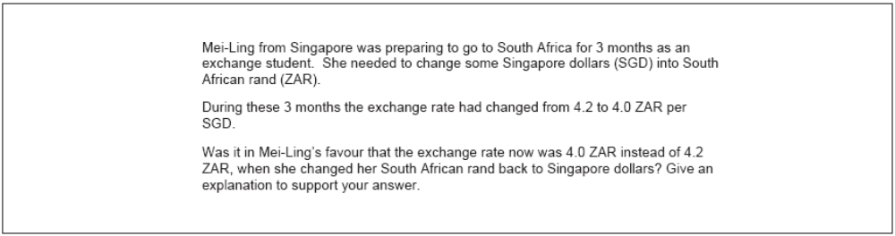

Content area: | Quantity
Difficulty: | Linked to 586 score points
Scoring:
Full credit: | Yes, with an adequate explanation

Country | Percent correct
Finland | 51 (1.4)
Hong Kong-China | 53 (1.5)
Korea | 40 (1.4)
Netherlands | 48 (1.5)
New Zealand | 42 (1.7)
Australia | 46 (1.0)
United Kingdom | 43 (1.2)
United States | 37 (1.5)
Note: Standard errors appear in parentheses.

Figure A.4: Level 3 mathematics question – Growing up
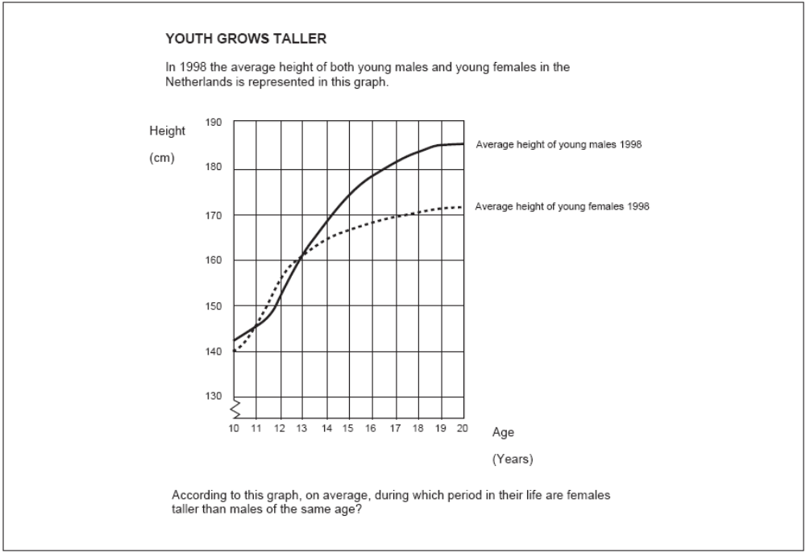

Content area: | Change and relationships
Difficulty: | Linked to 525 score points
Scoring:
Full credit: | Gives the correct interval from 11 to 13 years or states that girls are taller than boys when they are 11 and 12 years old.
Partial credit: | Other subsets (of 11, 12, 13) not included in the full credit section.

Country | Percent correct
 | Full credit | Partial credit
Finland | 67 (1.4) | 26 (1.2)
Hong Kong-China | 54 (1.7) | 34 (1.5)
Korea | 80 (1.0) | 4 (0.5)
Netherlands | 67 (1.4) | 23 (1.3)
New Zealand | 55 (1.3) | 34 (1.2)
Australia | 54 (1.2) | 36 (1.0)
United Kingdom | 53 (1.4) | 35 (1.3)
United States | 39 (1.4) | 43 (1.2)
Note: Standard errors appear in parentheses.
Figure A.5: Level 2 mathematics question – Staircase
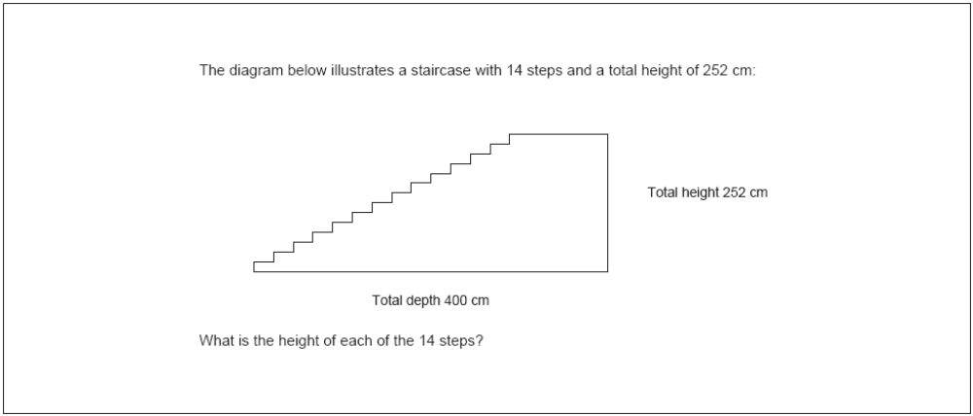

Content area: | Space and shape
Difficulty: | Linked to 421 score points
Scoring:
Full credit: | 18

Country | Percent correct
Finland | 85 (0.8)
Hong Kong-China | 87 (1.1)
Korea | 81 (1.0)
Netherlands | 85 (1.2)
New Zealand | 79 (1.2)
Australia | 78 (1.0)
United Kingdom | 74 (1.4)
United States | 70 (1.1)
Note: Standard errors appear in parentheses.

Figure A.6: Level 1 mathematics question – Exchange rate, question 1
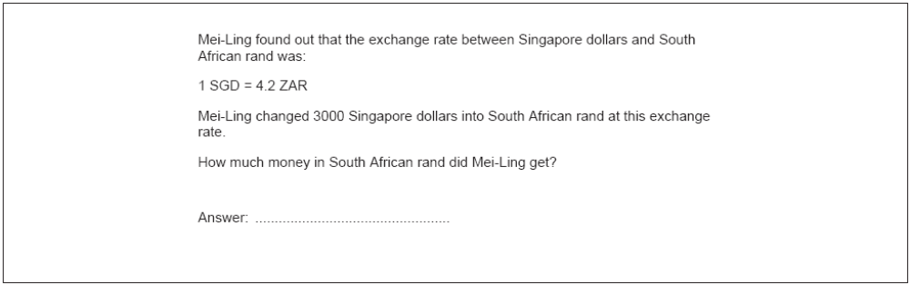

Content area: | Quantity
Difficulty: | Linked to 406 score points
Scoring:
Full credit: | 12 600 ZAR (with or without ZAR added)

Country | Percent correct
Finland | 90 (0.9)
Hong Kong-China | 89 (1.0)
Korea | 81 (1.1)
Netherlands | 85 (1.0)
New Zealand | 80 (1.1)
Australia | 81 (0.8)
United Kingdom | 74 (1.3)
United States | 54 (1.3)
Note: Standard errors appear in parentheses.

Appendix 3: Full detail of PISA mathematical literacy proficiency levels
Level | Lower score limit | What students can typically do
6 | 669.3 | At Level 6 students can conceptualise, generalise, and utilise information based on their investigations and modelling of complex problem situations. They can link different information sources and representations and flexibly translate among them. Students at this level are capable of advanced mathematical thinking and reasoning. These students can apply this insight and understandings along with a mastery of symbolic and formal mathematical operations and relationships to develop new approaches and strategies for attacking novel situations. Students at this level can formulate and precisely communicate their actions and reflections regarding their findings, interpretations, arguments, and the appropriateness of these to the original situations.
5 | 607.0 | At Level 5 students can develop and work with models for complex situations, identifying constraints and specifying assumptions. They can select, compare, and evaluate appropriate problem solving strategies for dealing with complex problems related to these models. Students at this level can work strategically using broad, well-developed thinking and reasoning skills, appropriate linked representations, symbolic and formal characterisations, and insight pertaining to these situations. They can reflect on their actions and formulate and communicate their interpretations and reasoning.
4 | 544.7 | At Level 4 students can work effectively with explicit models for complex concrete situations that may involve constraints or call for making assumptions. They can select and integrate different representations, including symbolic ones, linking them directly to aspects of real-world situations. Students at this level can utilise well-developed skills and reason flexibly, with some insight, in these contexts. They can construct and communicate explanations and arguments based on their interpretations, arguments, and actions.
3 | 482.4 | At Level 3 students can execute clearly described procedures, including those that require sequential decisions. They can select and apply simple problem solving strategies. Students at this level can interpret and use representations based on different information sources and reason directly from them. They can develop short communications reporting their interpretations, results and reasoning.
2 | 420.1 | At Level 2 students can interpret and recognise situations in contexts that require no more than direct inference. They can extract relevant information from a single source and make use of a single representational mode. Students at this level can employ basic algorithms, formulae, procedures, or conventions. They are capable of direct reasoning and making literal interpretations of the results.
1 | 357.8 | At Level 1 students can answer questions involving familiar contexts where all relevant information is present and the questions are clearly defined. They are able to identify information and to carryout routine procedures according to direct instructions in explicit situations. They can perform actions that are obvious and follow immediately from the given stimuli.

References
Caygill, R., Sturrock, F., & Chamberlain, M. C. (2007). Mathematics and science achievement in New Zealand: tracking the changes of Year 5 students in TIMSS 1994–2002. Wellington: Ministry of Education.
Chamberlain, M. C. (2007). Mathematics and science achievement in New Zealand: summing up New Zealand’s participation in three cycles of TIMSS at Year 9. Wellington: Ministry of Education.
Marshall, N., Caygill, R. & May, S. (2008). PISA 2006: reading literacy; how ready are our 15-year-olds for tomorrow’s world? Wellington: Ministry of Education.
Ministry of Education (2006). Pasifika education plan: monitoring report 2006. Wellington: Ministry of Education.
Ministry of Education (2007). Statement of intent 2007–2012. Wellington: Ministry of Education.
Ministry of Education (2008a). Ka Hikitia – Managing for success: the Māori education strategy 2008−2012. Wellington: Ministry of Education.
Ministry of Education (2008b). Schools plus: discussion document. Wellington: Ministry of Education.
OECD (2006). Assessing scientific, reading and mathematical literacy: a framework for PISA 2006. Paris: OECD.
OECD (2007a). PISA 2006: science competencies for tomorrow’s world, vol. 1: analysis. Paris: OECD.
OECD (2007b). PISA 2006: science competencies for tomorrow’s world, vol. 2: data. Paris: OECD.
OECD (in press). PISA 2006: technical report. Paris: OECD.
OECD (n.d.). Technical notes. Retrieved 28 March 2008 from: www.pisa.oecd.org/document/9/0,3343,en_32252351_32235731_39736777_1_1_1_1,00.html.
Sturrock, F., & May, S. (2002). PISA 2000: the New Zealand context. Wellington: Ministry of Education.
Telford, M., & Caygill, R. (2007). PISA 2006: how ready are our 15-year-olds for tomorrow’s world? Wellington: Ministry of Education.

Definitions and technical notes

Mean
Student performances in PISA are reported using means, which is a type of average, for groupings of students. In general, the mean of a set of scores is the sum of the scores divided by the number of scores, and is often referred to as ‘the average’. Note that for PISA, as with other large-scale studies, the means for a country are adjusted slightly (in technical terms ‘weighted’) to reflect the total population of 15-year-olds rather than just the sample.

Minimum group size for reporting achievement data
In this report student achievement data are not reported where the group size is less than 30 students.

OECD mean or average
The OECD mean, sometimes referred to as the OECD average, includes only the OECD countries – no non-OECD (partner) countries are included in this average. The OECD mean is the average of the means for the OECD countries.

Percentile
The percentages of students performing below or above particular points on the scale are given in this report. The lowest outer limit of achievement is the 5th percentile – the score at which only 5 percent of students achieved a lower score and 95 percent of students achieved a higher score. The highest outer limit is the 95th percentile – the score at which only 5 percent of students achieved a higher score and 95 percent of students a lower score; thus 90 percent of the 15-year-old student scores lie between the 5th and 95th percentiles.

Proficiency scale
PISA developed proficiency levels to describe the range in literacy across 15-year-old students. The proficiency levels describe the competencies of students achieving at that level and are anchored at certain score points on the achievement scale. Note that students were considered to be proficient at a particular level if, on the basis of their overall performance, they could be expected to answer at least half of the items in that level correctly. Typically, students who were proficient at higher levels had also demonstrated their abilities and knowledge at lower levels.

Scale score points
The design of PISA allows for a large number of questions to be used in mathematics, science and reading; each student answers only a portion of these questions. PISA employs techniques to enable population estimates of achievement to be produced for each country even though a sample of students responded to differing selections of questions. These techniques result in scaled scores which are on a scale with a mean of 500 and a standard deviation of 100. The OECD mean score of 500 points was established as the benchmark against which performance has since been measured in the first cycle of PISA where each subject was the major focus: in PISA 2000 for reading, in PISA 2003 for mathematics, and in PISA 2006 for science.

Standard error
Because of the technical nature of PISA, the calculation of statistics such as means and proportions have some uncertainty due to (i) generalising from the sample to the total 15-year-old school population, and (ii) inferring each student’s proficiency from their performance on a subset of items. The standard errors provide a measure of this uncertainty. In general, we can be 95 percent confident that the true population value lies within an interval 1.96 standard errors either side of the given statistic.

Statistically significant
In order to determine whether a difference between two means is actual, it is usual to undertake tests of significance. These tests take into account the means and the error associated with them. If a result is reported as not being statistically significant, then although the means might be slightly different, we do not have sufficient evidence to infer that they are different. All tests of statistical significance referred to in this report are at the 95 percent confidence level.

Further information
New Zealand’s PISA web page is at www.educationcounts.govt.nz/goto/pisa. The OECD’s PISA 2006 International Report can be accessed from the OECD PISA website: www.pisa.oecd.org. An interactive data selection facility, which allows selected analyses of international contextual information for student performance, is also available from this site, along with the international versions of the student, school and parent questionnaires. Further reporting of New Zealand PISA 2006 results will be available later in 2008.
PISA will be administered in New Zealand again during July and August 2009. The PISA 2009 results will be published by the OECD in December 2010.
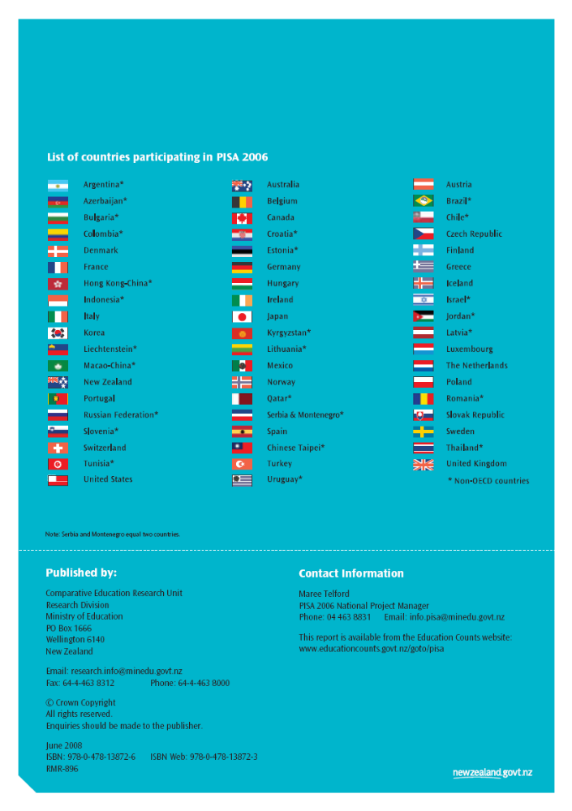

Students are aged between 15 years 3 months and 16 years 2 months. As most students are aged 15, they are referred to as 15-year-olds for brevity.
The countries participating in PISA 2006 are listed in Appendix 1.
Throughout this report, the term ‘significantly’ refers to statistical significance at the 0.05 level. See the ‘Definitions and technical notes’ at the end of this report for further details.
Only the reading report was published at the time this report was released (Marshall et al. 2008), the rest are in press.
See Table A.2 in Appendix 1 for details of how the three-yearly PISA assessments are structured.
Values come from OECD 2007a, Table A5.3, p. 365.
Please refer to ‘Definitions and technical notes’ at the end of this report for further details.
Students who had received less than one year’s instruction in English and those in Māori-immersion classes were excluded from the PISA sample in New Zealand.
Note that the figures presented here exclude missing or invalid responses – there were four percent of such responses in the sample. They also exclude the small proportion (0.2%) that mostly speak Māori at home.
Adjusted percentages are shown. There were two percent of students with missing data for these questions.
Note that the labels for these groupings have changed: what is now called first generation was called non-native; what is now called second generation was called first generation.

